SUPPLEMENTARY INFORMATION

Contents
Supplementary Figures and Tables

Supplementary Figure 1. Female-limited genetic enrichment analyses between endometriosis, BMI and WHRadjBMI GWAS datasets, using independent (r²<0.2) SNPs. The panels show: (1) The proportion of SNPs nominally associated (P<0.05) with WHRadjBMI (Panel A) or BMI (Panel B) by significance of overall and stage B endometriosis association (P<1.0 x 10⁻³ vs. P≥1x10⁻³); (2) The proportion of SNPs nominally associated (P<0.05) with overall and stage B endometriosis by significance of WHRadjBMI (Panel C) and BMI (Panel D) association (P<1.0 x 10⁻³ vs. P≥1x10⁻³). P-values of chi² tests assessing statistical difference between proportions are shown above each set of bars, and 95% confidence intervals of the proportions are given on each bar. For differences with P_{chisq} < 0.2, empirical p-values are given in brackets (see Methods).

Supplementary Figure 2. Directions of effect of SNPs associated with all (panel A) and stage B endometriosis (panel B) (P<0.001) and WHRadjBMI (P<0.05). Linear regression R² and p-values used to test for significant directionality of effects are shown.

Supplementary Figure 3. Graphical illustration of the GRAIL results: a. Overall endometriosis and WHRadjBMI, 79 genes were detected marked by 72 independent SNPs, b. Stage B endometriosis and WHRadjBMI, 77 genes were detected marked by 85 independent SNPs.

Supplementary Figure 4. Q-Q plots of observed vs. expected GWAS results for a. Overall endometriosis, b. Stage B endometriosis.

Supplementary Table 1. Association results of published IEC genome-wide significant endometriosis loci(1) in the GIANT BMI GWAS, and of BMI loci(2) in endometriosis GWAS (look-up results are shown in bold).

Supplementary Table 2. Contingency tables that are the basis of the chi² test for genetic enrichment (Figure 1), showing the numbers (proportions) of independent SNPs (r2 >0.2) associated with WHRadjBMI at P<0.05 vs. P≥0.05 by association P-value (P<1x10⁻³ vs. P≥ 1 x 10⁻³) for overall (a) and stage B (b) endometriosis.

Supplementary Table 3. Sensitivity analysis testing the effect of different significance thresholds for association detection in discovery (overall endometriosis) and look-up (WHRadjBMI) data-sets.

Supplementary Table 4. Sensitivity analysis testing the effect of different significance thresholds for association detection in discovery (overall endometriosis) and look-up (BMI) data-sets.

Supplementary Table 5. Polygenic prediction results of overall WHRadjBMI derived profile scores on overall endometriosis and stage B endometriosis.

Supplementary Table 6. Polygenic prediction results of female-limited WHRadjBMI derived profile scores on overall endometriosis and stage B endometriosis.

Supplementary Table 7. Polygenic prediction results of overall BMI derived profile scores on overall endometriosis and stage B endometriosis.

Supplementary Table 8. Polygenic prediction results of female-limited BMI derived profile scores on overall endometriosis and stage B endometriosis.

Supplementary Table 9. Directionality of effects of the shared SNPs (primary dataset p<1x10⁻³ and look-up dataset p<0.05) between endometriosis (all and stage B only) and BMI/WHRadjBMI GWAS results.

Supplementary Table 10. Directionality of effects of the shared SNPs (primary dataset p<1x10⁻³ and look-up dataset p<0.05) between endometriosis (all and stage B only) and female-limited BMI/WHRadjBMI GWAS results.

Supplementary Table 11. Annotation of genetic enrichment analysis results between all endometriosis and WHRadjBMI (n=52).

Supplementary Table 12. Annotation of genetic enrichment analysis results between stage B endometriosis and WHRadjBMI (n=57).

Supplementary Table 13. Results of the Mammalian Gene Expression Uterus database (MGEx-Udb)(4) look up for the 16 genes in human endometrium tissue from individuals with endometriosis and without.

Supplementary Table 14. Results of the cis-eQTL analysis in the MUTHER data for abdominal fat expression of the 16 genes(5).

Supplementary Table 15. Results of the differential cis-eQTL analysis between abdominal and gluteal fat in the MolOBB data on the 16 genes.

Supplementary Table 16. Results of over/under-representation of (a) 88 genes associated with all endometriosis (P<1.0x10⁻³) and WHRadjBMI (P<0.05), and (b) 103 genes associated with stage B endometriosis (P<1.0x10⁻³) and WHRadjBMI (P<0.05), in 241 biological processes in PANTHER.

Supplementary Table 17. Results of over/under-representation of (a) 88 genes associated with all endometriosis (P<1.0x10⁻³) and WHRadjBMI (P<0.05), and (b) 103 genes associated with stage B endometriosis (P<1.0x10⁻³) and WHRadjBMI (P<0.05), in 176 curated biological pathways in PANTHER.

Supplementary Table 18. Sensitivity analysis on over/under-representation of genes associated with all endometriosis and WHRadjBMI with using two additional p-value thresholds: (1) P<1x10⁻⁴ and (2) P<1x10⁻² in comparison to our original enrichment threshold of p<1x10⁻³, in 176 curated biological pathways in PANTHER.

Supplementary Table 19. Overall endometriosis and WHRadjBMI GRAIL results (P<0.5).

Supplementary Table 20. Stage B endometriosis and WHRadjBMI GRAIL results (P<0.5).

Supplementary Figure 1. Female-limited genetic enrichment analyses between endometriosis, BMI and WHRadjBMI GWAS datasets, using independent (r²<0.2) SNPs. The panels show: (1) The proportion of SNPs nominally associated (P<0.05) with WHRadjBMI (Panel A) or BMI (Panel B) by significance of overall and stage B endometriosis association (P<1.0 x 10⁻³ vs. P≥1x10⁻³); (2) The proportion of SNPs nominally associated (P<0.05) with overall and stage B endometriosis by significance of WHRadjBMI (Panel C) and BMI (Panel D) association (P<1.0 x 10⁻³ vs. P≥1x10⁻³). P-values of chi² tests assessing statistical difference between proportions are shown above each set of bars, and 95% confidence intervals of the proportions are given on each bar. For differences with P_{chisq} < 0.2, empirical p-values are given in brackets (see Methods).

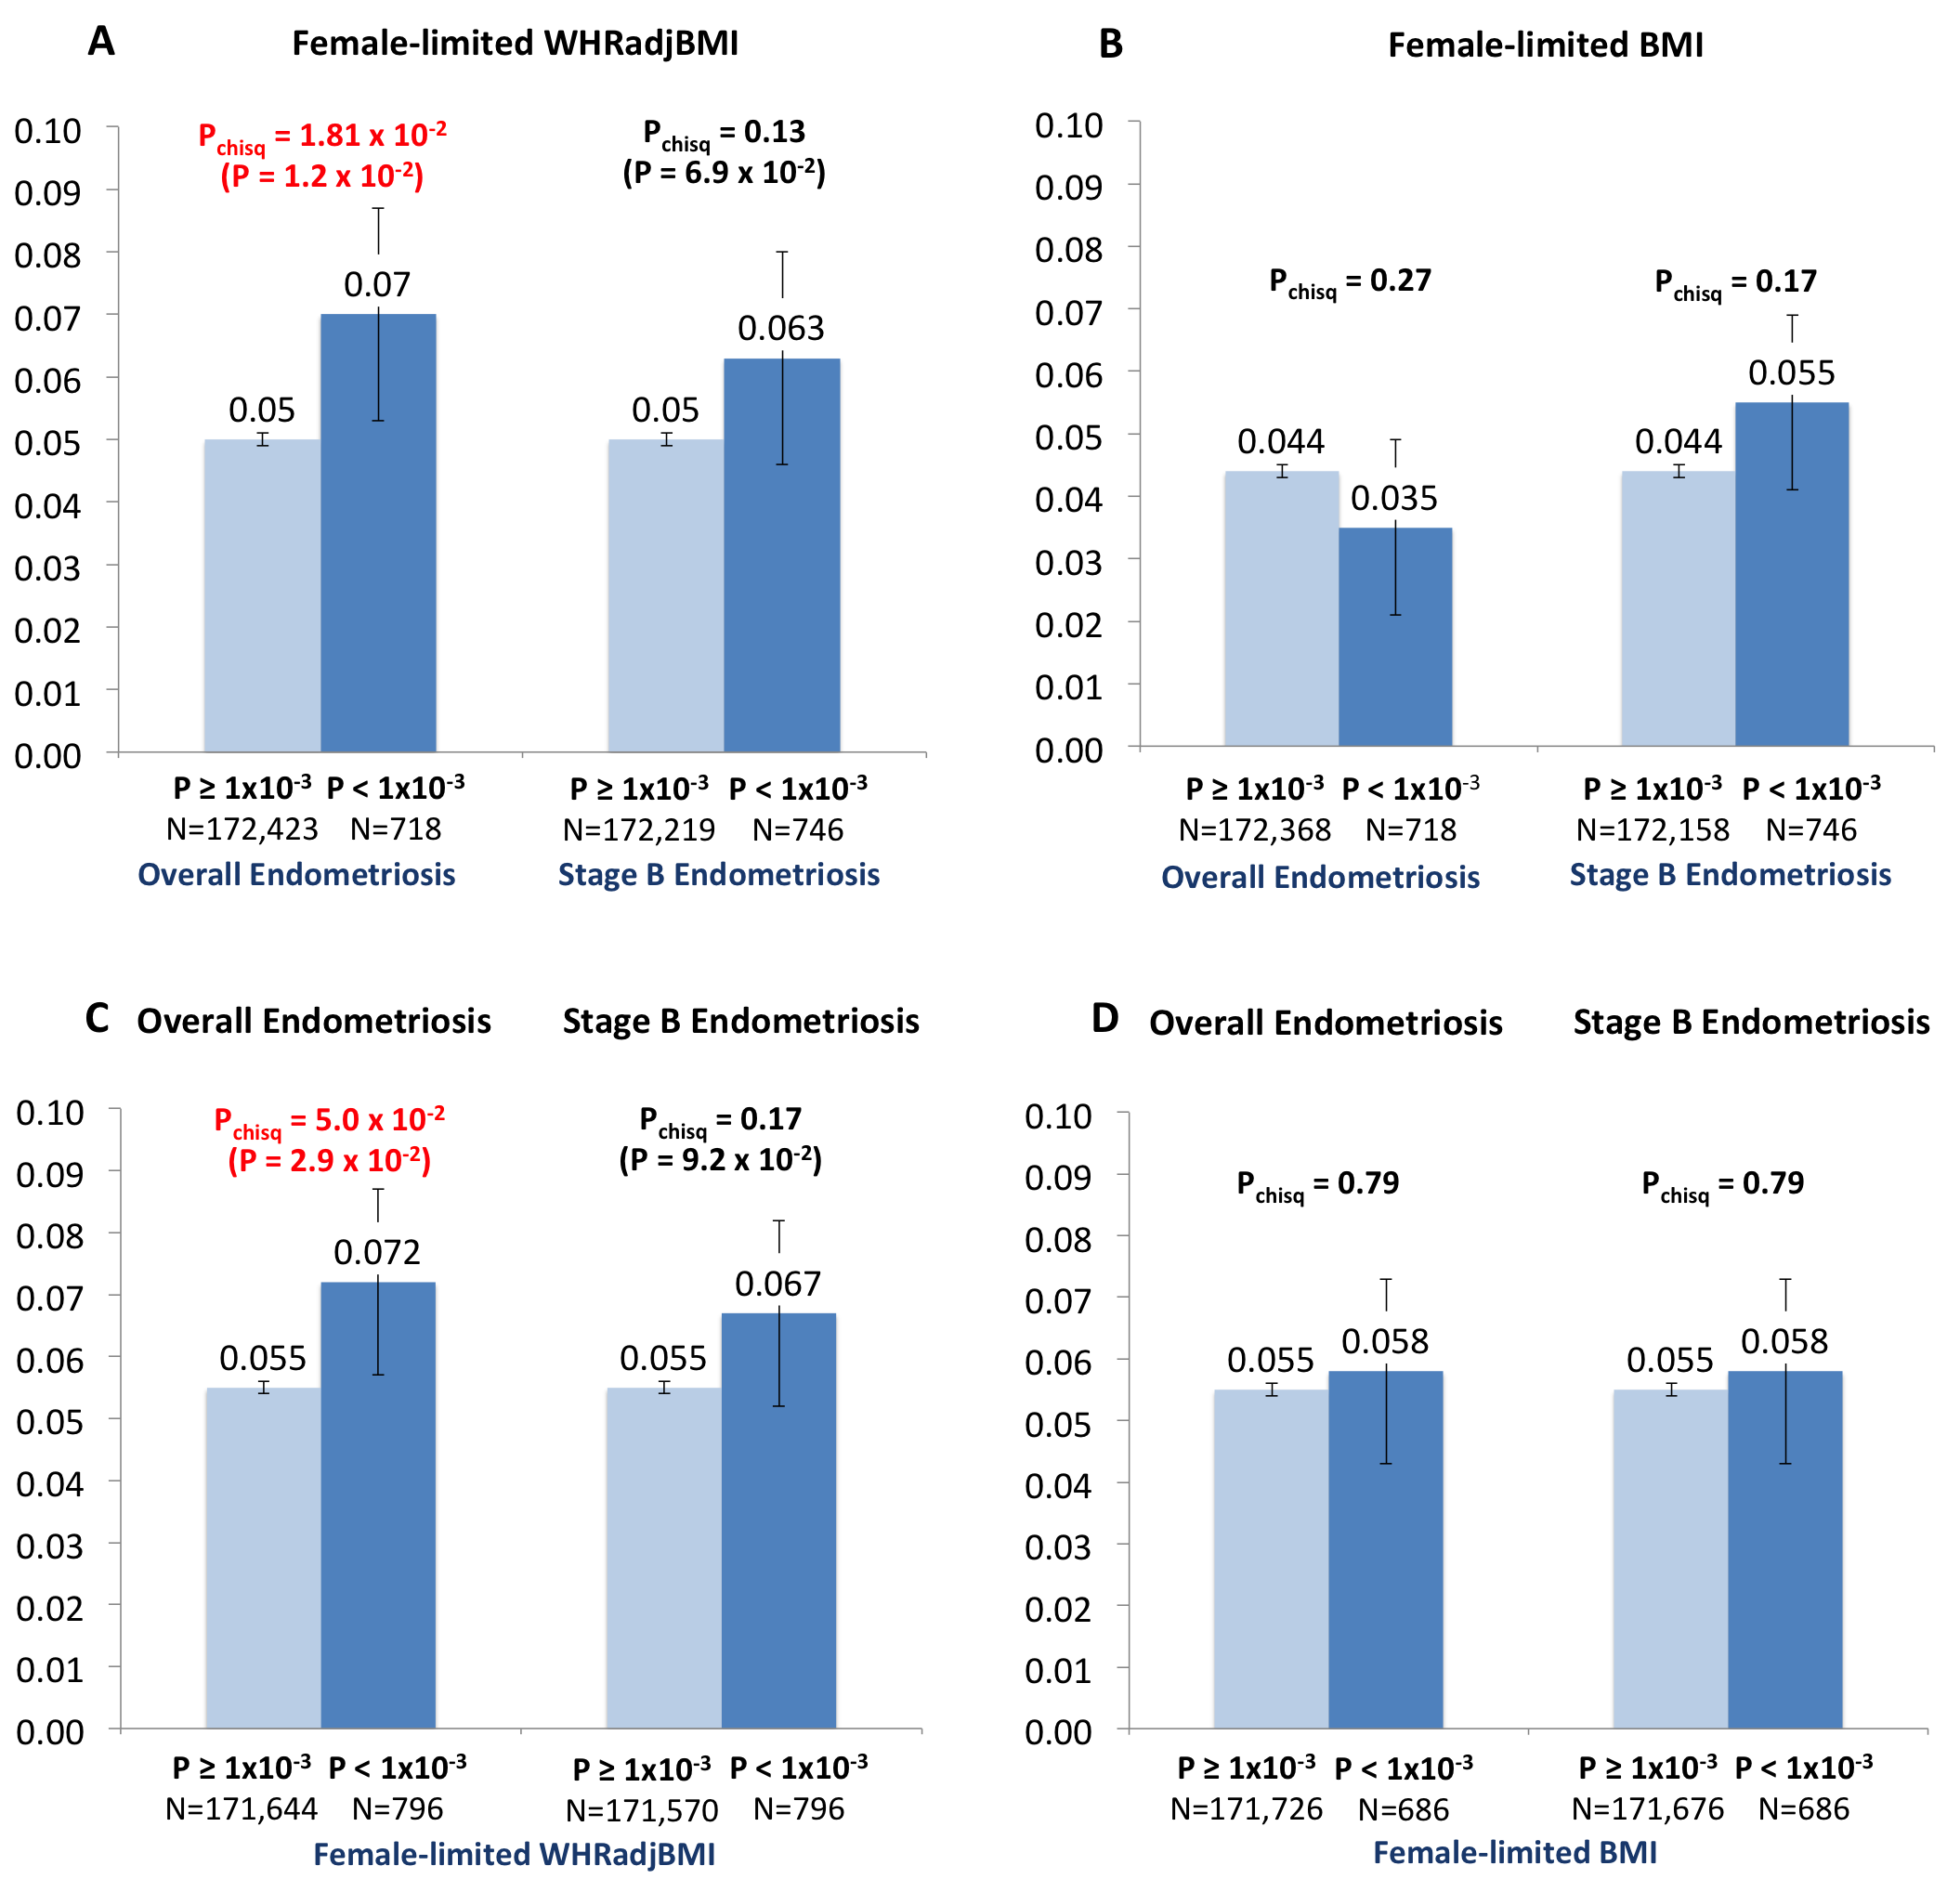

Supplementary Figure 2. Directions of effect of SNPs associated with all (panel A) and stage B endometriosis (panel B) (P<0.001) and WHRadjBMI (P<0.05). Linear regression R² and p-values used to test for significant directionality of effects are shown.

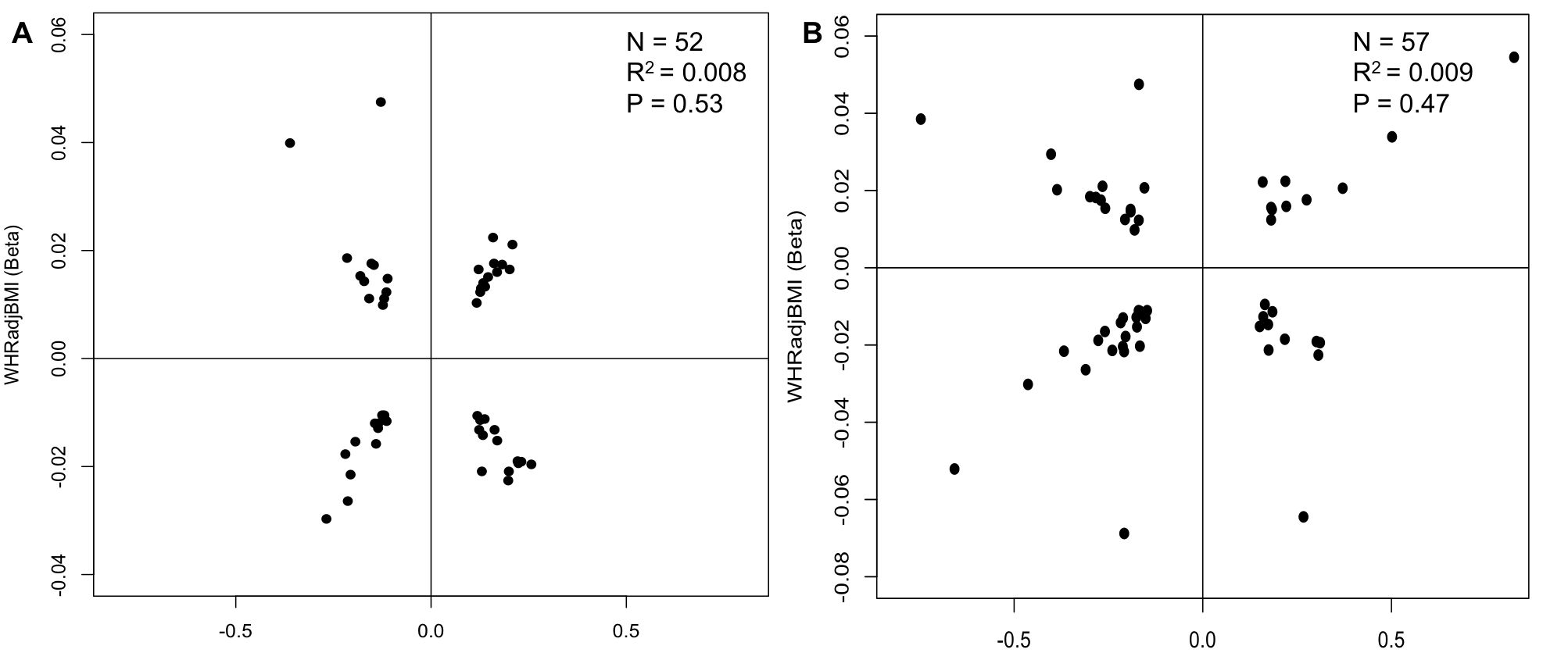
Overall Endometriosis (Beta)
Stage B Endometriosis (Beta)

Supplementary Figure 3. Graphical illustration of the GRAIL results: a. Overall endometriosis and WHRadjBMI, 79 genes were detected marked by 72 independent SNPs, b. Stage B endometriosis and WHRadjBMI, 77 genes were detected marked by 85 independent SNPs.

a. 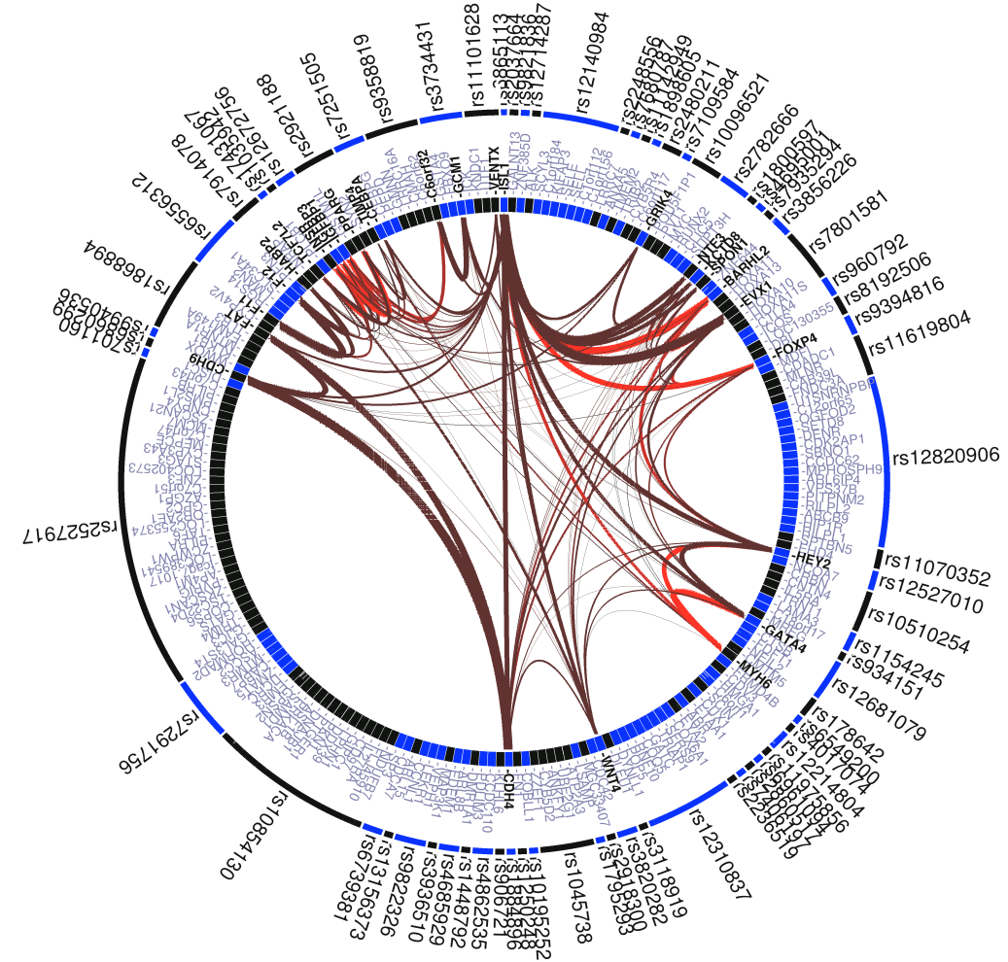

b. 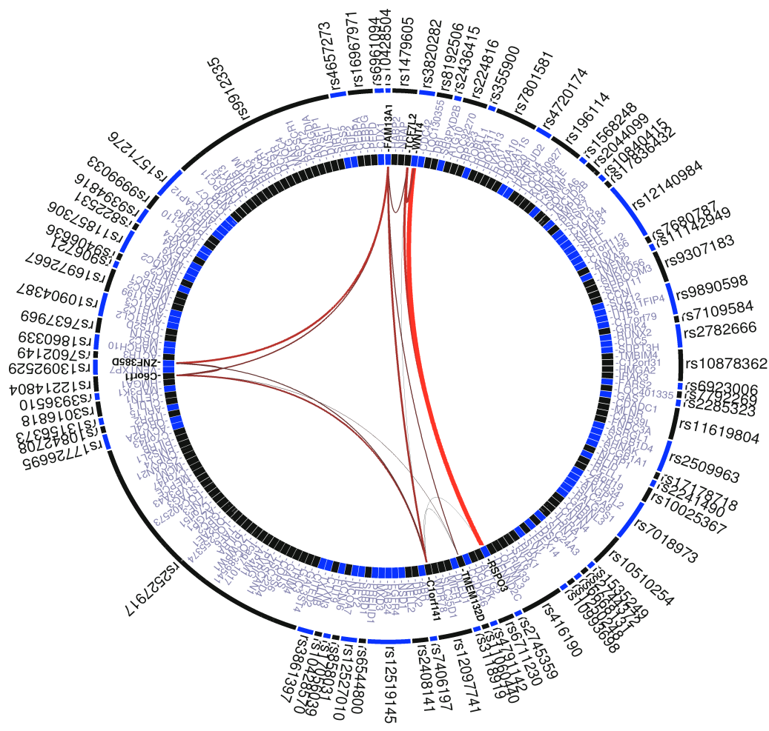

Supplementary Figure 4. Q-Q plots of observed vs. expected GWAS results for, a. Overall endometriosis, b. Stage B endometriosis.

a. Overall Endometriosis b. Stage B Endometriosis
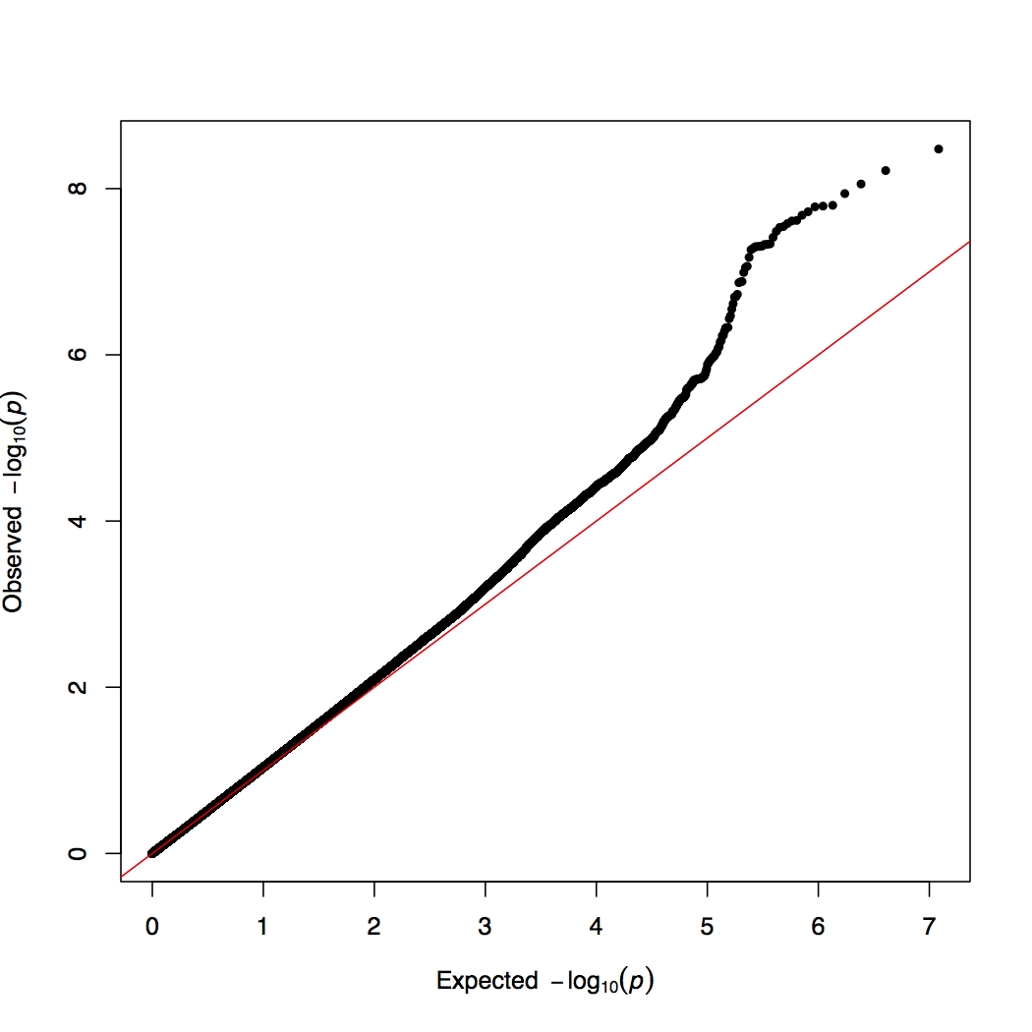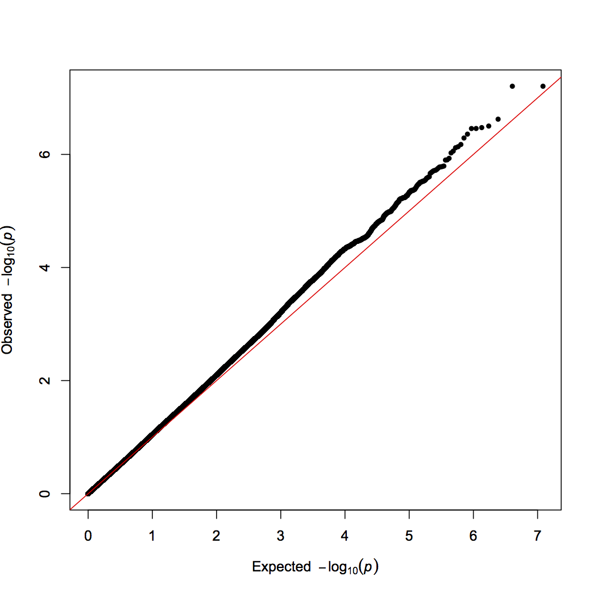

Supplementary Table 1. Association results of published IEC genome-wide significant endometriosis loci(1) in the GIANT BMI GWAS, and of BMI loci(2) in endometriosis GWAS (look-up results are shown in bold).

GWAS | SNP  (proxy; r²) | Chr | Location  (B36) | RAF  (allele) | Status | Endometriosis  All cases |  | Endometriosis  Stage B |  | Overall BMI |  | Female limited BMI |  |  | Nearest  Gene
 |  |  |  |  |  | P.Val^{b} | OR  (95% CI) | P.Val^{b} | OR  (95% CI) | P.Val^{c} | Effect  (SE) |  | P.Val^{d} | Effect  (SE)
Endometriosis | rs12700667 | 7 | 25868164 | 0.74 (A) | G | 5.1x10⁻⁷ | 1.21  (1.12-1.31) | 3.3x10⁻⁸ | 1.36  (1.23-1.50) | 0.27 | 0.006  (0.005) |  | 0.15 | 0.012 (0.080) | Intergenic
Endometriosis | rs7521902 | 1 | 22363311 | 0.75 (A) | G | 8.9x10⁻⁵ | 1.16  (1.08-1.25) | 7.5x10⁻⁵ | 1.26  (1.14-1.39) | 0.92 | -0.006 (0.006) |  | 0.97 | -0.001  (0.008) | WNT4
BMI | rs9816226 | 3 | 187,317,193 | 0.18 (A) | I (0.98) | 0.01 | 1.12  (1.03-1.22) | 0.16 | 1.08  (0.97-1.21) | 9.3x10⁻¹⁴ | -0.046  (0.006) |  | 2.4x10⁻⁸ | -0.045  (0.008) | ETV5
BMI | rs1514175 | 1 | 74,764,232 | 0.58 (A) | G | 0.02 | 0.92  (0.87-0.99) | 3.9x10⁻³ | 0.88  (0.80-0.96) | 1.6x10⁻⁹ | 0.029 (0.005) |  | 1.2x10⁻⁸ | 0.035  (0.006) | TNNI3K
BMI | rs543874 | 1 | 176,156,103 | 0.80 (A) | I (0.99) | 0.02 | 1.10  (1.02-1.19) | 0.03 | 1.12  (1.01-1.25) | 2.6x10⁻¹³ | -0.044  (0.006) |  | 7.1x10⁻¹² | -0.054  (0.008) | SEC16B
BMI | rs2890652 | 2 | 142,676,401 | 0.82 (T) | I (0.96) | 0.05 | 0.91  (0.81-1.00) | 0.02 | 0.86  (0.74-0.98) | 1.7x10⁻⁷ | -0.033 (0.006) |  | 8.7x10⁻⁴ | -0.027  (0.008) | LRP1B
BMI | rs12444979 | 16 | 19,933,600 | 0.14 (T) | I (0.97) | 0.07 | 1.10  (0.99-1.21) | 0.34 | 1.06  (0.93-1.21) | 4.9x10⁻¹¹ | -0.046 (0.007) |  | 2.3x10⁻⁶ | -0.043  (0.009) | GPRC5B
BMI | rs10968576 | 9 | 28,404,339 | 0.32 (A) | G | 0.08 | 0.94  (0.87-1.01) | 0.02 | 0.90  (0.81-0.99) | 2.2x10⁻⁸ | -0.029 (0.005) |  | 1.1x10⁻⁵ | -0.029  (0.007) | LRRN6C
BMI | rs987237 | 6 | 50,911,009 | 0.18 (G) | G | 0.08 | 0.93  (0.84-1.01) | 0.17 | 0.93  (0.82-1.03) | 7.9x10⁻¹⁶ | 0.049  (0.007) |  | 1.8x10⁻¹⁰ | 0.051 (0.008) | TFAP2B
BMI | rs10150332 | 14 | 79,936,964 | 0.21 (C) | I (0.99) | 0.09 | 1.01  (0.93-1.09) | 0.23 | 1.03  (0.93-1.14) | 3.2x10⁻⁷ | 0.029  (0.006) |  | 4.5x10⁻⁴ | 0.026  (0.008) | NRXN3
BMI | rs2241423 | 15 | 65,873,892 | 0.78 (A) | G | 0.14 | 1.06  (0.98-1.15) | 0.12 | 1.09  (0.98-1.20) | 1.4x10⁻¹⁰ | -0.037 (0.006) |  | 2.9x10⁻⁵ | -0.031  (0.007) | MAP2K5
BMI | rs3817334 | 11 | 47,607,569 | 0.59 (C) | I (0.99) | 0.14 | 1.05  (0.98-1.12) | 0.42 | 1.04  (0.95-1.13) | 5.6x10⁻¹¹ | -0.031  (0.005) |  | 4.7x10⁻⁷ | -0.031  (0.006) | MTCH2
BMI | rs7138803 | 12 | 50,247,468 | 0.63 (G) | G | 0.15 | 1.05  (0.98-1.12) | 0.39 | 1.04  (0.95-1.14) | 4.6x10⁻¹¹ | -0.032  (0.005) |  | 1.2x10⁻⁷ | -0.033 (0.006) | FAIM2
BMI | rs7359397 | 16 | 28,793,160 | 0.40 (T) | I (0.99) | 0.18 | 1.05  (0.98-1.12) | 0.88 | 1.01  (0.92-1.10) | 2.8x10⁻¹⁰ | 0.030  (0.005) |  | 3.3x10⁻⁵ | 0.026  (0.006) | SH2B1
BMI | rs3810291 | 19 | 47,569,003 | 0.32 (G) | I (0.90) | 0.23 | 1.05  (0.97-1.13) | 0.19 | 1.07  (0.97-1.17) | 1.2x10⁻⁷ | -0.029 (0.005) |  | 7.5x10⁻⁵ | -0.028  (0.007) | TMEM160
BMI | rs13078807 | 3 | 85,966,840 | 0.81 (G) | G | 0.25 | 0.95  (0.88-1.04) | 0.37 | 0.95  (0.85-1.06) | 7.7x10⁻⁸ | 0.032 (0.006) |  | 1.2x10⁻⁶ | 0.037  (0.008) | CADM2
BMI | rs713586 | 2 | 25,158,008 | 0.51 (T) | I (0.98) | 0.27 | 1.04  (0.97-1.11) | 0.16 | 1.07  (0.86-1.02) | 2.8x10⁻⁷ | -0.025 (0.007) |  | 3.0x10⁻⁸ | -0.034  (0.006) | RBJ
BMI | rs10767664 | 11 | 27,682,562 | 0.78 (A) | I (0.98) | 0.28 | 1.04  (0.97-1.13) | 0.60 | 1.03  (0.93-1.14) | 7.3x10⁻¹³ | 0.042  (0.006) |  | 2.8x10⁻⁹ | 0.044  (0.008) | BDNF
BMI | rs3797580ª  (rs2112347; r²=1.00) | 5 | 75,015,242 | 0.63 (T) | I (0.99) | 0.32 | 1.05  (0.96-1.14) | 0.53 | 1.04  (0.92-1.17) | 5.3x10⁻⁸ | 0.026 (0.005) |  | 1.9x10⁻⁵ | 0.027  (0.006) | FLJ35779
BMI | rs4771122 | 13 | 26,918,180 | 0.24 (A) | I (0.93) | 0.45 | 1.03  (0.95-1.12) | 0.32 | 1.06  (0.95-1.17) | 1.3x10⁻⁷ | -0.030 (0.006) |  | 1.6x10⁻⁵ | -0.032  (0.007) | MTIF3
BMI | rs4929949 | 11 | 8,604,593 | 0.48 (T) | I (0.99) | 0.48 | 1.02  (0.96-1.10) | 0.87 | 1.01  (0.98-1.16) | 8.3x10⁻⁸ | -0.026 (0.005) |  | 6.9x10⁻⁷ | -0.031  (0.006) | RPL27A
BMI | rs2287019 | 19 | 50,894,012 | 0.81 (T) | G | 0.49 | 1.03  (0.95-1.12) | 0.82 | 0.99  (0.88-1.10) | 3.6x10⁻⁷ | -0.036 (0.007) |  | 1.7x10⁻⁵ | -0.038  (0.009) | QPCTL
BMI | rs4836133 | 5 | 124,332,103 | 0.47 (C) | I (0.98) | 0.51 | 1.02  (0.96-1.09) | 0.26 | 1.05  (0.96-1.15) | 7.7x10⁻⁷ | -0.243 (0.005) |  | 6.8x10⁻⁵ | -0.025  (0.006) | ZNF608
BMI | rs571312 | 18 | 55,990,749 | 0.76 (C) | G | 0.55 | 1.02  (0.95-1.11) | 0.78 | 1.10  (0.99-1.21) | 1.2x10⁻²² | -0.055  (0.006) |  | 5.8x10⁻¹⁴ | -0.055  (0.007) | MC4R
BMI | rs13107325 | 4 | 103,407,732 | 0.91 (C) | I (0.83) | 0.59 | 1.03  (0.91-1.17) | 0.19 | 1.12  (0.95-1.32) | 2.4x10⁻⁷ | -0.056 (0.011) |  | 1.6x10⁻⁴ | -0.054  (0.014) | SLC39A8
BMI | rs2867125 | 2 | 612,827 | 0.17 (T) | G | 0.60 | 1.02  (0.94-1.12) | 0.31 | 1.07  (0.95-1.19) | 6.6x10⁻²² | -0.060  (0.006) |  | 1.7x10⁻¹⁷ | -0.068  (0.008) | TMEM18
BMI | rs206936 | 6 | 34,410,847 | 0.80 (A) | I (0.98) | 0.68 | 0.98  (0.90-1.06) | 0.88 | 0.99  (0.88-1.10) | 5.3x10⁻⁶ | -0.026 (0.006) |  | 3.2x10⁻² | -0.016 (0.008) | HMGA1
BMI | rs1555543 | 1 | 96,944,797 | 0.41 (A) | I (0.99) | 0.72 | 1.01  (0.95-1.08) | 0.79 | 1.01  (0.93-1.10) | 8.5x10⁻⁷ | -0.024 (0.005) |  | 1.2x10⁻⁴ | -0.024  (0.006) | PTBP2
BMI | rs10938397 | 4 | 44,877,284 | 0.43 (G) | I (0.99) | 0.76 | 1.01  (0.95-1.08) | 0.79 | 1.01  (0.93-1.11) | 5.6x10⁻¹⁷ | 0.042  (0.005) |  | 1.0x10⁻¹² | 0.046  (0.007) | GNPDA2
BMI | rs2815752 | 1 | 72,585,028 | 0.61 (A) | I (0.98) | 0.76 | 0.99  (0.92-1.06) | 0.86 | 0.99  (0.90-1.08) | 1.4x10⁻¹⁴ | 0.038  (0.005) |  | 1.5x10⁻⁸ | 0.036  (0.006) | NEGR1
BMI | rs887912 | 2 | 59,302,877 | 0.30 (T) | I (0.97) | 0.80 | 1.01  (0.94-1.08) | 0.53 | 1.03  (0.94-1.14) | 2.9x10⁻⁶ | 0.025 (0.005) |  | 2.3x10⁻⁴ | 0.025  (0.007) | FANCL
BMI | rs29941 | 19 | 39,001,372 | 0.32 (A) | G | 0.86 | 1.01  (0.94-1.08) | 0.69 | 1.02  (0.93-1.12) | 3.1x10⁻⁹ | -0.030  (0.005) |  | 4.3x10⁻⁷ | -0.030  (0.006) | KCTD15
BMI | rs11847697 | 14 | 29,584,863 | 0.04 (T) | I (0.92) | 0.88 | 1.01  (0.85-1.21) | 0.50 | 1.08  (0.86-1.37) | 4.2x10⁻⁹ | 0.076 (0.013) |  | 2.5x10⁻⁶ | 0.079  (0.017) | PRKD1
BMI | rs1558902 | 16 | 52,361,075 | 0.42 (A) | I (0.97) | 0.92 | 1.00  (0.94-1.07) | 0.82 | 1.01  (0.92-1.11) | 5.4x10⁻⁶² | 0.080  (0.005) |  | 8.8x10⁻³⁴ | 0.076  (0.006) | FTO
ª SNP was not genotyped in the endometriosis GWAS dataset; result shown is of proxy SNP.
^{b} Results are based on an updated GWAS performed using genotype data imputed up to 1000 Genomes pilot reference panel (B36, June 2010).
^{c} Results are from the GIANT BMI discovery GWAS dataset (N=123,865); 13 of the 32 BMI loci have P > 5.0 x 10⁻⁸, however, they reached genome-wide significance combined with replication analyses in up to a further 125,931 individuals(2).
^{d} Results a from the GIANT BMI discovery female-limited GWAS dataset (N=73,137)(3).

Supplementary Table 2. Contingency tables that are the basis of the chi² test for genetic enrichment (Figure 1), showing the numbers (proportions) of independent SNPs (r2 >0.2) associated with WHRadjBMI at P<0.05 vs. P≥0.05 by association P-value (P<1x10⁻³ vs. P≥ 1 x 10⁻³) for overall (a) and stage B (b) endometriosis.

a. Overall endometriosis and WHRadjBMI
 | WHRadjBMI P<0.05 | WHRadjBMI P≥0.05
Overall endometriosis P<1x10⁻³ | 52 (0.073) | 665 (0.927)
Overall endometriosis P≥1x10⁻³ | 8359 (0.049) | 164081 (0.951)
Chi² = 8.42, P = 3.7x10⁻³

b. Stage B endometriosis and WHRadjBMI
 | WHRadjBMI P<0.05 | WHRadjBMI P≥0.05
Stage B endometriosis P<1x10⁻³ | 57 (0.076) | 691 (0.924)
Stage B endometriosis P≥1x10⁻³ | 8267 (0.048) | 163980 (0.952)
Chi² = 12.33, P = 4.5x10⁻⁴

Supplementary Table 3. Sensitivity analysis testing the effect of different significance thresholds for association detection in discovery (overall endometriosis) and look-up (WHRadjBMI) data-sets.

Overall endometriosis (Discovery) | WHRadjBMI (Look-up)
 | P<0.05 | P≥0.05 | P<0.01 | P≥0.01 | P<0.001 | P≥0.001
P<1x10⁻² | 278 (0.053) | 5010 (0.947) | 64 (0.01) | 5224 (0.99) | 11 (0.002) | 5277 (0.998)
P≥1x10⁻² | 8133 (0.048) | 159736 (0.952) | 1720 (0.01) | 166149 (0.99) | 218 (0.001) | 167651 (0.999)
Chi² = 1.80, P = 0.18 |  |  | Chi² = 1.56, P = 0.21 |  | Chi² = 1.82, P = 0.18
P<1x10⁻³ | 52 (0.073) | 665 (0.927) | 14 (0.02) | 703 (0.98) | 2 (0.003) | 715 (0.997)
P≥1x10⁻³ | 8359 (0.049) | 164081 (0.951) | 1770 (0.01) | 170670 (0.99) | 227 (0.001) | 172213 (0.999)
Chi² = 8.42, P = 3.7x10⁻³ |  |  | Chi² = 5.13, P = 2.3x10⁻² |  | Chi² = 0.32, P = 0.57
P<1x10⁻⁴ | 8 (0.075) | 99 (0.925) | 5 (0.05) | 102 (0.95) | 1 (0.001) | 106 (0.99)
P≥1x10⁻⁴ | 8403 (0.049) | 164647 (0.951) | 1779 (0.01) | 171271 (0.99) | 228 (0.001) | 172822 (0.99)
Chi² = 1.07, P = 0.30 |  |  | Chi² = 9.96, P = 1.6x10⁻³ |  | Chi² = 0.91, P = 0.34
P<1x10⁻⁵ | 3 (0.15) | 17 (0.85) | 2 (0.10) | 18 (0.90) | 1 (0.05) | 19 (0.95)
P≥1x10⁻⁵ | 8408 (0.049) | 164729 (0.951) | 1782 (0.01) | 171355 (0.99) | 228 (0.001) | 172909 (0.999)
Chi² = 2.53, P = 0.11 |  |  | Chi² = 8.20, P = 4.2x10⁻³ |  | Chi² = 8.49, P = 3.6x10⁻³

Supplementary Table 4. Sensitivity analysis testing the effect of different significance thresholds for association detection in discovery (overall endometriosis) and look-up (BMI) data-sets.

Overall endometriosis (Discovery) | BMI (Look up)
 | P<0.05 | P≥0.05 | P<0.01 | P≥0.01 | P<0.001 | P≥0.001
P<1x10⁻² | 244 (0.046) | 5045 (0.954) | 58 (0.01) | 5231 (0.99) | 13 (0.002) | 5276 (0.998)
P≥1x10⁻² | 7238 (0.043) | 160696 (0.957) | 1606 (0.01) | 166328 (0.99) | 271 (0.001) | 167663 (0.999)
Chi² = 1.07 P = 0.30 |  |  | Chi² = 0.92, P = 0.34 |  | Chi² = 1.75, P = 0.19
P<1x10⁻³ | 29 (0.040) | 688 (0.96) | 7 (0.01) | 710 (0.99) | 1 (0.001) | 716 (0.999)
P≥1x10⁻³ | 7453 (0.043) | 165053 (0.957) | 1657 (0.01) | 170849 (0.99) | 283 (0.001) | 172223 (0.999)
Chi² = 0.07, P = 0.79 |  |  | Chi² = 0, P = 1 |  | Chi² = 0, P = 1
P<1x10⁻⁴ | 5 (0.047) | 102 (0.953) | 1 (0.009) | 106 (0.991) | 1 (0.009) | 106 (0.991)
P≥1x10⁻⁴ | 7477 | 165639 | 1663 (0.01) | 171453 (0.99) | 283 (0.001) | 172833 (0.999)
Chi² = 0, P = 1 |  |  | Chi² = 0, P = 1 |  | Chi² = 0.60, P = 0.44
P<1x10⁻⁵ | 1 (0.05) | 19 (0.95) | 1 (0.05) | 19 (0.95) | 1 (0.05) | 19 (0.95)
P≥1x10⁻⁵ | 7481 (0.043) | 165722 (0.957) | 1663 (0.01) | 171540 (0.99) | 283 (0.001) | 172920 (0.999)
Chi² = 0, P = 1 |  |  | Chi² = 0.50, P = 0.48 |  | Chi² = 6.67, P = 9.8x10⁻³

Supplementary Table 5. Polygenic prediction results of overall WHRadjBMI derived profile scores on overall endometriosis and stage B endometriosis.

Profiles | Overall endometriosis & overall WHR |  |  |  |  |  | Stage B endometriosis & overall WHR
 | OR | SE | z | P.Val | 95% CI | R² | OR | SE | z | P.Val | 95% CI | R²
Profile 1 (P<0.01) | 1.048 | 0.103 | 0.48 | 0.631 | 0.864 - 1.271 | 0.0000 | 1.051 | 0.103 | 0.51 | 0.610 | 0.867 - 1.275 | 0.0000
Profile 2 (P<0.05) | 1.169 | 0.258 | 0.71 | 0.477 | 0.759 - 1.803 | 0.0000 | 1.175 | 0.259 | 0.73 | 0.466 | 0.762 - 1.810 | 0.0000
Profile 3 (P<0.10) | 1.407 | 0.435 | 1.11 | 0.269 | 0.768 - 2.581 | 0.0001 | 1.412 | 0.436 | 1.12 | 0.265 | 0.770 - 2.587 | 0.0001
Profile 4 (P<0.20) | 1.745 | 0.790 | 1.23 | 0.218 | 0.719 - 4.241 | 0.0001 | 1.753 | 0.793 | 1.24 | 0.214 | 0.723 - 4.254 | 0.0001
Profile 5 (P<0.30) | 1.808 | 1.041 | 1.03 | 0.303 | 0.586 - 5.586 | 0.0001 | 1.821 | 1.046 | 1.04 | 0.297 | 0.591 - 5.615 | 0.0001
Profile 6 (P<0.40) | 1.665 | 1.158 | 0.73 | 0.464 | 0.426 - 6.509 | 0.0000 | 1.675 | 1.163 | 0.74 | 0.458 | 0.423 - 6.533 | 0.0000
Profile 7 (P<0.50) | 1.713 | 1.386 | 0.66 | 0.506 | 0.351 - 8.369 | 0.0000 | 1.706 | 1.379 | 0.66 | 0.508 | 0.350 - 8.314 | 0.0000
Profile 8 (P<0.75) | 2.893 | 3.125 | 0.98 | 0.325 | 0.348 - 24.03 | 0.0001 | 2.892 | 3.125 | 0.98 | 0.325 | 0.348 - 24.03 | 0.0001
Profile 9 (P<1.00) | 3.849 | 4.995 | 1.04 | 0.299 | 0.303 - 48.98 | 0.0001 | 3.894 | 5.044 | 1.05 | 0.294 | 0.308 - 49.30 | 0.0001

Supplementary Table 6. Polygenic prediction results of female-limited WHRadjBMI derived profile scores on overall endometriosis and stage B endometriosis.

Profiles | Overall endometriosis & female only WHR |  |  |  |  |  | Stage B endometriosis & female only WHR
 | OR | SE | z | P.Val | 95% CI | R² | OR | SE | z | P.Val | 95% CI | R²
Profile 1 (P<0.01) | 1.030 | 0.060 | 0.50 | 0.614 | 0.918 - 1.156 | 0.0000 | 1.030 | 0.061 | 0.51 | 0.612 | 0.918 – 1.156 | 0.0000
Profile 2 (P<0.05) | 1.045 | 0.142 | 0.32 | 0.746 | 0.800 - 1.364 | 0.0000 | 1.044 | 0.142 | 0.32 | 0.751 | 0.800 – 1.362 | 0.0000
Profile 3 (P<0.10) | 0.982 | 0.196 | -0.09 | 0.926 | 0.663 - 1.453 | 0.0000 | 0.964 | 0.193 | -0.18 | 0.855 | 0.651 – 1.427 | 0.0000
Profile 4 (P<0.20) | 0.974 | 0.286 | -0.09 | 0.930 | 0.548 - 1.732 | 0.0000 | 0.955 | 0.280 | -0.16 | 0.875 | 0.537 – 1.696 | 0.0000
Profile 5 (P<0.30) | 0.818 | 0.306 | -0.54 | 0.590 | 0.393 - 1.700 | 0.0000 | 0.796 | 0.297 | -0.61 | 0.542 | 0.383 – 1.655 | 0.0000
Profile 6 (P<0.40) | 0.813 | 0.362 | -0.46 | 0.642 | 0.340 - 1.945 | 0.0000 | 0.791 | 0.351 | -0.53 | 0.597 | 0.331 – 1.889 | 0.0000
Profile 7 (P<0.50) | 0.876 | 0.455 | -0.25 | 0.800 | 0.317 - 2.423 | 0.0000 | 0.848 | 0.439 | -0.32 | 0.749 | 0.307 – 2.339 | 0.0000
Profile 8 (P<0.75) | 1.189 | 0.813 | 0.25 | 0.800 | 0.311 - 4.542 | 0.0000 | 1.139 | 0.778 | 0.19 | 0.848 | 0.299 – 4.343 | 0.0000
Profile 9 (P<1.00) | 1.327 | 1.094 | 0.34 | 0.731 | 0.264 - 6.675 | 0.0000 | 1.262 | 1.038 | 0.28 | 0.777 | 0.252 – 6.330 | 0.0000

Supplementary Table 7. Polygenic prediction results of overall BMI derived profile scores on overall endometriosis and stage B endometriosis.

Profiles | Overall endometriosis & overall BMI |  |  |  |  |  | Stage B endometriosis & overall BMI
 | OR | SE | z | P.Val | 95% CI | R² | OR | SE | z | P.Val | 95% CI | R²
Profile 1 (P<0.01) | 1.130 | 0.159 | 0.87 | 0.385 | 0.857 – 1.490 | 0.0001 | 1.134 | 0.159 | 0.89 | 0.373 | 0.860 – 1.494 | 0.0001
Profile 2 (P<0.05) | 1.156 | 0.284 | 0.59 | 0.555 | 0.714 – 1.873 | 0.0000 | 1.164 | 0.286 | 0.62 | 0.536 | 0.719 – 1.885 | 0.0000
Profile 3 (P<0.10) | 1.351 | 0.479 | 0.85 | 0.397 | 0.673 – 2.709 | 0.0001 | 1.355 | 0.481 | 0.86 | 0.392 | 0.676 – 2.716 | 0.0001
Profile 4 (P<0.20) | 1.048 | 0.545 | 0.09 | 0.929 | 0.378 – 2.907 | 0.0000 | 1.044 | 0.543 | 0.08 | 0.934 | 0.377 – 2.894 | 0.0000
Profile 5 (P<0.30) | 1.114 | 0.756 | 0.16 | 0.873 | 0.295 – 4.213 | 0.0000 | 1.106 | 0.749 | 0.15 | 0.882 | 0.293 – 4.175 | 0.0000
Profile 6 (P<0.40) | 1.241 | 1.019 | 0.26 | 0.793 | 0.248 – 6.209 | 0.0000 | 1.213 | 0.996 | 0.24 | 0.814 | 0.242 – 6.067 | 0.0000
Profile 7 (P<0.50) | 1.586 | 1.522 | 0.48 | 0.631 | 0.242 – 10.41 | 0.0000 | 1.552 | 1.487 | 0.46 | 0.647 | 0.237 – 10.16 | 0.0000
Profile 8 (P<0.75) | 1.767 | 2.301 | 0.44 | 0.662 | 0.138 – 22.69 | 0.0000 | 1.702 | 2.214 | 0.41 | 0.683 | 0.133 – 21.77 | 0.0000
Profile 9 (P<1.00) | 2.121 | 3.379 | 0.47 | 0.637 | 0.093 – 48.17 | 0.0000 | 2.020 | 3.213 | 0.44 | 0.659 | 0.089 – 45.65 | 0.0000

Supplementary Table 8. Polygenic prediction results of female-limited BMI derived profile scores on overall endometriosis and stage B endometriosis.

Profiles | Overall endometriosis & female only BMI |  |  |  |  |  | Stage B endometriosis & female only BMI
 | OR | SE | z | P.Val | 95% CI | R² | OR | SE | z | P.Val | 95% CI | R²
Profile 1 (P<0.01) | 1.109 | 0.103 | 1.13 | 0.260 | 0.926 – 1.330 | 0.0001 | 1.112 | 0.102 | 1.15 | 0.250 | 0.928 – 1.332 | 0.0001
Profile 2 (P<0.05) | 1.108 | 0.191 | 0.60 | 0.551 | 0.790 – 1.554 | 0.0000 | 1.106 | 0.191 | 0.58 | 0.559 | 0.789 – 1.550 | 0.0000
Profile 3 (P<0.10) | 1.121 | 0.272 | 0.47 | 0.640 | 0.696 – 1.804 | 0.0000 | 1.114 | 0.270 | 0.44 | 0.657 | 0.962 – 1.792 | 0.0000
Profile 4 (P<0.20) | 1.256 | 0.426 | 0.67 | 0.503 | 0.645 – 2.442 | 0.0000 | 1.242 | 0.421 | 0.64 | 0.523 | 0.639 – 2.413 | 0.0000
Profile 5 (P<0.30) | 1.551 | 0.664 | 1.03 | 0.305 | 0.670 – 3.590 | 0.0001 | 1.526 | 0.653 | 0.99 | 0.323 | 0.660 – 3.529 | 0.0001
Profile 6 (P<0.40) | 1.874 | 0.976 | 1.21 | 0.227 | 0.675 – 5.199 | 0.0001 | 1.844 | 0.959 | 1.18 | 0.239 | 0.666 – 5.109 | 0.0001
Profile 7 (P<0.50) | 2.130 | 1.289 | 1.24 | 0.213 | 0.648 – 6.980 | 0.0001 | 2.105 | 1.274 | 1.23 | 0.219 | 0.642 – 6.895 | 0.0001
Profile 8 (P<0.75) | 3.260 | 2.645 | 1.45 | 0.146 | 0.663 – 16.00 | 0.0002 | 3.185 | 2.583 | 1.43 | 0.153 | 0.650 – 15.61 | 0.0002
Profile 9 (P<1.00) | 4.160 | 4.112 | 1.44 | 0.149 | 0.599 – 28.87 | 0.0002 | 4.088 | 4.034 | 1.43 | 0.154 | 0.591 – 28.27 | 0.0002

Supplementary Table 9. Directionality of effects of the shared SNPs (primary dataset p<1x10⁻³ and look-up dataset p<0.05) between endometriosis (all and stage B only) and BMI/WHRadjBMI GWAS results.

Analyses  Primary vs. Lookup dataset  (Total No. of enriched SNPs) | No. of SNPs with P<0.05 with concordant direction | No. of SNPs with P<0.05 with discordant direction | Binom test P.Value for direction*
 | Endometriosis vs. WHRadjBMI
AllEndo vs. WHR (52 SNPs) | 26 | 26 | 1.000
StbEndo vs. WHR (57 SNPs) | 29 | 28 | 1.000
WHR vs. AllEndo (45 SNPs) | 26 | 19 | 0.371
WHR vs. StbEndo (52 SNPs) | 25 | 27 | 0.890
 | Endometriosis vs. BMI
AllEndo vs. BMI (29 SNPs) | 13 | 16 | 0.711
StbEndo vs. BMI (34 SNPs) | 16 | 18 | 0.864
BMI vs. AllEndo (41 SNPs) | 19 | 22 | 0.755
BMI vs. StbEndo (46 SNPs) | 25 | 21 | 0.659

AllEndo = GWAS results including All endometriosis cases, StbEndo = GWAS results including only stage B endometriosis cases, WHR = WHRadjBMI GWAS results, BMI = BMI GWAS results. *Two-sided binomial test with P=0.5.

Supplementary Table 10. Directionality of effects of the shared SNPs (primary dataset p<1x10⁻³ and look-up dataset p<0.05) between endometriosis (all and stage B only) and female-limited BMI/WHRadjBMI GWAS results.

Analyses  Primary vs. Lookup dataset  (Total No. of enriched SNPs) | No. of SNPs with P<0.05 with concordant direction | No. of SNPs with P<0.05 with discordant direction | Binom test P.Value for direction*
 | Endometriosis vs. WHRadjBMI
AllEndo vs. WHR (50 SNPs) | 29 | 21 | 0.322
StbEndo vs. WHR (47 SNPs) | 25 | 22 | 0.771
WHR vs. AllEndo (57 SNPs) | 31 | 26 | 0.597
WHR vs. StbEndo (53 SNPs) | 24 | 29 | 0.583
 | Endometriosis vs. BMI
AllEndo vs. BMI (25 SNPs) | 12 | 13 | 1.000
StbEndo vs. BMI (41 SNPs) | 22 | 19 | 0.755
BMI vs. AllEndo (40 SNPs) | 17 | 23 | 0.430
BMI vs. StbEndo (40 SNPs) | 18 | 22 | 0.636

AllEndo = GWAS results including all endometriosis cases, StbEndo = GWAS results including only stage B endometriosis cases, WHR = Female-limited WHRadjBMI GWAS results, BMI = Female-limited BMI GWAS results. *Two-sided binomial test with P=0.5.
Supplementary Table 11. Annotation of genetic enrichment analysis results between all endometriosis and WHRadjBMI (n=52).

SNP | Chr | Location |  | Allele | Endometriosis |  | Overall WHRadjBMI |  |  | Nearest | Distance
 |  | (B36) | (RAF) |  | P.Value | OR (95% CIs) | P.Value | Effect | Std Err | Gene
rs560584 | 1 | 168357136 | T(0.41) |  | 1.42x10⁻⁴ | 1.14 (1.07-1.22) | 1.47x10⁻⁵ | -0.021 | 0.0046 | KIFAP3 | 46632
rs12700667 | 7 | 25868164 | A(0.74) |  | 5.13x10⁻⁷ | 1.22 (1.13-1.32) | 4.39x10⁻⁵ | -0.023 | 0.0053 | NFE2L3 | 290221
rs2921188 | 3 | 12387115 | A(0.64) |  | 5.92x10⁻⁴ | 1.13 (1.05-1.21) | 0.0011 | 0.017 | 0.0048 | PPARG | 0
rs1250248 | 2 | 215995338 | A(0.27) |  | 1.62x10⁻⁵ | 1.17 (1.09-1.26) | 0.0012 | 0.018 | 0.0052 | FN1 | 0
rs2630787 | 3 | 21847339 | C(0.52) |  | 9.17x10⁻⁴ | 1.12 (1.05-1.19) | 0.0019 | -0.015 | 0.0045 | ZNF659 | 79518
rs1430788 | 2 | 67721916 | C(0.31) |  | 9.35x10⁻⁵ | 1.15 (1.07-1.23) | 0.0027 | 0.016 | 0.0050 | ETAA1 | 230878
rs906721 | 3 | 184687691 | A(0.41) |  | 6.10x10⁻⁵ | 1.16 (1.08-1.24) | 0.0042 | 0.015 | 0.0050 | KLHL6 | 322
rs1868894 | 4 | 187606728 | C(0.80) |  | 2.33x10⁻⁴ | 1.16 (1.07-1.26) | 0.0049 | -0.018 | 0.0060 | MTNR1A | 85075
rs3820282 | 1 | 22340802 | T(0.16) |  | 3.36x10⁻⁷ | 1.26 (1.15-1.37) | 0.0050 | -0.019 | 0.0065 | WNT4 | 0
rs11101628 | 10 | 134856671 | G(0.05) |  | 8.39x10⁻⁴ | 1.43 (1.16-1.77) | 0.0064 | -0.04 | 0.0140 | KNDC1 | 0
rs10510254 | 3 | 3254498 | C(0.08) |  | 6.97x10⁻⁴ | 1.24 (1.09-1.40) | 0.0080 | 0.026 | 0.0095 | CRBN | 58107
rs7914078 | 10 | 115067194 | T(0.65) |  | 4.85x10⁻⁴ | 1.13 (1.06-1.21) | 0.0082 | -0.013 | 0.0048 | TCF7L2 | 151133
rs12681079 | 8 | 11521279 | C(0.26) |  | 2.82x10⁻⁴ | 1.16 (1.07-1.25) | 0.0091 | -0.017 | 0.0064 | GATA4 | 50598
rs6687139 | 1 | 168439886 | A(0.90) |  | 3.68x10⁻⁴ | 1.22 (1.09-1.36) | 0.0096 | -0.021 | 0.0077 | KIFAP3 | 129382
rs2527917 | 7 | 99405844 | C(0.52) |  | 6.32x10⁻⁴ | 1.12 (1.05-1.19) | 0.011 | -0.012 | 0.0046 | AZGP1 | 0
rs6961094 | 7 | 101333036 | T(0.12) |  | 2.23x10⁻⁵ | 1.25 (1.12-1.38) | 0.014 | -0.019 | 0.0076 | CUTL1 | 0
rs1035942 | 19 | 7150803 | A(0.28) |  | 2.36x10⁻⁴ | 1.14 (1.07-1.24) | 0.014 | 0.013 | 0.0052 | INSR | 0
rs12454262 | 18 | 46416077 | G(0.29) |  | 5.07x10⁻⁴ | 1.13 (1.05-1.22) | 0.014 | -0.048 | 0.0185 | MAPK4 | 0
rs2480211 | 6 | 84795899 | T(0.27) |  | 8.74x10⁻⁴ | 1.14 (1.05-1.23) | 0.014 | 0.013 | 0.0050 | C6orf117 | 4240
rs3856226 | 1 | 91017697 | C(0.55) |  | 6.70x10⁻⁴ | 1.12 (1.05-1.20) | 0.015 | 0.012 | 0.0046 | BARHL2 | 62314
rs12820906 | 12 | 122059076 | A(0.77) |  | 9.66x10⁻⁴ | 1.14 (1.06-1.24) | 0.015 | 0.014 | 0.0055 | PITPNM2 | 0
rs4695001 | 4 | 44004023 | T(0.15) |  | 2.75x10⁻⁴ | 1.18 (1.08-1.29) | 0.016 | 0.016 | 0.0063 | KCTD8 | 0
rs10095984 | 8 | 131257447 | T(0.90) |  | 5.28x10⁻⁴ | 1.23 (1.09-1.38) | 0.016 | 0.021 | 0.0084 | DDEF1 | 0
rs7017767 | 8 | 130534225 | C(0.91) |  | 4.97x10⁻⁴ | 1.23 (1.09-1.38) | 0.017 | 0.022 | 0.0086 | CCDC26 | 99816
rs2107654 | 17 | 61063535 | C(0.47) |  | 1.91x10⁻⁶ | 1.17 (1.09-1.25) | 0.020 | -0.011 | 0.0046 | CCDC46 | 0
rs1448792 | 9 | 22631633 | G(0.75) |  | 4.60x10⁻⁴ | 1.14 (1.06-1.23) | 0.020 | 0.013 | 0.0053 | AX747623 | 4566
rs1898605 | 2 | 12509146 | T(0.70) |  | 5.37x10⁻⁴ | 1.13 (1.05-1.22) | 0.020 | 0.012 | 0.0050 | TRIB2 | 265513
rs4862535 | 4 | 186634345 | A(0.83) |  | 5.78x10⁻⁴ | 1.17 (1.07-1.28) | 0.022 | 0.022 | 0.0094 | CCDC110 | 4468
rs12310837 | 12 | 119364955 | G(0.16) |  | 2.02x10⁻⁴ | 1.19 (1.08-1.30) | 0.023 | -0.014 | 0.0060 | TRIAP1 | 1192
rs1045738 | 17 | 4119692 | A(0.67) |  | 4.04x10⁻⁴ | 1.13 (1.06-1.22) | 0.024 | -0.011 | 0.0048 | UBE2G1 | 0
rs17227503 | 2 | 154965619 | A(0.79) |  | 8.58x10⁻⁵ | 1.18 (1.08-1.27) | 0.027 | -0.013 | 0.0057 | GALNT13 | 0
rs960792 | 2 | 204457495 | C(0.49) |  | 2.10x10⁻⁴ | 1.13 (1.06-1.21) | 0.027 | 0.011 | 0.0046 | CTLA4 | 10566
rs6549200 | 3 | 69455764 | G(0.08) |  | 3.43x10⁻⁴ | 1.24 (1.10-1.39) | 0.027 | -0.019 | 0.0081 | FRMD4B | 0
rs4017074 | 3 | 134743117 | C(0.65) |  | 5.09x10⁻⁴ | 1.13 (1.05-1.20) | 0.027 | -0.011 | 0.0048 | CDV3 | 32147
rs1795293 | 3 | 117761199 | G(0.14) |  | 2.04x10⁻⁴ | 1.20 (1.09-1.32) | 0.028 | -0.015 | 0.0067 | LSAMP | 114130
rs12433219 | 14 | 85760647 | C(0.51) |  | 3.07x10⁻⁴ | 1.13 (1.06-1.20) | 0.028 | 0.011 | 0.0046 | FLRT2 | 596623
rs6860299 | 5 | 26471819 | A(0.11) |  | 5.86x10⁻⁴ | 1.20 (1.08-1.33) | 0.030 | 0.017 | 0.0076 | CDH9 | 444647
rs17431067 | 20 | 8227734 | T(0.82) |  | 2.74x10⁻⁴ | 1.18 (1.08-1.30) | 0.031 | -0.015 | 0.0067 | PLCB1 | 0
rs10854130 | 19 | 14311282 | A(0.60) |  | 7.20x10⁻⁴ | 1.12 (1.05-1.20) | 0.033 | 0.010 | 0.0046 | CD97 | 41931
rs178642 | 14 | 22926736 | A(0.52) |  | 8.90x10⁻⁴ | 1.14 (1.06-1.23) | 0.034 | -0.014 | 0.0064 | MYH6 | 0
rs701160 | 1 | 230159104 | C(0.80) |  | 3.97x10⁻⁴ | 1.21 (1.09-1.35) | 0.038 | 0.015 | 0.0071 | DISC1 | 0
rs7291756 | 22 | 28656102 | A(0.75) |  | 3.23x10⁻⁴ | 1.15 (1.06-1.24) | 0.039 | -0.011 | 0.0052 | MTMR3 | 0
rs2248556 | 1 | 69468286 | A(0.08) |  | 2.83x10⁻⁴ | 1.25 (1.11-1.41) | 0.040 | -0.019 | 0.0089 | RP4-686N16.1 | 337170
rs9358819 | 6 | 25120271 | A(0.09) |  | 5.39x10⁻⁴ | 1.22 (1.09-1.37) | 0.040 | 0.017 | 0.0077 | NR_000030 | 34876
rs11070352 | 15 | 39945008 | G(0.33) |  | 8.18x10⁻⁴ | 1.12 (1.05-1.20) | 0.040 | 0.011 | 0.0052 | SPTBN5 | 0
rs3734431 | 6 | 52951388 | G(0.08) |  | 5.75x10⁻⁴ | 1.25 (1.10-1.41) | 0.043 | 0.018 | 0.0084 | GSTA4 | 0
rs4685929 | 3 | 5424157 | G(0.77) |  | 6.66x10⁻⁴ | 1.14 (1.06-1.24) | 0.043 | 0.012 | 0.0057 | EDEM1 | 187514
rs2918300 | 19 | 8648027 | T(0.36) |  | 6.39x10⁻⁴ | 1.13 (1.05-1.20) | 0.044 | -0.011 | 0.0050 | MGC33407 | 20726
rs1154245 | 18 | 19798212 | G(0.79) |  | 5.48x10⁻⁴ | 1.15 (1.06-1.25) | 0.045 | 0.012 | 0.0057 | LAMA3 | 9184
rs9667927 | 11 | 120127835 | C(0.07) |  | 8.66x10⁻⁴ | 1.31 (1.12-1.53) | 0.046 | 0.030 | 0.0142 | GRIK4 | 0
rs2037664 | 2 | 154987069 | T(0.93) |  | 1.90x10⁻⁴ | 1.29 (1.13-1.48) | 0.047 | -0.020 | 0.0094 | GALNT13 | 0
rs17626899 | 15 | 92016929 | G(0.42) |  | 2.23x10⁻⁴ | 1.13 (1.06-1.21) | 0.048 | -0.010 | 0.0048 | DQ601182 | 246337

Supplementary Table 12. Annotation of genetic enrichment analysis results between stage B endometriosis and WHRadjBMI (n=57).

SNP | Chr |  | Location | Allele |  | Stage B Endometriosis |  | Overall WHRadjBMI |  |  | Nearest | Distance
 |  | (B36) |  |  | (RAF) | P.Value | OR (95% C.I.) | P.Value | Effect | Std Err | Gene
rs11619804 | 13 | 49888131 |  |  | C(0.53) | 4.88x10⁻⁴ | 1.17(1.07-1.28) | 1.06x10⁻⁵ | 0.022 | 0.0048 | CAB39L | 0
rs12700667 | 7 | 25868164 |  |  | A(0.74) | 3.34x10⁻⁹ | 1.36(1.23-1.50) | 4.39x10⁻⁵ | -0.023 | 0.0053 | NFE2L3 | 290221
rs2782659 | 6 | 45794768 |  |  | G(0.33) | 4.24x10⁻⁴ | 1.18 (1.08-1.30) | 9.20x10⁻⁵ | 0.02 | 0.0050 | RUNX2 | 167970
rs6556301 | 5 | 176460183 |  |  | G(0.63) | 7.39x10⁻⁴ | 1.17 (1.07-1.28) | 1.90x10⁻⁴ | -0.021 | 0.0053 | FGFR4 | 2450
rs1250248 | 2 | 215995338 |  |  | A(0.27) | 2.93x10⁻⁸ | 1.32 (1.19-1.45) | 0.0012 | 0.018 | 0.0052 | FN1 | 0
rs4131816 | 1 | 161662648 |  |  | T(0.85) | 5.41x10⁻⁴ | 1.24 (1.10-1.41) | 0.0015 | 0.022 | 0.0067 | NUF2 | 70470
rs9912335 | 17 | 77552948 |  |  | T(0.69) | 3.09x10⁻⁴ | 1.19 (1.08-1.31) | 0.0035 | -0.021 | 0.0070 | ASPSCR1 | 0
rs10878362 | 12 | 64703760 |  |  | C(0.69) | 4.92x10⁻⁴ | 1.19 (1.08-1.31) | 0.0036 | 0.015 | 0.0050 | HMGA2 | 57421
rs2807357 | 1 | 22364571 |  |  | A(0.64) | 9.66x10⁻⁴ | 1.16 (1.06-1.27) | 0.0037 | -0.015 | 0.0050 | WNT4 | 22373
rs906721 | 3 | 184687691 |  |  | A(0.41) | 1.41x10⁻⁴ | 1.20 (1.09-1.32) | 0.0042 | 0.015 | 0.0050 | KLHL6 | 322
rs12267660 | 10 | 4419530 |  |  | G(0.85) | 7.98x10⁻⁴ | 1.24 (1.09-1.40) | 0.0046 | 0.02 | 0.0069 | CR749391 | 191913
rs11685481 | 2 | 67590253 |  |  | C(0.15) | 8.36x10⁻⁴ | 1.23 (1.09-1.38) | 0.0048 | 0.018 | 0.0060 | ETAA1 | 99215
rs3820282 | 1 | 22340802 |  |  | T(0.16) | 5.21x10⁻⁷ | 1.35 (1.20-1.52) | 0.0050 | -0.019 | 0.0065 | WNT4 | 0
rs16890431 | 4 | 14040485 |  |  | G(0.05) | 1.07x10⁻⁴ | 1.49 (1.22-1.83) | 0.0060 | -0.029 | 0.0102 | MGC4836 | 42291
rs16972667 | 15 | 79118422 |  |  | G(0.05) | 1.22x10⁻⁵ | 2.11 (1.51-2.95) | 0.0065 | -0.039 | 0.0135 | IL16 | 35021
rs498439 | 1 | 115795199 |  |  | T(0.17) | 2.07x10⁻⁵ | 1.31(1.15-1.48) | 0.0065 | -0.065 | 0.0227 | NGFB | 112818
rs11144059 | 9 | 70671417 |  |  | G(0.15) | 7.68x10⁻⁴ | 1.23 (1.09-1.39) | 0.0066 | 0.069 | 0.0242 | PIP5K1B | 0
rs7792269 | 7 | 47679838 |  |  | C(0.43) | 5.96x10⁻⁴ | 1.16 (1.07-1.27) | 0.0072 | 0.013 | 0.0047 | MGC16075 | 87761
rs2408141 | 12 | 43789830 |  |  | C(0.57) | 8.91x10⁻⁵ | 1.19 (1.09-1.30) | 0.0080 | 0.013 | 0.0046 | FKSG42 | 44368
rs10510254 | 3 | 3254498 |  |  | C(0.07) | 1.86x10⁻⁴ | 1.36 (1.16-1.61) | 0.0080 | 0.026 | 0.0095 | CRBN | 58107
rs760923 | 1 | 22229804 |  |  | T(0.76) | 7.37x10⁻⁴ | 1.19 (1.07-1.32) | 0.0086 | -0.015 | 0.0054 | ELA3A | 18181
rs1479605 | 10 | 115084799 |  |  | A(0.64) | 5.67x10⁻⁴ | 1.17 (1.07-1.28) | 0.0098 | -0.013 | 0.0047 | TCF7L2 | 168738
rs2527917 | 7 | 99405844 |  |  | C(0.51) | 1.31x10⁻⁴ | 1.18 (1.09-1.29) | 0.0110 | -0.012 | 0.0046 | AZGP1 | 0
rs6668131 | 1 | 10575192 |  |  | G(0.10) | 6.06x10⁻⁴ | 1.30 (1.12-1.52) | 0.0120 | -0.021 | 0.0081 | PEX14 | 0
rs6961094 | 7 | 101333036 |  |  | T(0.12) | 1.16x10⁻⁵ | 1.36 (1.19-1.56) | 0.0140 | -0.019 | 0.0076 | CUTL1 | 0
rs12454262 | 18 | 46416077 |  |  | G(0.29) | 5.84x10⁻⁴ | 1.18 (1.07-1.30) | 0.0140 | -0.048 | 0.0185 | MAPK4 | 0
rs9536500 | 13 | 53124625 |  |  | G(0.88) | 9.46x10⁻⁴ | 1.27 (1.10-1.47) | 0.0150 | 0.021 | 0.0084 | OLFM4 | 600435
rs6711230 | 2 | 73996236 |  |  | C(0.05) | 5.72x10⁻⁴ | 1.93 (1.33-2.81) | 0.0160 | 0.052 | 0.0206 | ACTG2 | 0
rs17178718 | 17 | 5492414 |  |  | T(0.86) | 8.12x10⁻⁴ | 1.24 (1.09-1.41) | 0.0170 | -0.019 | 0.0074 | NLRP1 | 63857
rs13335480 | 16 | 61624033 |  |  | A(0.14) | 4.60x10⁻⁴ | 1.25 (1.10-1.41) | 0.0200 | 0.016 | 0.0066 | CDH8 | 996495
rs822531 | 7 | 148260692 |  |  | T(0.79) | 9.40x10⁻⁴ | 1.20 (1.08-1.33) | 0.0200 | 0.016 | 0.0064 | EZH2 | 8319
rs9999033 | 4 | 186628317 |  |  | G(0.83) | 3.48x10⁻⁴ | 1.23 (1.10-1.38) | 0.0220 | 0.022 | 0.0091 | CCDC110 | 0
rs224816 | 5 | 81697753 |  |  | G(0.48) | 8.04x10⁻⁴ | 1.16 (1.06-1.26) | 0.0220 | 0.011 | 0.0046 | RPS23 | 87761
rs2100807 | 3 | 117506680 |  |  | C(0.18) | 7.82x10⁻⁴ | 1.21 (1.08-1.35) | 0.0240 | -0.015 | 0.0061 | LSAMP | 0
rs12097741 | 1 | 67300594 |  |  | C(0.18) | 8.30x10⁻⁴ | 1.21 (1.08-1.35) | 0.0240 | -0.015 | 0.0064 | SLC35D1 | 8277
rs1535249 | 20 | 19555534 |  |  | A(0.05) | 6.58x10⁻⁴ | 2.28 (1.42-3.67) | 0.0260 | 0.055 | 0.0234 | SLC24A3 | 0
rs6431897 | 2 | 7851260 |  |  | C(0.79) | 7.99x10⁻⁵ | 1.23 (1.11-1.37) | 0.0310 | 0.013 | 0.0058 | C2orf46 | 413464
rs1568248 | 3 | 117796042 |  |  | C(0.10) | 2.59x10⁻⁴ | 1.30 (1.13-1.51) | 0.0310 | -0.018 | 0.0078 | LSAMP | 148973
rs13092529 | 3 | 21009923 |  |  | G(0.89) | 4.03x10⁻⁴ | 1.30 (1.12-1.49) | 0.0310 | 0.017 | 0.0073 | HPX-42 | 412299
rs858031 | 21 | 38023983 |  |  | C(0.95) | 4.88x10⁻⁴ | 1.59 (1.22-2.06) | 0.0330 | 0.03 | 0.0135 | KCNJ6 | 0
rs2911890 | 4 | 37472706 |  |  | G(0.88) | 2.18x10⁻⁴ | 1.29 (1.13-1.49) | 0.0340 | -0.015 | 0.0069 | PGM2 | 32031
rs416190 | 1 | 114599221 |  |  | A(0.21) | 8.08x10⁻⁴ | 1.20 (1.08-1.33) | 0.0350 | 0.012 | 0.0056 | SYT6 | 101225
rs9890598 | 17 | 27061309 |  |  | C(0.91) | 3.24x10⁻⁴ | 1.33 (1.14-1.55) | 0.0360 | -0.018 | 0.0083 | C17orf79 | 141703
rs2048740 | 2 | 166020802 |  |  | C(0.08) | 8.47x10⁻⁴ | 1.32 (1.12-1.55) | 0.0360 | 0.019 | 0.0086 | FAM130A2 | 13601
rs7637969 | 3 | 192465170 |  |  | C(0.22) | 1.19x10⁻⁴ | 1.23 (1.11-1.36) | 0.0370 | -0.012 | 0.0057 | UTS2D | 2875
rs11060440 | 12 | 128611376 |  |  | T(0.10) | 1.74x10⁻⁴ | 1.45 (1.19-1.76) | 0.0380 | 0.021 | 0.0095 | TMEM132D | 0
rs3016818 | 18 | 569716 |  |  | C(0.71) | 9.88x10⁻⁴ | 1.18 (1.07-1.31) | 0.0380 | 0.011 | 0.0051 | CETN1 | 653
rs2241490 | 11 | 121475990 |  |  | T(0.27) | 9.70x10⁻⁴ | 1.20 (1.07-1.34) | 0.0390 | -0.011 | 0.0053 | BRCC2 | 15282
rs4082225 | 3 | 3283886 |  |  | T(0.05) | 1.70x10⁻⁵ | 1.65 (1.31-2.08) | 0.0410 | 0.034 | 0.0159 | CRBN | 87495
rs529439 | 5 | 6669277 |  |  | A(0.69) | 8.71x10⁻⁴ | 1.17 (1.07-1.28) | 0.0420 | -0.089 | 0.0422 | NSUN2 | 0
rs10840415 | 11 | 10421488 |  |  | G(0.87) | 7.51x10⁻⁴ | 1.24 (1.10-1.41) | 0.0430 | 0.014 | 0.0067 | AMPD3 | 7312
rs2509963 | 11 | 61949507 |  |  | C(0.74) | 7.99x10⁻⁴ | 1.18 (1.07-1.30) | 0.0430 | 0.011 | 0.0053 | SCGB1A1 | 2263
rs11857306 | 15 | 54533295 |  |  | C(0.38) | 7.19x10⁻⁵ | 1.20 (1.10-1.31) | 0.0440 | -0.001 | 0.0047 | MNS1 | 0
rs6923006 | 6 | 5387973 |  |  | G(0.06) | 8.75x10⁻⁵ | 1.47 (1.21-1.78) | 0.0440 | -0.02 | 0.0096 | FARS2 | 0
rs4791142 | 17 | 61089647 |  |  | A(0.44) | 1.99x10⁻⁴ | 1.18 (1.08-1.28) | 0.0460 | -0.009 | 0.0046 | CCDC46 | 0
rs6544800 | 2 | 45373126 |  |  | G(0.07) | 1.18x10⁻⁴ | 1.44 (1.19-1.74) | 0.0470 | 0.022 | 0.0104 | UNQ6975 | 37541
rs7602149 | 2 | 114357038 |  |  | C(0.08) | 3.23x10⁻⁴ | 1.35 (1.15-1.59) | 0.0470 | -0.018 | 0.0089 | ACTR3 | 6969

Supplementary Table 13. Results of the Mammalian Gene Expression Uterus database (MGEx-Udb)(4) look up for the 16 genes in human endometrium tissue from individuals with endometriosis and without.

SNP | Chr | Position | Distance | Closest gene | Normal endometrium tissue | Endometriosis endometrium tissue
rs560584 | 1 | 168357136 | 46632 | KIFAP3 | Transcribed | Transcribed
rs11619804 | 13 | 49888131 | 0 | CAB39L | Transcribed | Transcribed
rs12700667 | 7 | 25868164 | 290221 | NFE2L3 | Transcribed | Transcribed
rs709156 | 3 | 12436615 | 0 | PPARG | Dormant | Transcribed
rs1250248 | 2 | 215995338 | 0 | FN1 | Transcribed | Transcribed
rs1356100 | 3 | 21863481 | 95660 | ZNF659 | Dormant | Dormant
rs2860517 | 2 | 67603178 | 112140 | ETAA1 | Transcribed | Transcribed
rs906721 | 3 | 184687691 | 322 | KLHL6 | Transcribed | Transcribed
rs1868894 | 4 | 187606728 | 85075 | MTNR1A | Dormant | Dormant
rs3820282 | 1 | 22340802 | 0 | WNT4 | Transcribed | Transcribed
rs2782666 | 6 | 45799605 | 172807 | RUNX2 | Transcribed | Transcribed
rs6556301 | 5 | 176460183 | 2450 | FGFR4 | Dormant | Transcribed
rs4131816 | 1 | 161662648 | 70470 | NUF2 | Transcribed | Dormant
rs7326191 | 13 | 48737980 | 0 | CDADC1 | Transcribed | Transcribed
rs9912335 | 17 | 77552948 | 0 | ASPSCR1 | Dormant | Dormant
rs10878362 | 12 | 64703760 | 57421 | HMGA2 | Transcribed | Transcribed

Supplementary Table 14. Results of the cis-eQTL analysis in the MUTHER data for abdominal fat expression of the 16 genes(5).

SNP | Chr | Position | Closest Gene | Beta | P.Value | Adjusted P.Value**
rs560584 | 1 | 168357136 | KIFAP3 | -0.015 | 0.07 | 0.79
rs11619804 | 13 | 49888131 | CAB39L | 0.006 | 0.31 | 0.92
rs12700667 | 7 | 25868164 | HNRNPA2B1* | 0.024 | 0.52 | 0.98
rs709156 | 3 | 12436615 | PPARG | -0.029 | 0.15 | 0.93
rs1250248 | 2 | 215995338 | FN1 | 0.003 | 0.57 | 0.98
rs1356100 | 3 | 21863481 | N/A* | N/A | N/A | N/A
rs2860517 | 2 | 67603178 | ETAA1 | -0.002 | 0.7 | 0.98
rs906721 | 3 | 184687691 | KLHL24* | -0.032 | 0.26 | 0.95
rs1868894 | 4 | 187606728 | MTNR1A | -0.008 | 0.21 | 0.94
rs3820282 | 1 | 22340802 | WNT4 | -0.007 | 0.37 | 0.96
rs2782666 | 6 | 45799605 | CLIC5* | 0.033 | 0.07 | 0.79
rs6556301 | 5 | 176460183 | FGFR4 | -0.002 | 0.7 | 0.98
rs4131816 | 1 | 161662648 | NUF2 | 0.001 | 0.85 | 0.99
rs7326191 | 13 | 48737980 | CDADC1 | -0.003 | 0.63 | 0.98
rs9912335 | 17 | 77552948 | ASPSCR1 | -0.01 | 0.09 | 0.82
rs10878362 | 12 | 64703760 | HMGA2 | -0.011 | 0.05 | 0.71

* No probe covering NFE2L3, ZNF659, KHL6 and RUNX2 respectively. Where, there was a probe covering another close by gene within 500kb on either side of SNP, the results for those genes are reported.

** Benjamin Hochberg corrected p-values.

Supplementary Table 15. Results of the differential cis-eQTL analysis between abdominal and gluteal fat in the MolOBB data on the 16 genes.

SNP | Chr | Position | Closest gene | Distance | Fold change | P.Value | Adjusted P.Value**
rs560584 | 1 | 168357136 | KIFAP3 | 36163 | 0.14 | 6.70x10⁻³ | 0.04
rs11619804 | 13 | 49888131 | CAB39L* | N/A | N/A | N/A | N/A
rs12700667 | 7 | 25868164 | HNRNPA2B1* | 327908 | 0.04 | 0.35 | 0.56
rs709156 | 3 | 12436615 | PPARG | 0 | 0.15 | 0.15 | 0.32
rs1250248 | 2 | 215995338 | FN1 | 0 | 0.16 | 0.04 | 0.15
rs1356100 | 3 | 21863481 | N/A* | N/A | N/A | N/A | N/A
rs2860517 | 2 | 67603178 | ETAA1 | 111997 | -0.17 | 7.31x10⁻³ | 0.04
rs906721 | 3 | 184687691 | KLHL24* | 148359 | -0.13 | 0.07 | 0.19
rs1868894 | 4 | 187606728 | N/A* | N/A | N/A | N/A | N/A
rs3820282 | 1 | 22340802 | HSPG2* | 204425 | -0.16 | 0.02 | 0.09
rs2782666 | 6 | 45799605 | CLIC5* | 157123 | 0.2 | 0.01 | 0.06
rs6556301 | 5 | 176460183 | B4GALT7* | 499524 | 0.21 | 5.70x10⁻⁴ | 7.80x10⁻³
rs4131816 | 1 | 161662648 | N/A* | N/A | N/A | N/A | N/A
rs7326191 | 13 | 48737980 | CDADC1 | 0 | 0.12 | 0.03 | 0.1
rs9912335 | 17 | 77552948 | ASPSCR1 | 0 | 0.14 | 0.26 | 0.47
rs10878362 | 12 | 64703760 | LLPH* | 99349 | -0.02 | 0.76 | 0.87

* No probe covering CAB39L, NFE2L3, ZNF659, KHL6, MTNR1A,WNT4, RUNX2, FGFR4,NUF2 and HMGA2. Where there was a probe covering another close by gene within 500kb on either side of SNP, the results for those genes are reported.

** Genome-wide FDR corrected F test p-value.

Supplementary Table 16. Results of over/under-representation of (a) 88 genes associated with all endometriosis (P<1.0x10⁻³) and WHRadjBMI (P<0.05), and (b) 103 genes associated with stage B endometriosis (P<1.0x10⁻³) and WHRadjBMI (P<0.05), in 241 biological processes in PANTHER.

 | Number of genes in
Biological process | Biological process | Associated regions |  | P.Value
 |  | Observed | Expected
(a) Overall endometriosis vs. WHRadjBMI
Cellular process | 6400 | 51 | 28.16 | 7.85x10⁻⁷
Cell communication | 4504 | 40 | 19.82 | 2.09x10⁻⁶
Developmental process | 3204 | 31 | 14.10 | 1.20x10⁻⁵
Immune system process | 2716 | 22 | 11.95 | 4.27x10⁻³
Cell adhesion | 1411 | 14 | 6.21 | 4.89x10⁻³
System process | 2466 | 19 | 10.85 | 1.36x10⁻²
Cell cycle | 1867 | 15 | 8.21 | 2.48x10⁻²
Response to stimulus | 1921 | 14 | 8.45 | 6.60x10⁻²
Reproduction | 1143 | 8 | 5.03 | 0.17
Generation of precursor metabolites | 338 | 3 | 1.49 | 0.19
Metabolic process | 8351 | 43 | 36.74 | 0.19
Transport | 2984 | 17 | 13.13 | 0.23
Cellular component organization | 1496 | 9 | 6.58 | 0.31
Apoptosis | 1085 | 7 | 4.77 | 0.33
(b) Stage B endometriosis vs. WHRadjBMI
Developmental process | 3204 | 32 | 16.50 | 1.25x10⁻⁴
Cellular process | 6400 | 46 | 32.96 | 7.8x10⁻³
Cell communication | 4504 | 34 | 23.20 | 1.29x10⁻²
Cell cycle | 1867 | 17 | 9.62 | 1.71x10⁻²
Transport | 2984 | 23 | 15.37 | 5.05x10⁻²
Response to stimulus | 1921 | 16 | 9.89 | 6.20x10⁻²
Immune system process | 2716 | 20 | 13.99 | 8.45x10⁻²
System process | 2466 | 18 | 12.70 | 0.13
Cellular component organization | 1496 | 10 | 7.70 | 0.35
Metabolic process | 8351 | 46 | 43.01 | 0.55
Localization | 160 | 1 | 0.82 | 0.56
Apoptosis | 1085 | 6 | 5.59 | 0.83
Cell adhesion | 1411 | 6 | 7.27 | 0.85
Generation of precursor metabolites | 338 | 1 | 1.74 | 1

Supplementary Table 17. Results of over/under-representation of (a) 88 genes associated with all endometriosis (P<1.0x10⁻³) and WHRadjBMI (P<0.05), and (b) 103 genes associated with stage B endometriosis (P<1.0x10⁻³) and WHRadjBMI (P<0.05), in 176 curated biological pathways in PANTHER.

 | Number of genes in
Pathways | Pathway | Associated regions |  | P.Value
 |  | Observed | Expected
(a) Overall endometriosis vs. WHRadjBMI
Wnt signaling pathway | 297 | 7 | 1.08 | 1.07x10⁻⁴
Gonadotropin releasing hormone receptor pathway | 228 | 5 | 0.83 | 1.48x10⁻³
Cadherin signaling pathway | 153 | 4 | 0.55 | 2.40x10⁻³
Heterotrimeric G-protein signaling pathway-Gq alpha and Go alpha mediated pathway | 113 | 3 | 0.41 | 8.21x10⁻³
Metabotropic glutamate receptor group III pathway | 56 | 2 | 0.2 | 1.78x10⁻²
2-arachidonoylglycerol biosynthesis | 6 | 1 | 0.02 | 2.15x10⁻²
Integrin signalling pathway | 175 | 3 | 0.63 | 2.60x10⁻²
Interleukin signaling pathway | 95 | 2 | 0.34 | 4.69x10⁻²
Inflammation mediated by chemokine and cytokine signaling | 233 | 3 | 0.84 | 5.30x10⁻²
Alzheimer disease-presenilin pathway | 109 | 2 | 0.39 | 5.98x10⁻²
Endogenous_cannabinoid_signaling | 24 | 1 | 0.09 | 8.33x10⁻²
Heterotrimeric G-protein signaling pathway-Gi alpha and Gs alpha mediated pathway | 134 | 2 | 0.49 | 8.54x10⁻²
Alpha adrenergic receptor signaling pathway | 25 | 1 | 0.09 | 8.66x10⁻²
Oxidative stress response | 28 | 1 | 0.1 | 9.65x10⁻²
Histamine H1 receptor mediated signaling pathway | 29 | 1 | 0.11 | 9.98x10⁻²
Angiogenesis | 152 | 2 | 0.55 | 0.11
FAS signaling pathway | 31 | 1 | 0.11 | 0.11
Insulin/IGF pathway-mitogen activated protein kinase kinase/MAP kinase cascade | 32 | 1 | 0.12 | 0.11
Angiotensin II-stimulated signaling through G proteins and beta-arrestin | 37 | 1 | 0.13 | 0.13
Insulin/IGF pathway-protein kinase B signaling cascade | 37 | 1 | 0.13 | 0.13
Notch signaling pathway | 40 | 1 | 0.14 | 0.14
Oxytocin receptor mediated signaling pathway | 43 | 1 | 0.16 | 0.14
Thyrotropin-releasing hormone receptor signaling pathway | 45 | 1 | 0.16 | 0.15
Blood coagulation | 45 | 1 | 0.16 | 0.15
p53 pathway feedback loops 2 | 47 | 1 | 0.17 | 0.16
PI3 kinase pathway | 47 | 1 | 0.17 | 0.16
Ionotropic glutamate receptor pathway | 49 | 1 | 0.18 | 0.16
5HT2 type receptor mediated signaling pathway | 50 | 1 | 0.18 | 0.17
Alzheimer disease-amyloid secretase pathway | 62 | 1 | 0.22 | 0.20
Ubiquitin proteasome pathway | 62 | 1 | 0.22 | 0.20
B cell activation | 64 | 1 | 0.23 | 0.21
Nicotinic acetylcholine receptor signaling pathway | 74 | 1 | 0.27 | 0.24
Endothelin signaling pathway | 79 | 1 | 0.29 | 0.25
p53 pathway | 81 | 1 | 0.29 | 0.26
Cytoskeletal regulation by Rho GTPase | 82 | 1 | 0.3 | 0.26
Parkinson disease | 88 | 1 | 0.32 | 0.27
FGF signaling pathway | 115 | 1 | 0.42 | 0.34
PDGF signaling pathway | 132 | 1 | 0.48 | 0.38
Huntington disease | 142 | 1 | 0.51 | 0.40
(b) Stage B endometriosis vs. WHRadjBMI
Wnt signaling pathway | 297 | 7 | 1.32 | 3.84x10⁻⁴
Cadherin signaling pathway | 153 | 5 | 0.68 | 6.42x10⁻⁴
TGF-beta signaling pathway | 95 | 4 | 0.42 | 1.48x10⁻³
FGF signaling pathway | 115 | 4 | 0.51 | 2.96x10⁻³
Alzheimer disease-presenilin pathway | 109 | 3 | 0.48 | 1.30x10⁻²
Gonadotropin releasing hormone receptor pathway | 228 | 4 | 1.01 | 1.92x10⁻²
Inflammation mediated by chemokine and cytokine signaling | 233 | 4 | 1.04 | 2.06x10⁻²
Purine metabolism | 7 | 1 | 0.03 | 3.07x10⁻²
B cell activation | 64 | 2 | 0.28 | 3.34x10⁻²
Circadian clock system | 9 | 1 | 0.04 | 3.93x10⁻²
Cytoskeletal regulation by Rho GTPase | 82 | 2 | 0.36 | 5.21x10⁻²
Interleukin signaling pathway | 95 | 2 | 0.42 | 6.74x10⁻²
Hedgehog signaling pathway | 21 | 1 | 0.09 | 8.92x10⁻²
Heterotrimeric G-protein signaling pathway-Gq alpha and Go alpha mediated pathway | 113 | 2 | 0.5 | 9.06x10⁻²
Axon guidance mediated by Slit/Robo | 25 | 1 | 0.11 | 0.11
Heterotrimeric G-protein signaling pathway-Gi alpha and Gs alpha mediated pathway | 134 | 2 | 0.6 | 0.12
Synaptic_vesicle_trafficking | 29 | 1 | 0.13 | 0.12
Histamine H1 receptor mediated signaling pathway | 29 | 1 | 0.13 | 0.12
Huntington disease | 142 | 2 | 0.63 | 0.13
Axon guidance mediated by netrin | 34 | 1 | 0.15 | 0.14
Angiogenesis | 152 | 2 | 0.68 | 0.15
Angiotensin II-stimulated signaling through G proteins and beta-arrestin | 37 | 1 | 0.16 | 0.15
Notch signaling pathway | 40 | 1 | 0.18 | 0.16
p38 MAPK pathway | 41 | 1 | 0.18 | 0.17
Muscarinic acetylcholine receptor 2 and 4 signaling pathway | 43 | 1 | 0.19 | 0.17
Integrin signalling pathway | 175 | 2 | 0.78 | 0.18
Muscarinic acetylcholine receptor 1 and 3 signaling pathway | 46 | 1 | 0.2 | 0.19
Ionotropic glutamate receptor pathway | 49 | 1 | 0.22 | 0.20
Metabotropic glutamate receptor group III pathway | 56 | 1 | 0.25 | 0.22
Alzheimer disease-amyloid secretase pathway | 62 | 1 | 0.28 | 0.24
Ras Pathway | 73 | 1 | 0.32 | 0.28
Nicotinic acetylcholine receptor signaling pathway | 74 | 1 | 0.33 | 0.28
Endothelin signaling pathway | 79 | 1 | 0.35 | 0.30
T cell activation | 82 | 1 | 0.36 | 0.31
Parkinson disease | 88 | 1 | 0.39 | 0.32
PDGF signaling pathway | 132 | 1 | 0.59 | 0.45

Supplementary Table 18. Sensitivity analysis on over/under-representation of genes associated with all endometriosis and WHRadjBMI with using two additional p-value thresholds: (1) P<1x10⁻⁴ and (2) P<1x10⁻² in comparison to our original enrichment threshold of p<1x10⁻³, in 176 curated biological pathways in PANTHER.

Pathways:  Original enrichment threshold (P<1x10⁻³) | N of genes in |  |  | P-value | Pathways:  Original enrichment threshold (P<1x10⁻⁴) | N genes in |  | P-value | Pathways:  Original enrichment threshold (P<1x10⁻²) | N genes in |  | P-value
 | Pathway | Associated regions |  |  |  | associated regions |  |  |  | associated regions
 |  | Obs | Exp |  |  | Obs | Exp |  |  | Obs | Exp
Wnt signaling pathway | 297 | 7 | 1.08 | 1.07x10⁻⁴ | Alzheimer disease-presenilin pathway | 1 | 0.07 | 6.78x10⁻² | Wnt signaling pathway | 22 | 4.89 | 8.29x10⁻⁹
Gonadotropin releasing hormone receptor p* | 228 | 5 | 0.83 | 1.48x10⁻³ | Cadherin signaling | 1 | 0.1 | 9.39x10⁻² | Cadherin signaling | 14 | 2.52 | 3.86x10⁻⁷
Cadherin signaling | 153 | 4 | 0.55 | 2.40x10⁻³ | Integrin signalling | 1 | 0.11 | 0.11 | Gonadotropin releasing hormone receptor p* | 13 | 3.75 | 1.34x10⁻⁴
Heterotrimeric G-protein signaling p* | 113 | 3 | 0.41 | 8.21x10⁻³ | Wnt signaling pathway | 1 | 0.19 | 0.18 | Ionotropic glutamate receptor pathway | 6 | 0.81 | 1.87x10⁻⁴
Metabotropic glutamate receptor g III | 56 | 2 | 0.2 | 1.78x10⁻² | Gonadotropin releasing hormone receptor p* | 0 | 0.15 | 0.86 | Alzheimer disease-presenilin pathway | 8 | 1.79 | 5.26x10⁻⁴
2-arachidonoylglycerol biosynthesis | 6 | 1 | 0.02 | 2.15x10⁻² |  |  |  |  | Metabotropic glutamate receptor g III | 5 | 0.92 | 2.55x10⁻³
Integrin signalling | 175 | 3 | 0.63 | 2.60x10⁻² |  |  |  |  | Heterotrimeric G-protein signaling p* | 7 | 1.86 | 2.98x10⁻³
Interleukin signaling | 95 | 2 | 0.34 | 4.69x10⁻² |  |  |  |  | Muscarinic acetylcholine receptor 1 and 3 signaling | 4 | 0.76 | 7.46x10⁻³
Inflammation mediated by chemokine and cytokine signaling | 233 | 3 | 0.84 | 5.30x10⁻² |  |  |  |  | Alpha adrenergic receptor signaling | 3 | 0.41 | 8.51x10⁻³
Alzheimer disease-presenilin pathway | 109 | 2 | 0.39 | 5.98x10⁻² |  |  |  |  | Histamine H1 receptor mediated signaling | 3 | 0.48 | 1.27x10⁻²

Abbreviations: Obs; Number of genes observed, Exp: Number of genes expected, p*: Pathway

Supplementary Table 19. Overall endometriosis and WHRadjBMI GRAIL results (P<0.5).

SNP | GRAIL P.Value | Candidate Genes
rs1884896 | 0.00155131 | CDH4
rs6860299 | 0.002823147 | CDH9
rs12681079 | 0.003374109 | GATA4
rs6865113 | 0.004806768 | ISL1
rs7914078 | 0.005194232 | TCF7L2
rs7251505 | 0.005421934 | CEBPA
rs12527010 | 0.007514152 | HEY2
rs3856226 | 0.010983828 | BARHL2
rs6556312 | 0.011331097 | F12
rs1800597 | 0.011738681 | NTF3
rs4695001 | 0.016999202 | KCTD8
rs7109584 | 0.023557656 | GRIK4
rs7935294 | 0.025248549 | SPON1
rs178642 | 0.031833826 | MYH6
rs9394816 | 0.038850722 | FOXP4
rs12672756 | 0.04064821 | IGFBP1
rs1035942 | 0.041069247 | INSR
rs7801581 | 0.050245498 | EVX1
rs1868894 | 0.053024171 | F11
rs6961094 | 0.053075949 | CUX1
rs3820282 | 0.055465195 | WNT4
rs701160 | 0.0579414 | DISC1
rs11101628 | 0.06825186 | VENTX
rs2236519 | 0.073315747 | EYA2
rs2921188 | 0.0807836 | PPARG
rs2860517 | 0.11192832 | ETAA1
rs9358819 | 0.12780715 | C6orf32
rs11975856 | 0.12985308 | SCIN
rs3734431 | 0.14624424 | GCM1
rs10096521 | 0.17220283 | MYC
rs6549200 | 0.19477808 | FRMD4B
rs11142949 | 0.19997249 | TMEM2
rs2782666 | 0.20897683 | RUNX2
rs2480211 | 0.23074961 | CYB5R4
rs1154245 | 0.23085773 | LAMA3
rs12214804 | 0.23826743 | C6orf1
rs9822326 | 0.28296197 | LEKR1
rs1250248 | 0.28653581 | FN1
rs12714287 | 0.28820387 | ALK
rs1898605 | 0.32003378 | TRIB2
rs13156373 | 0.32043679 | ARL15
rs7680787 | 0.33028121 | ANXA5
rs2918300 | 0.33111131 | MGC33407
rs10195252 | 0.33188499 | COBLL1
rs3936510 | 0.33244734 | MAP3K1
rs4017074 | 0.38266764 | CDV3
rs1795293 | 0.38969374 | LSAMP
rs9821836 | 0.39506405 | ZNF385D
rs2248556 | 0.4015406 | LRRC7
rs17431067 | 0.41220964 | PLCB1

Supplementary Table 20. Stage B endometriosis and WHRadjBMI GRAIL results (P<0.5).

SNP | GRAIL P.Value | Candidate Genes
rs12097741 | 0.005063789 | C1orf141
rs13092529 | 0.008473136 | ZNF385D
rs2745359 | 0.008799377 | RSPO3
rs11060440 | 0.022837518 | TMEM132D
rs10428504 | 0.023836545 | FAM13A1
rs4791142 | 0.053326063 | CCDC46
rs1479605 | 0.064153465 | TCF7L2
rs12214804 | 0.064346222 | C6orf1
rs858031 | 0.074058519 | KCNJ6
rs3820282 | 0.074970382 | WNT4
rs2241490 | 0.085936672 | BLID
rs13156373 | 0.14059526 | ARL15
rs7602149 | 0.14166233 | ACTR3
rs4720174 | 0.14226363 | TBX20
rs7109584 | 0.14699399 | GRIK4
rs2782666 | 0.14748572 | RUNX2
rs10842708 | 0.15401581 | ITPR2
rs7637969 | 0.16234652 | OSTN
rs12527010 | 0.16443803 | HEY2
rs2408141 | 0.16860076 | DBX2
rs355900 | 0.17825353 | COBLL1
rs7680787 | 0.18365604 | ANXA5
rs9394816 | 0.19610761 | FOXP4
rs10878362 | 0.20016693 | HMGA2
rs1250248 | 0.21883538 | FN1
rs3861397 | 0.22533683 | CITED2
rs9307183 | 0.23357478 | SHROOM3
rs7406197 | 0.25150749 | ABR
rs2744372 | 0.25213981 | DSP
rs9406636 | 0.26098233 | BNC2
rs2285323 | 0.26236462 | GAS7
rs8192506 | 0.26391484 | LOC130355
rs11619804 | 0.27926838 | MLNR
rs17178718 | 0.2968041 | NLRP1
rs7801581 | 0.31877328 | EVX1
rs1535249 | 0.31985711 | SLC24A3
rs4657273 | 0.38215288 | RGS5
rs2436415 | 0.3832582 | SH3PXD2B
rs9999033 | 0.38942485 | PDLIM3
rs6961094 | 0.49513149 | CUX1

REFERENCES

1 Painter, J.N., Anderson, C.A., Nyholt, D.R., Macgregor, S., Lin, J., Lee, S.H., Lambert, A., Zhao, Z.Z., Roseman, F., Guo, Q. et al. (2010) Genome-wide association study identifies a locus at 7p15.2 associated with endometriosis. Nat. Genet., 43, 51-54.
2 Speliotes, E.K., Willer, C.J., Berndt, S.I., Monda, K.L., Thorleifsson, G., Jackson, A.U., Allen, H.L., Lindgren, C.M., Luan, J., Magi, R. et al. (2010) Association analyses of 249,796 individuals reveal 18 new loci associated with body mass index. Nat. Genet., 42, 937-948.
3 Randall, J.C., Winkler, T.W., Kutalik, Z., Berndt, S.I., Jackson, A.U., Monda, K.L., Kilpelainen, T.O., Esko, T., Magi, R., Li, S. et al. (2013) Sex-stratified genome-wide association studies including 270,000 individuals show sexual dimorphism in genetic loci for anthropometric traits. PLoS. Genet., 9, e1003500.
4 Bajpai, A.K., Davuluri, S., Chandrashekar, D.S., Ilakya, S., Dinakaran, M. and Acharya, K.K. (2012) MGEx-Udb: a mammalian uterus database for expression-based cataloguing of genes across conditions, including endometriosis and cervical cancer. PloS. One., 7, e36776.
5 Grundberg, E., Small, K.S., Hedman, A.K., Nica, A.C., Buil, A., Keildson, S., Bell, J.T., Yang, T.P., Meduri, E., Barrett, A. et al. (2012) Mapping cis- and trans-regulatory effects across multiple tissues in twins. Nat. Genet., 44, 1084-1089.

