Supporting Information
G protein-coupled receptors contain two conserved packing clusters

O. B. Sanchez-Reyes, A. L. G. Cooke, D. Tranter, M. Eilers, D. Rashid, P. J. Reeves* and S. O. Smith*

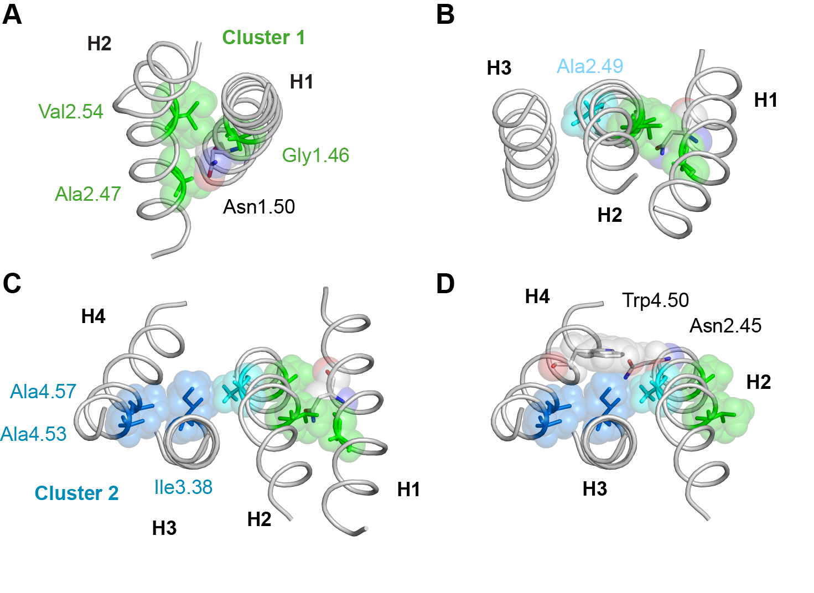

Fig. S1. Packing clusters are at the crossing points of H1-H2 and H3-H4. The TM helices in membrane proteins typically associate with neighboring helices in either a left- or right-handed geometry. The individual helices in TM helix bundles characteristic of polytopic membrane proteins show a preference for a +20° tilt between helices (left-handed packing). Antiparallel helix-helix interactions are more common and lead to more tightly packed interfaces than parallel interactions (1, 2). The helices tilt in order to provide better van der Waals contact between side chains and/or the peptide backbone, which can fit together in a knobs-into-holes packing arrangement. Two common packing motifs observed in membrane proteins are “leucine-zipper”-like motifs and “GxxxG”-like motifs (3). The leucine-zipper motifs are associated through left-handed coiled coils of helices and often involve large side chains (e.g. leucines) packing against small side chains (e.g. alanine) across the helix interface, whereas the GxxxG-like motifs can be either left- or right-handed and involve small (group-conserved) residues (e.g. Gly, Ala, Ser, Cys) packing against one another at the helix crossing angles (3, 4). The small residues at the cross-points allow close helix association, which facilitates interhelical hydrogen-bond formation that may strongly stabilize the interaction between helices. In the rhodopsin crystal structure, the H1-H2 and H2-H3 helix pairs pack with left-handed crossing angles and the H3-H4 helix pair packs with a right-handed crossing angle. Group-conserved residues with small side chains facilitate tight packing at these crossing points. In the case of H1-H2 and H3-H4, the helix pairs are stabilized by interhelical hydrogen bonds. This is not the case for the H2-H3 interface, which allows this interface to rotate upon activation in rhodopsin (5). The packing of these four helices is illustrated in panels (A-D).
(A) Close packing of H1 and H2 is mediated by Gly1.46 and Ala2.47. The short interhelical distance allows the Asn1.50 amide side chain to hydrogen bond to Asp2.50. This hydrogen bond stabilizes the H1-H2 dimer. (B) Packing of H2 onto H3 is mediated by Ala2.49. This view of the TM helices is rotated relative to the view in (A) to more clearly show the left-handed crossing angle of H2 and H3. (C) Helix H4 packs onto H3 with a right-handed crossing angle similar to that in glycophorin A where the GxxxG motif was first characterized (6). Ala4.53 and Ala4.57 mediate the packing interaction and comprise an “AxxxA” motif. (D) Packing cluster 2 is stabilized by hydrogen bonding interactions between the indole NH of Trp4.50 and polar side chains at either position 2.45 on H2 or 3.42 on H3. Asn2.45 is the prevalent amino acid (52%) at this position, followed by serine (29%), while position 3.42 is conserved as serine (22%), threonine (19%) or asparagine (16%).

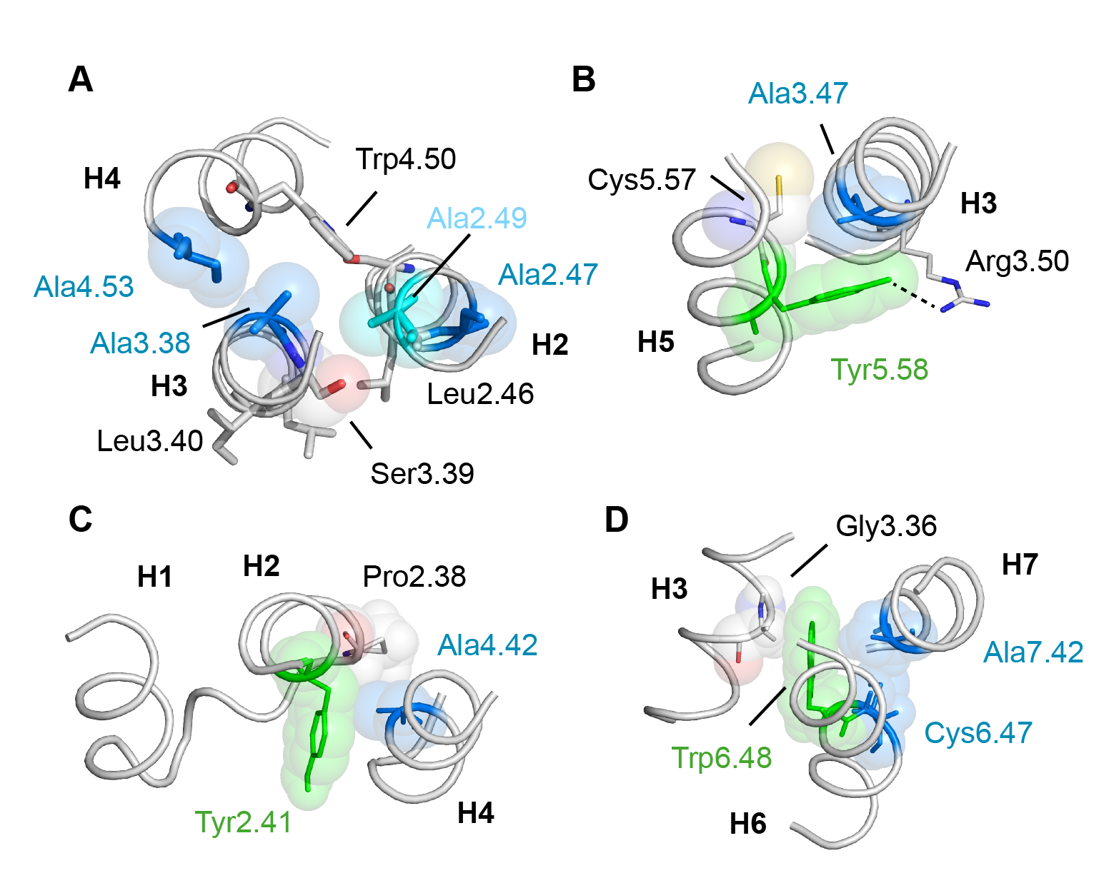

Fig. S2. Group-conserved residues in TM helices outside of the packing clusters. Most of the residues with high packing values contribute to either packing cluster 2 or packing cluster 1. There are six group-conserved residues (Ala2.49, Ser3.39, Ser3.47, Ala4.42, Cys6.47 and Ala7.42) that do not contribute to either of the packing clusters (Fig. 1, Table S4). Ala2.49 and Ser3.39 reside within the TM core and mediate the interactions between H2 and H3. Ser3.39 also serves as a possible coordination site for an allosteric Na+ ion (7). The other four small group-conserved residues lie outside the core and pack against a conserved aromatic residue. This motif, where a small residue creates a notch on the surface of the TM helix into which an aromatic side chain packs, is common in membrane proteins (8).
(A) Ala2.49 is part of the conserved LAxAD motif on H2. Within this motif, Leu2.46 and Asp2.50 are part of activation switch 2, while Ala2.47 is part of cluster 1. Leu2.46 and Ala2.49 lie in the H2-H3 interface. Both residues are highly conserved. Leu2.46 is a signature residue with a sequence identity of 94%. Leu2.46 and Ala2.49 both pack against Ser3.39, which has one of the highest group-conservations in the family A GPCRs if the olfactory receptors are excluded from the analysis. Ala2.49 and Ser3.39 pack against one another across the dimer interface in most family A GPCRs, as shown here for the β₂-adrenergic receptor (9). (B) Ser3.47 is on the intracellular end of TM helix H3 and mediates the interaction between H3 and H5. The interaction is of functional significance. The small side chain at position 3.47 is located between Cys5.57 and Tyr5.58 in the inactive structure. However, this panel shows the structure of active opsin – where alanine is found at position 3.47 (10). Upon activation, the molecular notch created by the Ala3.47 side chain serves to orient the aromatic chain of Tyr5.58, which interacts with Arg3.50 (11). The packing interaction of H3 and H5 mediated by Ser3.47 is similar to the packing clusters 1 and 2. First, this site represents the crossing point of these two helices. Second, residues with small side chains facilitate close helix packing. Position 3.47 is group-conserved mainly as serine (48%) and alanine (36%), while position 5.57 is mainly cysteine (39%). The close packing permits interhelical hydrogen bonding (e.g. Arg3.50 and Tyr5.58). In addition in rhodopsin, Tyr3.51 of the conserved D/ERY motif on H3, hydrogen bonds with a glutamine residue on H5 on the lipid-facing side of the H3-H5 dimer, suggesting a possible role for Tyr3.51. (C) Ala4.42 mediates the interaction of H4 with the intracellular end of H2. This position is conserved as alanine (30%) or cysteine (30%) and interacts with Tyr2.41 and Pro2.38. Position 2.41 is conserved as a large hydrophobic residue and position 2.38 is often a proline. The proline is the transition point between intracellular loop 1 and TM helix H2. (D) The packing interactions mediated by Ala7.42 are similar to those mediated by Ser3.47 in panel (B). The small side chain packs against a conserved cysteine at position 6.47 and forms a packing surface for the conserved Trp6.48 on H6. Ala7.42 has a group conservation of 83%.

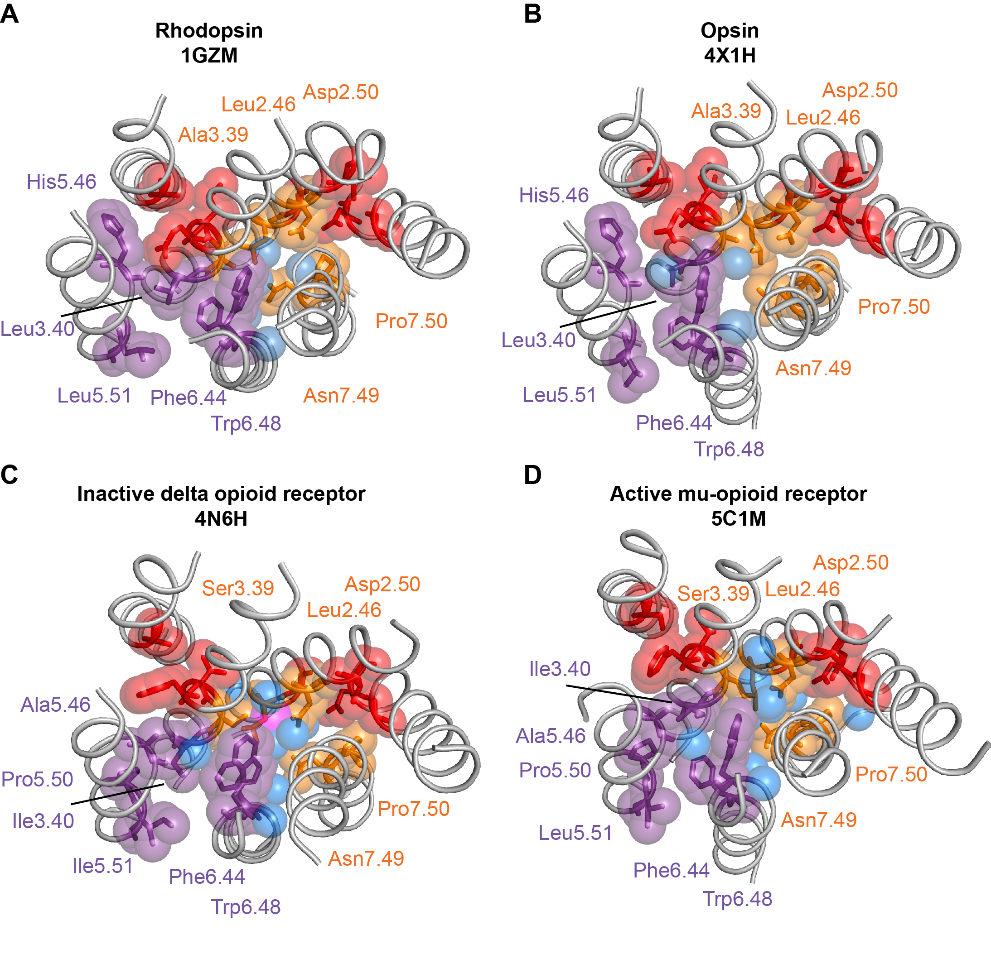

Fig. S3. Location of water and residues that change their packing interactions relative to packing clusters 1 and 2. (A, B) Location of water (blue spheres) in the high-resolution structures of inactive rhodopsin (12) and active opsin (13). (C,D) Location of water (blue spheres) in the high-resolution structures of the inactive delta opioid receptor (14) and active mu opioid receptor (15). These structures were selected on the basis of their high resolution and ability to define structural water. The conserved water network in the interior of the receptor is known to change upon activation. Water molecules are in the interfaces of the switch region and not in the packing clusters (shown in red). In rhodopsin, a water molecule is not observed in switch 1 (purple), but a water is observed to interact with the backbone C=O of residue 5.46 in both active rhodopsin and the mu opioid receptor where it mediates the H3, H5 and H6 interaction. In switch 2 (orange), the water molecules that mediate hydrogen bonding in the inactive state are displaced after activation and this allows direct hydrogen bonding together with more tightly packing of this residues. In the active mu opioid receptor, the free backbone carbonyl at residue 7.46 gains an interaction with water. Three water molecules are observed in the active mu opioid receptor above the level of the packing clusters between H2 and H3.

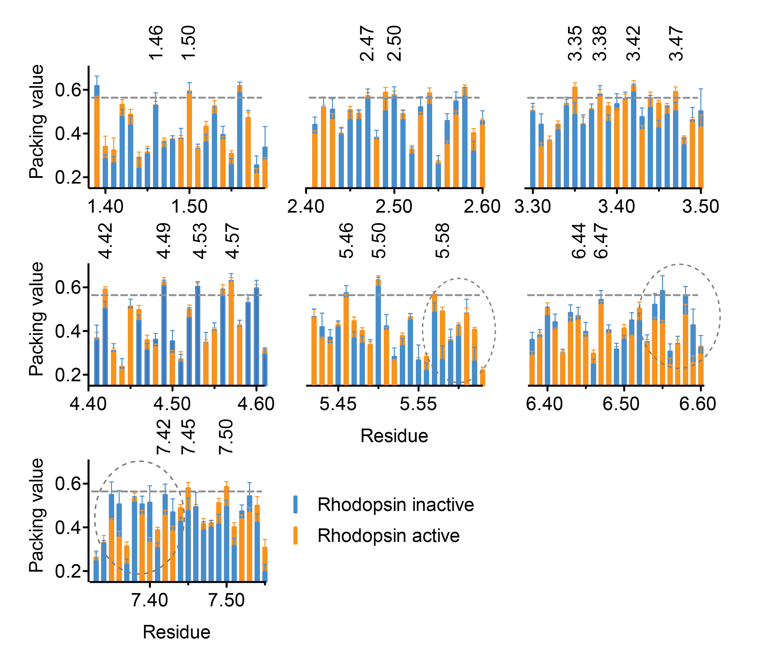

Fig. S4. Comparison of TM helix packing between inactive and active rhodopsin. The occluded surface packing analysis was carried out on multiple crystal structures of inactive (blue) and active (orange) rhodopsin (see Methods and below). For each residue, the state (active or inactive) with the lower packing value is plotted in front. For example, the histograms for helix H6 are mostly orange indicative of looser packing in the active state. This reflects the outward rotation of H6 upon activation, which results in overall lower packing values in this helix. The standard deviation in the packing values is shown in the histograms and indicates the variability of packing values between crystal structures of the same GPCR sequence.
Comparison of packing values between the active and inactive structures shows the largest changes at the intracellular end of H5 and extracellular ends of TM helices H6 and H7, (highlighted by dashed circles). For example, large changes in the packing of Ala7.42 is observed upon activation. As mentioned above, Ala7.42 has a high packing value in the inactive structure as it serves as a notch for packing of the conserved Trp6.48. As Trp6.48 moves away from this alanine during activation, the packing interaction decreases.
Large changes in packing are also observed in Ala6.55 and Phe6.59. We have recently described how retinal isomerization and deprotonation of the retinal’s protonated Schiff’s base lead to a shift of a conserved tyrosine on EL2 in rhodopsin that is packed against Ala6.55 (5). Motion of this tyrosine allows the extracellular end of H6 to pivot inward due to a change in hydrogen bonding interactions triggered by Schiff’s base deprotonation. These changes in hydrogen bonding are also reflected in the large packing changes at the extracellular end of H7, notably Met7.35 and Phe7.36.
The residues comprising the packing clusters do not change packing significantly upon activation.
The receptors analyzed were as follows: inactive rhodopsin - 1F88, 1HZX, 1L9H, 1U19, 2HPY, 2G87, 2I35, 2I36, 2I37, 2J4Y, 2PED, 2X72, 3OAX, 2Z73, 2ZIY, 3AYM, 3AYN, 4WW3; active rhodopsin - 3CAP, 3DQB, 3PQR, 4A4M, 4BEY, 4BEZ, 4J4Q. The analysis does not account for the fact that the active structures were generated by different methods.

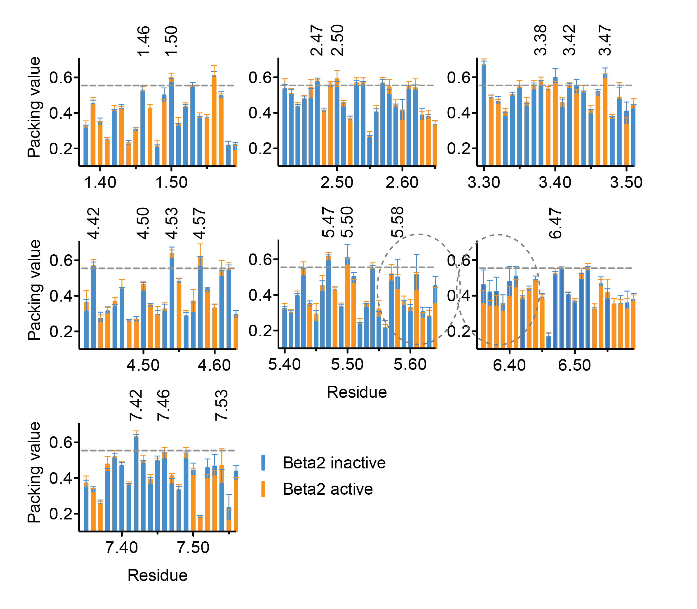

Fig. S5. Comparison of TM helix packing between inactive and active β2-adrenergic receptor. The occluded surface packing analysis was carried out on multiple crystal structures of the inactive (blue) and active (orange) β₂-adrenergic receptor. The standard deviation in the packing values is shown in the histograms and indicates the variability of packing values between crystal structures of the same GPCR sequence. Comparison of the packing values between the active and inactive structures shows the largest changes at the extracellular ends of TM helices H5 and H6 (highlighted by dashed circles). In this receptor, the largest differences in packing are observed at the intracellular ends of H5 and H6. These changes are largely due to the close binding of nanobodies (and/or G protein) that stabilize the active structure. These proteins were not included in the packing calculations. The residues comprising the packing clusters do not change packing significantly upon activation.
The receptors analyzed were as follows: inactive β₂-adrenergic receptor – 3D4S, 3NY8, 3NYA, 4GBR; active β₂-adrenergic receptor - 4LDE, 4LDL, 4LDO, 4QKX, 3P0G, 3PDS, 3SN6. The analysis does not account for the fact that the structures were generated by different methods and may reflect various degrees of activity.
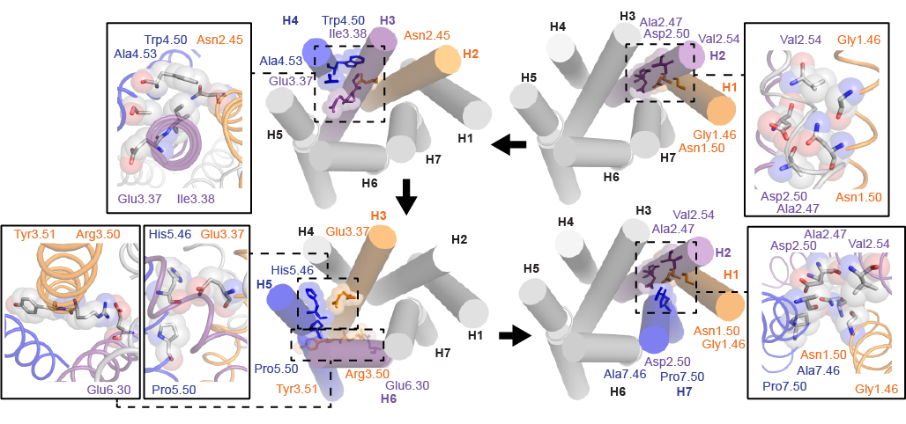

Fig. S6. Proposed folding pathway for the TM helices in rhodopsin. The tightly packed clusters in GPCRs suggest a role not only in the stability of the folded protein, but also as guides to direct the assembly of the GPCR as each individual helix is released from the translocon during protein synthesis and membrane insertion. The first two helices to be inserted into the bilayer are H1 and H2. The most conserved residue on H1 (Asn1.50) is highly polar and energetically unfavorable in the center of a TM helix with a ΔG of ~1.5 kcal/mol, comparable to the unfavorable insertion of glutamate and arginine (16). The most conserved residue on H2 (Asp2.50) is also highly polar and has an unfavorable ΔG of ~2 kcal/mol, comparable to the unfavorable insertion of Lys (16). However, the Asn1.50 and Asp2.50 are at the same position in the membrane bilayer (relative to the membrane surface) and their interaction is strongly favorable when both helices are inserted into the membrane bilayer together (17). These specific interactions are guided by the surrounding residues (Gly1.46, Ala2.47 and Leu2.54) to form the first packing cluster. Mutations of G1.46L (18) and A2.47L (unpublished results) are destabilizing.
The thermodynamically favorable association of the first two helices upon bilayer insertion sets the stage for the assembly of the subsequent helices onto this nascent scaffold. H3 and H4 are the next to enter the bilayer and are stabilized by the interaction of residues in packing cluster 2. Mutation of Ala4.53 and Ala4.57 are destabilizing (Fig. 2).
Both packing clusters 1 and 2 are formed by the time H5 and H6 are inserted into the membrane. H5 interacts with the packing cluster 2 through the carbonyl at position 5.46 that is free to hydrogen bond due to the conserved proline at 5.50. H6 interacts with the TM core through two residues: Met6.40 and Phe6.44. Glu6.30 at the intracellular end of H6 forms a strong electrostatic interaction with Arg3.50 on H3 as part of the well-known ionic lock. Finally, Ser7.46 and Pro7.50 are part of the conserved residues contributing to packing cluster 2 in family A receptors.
The proposed folding pathway explains why many of the ADRP mutants are associated with receptor misfolding. G1.46V and A4.53V – both central residues in the packing clusters 2 and 1, respectively - are ADRP mutants (19). Similarly, Cys3.25, Cys187 and Gly106, which form the extracellular folding core (20), are sites of ADRP mutations. We propose that the interaction of H5 and H7 with the H1-H4 scaffold is mediated in part by the carbonyl groups of residues 5.46 and 7.46, both of which are sites of ADRP mutations.

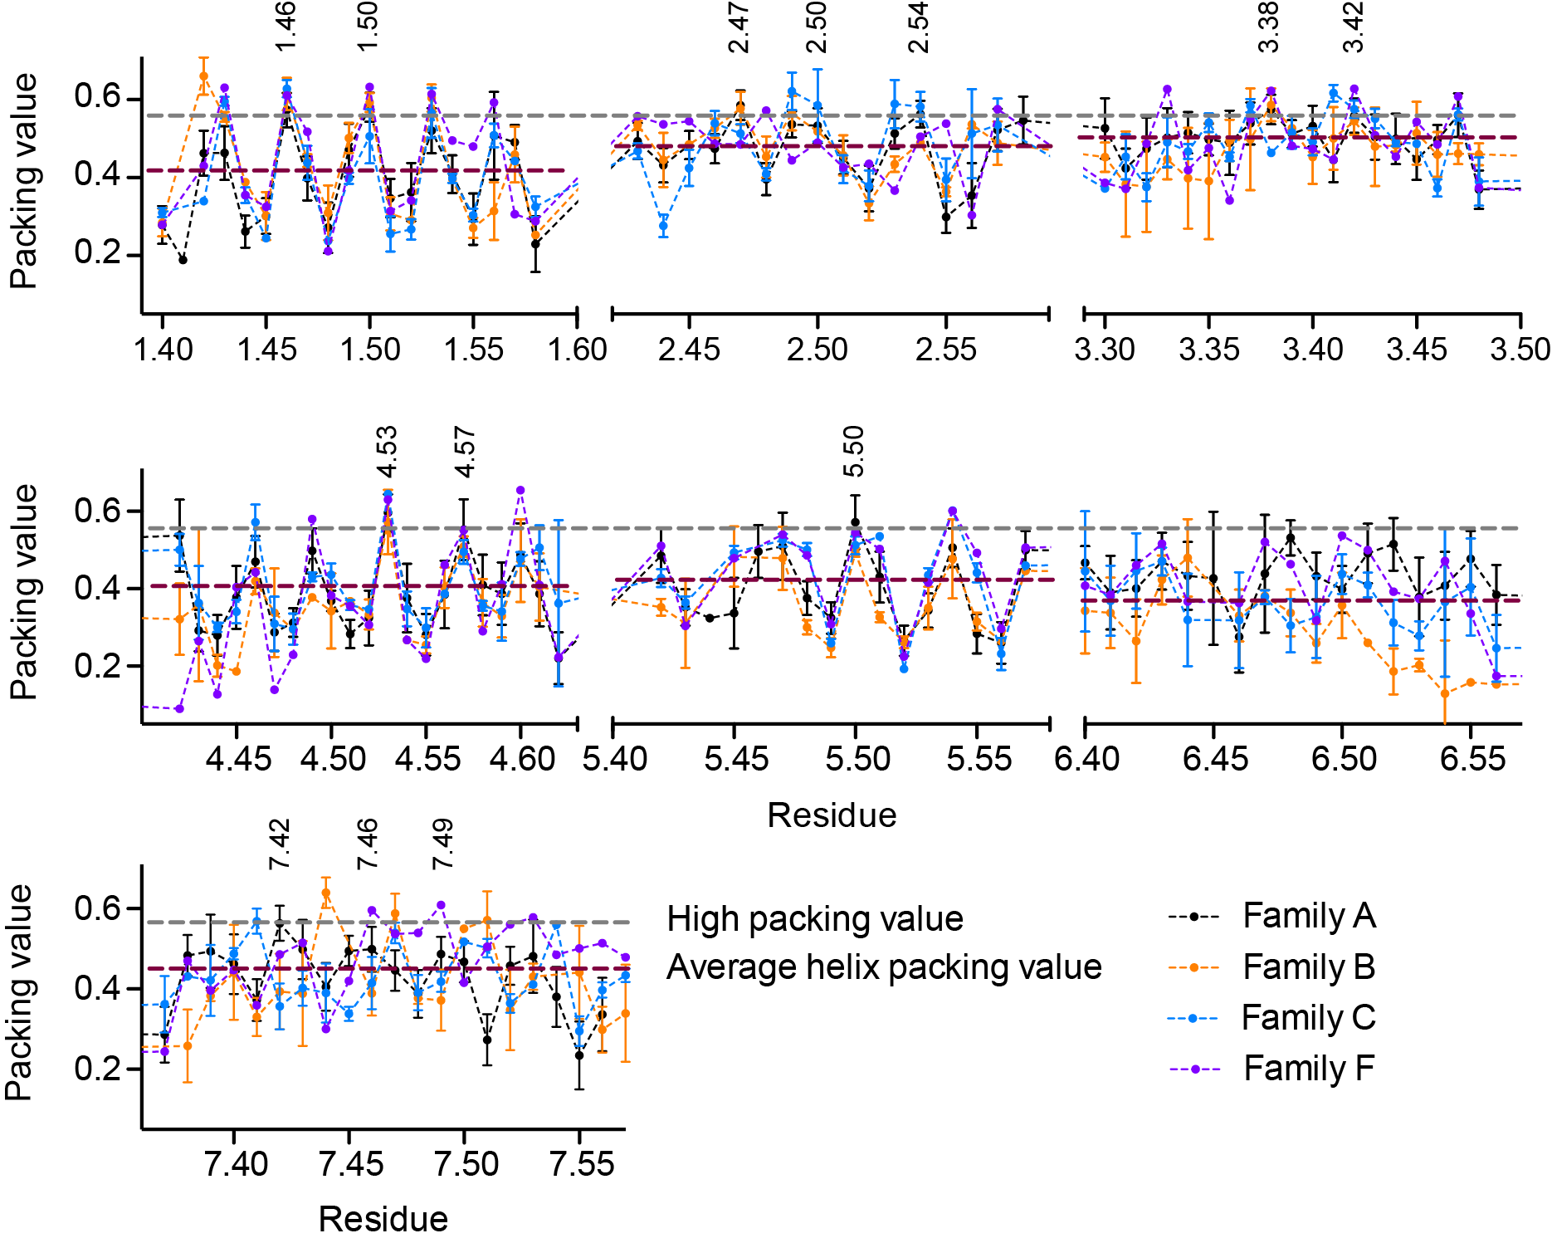

Fig. S7. Comparison of TM helix packing between family B, C and F GPCRs. The occluded surface packing analysis was carried out on structures from the family B (orange), family C (blue) and family F (green) GPCRs and compared to the family A receptors (black). H2 and H3 have the highest average packing values across all receptors. The packing values of H1 and H4 exhibit a clear repeat of high and low packing values reflecting residues oriented toward the helical bundle (high packing values) or toward the surrounding lipid (low packing values). In helix H1, residues 1.46 and 1.50 exhibit high packing values similar to those associated with packing cluster 1 in the family A GPCRs. In helix H4, residue 4.53 is tightly packed as in cluster 2 of the family A GPCRs. Receptors analyzed: family B - Corticotropin-releasing factor receptor 1 (4K5Y)(21), glucagon receptor (4L6R)(22); family C - metabotropic glutamate receptor 5 (4OO9)(23); metabotropic glutamate receptor 1 (4OR2)(24); and family F - smoothened receptor (4JKV)(25). No errors are reported for the family F receptors, which consist of a single structure.

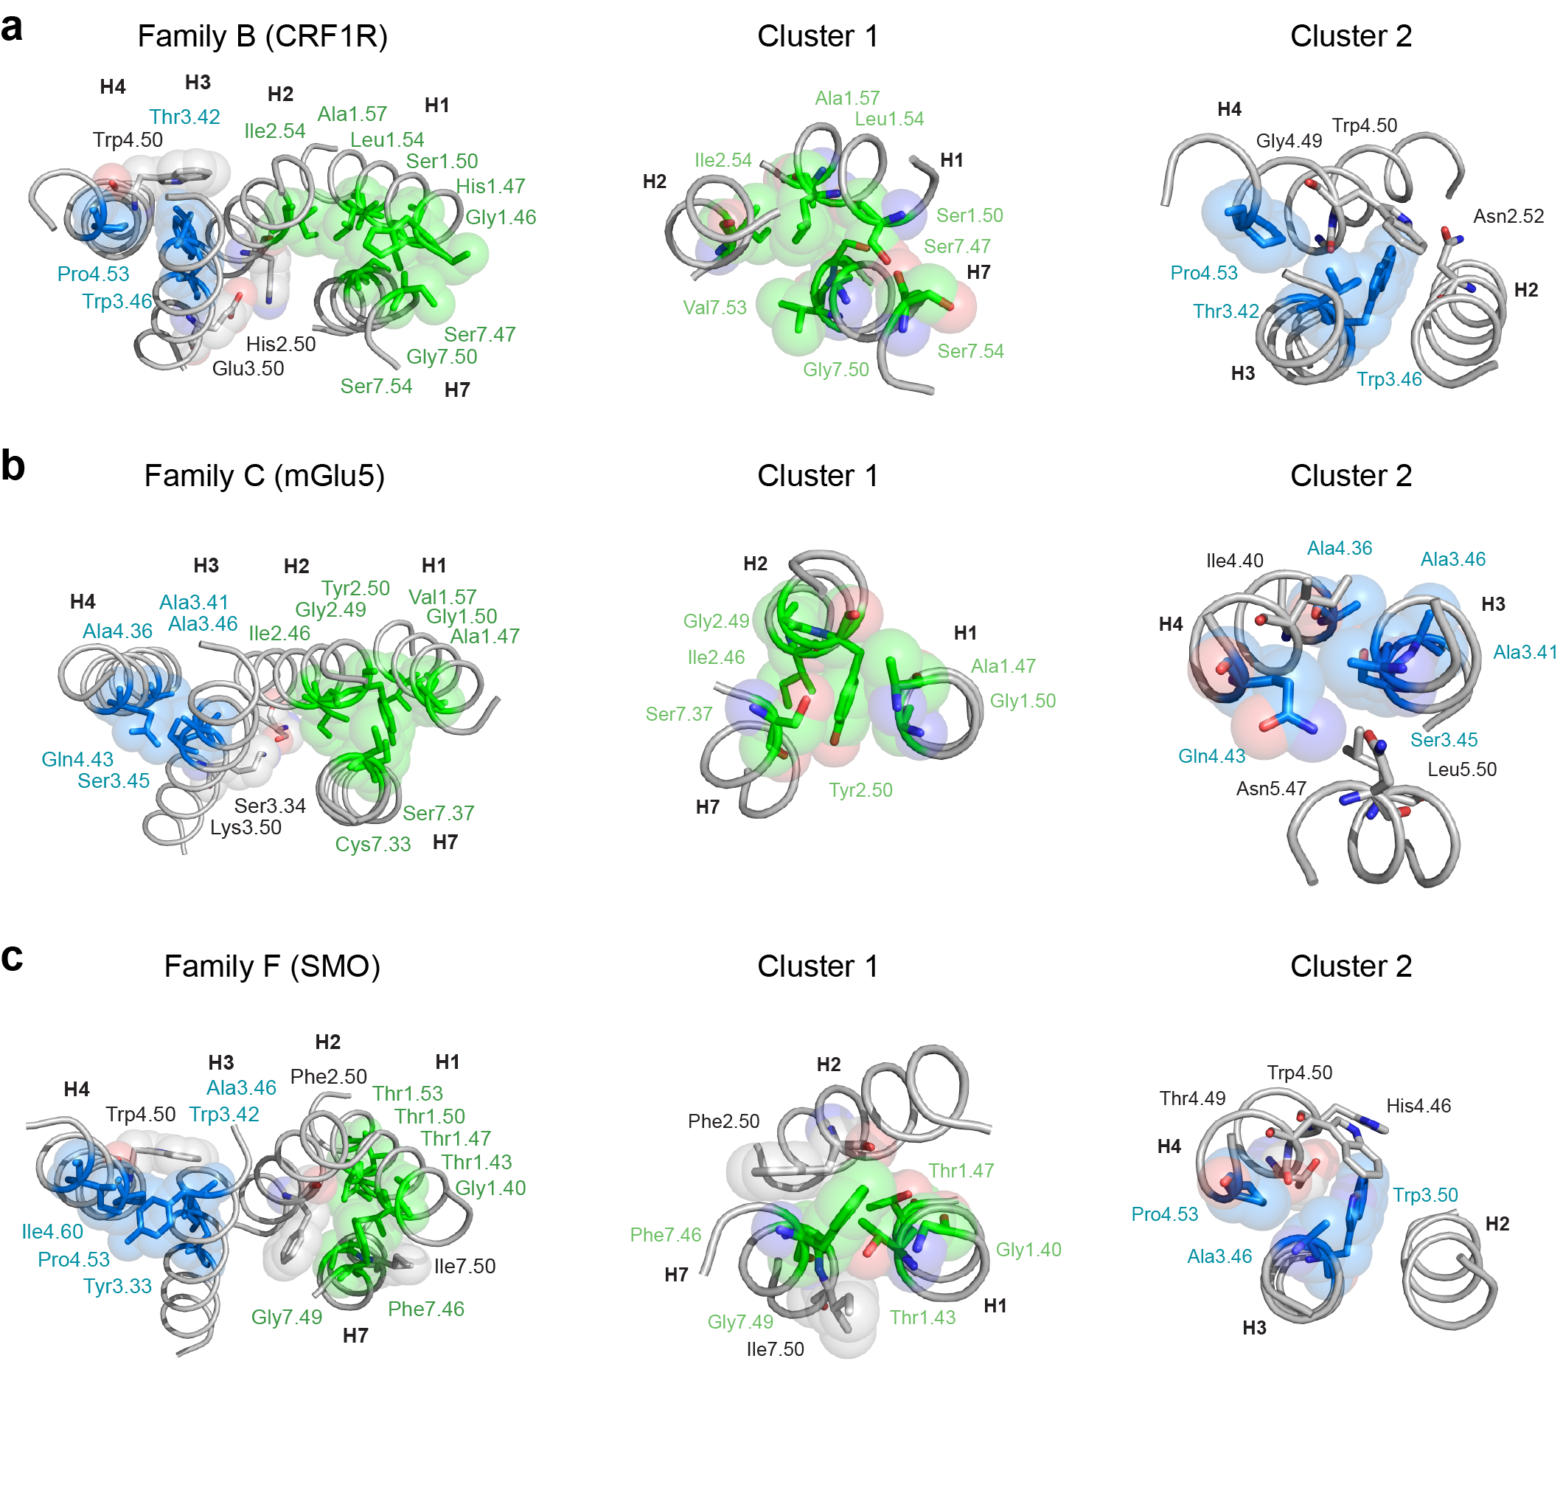

Fig. S8. Packing clusters 1 and 2 in crystal structures of family B, C and F GPCRs. We have extended our packing analysis to the family B, C and F GPCRs (Fig. S7 and Table S5). Despite the limited number of non-family A structures, there are several general features that emerge. First, the structure-based alignment shows that group-conserved residues fall at similar conserved positions. For example, the residue at position 1x46 in the crystal structures of all GPCRs studied corresponds to the crossing point of helices H1 and H2. This residue is group-conserved as a small or weakly polar residue (Gly, Ser, or Cys) across the GPCR families (i.e. it is playing the same structural role). It is the most conserved residue on H1 in the family B and C receptors. The same type of group conservation holds for positions 2x49 and 3x38 (Table S5). Second, tryptophan packing is a conserved feature of cluster 2 of the family A, B and F receptors. Tryptophan has a large side chain and is the most conserved residue at position 3.46 in the family B and at position 3.50 in the family F receptors. In all three families, this conserved aromatic residue packs against Trp4.50, a highly conserved tryptophan residue on TM helix H4. Third, interhelical hydrogen bonding and aromatic stacking interactions are prevalent in the packing clusters and have been previously described as interactions that stabilize helix-helix interactions (8). There are several examples of these types of conserved structural features described below. The observation that the most tightly packed residues occur at the same positions across the GPCR families and often have conserved structural roles argues that the packing clusters 1 and 2 are highly conserved throughout the GPCR superfamily.
(A) The family B receptor structures determined to date are the corticotropin-releasing factor receptor 1 (4K5Y) and the human glucagon receptor (4L6R). Five of the fifteen most tightly packed residues in the family B receptors form the second packing cluster (see Table S5). These include residues 1.47, 1.50, 1.54, 1.57 and 2.54. Other residues that contribute to cluster 1 (Gly1.46, Ser7.47, Gly7.50 and Ser7.54) are among the most tightly packed in the family B crystal structures, but do not align with at least one of the other families (see Table S5).
As with the family A receptors, there are several residues on H7 that interact with cluster 1 and have high packing values. Ser1.50 (0.593), the most conserved residue on H1, packs tightly against the highly conserved Gly7.50 (0.571) on H7 and is hydrogen bonded to the backbone carbonyl of Ser7.47 (0.589). A strong backbone distortion in H7 allows the Ser7.47 carbonyl group to hydrogen bond to Ser1.50. The second most highly conserved (85%) residue on H1 is Gly1.46 (0.661), which packs against Ser7.54. Together these four residues (two serines and two glycines) mediate close packing of H1 and H7. That is, the highly conserved glycines allow the Ser1.50 and the backbone of Ser7.47 to hydrogen bond. Gly7.50 is analogous to Pro7.50 in family A GPCRs because it allows the distortion of H7. Ile2.54, the most highly packed residue on H2, mediates the interaction of H1 with H2. This residue packs against Ala1.57, which is group-conserved as Ala (38%) or Cys (21%). These interactions set the orientation of His2.50, the most conserved residue on H2, which interacts with Glu3.50 on H3.
The second packing cluster involves three residues with high packing values (Ala3.42, Trp3.46 and Pro4.53). There is remarkable structural conservation within this cluster. First, residues with small side chains mediate close helix packing. Pro4.53 (89% conservation in family B) introduces a distortion of H4 that allows the carbonyl backbone of Gly4.49 (87%) to pack between Thr3.42 and Trp3.46. Position 3.42 is group-conserved as Ala (43%) or Ser (26%). Second, in a fashion similar to family A receptors, cluster 2 facilitates packing and interhelical hydrogen bonding of Trp4.50. Trp4.50 is the most conserved residue on H4 and hydrogen bonds with Asn2.52, similar to family A where Trp4.50 hydrogen bonds with Asn2.45. Trp3.46 is highly conserved as a tryptophan (98%) on H3 in the family B receptors and its aromatic stacking with Trp4.50 is very similar to that observed in the family F receptors (see below).
(B) The family C GPCR structures available to date are the metabotropic glutamate receptor 1 (4OR2) and 5 (4OO9). Cluster 1 in the family C GPCRs is centered on Gly1.50. This glycine packs against the side chain of Tyr2.50 on H2. Aromatic-glycine packing interactions are common in transmembrane helices. These motifs take advantage of the favorable electrostatic interactions between the flat surface of the aromatic ring and the CH₂ of glycine (26, 27). Ala1.47, one helical turn above Gly1.50, facilitates the close packing of H1 and H2. This position is group-conserved across the family C family as predominantly alanine (57%) or serine (13%). Cluster 1 also includes Ser7.37, the third most tightly packed residue on H7. Other highly packed residues contributing to this cluster are Ile2.46 and Gly2.49.
The second packing cluster involves a string of residues (Gly3.37, Ala3.41, Ser3.45, Ala3.46, and Ala4.36) with small side chains that mediate the interaction of H3 and H4. As described above, the close packing of helices facilitates interhelical hydrogen bonding. In this case, Gly3.37, which is directly above Ala3.41, is highly conserved in the family C receptors (65%) and its backbone C=O group is a site of hydrogen-bonding for the side chain NH₂ of Gln4.43 (61%). Gln4.43 also forms a hydrogen bond with Asn5.47 on H5. Asn5.47 is generally conserved as a polar residue (70%). This interaction may be similar to the functionally important Glu3.37-His5.46 interaction that produces (reversible) stabilizing contacts in both the inactive and active states in the visual receptor rhodopsin. Ser3.45 is highly conserved (61%) and packs against Leu5.50, the most highly conserved residue on H5.
(C) The smoothened (SMO) receptor structure was recently determined as an example of GPCR family F (or frizzled) receptors (28). These receptors are involved in the hedgehog signaling pathway and are the most distantly related family of GPCRs. Nevertheless, the packing analysis indicates that both cluster 1 and cluster 2 are evolutionarily conserved.
Cluster 1 involves a large portion of the surface of helix H1. The first residue that is part of this cluster is Gly1.40. On the same helix face as Gly1.40 are two highly conserved threonine residues (Thr1.47 and Thr1.50) with packing values of 0.633 and 0.615, respectively. H1 interacts with H2 and H7 via a glycine-phenylalanine packing motif where Gly1.40 packs against Phe7.46 and Gly7.49 packs against Phe2.50. Similar aromatic-glycine packing was described above for cluster 1 in the family C receptors. Gly7.49 is strictly conserved as glycine and Phe2.50 is the most conserved residue on H2. The close packing of H1-H2-H7 allows interhelical hydrogen bonding of Asn2.47 with the backbone of H7.
The second packing cluster in the SMO receptor involves H3 and H4. As in the family B receptors, the core of this packing cluster involves two conserved interactions. The first is aromatic stacking of Trp3.42 on H3 with Trp4.50 on H4. The second is packing of a small residue (Ala3.46) on H3 with a proline (Pro4.53) on H4. In addition to these interactions, Tyr3.33, which is strictly conserved in the family F receptors, extends this cluster by packing on Ile4.60, which has the second highest packing value in the SMO crystal structure (Table S5).
Below this interaction, Pro4.53 packs on Ala3.46. The carbonyl group of Thr4.49 that is free because of the proline interacts with Trp3.42 and Trp4.50. Thr4.49 is 80% conserved as alanine and the stacked residues Trp3.42 and Trp4.50 are strictly conserved.

Table S1. Signature residues conservation in family A GPCRs (percent identity)

Position | Residue | Family A¹ | Family A excluding olfactory² | Olfactory receptors³ | Analyzed crystal structures⁴
1.49 | Gly | 72 | 62 (67) | 88 | 69
1.50 | Asn | 99 | 98 (98) | 99 | 94
2.46 | Leu | 92 | 93 (93) | 92 | 97
2.47 | Ala | 54 | 81 (71) | 23 | 80
2.50 | Asp | 88 | 93 (90) | 82 | 100
3.25 | Cys | 91 | 88 (87) | 99 | 93
3.39 | Ser | 43 | 71 (72) | 4 (Glu 80%) | 80
3.43 | Leu | 80 | 73 (73) | 92 | 87
3.49 | Asp | 82 | 60 (64) | 99 | 80
3.5 | Arg | 97 | 97 (95) | 96 | 100
3.51 | Tyr | 74 | 65 (67) | 77 | 87
4.50 | Trp | 74 | 94 (96) | 55 | 100
5.50 | Pro | 60 | 74 (77) | 38 | 90
5.58 | Tyr | 92 | 86 (77) | 98 | 97
6.44 | Phe | 48 | 75 (71) | 1 | 83
6.47 | Cys | 36 | 69 (70) | 0.1 | 73
6.48 | Trp | 40 | 73 (68) | 0.1 | 80
6.50 | Pro | 50 | 94 (99) | 0.1 | 100
7.49 | Asn | 89 | 81 (68) | 98 | 90
7.50 | Pro | 97 | 95 (88) | 99 | 100
7.53 | Tyr | 96 | 94 (85) | 98 | 93
¹Residue conservation of all sequences compiled for Family A receptors in the GPCR database as of 2012.
²Residue conservation of all sequences compiled for Family A receptors in the GPCR database excluding the olfactory receptor subfamily. The residue conservation obtained from GPCRdb for human GPCRs excluding the olfactory receptor subfamily is in parenthesis.
³Residue conservation of all sequences compiled for the olfactory receptor subfamily receptors in the GPCR database as of 2012. The numbers in parentheses correspond to the sequence identity in the olfactory receptor subfamily.
⁴Residue conservation of the crystal structure sequences analyzed in Figure 2.

Table S2. Group conserved (Gly, Ala, Ser, Cys) residues in family A GPCRs

Position | Family A¹ | Family A excluding olfactory receptors² | Olfactory receptors³ | Analyzed crystal structures⁴
1.46 | 59 | 76 (77) | 83 | 80
1.49⁵ | 80 | 69 (79) | 95 | 79
2.47 | 93 | 89 (83) | 98 | 93
2.49 | 58 | 88 (86) | 24 | 97
3.38 | 49 | 61 (65) | 64 | 83
3.39 | 54 | 89 (88) | 2 | 100
3.47 | 92 | 87 (88) | 98 | 100
3.53 | 79 | 67 (71) | 99 | 97
4.42 | 70 | 66 (68) | 76 | 94
4.53 | 85 | 82 (78) | 92 | 91
4.57 | 71 | 72 (64) | 73 | 91
5.57 | 71 | 55 (55) | 98 | 53
6.47 | 60 | 83 (82) | 1 | 93
7.42 | 53 | 73 (74) | 11 | 89
7.46 | 51 | 81 (87) | 15 (Pro 95%) | 97
¹Residue conservation of all sequences compiled for Family A receptors in the GPCR database as of 2012.
²Residue conservation of all sequences compiled for Family A receptors in the GPCR database excluding the olfactory receptor subfamily. The residue conservation obtained from GPCRdb for human GPCRs excluding the olfactory receptor subfamily is in parenthesis.
³Residue conservation of all sequences compiled for the olfactory receptor subfamily receptors in the GPCR database as of 2012. The numbers in parentheses correspond to the sequence identity in the olfactory receptor subfamily.
⁴Residue conservation of the crystal structure sequences analyzed in Figure 2.
⁵Residues in bold are also signature conserved.

Table S3: References of crystal structures used for packing analysis.
Receptor | PDB identifier (Reference) | Receptor | PDB identifier (Reference)
5-HT1B serotonin receptor | 4IAQ (29) | Lysophosphatidic acid receptor LPA1 | 4Z35 (30)
5-HT2B serotonin receptor | 4IB4 (31) | Sphingosine-1-phosphate receptor S1P1 | 3V2Y (32)
M1 acetylcholine receptor | 5CXV (33) | Adenosine A2A receptor | 4EIY (34)
M2 acetylcholine receptor | 3UON (35) | P2Y1 purinoreceptor | 4XNW (36)
M3 acetylcholine receptor | 4U15 (37) | P2Y12 purinoreceptor | 4NTJ (38)
M4 acetylcholine receptor | 5DSG (33) | Rhodopsin | 1U19 (39)
β₁-adrenergic receptor | 4BVN (40) |  | 1F88 (41)
β₂-adrenergic receptor | 2RH1 (9) |  | 1HZX (42)
 | 3D4S (43) |  | 1L9H (44)
 | 3NY8 and 3NYA (45) |  | 1GZM (12)
 | 4GBR (46) |  | 2HPY (47)
 | 4LDE, 4LDL and 4LDO (48) |  | 2G87 (49)
 | 4QKX (50) |  | 2I35, 2I36 and 2I37 (51)
 | 3P0G (52) |  | 2J4Y (53)
 | 3PDS (54) |  | 2PED (55)
 | 3SN6 (56) |  | 2X72 (57)
Dopamine D3 receptor | 3PBL (58) |  | 3OAX (59)
Histamine 1 receptor | 3RZE (60) |  | 2Z73 (61)
Angiotensin II type 1 receptor | 4ZUD (62) |  | 2ZIY (63)
Neurotensin NTS1 | 4BV0 (64) |  | 3AYM and 3AYN (65)
δ-opioid receptor | 4N6H (14) |  | 4WW3 (66)
κ-opioid receptor | 4DJH (67) |  | 3CAP (10)
μ-opioid receptor | 4DKL (68) |  | 3DQB (69)
Nociceptin/orphanin receptor | 4EA3 (70) |  | 3PQR (71)
Orexin receptor 1 | 4ZJC (72) |  | 4A4M (73)
Orexin receptor 2 | 4S0V (74) |  | 4BEY and 4BEZ (75)
Protease-activated receptor 1 | 3VW7 (76) |  | 4J4Q (77)
Chemokine receptor CCR5 | 4MBS (78)
Chemokine receptor CXCR4 | 3ODU (79)
Free fatty acid receptor FFA1 | 4PHU (80)

Table S4: Structure-based alignment of average packing values in the family A, B, C and F GPCRs (15 most tightly packed residues of each family are in red).

H1 |  |  |  |  | H2 |  |  |  |  | H3
 | Family A | Family B | Family C | Family F |  | Family A | Family B | Family C | Family F |  | Family A | Family B | Family C | Family F
1x42 | 0.474 | 0.661 | 0.340 | 0.430 | 2x43 | 0.496 | 0.535 | 0.469 | 0.558 | 3x30 | 0.506 | 0.453 | 0.372 | 0.387
1x43 | 0.458 | 0.556 | 0.596 | 0.631 | 2x44 | 0.444 | 0.446 | 0.277 | 0.537 | 3x31 | 0.408 | 0.384 | 0.454 | 0.371
1x44 | 0.267 | 0.389 | 0.355 | 0.355 | 2x45 | 0.494 | 0.486 | 0.425 | 0.545 | 3x32 | 0.404 | 0.377 | 0.376 | 0.487
1x45 | 0.314 | 0.302 | 0.245 | 0.325 | 2x46 | 0.479 | 0.527 | 0.540 | 0.487 | 3x33 | 0.440 | 0.447 | 0.491 | 0.627
1x46 | 0.569 | 0.615 | 0.629 | 0.611 | 2x47 | 0.588 | 0.578 | 0.513 | 0.485 | 3x34 | 0.515 | 0.399 | 0.468 | 0.419
1x47 | 0.393 | 0.444 | 0.438 | 0.518 | 2x48 | 0.397 | 0.454 | 0.409 | 0.572 | 3x35 | 0.500 | 0.392 | 0.541 | 0.476
1x48 | 0.277 | 0.310 | 0.238 | 0.211 | 2x49 | 0.534 | 0.565 | 0.622 | 0.445 | 3x36 | 0.444 | 0.496 | 0.454 | 0.342
1x49 | 0.481 | 0.502 | 0.399 | 0.418 | 2x50 | 0.537 | 0.519 | 0.586 | 0.490 | 3x37 | 0.521 | 0.499 | 0.585 | 0.550
1x50 | 0.569 | 0.593 | 0.506 | 0.633 | 2x51 | 0.443 | 0.458 | 0.422 | 0.427 | 3x38 | 0.586 | 0.587 | 0.464 | 0.623
1x51 | 0.351 | 0.307 | 0.256 | 0.314 | 2x52 | 0.363 | 0.335 | 0.379 | 0.436 | 3x39 | 0.510 | 0.527 | 0.517 | 0.482
1x52 | 0.386 | 0.291 | 0.268 | 0.342 | 2x53 | 0.507 | 0.435 | 0.589 | 0.367 | 3x40 | 0.519 | 0.453 | 0.492 | 0.474
1x53 | 0.537 | 0.605 | 0.566 | 0.615 | 2x54 | 0.572 | 0.490 | 0.582 | 0.505 | 3x41 | 0.431 | 0.501 | 0.617 | 0.446
1x54 | 0.418 | 0.396 | 0.399 | 0.495 | 2x55 | 0.302 | 0.364 | 0.395 | 0.539 | 3x42 | 0.563 | 0.545 | 0.576 | 0.628
1x55 | 0.309 | 0.272 | 0.304 | 0.480 | 2x551 | 0.319 |  |  |  | 3x43 | 0.502 | 0.480 | 0.552 | 0.509
1x56 | 0.505 | 0.314 | 0.509 | 0.593 | 2x56 | 0.511 | 0.537 | 0.513 | 0.304 | 3x44 | 0.483 | 0.483 | 0.492 | 0.454
1x57 | 0.483 | 0.460 | 0.443 | 0.306 | 2x57 | 0.561 | 0.489 | 0.535 | 0.576 | 3x45 | 0.447 | 0.514 | 0.487 | 0.543
1x58 | 0.239 | 0.253 | 0.326 | 0.288 | 2x58 | 0.368 | 0.535 | 0.469 | 0.558 | 3x46 | 0.501 | 0.460 | 0.374 | 0.485
 |  |  |  |  |  |  |  |  |  | 3x47 | 0.558 | 0.462 | 0.562 | 0.608
 |  |  |  |  |  |  |  |  |  | 3x48 | 0.363 | 0.460 | 0.390 | 0.374

¹Structure alignment is based on the crystal structures of family A of GPCRs (81). Note that for each family there is a different numbering system: family A (82), family B (83), family C (84) and family F (28). The most conserved residues in each helix for each receptor subfamily are in bold. These residues correspond to residue X.50 for that subfamily. Crystal structures used to construct this table are listed in Methods and Fig S7.

H4 |  |  |  |  | H5 |  |  |  |  | H6
 | Family A | Family B | Family C | Family F |  | Family A | Family B | Family C | Family F |  | Family A | Family B | Family C | Family F
4x42 | 0.537 | 0.321 | 0.53 | 0.09 | 5x44 | 0.451 | 0.353 | 0.428 | 0.511 | 6x37 | 0.474 | 0.423 | 0.532 | 0.604
4x43 | 0.292 | 0.359 | 0.431 | 0.265 | 5x45 | 0.364 | 0.311 | 0.365 | 0.304 | 6x38 | 0.379 | 0.304 | 0.398 | 0.343
4x44 | 0.283 | 0.202 | 0.309 | 0.127 | 5x451 | 0.337 |  |  |  | 6x39 | 0.385 | 0.270 | 0.378 | 0.312
4x45 | 0.373 | 0.187 | 0.362 | 0.404 | 5x46' | 0.335 | 0.483 | 0.494 | 0.479 | 6x40 | 0.465 | 0.472 | 0.540 | 0.566
4x46 | 0.475 | 0.420 | 0.604 | 0.442 | 5x461 | 0.438 |  |  |  | 6x41 | 0.459 | 0.343 | 0.445 | 0.408
4x47 | 0.286 | 0.338 | 0.359 | 0.139 | 5x47 | 0.497 | 0.479 | 0.526 | 0.54 | 6x42 | 0.320 | 0.338 | 0.369 | 0.384
4x48 | 0.317 | 0.295 | 0.267 | 0.229 | 5x48 | 0.368 | 0.300 | 0.501 | 0.486 | 6x43 | 0.439 | 0.265 | 0.446 | 0.461
4x49 | 0.503 | 0.378 | 0.423 | 0.58 | 5x49 | 0.322 | 0.248 | 0.260 | 0.308 | 6x44 | 0.505 | 0.423 | 0.471 | 0.516
- |  | 0.618 |  |  | 5x50 | 0.557 | 0.494 | 0.513 | 0.545 | 6x45 | 0.375 | 0.480 | 0.320 | 0.367
4x50 | 0.370 | 0.343 | 0.457 | 0.382 | 5x51 | 0.436 | 0.327 | 0.536 | 0.503 | - | 0.427
4x51 | 0.284 | 0.368 | 0.367 | 0.355 | 5x52 | 0.290 | 0.262 | 0.193 | 0.225 | 6x46 | 0.251 | 0.331 | 0.319 | 0.363
4x52 | 0.317 | 0.334 | 0.343 | 0.307 | 5x53 | 0.345 | 0.350 | 0.435 | 0.416 | 6x47 | 0.515 | 0.381 | 0.379 | 0.521
4x53 | 0.600 | 0.572 | 0.638 | 0.63 | 5x54 | 0.506 | 0.477 | 0.602 | 0.601 | 6x48 | 0.477 | 0.338 | 0.305 | 0.463
4x54 | 0.360 | 0.267 | 0.316 | 0.267 | 5x55 | 0.310 | 0.315 | 0.442 | 0.493 | 6x49 | 0.404 | 0.260 | 0.327 | 0.318
4x55 | 0.274 | 0.255 | 0.263 | 0.219 | 5x56 | 0.278 | 0.265 | 0.232 | 0.297 | 6x50 | 0.391 | 0.357 | 0.438 | 0.537
4x56 | 0.363 | 0.403 | 0.38 | 0.462 | 5x57 | 0.498 | 0.446 | 0.460 | 0.506 | 6x51 | 0.458 | 0.260 | 0.410 | 0.5
4x57 | 0.539 | 0.509 | 0.473 | 0.552 |  |  |  |  |  | 6x52 | 0.482 | 0.186 | 0.313 | 0.392
4x58 | 0.422 | 0.364 | 0.365 | 0.29 |  |  |  |  |  | 6x53 | 0.326 | 0.203 | 0.279 | 0.374
4x59 | 0.372 | 0.329 | 0.288 | 0.411 |  |  |  |  |  | 6x54 | 0.460 | 0.129 | 0.366 | 0.472
4x60 | 0.435 | 0.473 | 0.489 | 0.655 |  |  |  |  |  | 6x55 | 0.431 | 0.158 | 0.405 | 0.336
4x61 | 0.426 | 0.405 | 0.547 | 0.41 |  |  |  |  |  | 6x56 | 0.363 | 0.153 | 0.246 | 0.174

¹Structure alignment is based on the crystal structures of family A of GPCRs (81). Note that for each family there is a different numbering system: family A (82), family B (83), family C (84) and family F (28). The most conserved residues in each helix for each receptor subfamily are in bold. These residues correspond to residue X.50 for that subfamily. Crystal structures used to construct this table are listed in Methods and Fig S7.

H7
 | Family A | Family B | Family C | Family F
7x37 | 0.292 | 0.258 | 0.362 | 0.244
7x38 | 0.488 | 0.384 | 0.432 | 0.47
7x39 | 0.427 | 0.442 | 0.422 | 0.396
7x40 | 0.460 | 0.331 | 0.488 | 0.447
7x41 | 0.393 | 0.394 | 0.569 | 0.359
7x42 | 0.523 | 0.389 | 0.357 | 0.486
7x43 | 0.480 | 0.640 | 0.402 | 0.515
7x44 | 0.416 | 0.419 | 0.390 | 0.3
- | 0.618 |  | 0.549 | 0.588
7x45 | 0.482 | 0.390 | 0.415 | 0.42
7x46 | 0.503 | 0.589 | 0.339 | 0.596
7x47 | 0.449 | 0.377 | 0.415 | 0.537
7x48 | 0.394 | 0.372 | 0.540 | 0.54
7x49 | 0.480 | 0.550 | 0.391 | 0.609
7x50 | 0.482 | 0.571 | 0.418 | 0.416
7x51 | 0.286 | 0.348 | 0.518 | 0.505
7x52 | 0.449 | 0.431 | 0.502 | 0.561
7x53 | 0.489 | 0.501 | 0.365 | 0.578
- | - | - | 0.412 | -
7x54 | 0.393 | 0.441 | 0.428 | 0.485
'7x55' | 0.229 | 0.299 | 0.560 | 0.501

¹Structure alignment is based on the crystal structures of family A of GPCRs (81). Note that for each family there is a different numbering system: family A (82), family B (83), family C (84) and family F (28). The most conserved residues in each helix for each receptor subfamily are in bold. These residues correspond to residue X.50 for that subfamily. Crystal structures used to construct this table are listed in Methods and Fig S7.

Table S5: Residues with the highest packing values across GPCR families.¹

Helix | Structure  based  alignment² | Family A  (Rhodopsin) ³ | Family B  (GCGR) | Family C  (mGluR5) | Family F  (SMO)
H1 | 1x43 | 1.43 F/C (0.458) | 1.47 Y/C (0.556) | 1.47 A/S (0.596) | 1.40 S/G (0.631)
 | 1x46 | 1.46 G/S (0.569) | 1.50 S (0.615) | 1.50 G (0.629) | 1.43 C (0.611)
 | 1x50 | 1.50 N (0.569)⁴ | 1.54 L (0.593) | 1.54 T/A (0.506) | 1.47 T (0.633)
 | 1x53 | 1.53 V/A (0.537) | 1.57 A/T (0.605) | 1.57 V (0.566) | 1.50 T (0.615)
H2 | 2x47 | 2.47 A (0.588) | 2.54 C/S (0.578) | 2.43 L (0.513) | 2.46 L/Y (0.485)
 | 2x49 | 2.49 A/S (0.534) | 2.56 S/A (0.565) | 2.45 G/L (0.622) | 2.48 A/G (0.445)
 | 2x54 | 2.54 L/G (0.572) | 2.61 A/N (0.490) | 2.50 Y/F (0.582) | 2.53 V/G (0.505)
H3 | 3x25 | 3.25 C (0.610) | 3.29 C (0.571) | 3.29 C (0.542) | 3.25 C (0.634)
 | 3x38 | 3.38 A/S (0.586) | 3.42 A/S (0.587) | 3.42 C/S (0.464) | 3.38 A (0.623)
 | 3x42 | 3.42 F/L (0.563) | 3.46 W (0.545) | 3.46 L/I (0.576) | 3.42 W (0.628)
 | 3x47 | 3.47 S/A (0.558) | 3.51 G/A (0.462) | 3.51 T/S (0.562) | 3.47 T/S (0.608)
H4 | 4x53 | 4.53 S/A (0.600) | 4.53 P (0.572) | 4.43 Q/I (0.638) | 4.53 P (0.63)
H5 | 5x54 | 5.54 I/M (0.506) | 5.50 N (0.477) | 5.54 C/G (0.602) | 5.58 G (0.601)
¹The table lists the residues with the highest packing values that are shared in at least two families of GPCRs. Listed are the most prevalent amino acids at each position.
²Structure alignment points out the position of the residue alpha carbon based on the available crystal structures of GPCRs.
³Residue numbering for family A, B, C and F are based on Ballesteros-Weinstein, Wootten, Pin and Wang generic numbering of rhodopsin, GCGR, mGluR5 and SMO receptors, respectively, (81).
⁴Family specific signature residues and the conserved H3-EL2 cysteine disulfide bond are shown in bold.

References
1. Bowie JU (1997) Helix packing angle preferences. Nat. Struct. Biol. 4:915-917.
2. Lee SY & Chirikjian GS (2004) Interhelical angle and distance preferences in globular proteins. Biophys. J. 86(2):1105-1117.
3. Eilers M, Patel AB, Liu W, & Smith SO (2002) Comparison of helix interactions in membrane and soluble α-bundle proteins. Biophys. J. 82(5):2720-2736.
4. Eilers M, Shekar SC, Shieh T, Smith SO, & Fleming PJ (2000) Internal packing of helical membrane proteins. Proc. Natl. Acad. Sci. USA 97:5796-5801.
5. Kimata N, et al. (2016) Retinal orientation and interactions in rhodopsin reveal a two-stage trigger mechanism for activation. Nat Commun 7.
6. MacKenzie KR, Prestegard JH, & Engelman DM (1997) A transmembrane helix dimer: Structure and implications. Science 276(5309):131-133.
7. Katritch V, et al. (2014) Allosteric sodium in class A GPCR signaling. Trends Biochem Sci 39(5):233-244.
8. Javadpour MM, Eilers M, Groesbeek M, & Smith SO (1999) Helix packing in polytopic membrane proteins: role of glycine in transmembrane helix association. Biophys. J. 77:1609-1618.
9. Cherezov V, et al. (2007) High-resolution crystal structure of an engineered human β2-adrenergic G protein-coupled receptor. Science 318(5854):1258-1265.
10. Park JH, Scheerer P, Hofmann KP, Choe HW, & Ernst OP (2008) Crystal structure of the ligand-free G-protein-coupled receptor opsin. Nature 454(7201):183-187.
11. Goncalves JA, et al. (2010) Highly conserved tyrosine stabilizes the active state of rhodopsin. Proc. Natl. Acad. Sci. USA 107(46):19861-19866.
12. Li J, Edwards PC, Burghammer M, Villa C, & Schertler GFX (2004) Structure of bovine rhodopsin in a trigonal crystal form. J. Mol. Biol. 343(5):1409-1438.
13. Blankenship E, Vahedi-Faridi A, & Lodowski DT (2015) The high-resolution structure of activated opsin reveals a conserved solvent network in the transmembrane region essential for activation. Structure 23(12):2358-2364.
14. Fenalti G, et al. (2014) Molecular control of δ-opioid receptor signalling. Nature 506(7487):191-196.
15. Huang WJ, et al. (2015) Structural insights into μ-opioid receptor activation. Nature 524(7565):315-321.
16. Hessa T, et al. (2007) Molecular code for transmembrane-helix recognition by the Sec61 translocon. Nature 450(7172):1026-1030.
17. Choma C, Gratkowski H, Lear JD, & DeGrado WF (2000) Asparagine-mediated self-association of a model transmembrane helix. Nat. Struct. Biol. 7:161-166.
18. Bosch L, Ramon E, del Valle LJ, & Garriga P (2003) Structural and functional role of helices I and II in rhodopsin - A novel interplay evidenced by mutations at Gly-51 and Gly-89 in the transmembrane domain. J. Biol. Chem. 278(22):20203-20209.
19. Fanelli F & Seeber M (2010) Structural insights into retinitis pigmentosa from unfolding simulations of rhodopsin mutants. FASEB J. 24(9):3196-3209.
20. Rader AJ, et al. (2004) Identification of core amino acids stabilizing rhodopsin. Proc. Natl. Acad. Sci. USA 101(19):7246-7251.
21. Hollenstein K, et al. (2013) Structure of class B GPCR corticotropin-releasing factor receptor 1. Nature 499(7459):438-443.
22. Siu FY, et al. (2013) Structure of the human glucagon class B G-protein-coupled receptor. Nature 499(7459):444-449.
23. Dore AS, et al. (2014) Structure of class C GPCR metabotropic glutamate receptor 5 transmembrane domain. Nature 511(7511):557-562.
24. Wu HX, et al. (2014) Structure of a class C GPCR metabotropic glutamate receptor 1 bound to an allosteric modulator. Science 344(6179):58-64.
25. Wang C, et al. (2013) Structure of the human smoothened receptor bound to an antitumour agent. Nature 497(7449):338-343.
26. Shieh T, Han M, Sakmar TP, & Smith SO (1997) The steric trigger in rhodopsin activation. J. Mol. Biol. 269:373-384.
27. Martin R, Gupta K, Ninan Nisha S, Perry K, & Van Duyne Gregory D (2012) The survival motor neuron protein forms soluble glycine zipper oligomers. Structure 20(11):1929-1939.
28. Wang C, et al. (2014) Structural basis for Smoothened receptor modulation and chemoresistance to anticancer drugs. Nat Commun 5:4355-4355.
29. Wang C, et al. (2013) Structural basis for molecular recognition at serotonin receptors. Science 340(6132):610-614.
30. Chrencik JE, et al. (2015) Crystal structure of antagonist bound human lysophosphatidic acid receptor 1. Cell 161(7):1633-1643.
31. Wacker D, et al. (2013) Structural features for functional selectivity at serotonin receptors. Science 340(6132):615-619.
32. Hanson MA, et al. (2012) Crystal structure of a lipid G protein-coupled receptor. Science 335(6070):851-855.
33. Thal DM, et al. (2016) Crystal structures of the M1 and M4 muscarinic acetylcholine receptors. Nature 531(7594):335-340.
34. Liu W, et al. (2012) Structural basis for allosteric regulation of GPCRs by sodium ions. Science 337(6091):232-236.
35. Haga K, et al. (2012) Structure of the human M2 muscarinic acetylcholine receptor bound to an antagonist. Nature 482(7386):547-551.
36. Zhang DD, et al. (2015) Two disparate ligand-binding sites in the human P2Y(1) receptor. Nature 520(7547):317-321.
37. Thorsen TS, Matt R, Weis WI, & Kobilka BK (2014) Modified T4 lysozyme fusion proteins facilitate G protein-coupled receptor crystallogenesis. Structure 22(11):1657-1664.
38. Zhang KH, et al. (2014) Structure of the human P2Y(12) receptor in complex with an antithrombotic drug. Nature 509(7498):115-118.
39. Okada T, et al. (2004) The retinal conformation and its environment in rhodopsin in light of a new 2.2 Å crystal structure. J. Mol. Biol. 342(2):571-583.
40. Miller-Gallacher JL, et al. (2014) The 2.1 Å resolution structure of cyanopindolol-bound β1-adrenoceptor identifies an intramembrane Na(+) ion that stabilises the ligand-free receptor. PLoS ONE 9(3):e92727.
41. Palczewski K, et al. (2000) Crystal structure of rhodopsin: A G protein-coupled receptor. Science 289(5480):739-745.
42. Teller DC, Okada T, Behnke CA, Palczewski K, & Stenkamp RE (2001) Advances in determination of a high-resolution three- dimensional structure of rhodopsin, a model of G-protein- coupled receptors (GPCRs). Biochemistry 40(26):7761-7772.
43. Hanson MA, et al. (2008) A specific cholesterol binding site is established by the 2.8 Å structure of the human β₂-adrenergic receptor. Structure 16(6):897-905.
44. Okada T, et al. (2002) Functional role of internal water molecules in rhodopsin revealed by x-ray crystallography. Proc. Natl. Acad. Sci. USA 99(9):5982-5987.
45. Wacker D, et al. (2010) Conserved binding mode of human β₂ adrenergic receptor inverse agonists and antagonist revealed by X-ray crystallography. J. Am. Chem. Soc. 132(33):11443-11445.
46. Zou Y, Weis WI, & Kobilka BK (2012) N-terminal T4 lysozyme fusion facilitates crystallization of a G protein coupled receptor. PLoS ONE 7(10):e46039.
47. Nakamichi H & Okada T (2006) Local peptide movement in the photoreaction intermediate of rhodopsin. Proc. Natl. Acad. Sci. USA 103(34):12729-12734.
48. Ring AM, et al. (2013) Adrenaline-activated structure of β2-adrenoceptor stabilized by an engineered nanobody. Nature 502(7472):575-+.
49. Nakamichi H & Okada T (2006) Crystallographic analysis of primary visual photochemistry. Angew. Chem. Int. Ed. Engl. 45(26):4270-4273.
50. Weichert D, et al. (2014) Covalent agonists for studying G protein-coupled receptor activation. Proc Natl Acad Sci USA 111(29):10744-10748.
51. Salom D, et al. (2006) Crystal structure of a photoactivated deprotonated intermediate of rhodopsin. Proc. Natl. Acad. Sci. USA 103(44):16123-16128.
52. Rasmussen SGF, et al. (2011) Structure of a nanobody-stabilized active state of the β₂ adrenoceptor. Nature 469(7329):175-180.
53. Standfuss J, et al. (2007) Crystal structure of a thermally stable rhodopsin mutant. J. Mol. Biol. 372(5):1179-1188.
54. Rosenbaum DM, et al. (2011) Structure and function of an irreversible agonist-β2 adrenoceptor complex. Nature 469(7329):236-240.
55. Nakamichi H, Buss V, & Okada T (2007) Photoisomerization mechanism of rhodopsin and 9-cis-rhodopsin revealed by X-ray crystallography. Biophys. J. 92(12):L106-L108.
56. Rasmussen SGF, et al. (2011) Crystal structure of the β₂ adrenergic receptor-Gs protein complex. Nature 477(7366):549-555.
57. Standfuss J, et al. (2011) The structural basis of agonist-induced activation in constitutively active rhodopsin. Nature 471(7340):656-660.
58. Chien EYT, et al. (2010) Structure of the human dopamine D3 receptor in complex with a D2/D3 selective antagonist. Science 330(6007):1091-1095.
59. Makino CL, Riley CK, Looney J, Crouch RK, & Okada T (2010) Binding of more than one retinoid to visual opsins. Biophys. J. 99(7):2366-2373.
60. Shimamura T, et al. (2011) Structure of the human histamine H₁ receptor complex with doxepin. Nature 475(7354):65-70.
61. Murakami M & Kouyama T (2008) Crystal structure of squid rhodopsin. Nature 453(7193):363-367.
62. Zhang H, et al. (2015) Structural basis for ligand recognition and functional selectivity at angiotensin receptor. J. Biol. Chem. 290(49):29127-29139.
63. Shimamura T, et al. (2008) Crystal structure of squid rhodopsin with intracellularly extended cytoplasmic region. J. Biol. Chem. 283(26):17753-17756.
64. Egloff P, et al. (2014) Structure of signaling-competent neurotensin receptor 1 obtained by directed evolution in Escherichia coli. Proc. Natl. Acad. Sci. USA 111(6):E655-E662.
65. Murakami M & Kouyama T (2011) Crystallographic analysis of the primary photochemical reaction of squid rhodopsin. J. Mol. Biol. 413(3):615-627.
66. Murakami M & Kouyama T (2015) Crystallographic study of the LUMI intermediate of squid rhodopsin. PLoS ONE 10(5):e0126970.
67. Wu H, et al. (2012) Structure of the human κ-opioid receptor in complex with JDTic. Nature 485(7398):327-332.
68. Manglik A, et al. (2012) Crystal structure of the μ-opioid receptor bound to a morphinan antagonist. Nature 485(7398):321–326.
69. Scheerer P, et al. (2008) Crystal structure of opsin in its G-protein-interacting conformation. Nature 455(7212):497-502.
70. Thompson AA, et al. (2012) Structure of the nociceptin/orphanin FQ receptor in complex with a peptide mimetic. Nature 485(7398):395-399.
71. Choe HW, et al. (2011) Crystal structure of metarhodopsin II. Nature 471(7340):651-655.
72. Yin J, et al. (2016) Structure and ligand-binding mechanism of the human OX1 and OX2 orexin receptors. Nat Struct Mol Biol 23(4):293-299.
73. Deupi X, et al. (2012) Stabilized G protein binding site in the structure of constitutively active metarhodopsin-II. Proc. Natl. Acad. Sci. USA 109(1):119-124.
74. Yin J, Mobarec JC, Kolb P, & Rosenbaum DM (2015) Crystal structure of the human OX2 orexin receptor bound to the insomnia drug suvorexant. Nature 519(7542):247-250.
75. Singhal A, et al. (2013) Insights into congenital stationary night blindness based on the structure of G90D rhodopsin. EMBO Rep. 14(6):520-526.
76. Zhang C, et al. (2012) High-resolution crystal structure of human protease-activated receptor 1. Nature 492(7429):387-392.
77. Park JH, et al. (2013) Opsin, a structural model for olfactory receptors? Angew. Chem. Int. Ed. Engl. 52(42):11021-11024.
78. Tan Q, et al. (2013) Structure of the CCR5 chemokine receptor–HIV entry inhibitor maraviroc complex. Science 341(6152):1387-1390.
79. Wu B, et al. (2010) Structures of the CXCR4 chemokine GPCR with small-molecule and cyclic peptide antagonists. Science 330(6007):1066-1071.
80. Srivastava A, et al. (2014) High-resolution structure of the human GPR40 receptor bound to allosteric agonist TAK-875. Nature 513(7516):124-127.
81. Isberg V, et al. (2015) Generic GPCR residue numbers - aligning topology maps while minding the gaps. Trends Pharmacol. Sci. 36(1):22-31.
82. Ballesteros JA & Weinstein H (1995) Integrated methods for the construction of three dimensional models and computational probing of structure-function relations in G-protein coupled receptors. Methods Neurosci. 25:366-428.
83. Wootten D, Simms J, Miller LJ, Christopoulos A, & Sexton PM (2013) Polar transmembrane interactions drive formation of ligand-specific and signal pathway-biased family B G protein-coupled receptor conformations. Proc. Natl. Acad. Sci. USA 110(13):5211-5216.
84. Pin J-P, Galvez T, & Prézeau L (2003) Evolution, structure, and activation mechanism of family 3/C G-protein-coupled receptors. Pharmacol. Ther. 98(3):325-354.

