Aerobic biotransformation of alkyl branched aromatic alkanoic naphthenic acids via two different pathways by a new isolate of Mycobacterium.

Running Title: Isolation and characterisation of an aromatic NA degrading Mycobacterium spp.

Richard J. Johnson¹, Charles E. West², Aisha M. Swaih¹, Ben D. Folwell¹, Ben E. Smith ⁪ ³, Steven J. Rowland² and Corinne Whitby^{1*}

¹Department of Biological Sciences, University of Essex, Wivenhoe Park, Colchester, Essex, CO4 3SQ, UK.
²Petroleum & Environmental Geochemistry Group, Biogeochemistry Research Centre, School of Geography, Earth & Environmental Sciences, University of Plymouth, Plymouth, PL4 8AA, UK.
³Oil Plus Ltd., Dominion House, Kennet Side, Newbury, RG14 5PX, UK.
⁪ Present address: BP Exploration, Exploration & Production Technology, Sunbury Business Park, Chertsey Road Sunbury-on-Thames, Middlesex, TW16 7LN.

*Corresponding author
Tel: +44 (0)1206 872062

Email: cwhitby@essex.ac.uk
Word count: 4078

Summary
Naphthenic acids (NAs) are complex mixtures of carboxylic acids found in weathered crude oils and oil sands, and are toxic, corrosive and persistent. However, little is known about the microorganisms and mechanisms involved in NA degradation. We isolated a sediment bacterium (designated strain IS2.3), with 100% 16S rRNA gene sequence identity to Mycobacterium aurum, that degraded synthetic NAs (4′-n-butylphenyl)-4-butanoic acid (n-BPBA) and (4′-t-butylphenyl)-4-butanoic acid (t-BPBA). n-BPBA was readily oxidised with almost complete degradation (96.8% ± 0.3) compared to t-BPBA (77.8% ± 3.7 degraded) by day 49. Cell counts increased four-fold by day 14 but decreased after day 14 for both n- and t-BPBA.
At day 14, (4′-butylphenyl)ethanoic acid (BPEA) metabolites were detected. Additional metabolites produced during t-BPBA degradation were identified by mass spectrometry of derivatives as (4'-carboxy-t-butylphenyl)-4-butanoic acid and (4'-carboxy-t-butylphenyl)ethanoic acid; suggesting that strain IS2.3 used omega oxidation of t-BPEA to oxidise the tert-butyl side chain to produce (4'-carboxy-t-butylphenyl)ethanoic acid, as the primary route for biodegradation. However, strain IS2.3 also produced this metabolite through initial omega oxidation of the tert-butyl side chain of t-BPBA, followed by beta-oxidation of the alkanoic acid side chain. In conclusion, an isolate belonging to the genus Mycobacterium degraded highly branched aromatic NAs via two different pathways.

Introduction
Exploitation of the vast oil sands in Northern Alberta, Canada have resulted in the accumulation of ~840 million m³ of oil sands tailings, (the by-products of bitumen extraction) which are stored in large tailings ponds (Siddique et al., 2011). A major problem associated with tailings ponds is the presence of recalcitrant, toxic organic acids, collectively known as naphthenic acids (NAs) (Headley and McMartin, 2004; Whitby, 2010). Recently, concerns have been raised about the potential deleterious impacts of NAs to the environment (Headley and McMartin, 2004).
NAs are complex mixtures comprising predominantly cycloaliphatic and straight chain and alkyl substituted acyclic carboxylic acids (Rowland et al., 2011a-c). Although aromatic NAs make up a small percentage of some NA mixtures (e.g. Rowland et al., 2011c,d), they may contribute disproportionately to the overall toxicity and recalcitrance of NAs (Headley and McMartin, 2004; Johnson et al., 2011). Despite their persistence and toxicity, little is known about the mechanisms involved in aromatic NA degradation. Johnson et al. (2011) reported a microbial consortium, comprising predominantly Burkholderia spp., Pseudomonas spp. and Sphingomonas spp. that was capable of butylphenylbutanoic acid (BPBA) degradation.
Previous studies have shown that a number of isolates can metabolise non-aromatic cyclohexane carboxylic acid (CHCA) either through beta-oxidation (e.g. Pseudomonas putida and Alcaligenes faecalis; reclassified as Achromobacter denitrificans; Blakley, 1974; 1978; Blakley and Papish 1982), or via a pathway similar to benzoate degradation (e.g. Corynebacterium cyclohexanicum) (Tokuyama and Kaneda, 1973), or via the aromatisation of the cyclohexane ring (e.g. Arthrobacter spp.; reclassified as Arthrobacter globiformis) (Blakley, 1974). Although mixed cultures have been shown to degrade alkyl phenyl alkanoic acids (Johnson et al., 2011), their degradation by a pure culture has not been demonstrated previously. Such model microorganisms are needed if detailed mechanistic studies on aromatic NA degradation are to be undertaken in order to increase the likelihood of achieving enhanced NA bioremediation. In this study, we aimed to isolate a microorganism that could degrade BPBAs (that differed in the branching of their alkyl side chains), identify the metabolites produced and elucidate the BPBA degradation pathway. This information is important as it would enable improved bioremediation of aromatic NAs in the environment and reduce current high costs for oil sands tailings storage and decontamination.

Results

Isolation and characterisation of an aromatic NA-degrading isolate
A strain derived from hydrocarbon-contaminated sediments (with a dissolved organic carbon content of 30.34 (± 0.37) mg g⁻¹, salinity 3.4 ‰) from Avonmouth, UK was isolated on MSM agar plates that contained n-BPBA as the sole carbon and energy source, and shown to be unable to grow on the same medium without n-BPBA. The isolate (designated strain IS2.3) formed white, diffuse colonies when grown on R2A agar and when strain IS2.3 was grown on MSM agar containing n-BPBA, it was a non-motile, non-filamentous, short Gram-positive rod (Fig. 1A). However, when strain IS2.3 was grown in liquid MSM containing 1% (w/v) glucose, it developed a filamentous form (Fig. 1B). However, following manual shaking of the flask, the filaments could be readily disrupted (Fig. 1C).
BIOLOG redox technology based on tetrazolium dye reduction (as an indicator of sole-carbon source utilization) was applied to determine the ability of strain IS2.3 to oxidize various carbon substrates (Fig. 2, Supplementary Fig. 1). No significant colour formation was observed in the control wells without substrates (Supplementary Fig. 1). Strain IS2.3 could oxidise several carbon substrates including polymers (Tween 40 and Tween 80), various carbohydrates (e.g. gentiobiose, D-glucose, maltose, mannose, D-trehalose and turanose), carboxylic acids (e.g. acetic acid, D-galacturonic acid) and alcohols such as 2,3-butanediol and glycerol (Fig. 2).

Phylogenetic analysis of the 16S rRNA gene from strain IS2.3.
The 16S rRNA gene from strain IS2.3 was sequenced, a Jukes Cantor DNA-distance and neighbour joining analysis was performed; the phylogenetic tree is presented in Fig. 3. Strain IS2.3 showed the closest phylogenetic sequence similarity to Mycobacterium aurum (Tsukamura) ATC23070 (Tsukamura and Tsukamura, 1966) with 100% bootstrap support. The 16S rRNA gene sequence of strain IS2.3 also clustered with other Mycobacterium spp. including M. fluoranthenivorans, M. neoaurum and M. frederiksbergense but was more distantly related to M. tuberculosis, M. bovis and the PAH degrader M. vanbaalenii PYR-1. BLASTN analysis demonstrated that strain IS2.3 had 100% 16S rRNA gene sequence identity to Mycobacterium aurum and 99% similarity to several Mycobacterium spp. (Supplementary Table 1).

Degradation of n- and t-BPBA by strain IS2.3
Degradation of n-, and t-BPBA by strain IS2.3 was investigated. n-BPBA was more readily degraded than t-BPBA, demonstrating that BPBA degradation rates decreased as the degree of alkyl branching increased (Fig. 4) as observed previously with a mixed microbial enrichment culture (Johnson et al. 2011). When strain IS2.3 was incubated with n-BPBA as the sole carbon and energy source, almost complete degradation occurred by day 49, with only 3.2% (± 0.3) remaining (Fig. 4). By day 14, 81.7% (± 7.5) of n-BPBA was degraded and by day 35, 93.9% (± 1.3) had been transformed (Fig. 4). When strain IS2.3 was incubated with t-BPBA as the sole carbon and energy source, by day 14, 47.9% (± 7.7) of t-BPBA had been degraded and by day 35 and 49, t-BPBA degradation had increased to 70.0% (± 3.7) and 77.8% (± 3.7) respectively (Fig. 4).
Cell counts increased minimally but significantly up to four-fold from 1.6 x 10⁵ cfu mL⁻¹ (at day 0) to 7.3 x 10⁵ cfu mL⁻¹ (at day 14) (p= 0.05) for n-BPBA; and from 2.2 x 10⁵ cfu mL⁻¹ (at day 0) to 7.6 x 10⁵ cfu mL⁻¹ (at day 14) (p= 0.01) for t-BPBA. After day 14, cell numbers significantly decreased five fold to 1.5 x 10⁵ cfu mL⁻¹ (at day 49) (p= 0.04) for n-BPBA and 2.0 x 10⁵ cfu mL⁻¹ (at day 49) (p= 0.01) for t-BPBA. NaOH controls revealed no significant increase in cell numbers during the 49 day incubation (p= 0.45).
During n-BPBA degradation, a metabolite was produced (by day 14). Based on a comparison of its GC retention time and mass spectrum with those of a synthetic acid (TMS ester; Rowland et al., 2011d), this metabolite was identified as (4′-n-butylphenyl)ethanoic acid (n-BPEA), as previously reported for the degradation of n-BPBA by a mixed microbial enrichment culture (Johnson et al., 2011). As demonstrated with n-BPBA, degradation of t-BPBA proceeded with the production of a metabolite at day 14, the trimethylsilyl (TMS) ester of which had a retention time and mass spectrum which corresponded to that of synthetic (4′-t-butylphenyl)ethanoic acid (t-BPEA; TMS ester; Rowland et al., 2011d), a metabolite identified previously from degradation of t-BPBA by a mixed culture (Johnson et al. 2011).
In addition to t-BPEA, degradation of t-BPBA by strain IS2.3 also produced two further metabolites; the first by day 35 and a second metabolite by day 42. The mass spectrum of the first-eluting metabolite was characterised by a base peak ion at m/z 249 and no obvious molecular ion (Fig. 5A). Ions at m/z 338 and 322 were however, tentatively assigned as due to losses of 28 atomic mass units (equivalent to the loss of carbon monoxide) and 44 atomic mass units (equivalent to the loss of carbon dioxide) from a putative molecular ion (m/z 366, absent) of the bis-TMS ester of (4'-carboxy-t-butylphenyl)ethanoic acid. The abundant ion (m/z 249) is explained by a very favourable double benzylic fragmentation. The m/z 73 (B⁺) ion is typical of charge retention on the TMS group. There are two possibilities for this since there are two derivatised carboxylic acid groups in the diacid. To confirm these conjectures, a sample of the metabolites was also derivatised by refluxing with BF₃/methanol. This would be expected to produce the dimethyl ester of a diacid. As expected, GC-MS analysis of these products revealed a component with a mass spectrum now characterised by a clear molecular ion (m/z 250; Fig. 5B) and a base peak ion at m/z 191, attributed to a double benzylic fragmentation and loss of one or other of the methylcarboxy moieties (Fig. 5B) of (4'-carboxy-t-butylphenyl)ethanoic acid, dimethyl ester. (The base peak ion m/z 191 was also observed previously in the mass spectrum of the methyl ester of synthetic t-BPEA, due to a triple benzylic cleavage (Rowland et al., 2011d) and herein in the methyl ester of the corresponding t-BPEA metabolite (data not shown)). The mass spectrum of the TMS-derivatized second-eluting metabolite was characterised by a base peak ion at m/z 277 and again no obvious molecular ion (Fig. 5C). We assign this metabolite tentatively to (4'-carboxy-t-butylphenyl)-4-butanoic acid (molecular ion m/z 394, absent). The base peak ion (m/z 277) is then explained by the favourable benzylic cleavage with loss of a mass 117 moiety (Fig. 5C). The ion m/z 350 was due to loss of 44 atomic mass units (equivalent to the loss of carbon dioxide) from the putative molecular ion of the bis-TMS ester. This was observed previously in the mass spectra of the TMS esters of a number of synthetic alkylphenylethanoic acids (Rowland et al., 2011d). The spectrum of the dimethyl ester was too weak to provide additional confirmation. Thus we assign the two new metabolites as (4'-carboxy-t-butylphenyl)-4-butanoic acid and (4'-carboxy-t-butylphenyl)ethanoic acid respectively.
Quantification of the two new metabolites revealed that although both metabolites were present in low abundance, 4.9% of the (4'-carboxy-t-butylphenyl)ethanoic acid was produced by day 35 and was not further metabolized by day 42 compared to 1.5% of the (4'-carboxy-t-butylphenyl)-4-butanoic acid produced by day 42 (Fig 6). These differences in metabolite production suggest that there are two different pathways for t-BPBA degradation (Fig. 7). Specifically, strain IS2.3 used omega oxidation of t-BPEA to oxidise the tert-butyl side chain to produce (4'-carboxy-t-butylphenyl)ethanoic acid, as the primary route for biodegradation. However, strain IS2.3 also produced the (4'-carboxy-t-butylphenyl)ethanoic acid metabolite through initial omega oxidation of the tert-butyl side chain of t-BPBA to produce (4'-carboxy-t-butylphenyl)-4-butanoic acid, followed by beta-oxidation of the alkanoic acid side chain (Fig.7).

Discussion
We isolated a sediment bacterium (designated strain IS2.3), (with 100% 16S rRNA sequence identity to Mycobacterium aurum), that degraded aromatic alkanoic NAs (n-BPBA and t-BPBA). We also identified two new metabolites as (4'-carboxy-t-butylphenyl)-4-butanoic acid and (4'-carboxy-t-butylphenyl)ethanoic acid respectively, suggesting two different pathways for t-BPBA degradation by strain IS2.3.
Although degradation of aromatic alkanoic NAs has been demonstrated previously using a mixed consortium (Johnson et al., 2011), this to our knowledge is the first report of a single isolate with the metabolic capability to transform aromatic alkanoic NAs. During BPBA degradation both (4′-n-butylphenyl)ethanoic acid (n-BPEA) and (4′-t-butylphenyl)ethanoic acid (t-BPEA) metabolites were produced. Similar metabolites have also been identified previously during degradation of both aromatic alkanoic NAs (Johnson et al., 2011) and alicyclic alkanoic NAs (Smith et al., 2008; Rowland et al., 2011e), suggesting that BPBA degradation by strain IS2.3 proceeded via the same beta-oxidation pathway as was found previously. Indeed, several different microorganisms including Pseudomonas putida have been shown to metabolize carbon substrates such as phenylalkanoic acids and cyclohexanecarboxylic acid (CHCA) by aerobic beta-oxidation pathways (Blakley, 1974; Blakley and Papish, 1982; Olivera et al., 1998).

In addition to the BPEA metabolites, degradation of t-BPBA by strain IS2.3 also produced (4'-carboxy-t-butylphenyl)-4-butanoic acid and (4'-carboxy-t-butylphenyl)ethanoic acid metabolites that have not been identified previously. This suggests that strain IS2.3 is capable of omega oxidation of the tert-butyl side chain of t-BPEA to produce (4'-carboxy-t-butylphenyl)ethanoic acid, which is the major route for degradation; but additionally, strain IS2.3 is capable of producing the final (4'-carboxy-t-butylphenyl)ethanoic acid metabolite through initial omega oxidation of the tert-butyl side chain of 4'-t-BPBA, followed by beta-oxidation of the (4'-carboxy-t-butylphenyl)-4-butanoic acid intermediate to produce the final (4'-carboxy-t-butylphenyl)ethanoic acid through a minor pathway (Fig. 7). Although a previous report demonstrated that a mixed culture oxidized n-BPBA to a diacid metabolite (Johnson et al., 2011), this is the first report of an individual microorganism capable of oxidising the tert branched alkyl side chain of a NA. Production of identifiable diacids by such mechanisms may help to explain the detection of so-called O₄ (e.g. diacid) species in NAs by electrospray ionisation mass spectrometry (e.g. Headley et al., 2011) and the postulation of diacids in oil sands process water NAs from nuclear magnetic resonance spectroscopy data (Frank et al., 2009).

Hydrocarbon biodegradation is greatly inhibited by terminal branching (Schaeffer et al., 1979) and previous studies have shown that hydrocarbons with terminal dimethyl branches are relatively resistant to microbial oxidation (Hammond and Alexander, 1972). Furthermore, Mycobacterium spp have been shown to degrade the highly branched squalane (2,4-,6,10,15,19,23-hexamethyltetracosane) via oxidation of the terminal carbon as the initial step (Berekaa and Steinbuchel, 2000)., The ω-hydroxylase activity of a cytochrome P450 enzyme (CYP124) identified in M. tuberculosis preferentially metabolises methyl-branched lipids and oxidises the chemically disfavoured ω-position (Johnston et al., 2009). Interestingly, Pirnik et al. (1974) observed that “ω-oxidation of long chain acids with ω-1 methyl branching seems slow enough to permit at least one cycle of beta oxidation before a dicarboxylic acid is fully established”. We observed a similar phenomenon but with very different compounds.

Mycobacteria have also been shown to metabolise a range of other branched acyclic isoprenoid alkanes including n- and methyl substituted alkanes (Cox et al., 1976) and PAHs, with the complete pyrene degradation pathway elucidated in Mycobacterium vanbaalenii PYR-1 (Kim et al., 2007), which shares 96% 16S rRNA sequence similarity to strain IS2.3. However, the terminal carbons in branched alkanes such as squalane are only iso-branched (dimethyl) and therefore not as highly branched as the side chain in t-BPEA (trimethyl). Moreover, in the present study, strain IS2.3 was not able to catabolise the aromatic ring of n- or t-BPBA, which may have possibly been due to sub-optimal incubation times or experimental conditions for complete mineralisation.
In the present study, cell counts increased minimally but significantly as has been previously found when a mixed sediment community was also grown on BPBAs (Johnson et al. 2011). The decrease in cell numbers observed after day 14 when IS2.3 was grown on n- and t-BPBA may be due to either substrate limitation as a result of almost complete degradation of the parent compound (as in the case of n-BPBA) or as a result of the production of (4'-carboxy-t-butylphenyl)-4-butanoic acid and (4'-carboxy-t-butylphenyl)ethanoic acid metabolites (as in the case of t-BPBA) and that these metabolites may have been toxic to IS2.3.
It has been shown that carbon dioxide is essential for growth for all Mycobacteria (Ratledge, 1982). A build up of 8% (v/v) CO₂ has been recommended to improve the growth of clinical (slow-growing) isolates (Ratledge, 1982) and static culture vessels have been recommended for reducing the lag time for fast-growing isolates (Hartmans et al., 2006). In the present study, no additional supplementation of CO₂ was required for growth on BPBAs. It was also found that static cultures of strain IS2.3 decreased incubation times required for growth (data not shown). Furthermore, members of Mycobacterium such as Mycobacterium aurum Tsukamura (Tsukamura and Tsukamura, 1966) have been shown to grow both at 28°C and 37°C (Tsukamura, 1966).
Mycobacteria are considered generalists, utilising a wide range of substrates including glycerol and amino acids (Hartmans et al., 2006). Our findings also showed that strain IS2.3 could oxidise several carbon substrates including polymers, various carbohydrates, carboxylic acids and alcohols. In conclusion, an environmental microorganism designated strain IS2.3 was isolated with high 16S rRNA gene sequence identity to Mycobacterium spp. which could degrade both n-BPBA and the more branched t-BPBA within weeks. Additional metabolites produced during t-BPBA degradation indicated that strain IS2.3 catabolised t-BPBA via two different pathways, which to our knowledge have not been observed previously by an individual microorganism. Therefore, strain IS2.3 may be an appropriate model organism with which to study the pathways involved in aromatic NA biodegradation.

Experimental Procedures

Culture isolation and light microscopy
(4′-n-butylphenyl)-4-butanoic acid (n-BPBA) and (4′-t-butylphenyl)-4-butanoic acid (t-BPBA) were synthesised as described previously (Smith et al., 2008). Sediment samples (top 3 cm) were obtained from Avonmouth Docks, Avonmouth UK (51:31:28N, 2:41:04W) in October 2006. The sample site is a shallow water tidal pool at the mouth of the River Avon on the Severn Estuary adjacent to numerous large chemical manufacturing plants and a gas fired power station and subjected to over 20 years exposure to various unknown hydrocarbons. Total dissolved organic carbon (DOC) of the sediment samples was measured on a Shimadzu TOC-VCSH Total Organic Carbon analyser and anion/cation measurements were performed using a Dionex ICS-3000 as described previously (Johnson, 2011). To select for hydrocarbon degrading microorganisms, sediment samples were enriched aerobically in 25 mL of minimal salts medium (MSM) containing 1% (v/v) heavy crude oil (Tia Juana Pesado) as the sole carbon source as previously described (Johnson et al., 2011). Enrichment cultures were subsequently streaked onto MSM plates made with washed agar, containing either n- or t-BPBA dissolved in 0.1 M NaOH (final concentration in the medium 2 mg L⁻¹) and incubated statically at 20°C in the dark. A total of 5 colonies were obtained from MSM plates made with washed agar, containing n-BPBA, and 6 colonies were obtained on the respective agar plates containing t-BPBA. All 11 colonies obtained comprised of different morphology types and were selected and streaked onto fresh MSM agar containing the same concentration of either n- or t-BPBA, as previously described. Any isolates that grew when streaked on MSM agar control plates containing no BPBAs were discarded. Only one colony was obtained (that also failed to grow on the control plates) and was designated IS2.3. The IS2.3 culture was stored in 80% (v/v) glycerol at -80 °C. Gram stains of strain IS2.3 were analysed by light microscopy using an Olympus BX41 microscope fitted with a digital camera and imaging system (Colorview II).

Degradation of n- and t-BPBA by strain IS2.3
An inoculum of isolate Is2.3 was prepared by inoculating a single colony of Is2.3 into a 125 mL serum bottle containing 45 mL MSM containing 1% (w/v) glucose (Fisher Scientific) as the sole carbon source. The culture was incubated statically at 30°C for 48 h until an optical density at 600 nm of 0.501 was achieved. To remove trace amounts of glucose, the cells were washed three times in MSM by centrifugation at 4,000 x g for 10 min. To ensure the washed culture was homogenous, it was shaken manually for five min prior to inoculation into the degradation experiments. The degradation experiments were set up by inoculating the washed culture of IS2.3 (2% v/v) into 125 mL serum bottles containing 25 mL MSM and either n- or t-BPBA (final concentration 4 mg L⁻¹) as described previously (Johnson et al., 2011). Killed controls (to determine whether any abiotic loss had occurred) were prepared by Tyndallization of the inocula before BPBA addition. Lack of viable cells in the killed controls was checked prior to inoculation by spreading 100 μl of culture onto nutrient agar plates, and incubating at 20°C for 48 h. Abiotic controls containing MSM with the individual BPBA isomer (dissolved in 0.1 M NaOH and added to a final concentration of 4 mg L⁻¹) were also prepared. Procedural blanks containing either strain IS2.3 inoculated (2% v/v) in MSM only or MSM supplemented with 0.1M NaOH (10 ml) were also performed. All controls, procedural blanks and test samples were performed in triplicate and incubated statically at 20°C, with no additional supplementation of CO₂. Destructive sampling was carried out at days 0, 14, 35, 42 and 49 and BPBAs extracted using ethyl acetate (HPLC, Fisher) as described previously (Smith et al., 2008; Johnson et al., 2011). The pH of the medium before extraction was pH 7.0. Cell counts were performed on cultures grown on n- and t-BPBA as well as procedural blanks by manually shaking the flasks vigorously for five min. To ensure that filaments were completely disrupted, cultures were checked visually using light microscopy as described previously. Serial dilutions of the cultures were performed in MSM as the diluent and100 μl of the culture was plated onto R2A Agar plates. Plates were incubated at 20 °C for 48 h. Visible colonies were counted and the cfu mL⁻¹ calculated.
Ethyl acetate extracts were analysed on an Agilent gas chromatograph-mass selective detector (Agilent Technologies, Wilmington, DE, USA). This comprised a 7890A gas chromatograph fitted with a 7683B Series autosampler and a 5975A quadrupole mass selective detector. The column was a HP-5MS fused silica capillary column (30 m x 0.25 mm internal diameter x 0.25 mm film thickness). The carrier gas was helium at a constant flow of 1.0 mL min⁻¹. One microliter samples were injected into a 300°C splitless injector. The oven temperature was programmed from 40°C to 300°C at 10°C min⁻¹ and held for 10 min. Data and chromatograms were monitored and recorded using ChemStation (Revision E.01.00.237, Agilent Technologies, Wilmington, DE, USA) software. The quadrupole mass spectrometer used ionization energy of 70 eV and an ion source temperature of 230 °C. It was operated in full scan mode, with a mass range of 50-550 Da monitored.

BIOLOG GP2 MicroplateTM respiration assay
A suspension of strain IS2.3 in MSM was used to inoculate Triplicate BIOLOG GP2 plates (BIOLOG Inc., Hayward, Calif. USA) (150 µL per well) and incubated at 20°C for 48 h. At 24 h and 48 h the OD₅₉₀ of each plate was measured on a VERSAmax microplate reader (Molecular Devices) and analysed using SOFT Max Pro (version 3.1.1) software, against the substrate blank well.

16S rRNA Gene Sequence Analysis
Colony PCR was performed on strain IS2.3 by taking a single colony and mixing with 10 μl sterile water and 1μl of this cell suspension was used as the template for PCR amplification. PCR reactions (50 µL) contained: 1x buffer (Qiagen), 0.2 mM dNTPs (Fermentas), 0.4 μM each primers (pA/pH') (Edwards et al., 1989), 2.5 U Taq DNA Polymerase (Qiagen). PCR cycling conditions were as follows: 95°C for 5 min followed by 28 cycles of 94 °C for 30 s, 57 °C for 30 s and 72 °C for 1.5 min; then 72 °C for 10 min. PCR amplifications were performed using a Gene Amp® PCR system 9700 Thermocycler (Applied Biosystems). PCR products were purified using a QIAquick® PCR purification kit (Qiagen) according to the manufacturer’s instructions, sequenced bidirectionally using the primers pA, pC and pC', pF' and pG' (Edwards et al., 1989) by GATC Biotech (Konstanz, Germany). Sequences were checked for ambiguous bases; the 16S rRNA gene consensus sequence was assembled to a total length of 1452 bp and submitted to GenBank under the accession number HQ224877.

Phylogenetic analysis of 16S rRNA Sequence from strain IS2.3
The 16S rRNA sequence recovered from strain IS2.3, together with selected sequences from the GenBank database were aligned using the RDP INFERNAL alignment tool (Nawrocki and Eddy, 2007). Phylogenetic analysis was performed on a 1361 bp consensus sequence using PHYLIP 3.4 with Jukes-Cantor distance and neighbor-joining methods (Jukes and Cantor, 1969; Saitou and Nei, 1987). Bootstrap analysis was based on 100 replicates using SEQBOOT (PHYLIP 3.4). Tree construction was performed using Treeview (WIN32) version 1.5.2 (Page, 1996).
Statistical Analysis
Statistical analysis was carried out using SPSS v18.0 with ANOVA.

Acknowledgements
This work was supported by a NERC CASE studentship with Oil Plus Ltd (REF: NER/S/A/2006/14134) and the University of Essex. The authors wish to thank John Green for technical assistance and acknowledge funding from the ERC for Charles West (grant no. 228149 to SJR). We thank Dr McGenity (Department of Biological Sciences, University of Essex, UK) and Dr Jones (School of Chemistry, University of East Anglia, UK) for useful comments on the manuscript.

References
Adékambi, T., and Drancourt, M. (2004) Dissection of phylogenetic relationships among 19 rapidly growing Mycobacterium species by 16S rRNA, hsp65, sodA, recA and rpoB gene sequencing. Int J Syst Evol Microbiol 54: 2095-2105.
Berekaa, M.M., and Steinbuchel, A. (2000) Microbial degradation of the multiply branched alkane 2, 6, 10, 15, 19, 23-hexamethyltetracosane (squalane) by Mycobacterium fortuitum and Mycobacterium ratisbonense. Appl Environ Microbiol 66: 4462-4467.
Blakley, E.R. (1974) The microbial degradation of cyclohexane carboxylic acid: a pathway involving aromatization to form p-hydroxybenzoic acid. Can J Microbiol 20: 1297-1306.
Blakley, E.R. (1978) The microbial degradation of cyclohexanecarboxylic acid by a beta-oxidation pathway with simultaneous induction to the utilization of benzoate. Can J Microbiol 24: 847-855.
Blakley, E.R., and Papish, B. (1982) The metabolism of cyclohexanecarboxylic acid and 3-cyclohexenecarboxylic acid by Pseudomonas putida. Can J Microbiol 28: 1324-1329.
Cole, S.T., Brosch, R., Parkhill, J., Garnier, T., Churcher, C., Harris, D., et al. (1998) Deciphering the biology of Mycobacterium tuberculosis from the complete genome sequence. Nature 393: 537-544.
Cox, R.E., Maxwell, J.R., and Myers, R.N. (1976) Monocarboxylic acids from oxidation of acyclic isoprenoid alkanes by Mycobacterium fortuitum Lipids 11: 72-76.
Edwards, U., Rogall, T., Bloecker, H., Emde, M., and Boettger, E.C. (1989) Isolation and direct complete nucleotide determination of entire genes. Characterization of a gene coding for 16S ribosomal RNA. Nucleic Acids Res 17: 7843-7851.
Frank R.A., Fischer K., Kavanagh R., Burnison B.K., Arsenault G., Headley J.V. et al. (2009) Effect of carboxylic acid content on the acute toxicity of oil sands naphthenic acids. Environ Sci Technol 43: 266-271.
Garnier, T., Eiglmeier, K., Camus, J.C., Medina, N., Mansoor, H., Pryor, M., et al. (2003) The complete genome sequence of Mycobacterium bovis. Proc Natl Acad Sci USA 100: 7877.
Hammond, M.W., and Alexander, M. (1972) Effect of chemical structure on microbial degradation of methyl-substituted aliphatic acids. Environ Sci Technol 6: 732-735.
Hartmans, S., De Bont, J., and Stackebrandt, E. (2006) The Genus Mycobacterium - Nonmedical, In The prokaryotes : a handbook on the biology of bacteria. Dworkin, M., Falkow, S., Rosenberg, E., Schleifer, K., and Stackebrandt, E. (eds). New York: Springer Science and Business Media, pp. 889-918.
Headley, J.V., and McMartin, D.W. (2004) A Review of the Occurrence and Fate of Naphthenic Acids in Aquatic Environments. J Environ Sci Health A 39: 1989-2010.
Headley J.V., Barrow M.P., Peru, K.M., Fahlman, B., Frank, R.A., Bickerton, G. et al. (2011) Preliminary fingerprinting of Athabasca oil sands polar organics in environmental samples using electrospray ionization Fourier transform ion cyclotron resonance mass spectrometry. Rap Comm Mass Spectrom 25: 1899-1909.
Hormisch, D., Brost, I., Kohring, G.W., Giffhorn, F., Kroppenstedt, R.M., Stackebrandt, E., et al. (2004) Mycobacterium fluoranthenivorans sp. nov., a fluoranthene and aflatoxin B1 degrading bacterium from contaminated soil of a former coal gas plant. Syst Appl Microbiol 27: 653-660.
Johnson, R.J. (2011) Chemical and molecular microbial characterisation of the biodegradation of alkyl phenyl alkanoic acids. Ph.D thesis, University of Essex, UK.
Johnson, R.J., Smith, B.E., Sutton, P.A., McGenity, T.J., Rowland, S.J., and Whitby, C. (2011) Microbial biodegradation of aromatic alkanoic naphthenic acids is affected by the degree of alkyl side chain branching. ISME J 5: 486-496.
Johnston J.B., Kells, P.M., Podust, L.M., and Ortiz de Montellano (2009) Biochemical and structural characterization of CYP124: A methyl-branched lipid ω-hydroxylase from Mycobacterium tuberculosis. Proc Natl Acad Sci USA 106: 20687-20692.
Jukes, T.H., and Cantor, C.R. (1969) Mammalian Protein Metabolism. Munro, H.N. (eds). New York: Academic Press.
Kim, S.J., Kweon, O., Jones, R.C., Freeman, J.P., Edmondson, R.D., and Cerniglia, C.E. (2007) Complete and integrated pyrene degradation pathway in Mycobacterium vanbaalenii PYR-1 based on systems biology. J Bacteriol 189: 464.
Kim, S.J., Kweon, O., Jones, R.C., Edmondson, R.D., and Cerniglia, C.E. (2008) Genomic analysis of polycyclic aromatic hydrocarbon degradation in Mycobacterium vanbaalenii PYR-1. Biodegradation 19: 859-881.
Nawrocki, E.P., and Eddy, S.R. (2007) Query-dependent banding (QDB) for faster RNA similarity searches. PLoS Comput Biol 3: e56.
Olivera, E.R., Miñambres, B., García, B., Muñiz, C., Moreno, M.A., Ferrández, A. et al. (1998) Molecular characterization of the phenylacetic acid catabolic pathway in Pseudomonas putida U: The phenylacetyl-CoA catabolon. Proc Natl Acad Sci USA 95: 6419-6424.
Page, R.D. (1996) TreeView: an application to display phylogenetic trees on personal computers. Comput Appl Biosci 12: 357-358.
Pirnik, M.P., Atlas, R.M and Bartha, R. (1974). Hydrocarbon metabolism by Brevibacterium erythrogenes: Normal and branched alkanes. J Bacteriol 119: 868-878.
Ratledge, C. (1982) Nutrition, Growth and Metabolism, In Biology of the Mycobacteria. Ratledge, C. (eds). London: Academic Press Inc., pp. 185-271.
Rowland, S.J., Scarlett, A.G., Jones, D., West, C.E. and Frank, R.A. (2011a) Diamonds in the rough: Identification of individual naphthenic acids in oil sands process water. Environ Sci Technol 45: 3154-3159.
Rowland, S.J., West, C.E., Scarlett, A.G. and Jones, D. (2011b) Identification of individual acids in a commercial sample of naphthenic acids from petroleum by two dimensional comprehensive gas chromatography-mass spectrometry. Rap Comm Mass Spec 25: 1741-1751.
Rowland, S.J., West, C.E., Scarlett, A.G., Jones, D. and Frank, R.A. (2011c) Identification of individual tetra- and pentacyclic naphthenic acids in oil sands process water by comprehensive two-dimensional gas chromatography-mass spectrometry. Rap Comm Mass Spec 25: 1198-1204.
Rowland, S.J., West, C.E., Scarlett, A.G., Jones, D., Boberek, M., Pan, L. et al. (2011d) Monocyclic and monoaromatic naphthenic acids: Synthesis & Characterisation. Environ Chem Letts [doi: 10.1007/s10311-011-0314-6].
Rowland, S.J., Jones, D., Scarlett, A.G., West, C.E., Liu Pok Hin, Boberek, M. et al. (2011e) Synthesis and toxicity of some metabolites of the microbial degradation of synthetic naphthenic acids. Science of Total Environment 409: 2936-2941.
Saitou, N., and Nei, M. (1987) The neighbor-joining method: a new method for reconstructing phylogenetic trees. Mol Biol Evol 4: 406-495.
Schaeffer, T.L., Cantwell, S.G., Brown, J.L., Watt, D.S., and Fall, R.R. (1979) Microbial growth on hydrocarbons: terminal branching inhibits biodegradation. Appl Environ Microbiol 38: 749.
Siddique, T., Penner, T., Semple, K., and Foght, J. (2011) Anaerobic biodegradation of longer chain n-alkanes coupled to methane production in oil sand tailings. Environ Sci Technol 45: 5892-5899.
Simmon, K.E., Low, Y.Y., Brown-Elliott, B.A., Wallace, R.J., and Petti, C.A. (2009) Phylogenetic analysis of Mycobacterium aurum and Mycobacterium neoaurum with redescription of M. aurum culture collection strains. Int J Syst Evol Microbiol 59: 1371-1375
Smith, B.E., Lewis, C.A., Belt, S.T., Whitby, C., and Rowland, S.J. (2008) Effects of alkyl chain branching on the biotransformation of naphthenic acids. Environ Sci Technol 49: 9323-9328.
Stingley, R.L., Khan, A.A., and Cerniglia, C.E. (2004) Molecular characterization of a phenanthrene degradation pathway in Mycobacterium vanbaalenii PYR-1. Biochem Bioph Res Comm 322: 133-146.
Tokuyama, T., and Kaneda, T. (1973) Corynebacterium cyclohexanicum n. sp.: a cyclohexanecarboxylic acid utilizing bacterium. Can J Microbiol 19: 937-949.
Tsukamura, M. (1966) Adansonian classification of mycobacteria. Microbiology 45: 253.
Tsukamura, M., and Tsukamura, S. (1966) Mycobacterium aurum; a new species. Igaku to seibutsugaku 72: 270.
Whitby, C. (2010) Microbial Naphthenic Acid Degradation. Adv Appl Microbiol 70: 93-125.
Figure Legends
Figure 1. Gram stains of strain IS2.3 visualised using a light microscope. (A): strain IS2.3 grown on MSM agar plates containing n-BPBA (final concentration 2 mg L⁻¹); (B) strain IS2.3 showing filamentous form when grown on MSM containing (1% w/v) glucose without shaking; and (C) strain IS2.3 grown on MSM containing (1% w/v) glucose after shaking.

Figure 2. BIOLOG substrate respiration by strain IS2.3 at OD₅₉₀. Error bars represent standard errors of results from three BIOLOG plates.

Figure 3. Phylogenetic analysis of the 16S rRNA gene sequence from strain IS2.3. Included are 16S rRNA gene sequences from type strains obtained from GenBank. Sequence analysis was based on 1361 bp using Jukes-Cantor DNA distance and neighbour-joining methods. E. coli was used as an outgroup. Bootstrap values represent percentages from 100 replicates of the data and percentages >80% are shown. The scale bar indicates 0.1 substitutions per nucleotide base.

Figure 4. Degradation of n- and t-BPBA by strain IS2.3. Calculated as a percentage of either n- or t-BPBA remaining compared to killed controls. Error bars represent standard error of the mean (n=3). n-BPBA (■), and t-BPBA (♦)

Figure 5. Mass spectra of metabolites produced during degradation of t-BPBA. (A) Mass spectrum of trimethylsilylated ester assigned to (4'-carboxy-t-butylphenyl)ethanoic acid (bis-TMS ester). (B) Mass spectrum of dimethyl ester assigned to (4'-carboxy-t-butylphenyl)ethanoic acid (C) Mass spectrum of trimethylsilylated ester assigned to (4'-carboxy-t-butylphenyl)-4-butanoic acid (bis-TMS ester).

Figure 6. Percentage production of the metabolites (4'-carboxy-tert-butylphenyl)ethanoic acid and (4'-carboxy-tert-butylphenyl)-4-butanoic acid following t-BPBA degradation over 42 days enrichment.

Figure 7. Postulated biotransformation of 4'-BPBA by strain IS 2.3.

Supplementary Figure 1. BIOLOG substrate respiration patterns by strain IS2.3. Numbers below carbon substrate name represent mean OD₅₉₀ (n=3) and numbers in brackets represent standard errors of results from three BIOLOG plates. Coloured cells indicate the range of substrate oxidation based on OD₅₉₀ measurement: white OD₅₉₀ between 0.000-0.009 (minor), light grey OD₅₉₀ between 0.010-0.090 (medium), and dark grey OD₅₉₀ between 0.100-2.00 (major).

Table Legends
Supplementary Table 1. BLASTN analysis of 16S rRNA gene sequence from strain IS2.3 compared to representative members of the Mycobacterium. 16S rRNA sequences from type strains were obtained from Genbank.

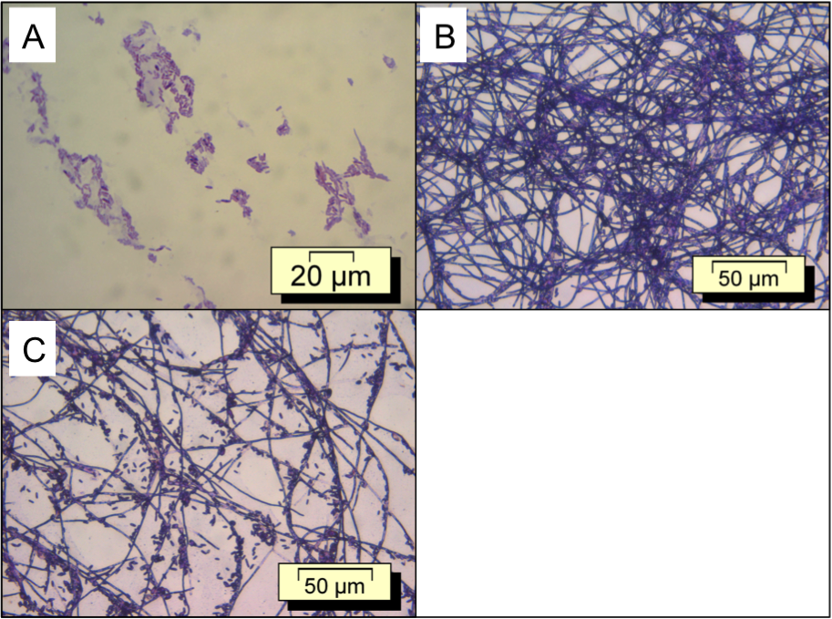
Figure 1

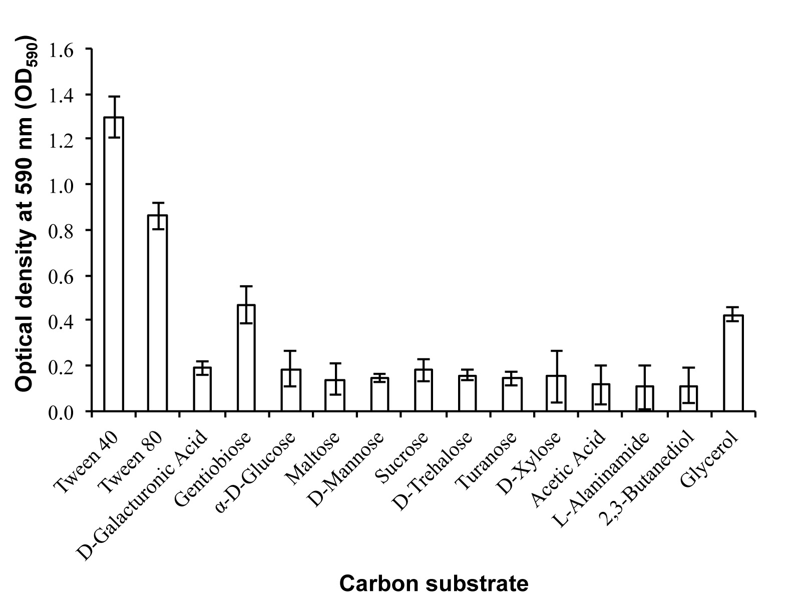
Figure 2

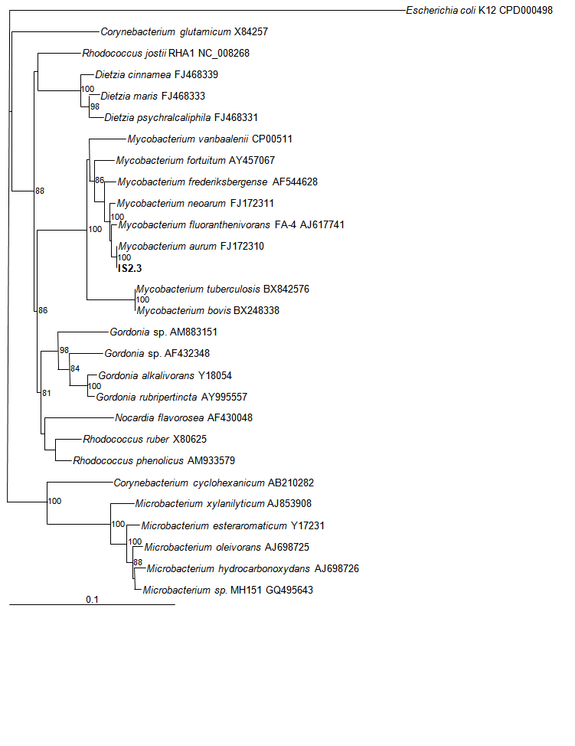Figure 3.

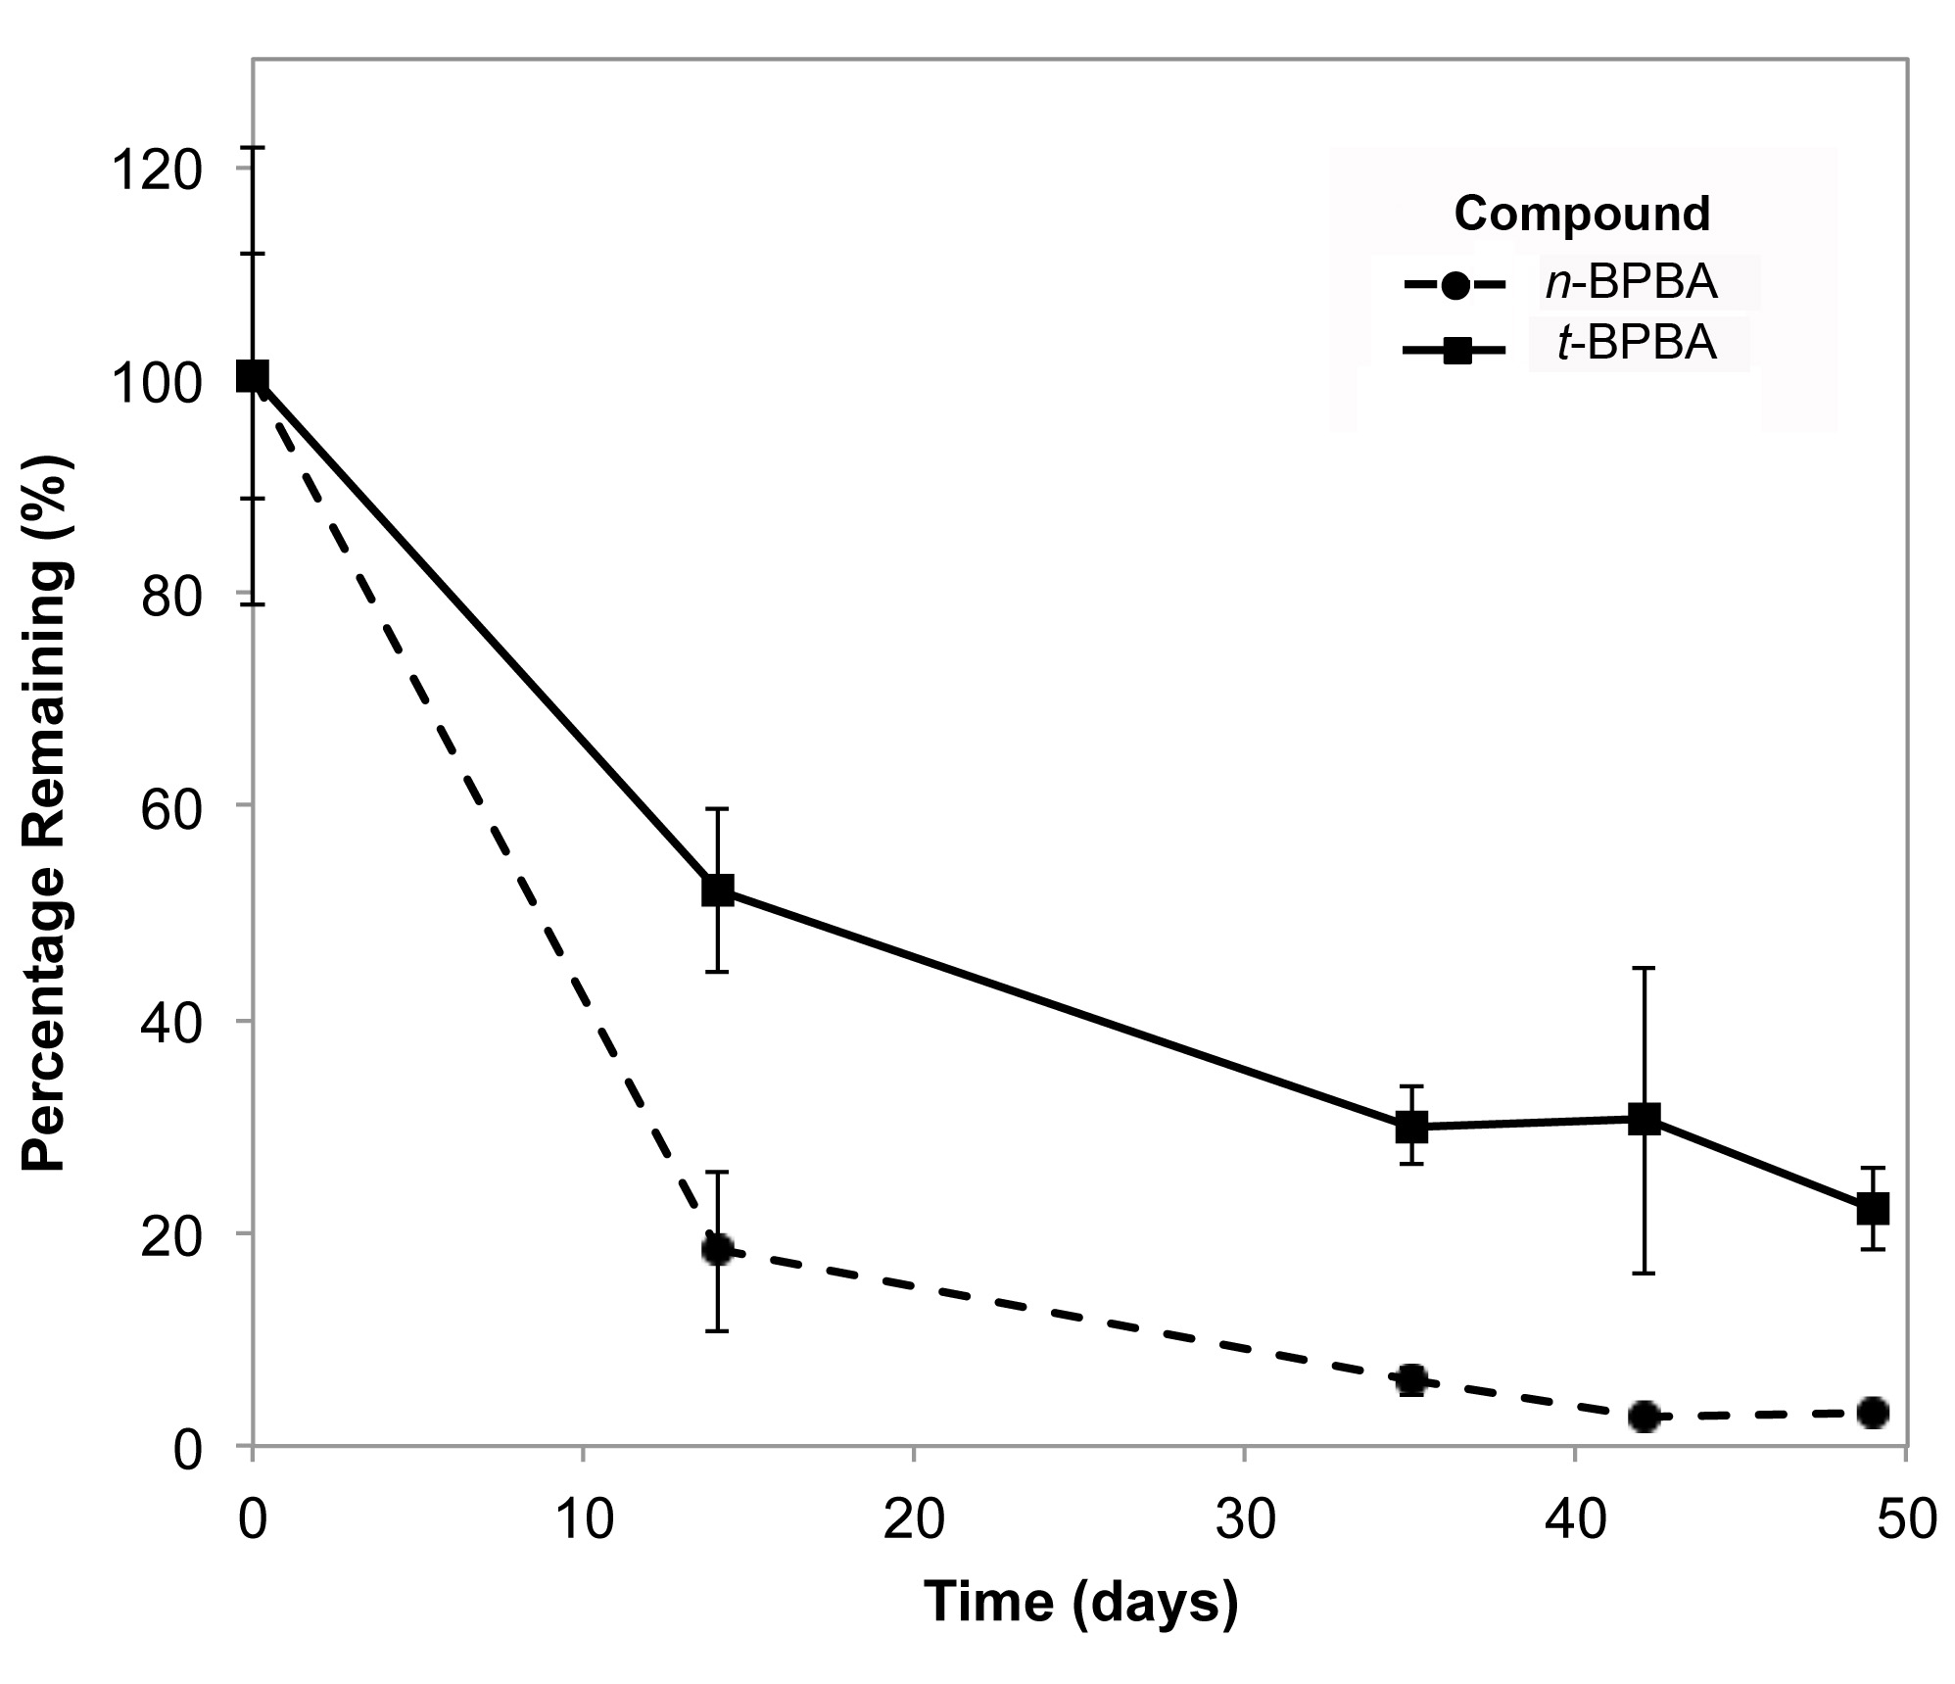
Figure 4

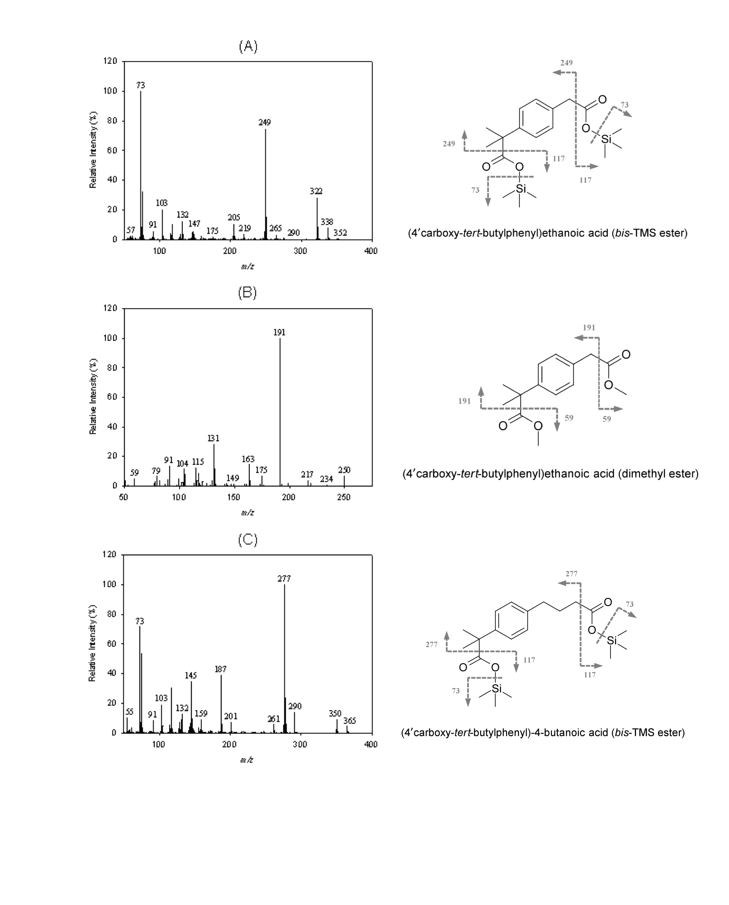

Figure 5
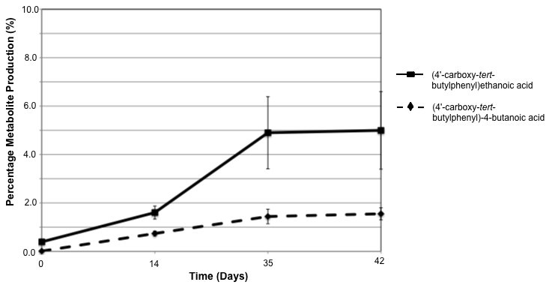
Figure 6

Figure 6

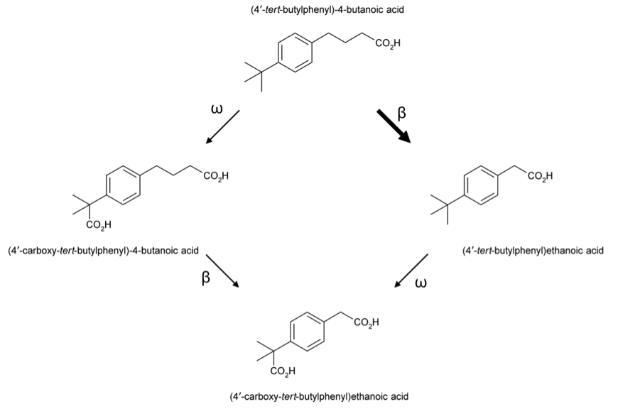

Figure 7

Water  0.000  (±0.00) | α-Cyclodextrin  0.000  (±0.03) | β-Cyclodextrin  0.007 (±0.06) | Dextrin  0.110 (±0.06) | Glycogen  0.083  (±0.02) | Inulin  0.000  (±0.07) | Mannan  0.043  (±0.08) | Tween 40  1.298  (±0.09) | Tween 80  0.863  (±0.06) | N-acetyl-D-Glucosamine  0.085  (±0.09) | N-Acetyl-β-D-Mannosamine  0.093  (±0.17) | Amygdalin  0.020  (±0.06)
L-Arabinose  0.082  (±0.17) | D-Arabitol  0.033  (±0.09) | Arbutin  0.051  (±0.07) | D-Cellobiose  0.046  (±0.04) | D-Fructose  0.089  (±0.05) | L-Fucose  0.021  (±0.05) | D-Galactose  0.034  (±0.05) | D-Galacturonic Acid  0.190  (±0.03) | Gentiobiose  0.468  (±0.08) | D-Gluconic Acid  0.016  (±0.08) | α-D-Glucose  0.188  (±0.08) | m-Inositol  0.000  (±0.07
α-D-Lactose  0.077  (±0.08) | Lactulose  0.008  (±0.04) | Maltose  0.138  (±0.07) | Maltotriose  0.072  (±0.03) | D-Mannitol  0.076  (±0.03) | D-Mannose  0.149  (±0.02) | D-Melezitose  0.058  (±0.01) | α-Melibiose  0.010  (±0.08) | α Methyl-D-Galactoside  0.000  (±0.05) | β Methyl-D-Galactoside  0.000  (±0.02) | 3-Methyl Glucose  0.064  (±0.08) | α -Methyl-D-Glucoside  0.020  (±0.04)
β-Methyl-D-Glucoside  0.020  (±0.02) | α-Methyl-D-Mannoside  0.000  (±0.05) | Palatinose  0.006  (±0.05) | D-Psicose  0.084  (±0.16) | D-Raffinose  0.035  (±0.07) | L-Rhamnose  0.058  (±0.15) | D-Ribose  0.045  (±0.18) | Salicin  0.000  (±0.07) | Sedoheptulosan  0.000  (±0.09) | D-Sorbitol  0.000  (±0.05) | Stachyose  0.000  (±0.06) | Sucrose  0.182  (±0.05)
D-Tagatose  0.056  (±0.06) | D-Trehalose  0.159  (±0.03) | Turanose  0.146  (±0.03) | Xylitol  0.028  (±0.02) | D-Xylose  0.152  (±0.11) | Acetic Acid  0.117  (0.09) | α-Hydroxybutyric Acid  0.038  (±0.04) | β -Hydroxybutyric Acid  0.050  (±0.05) | γ -Hydroxybutyric Acid  0.086  (±0.09) | ρ-Hydroxy-Phenylacetic Acid  0.020  (±0.03) | α-Ketoglutaratic Acid  0.033  (±0.04) | α-Ketovaleric Acid  0.030  (±0.04)
Lactamide  0.005  (±0.08) | D-Lactic Acid Methyl Ester  0.021  (±0.03) | L-Lactic Acid  0.061  (±0.032) | D-Malic Acid  0.000  (±0.04) | L-Malic Acid  0.000  (±0.01) | Pyruvatic acid Methyl Ester  0.000  (±0.03) | Succinic Acid Mono-Methyl Ester  0.048  (±0.03) | Propionic Acid  0.081  (±0.02) | Pyruvic Acid  0.098  (±0.15) | Succinamic Acid  0.000  (±0.01) | Succinic acid  0.000  (±0.05) | N-acetyl-L-Glutamic Acid  0.076  (±0.09)
L-Alaninamide  0.105  (±0.09) | D-Alanine  0.043  (±0.08) | L-Alanine  0.095  (±0.09) | L-Alanyl-Glycine  0.050  (±0.07) | L-Asparagine  0.040  (±0.02) | L-Glutamic acid  0.063  (±0.06) | Glycyl-L-Glutamic Acid  0.024  (±0.04) | L-Pyroglutamic Acid  0.045  (±0.04) | L-Serine  0.009  (±0.01) | Putrescine  0.008  (±0.01) | 2,3-Butanediol  0.113  (±0.08) | Glycerol  0.427  (±0.03)
Adenosine  0.022  (±0.03) | 2'-Deoxy  Adenosine  0.001  (±0.02) | Inosine  0.010  (±0.02) | Thymidine  0.073  (±0.09) | Uridine  0.011  (±0.04) | Adenosine-5'-Monophosphate  0.003  (±0.02) | Thymidine-5'-Monophosphate  0.007  (±0.02) | Uridine-5'-Monophosphate  0.007  (±0.02) | D-Fructose-6-Phosphate  0.013  (±0.02) | α-D-Glucose-1-Phosphate  0.000  (±0.02) | D-Glucose-6-Phosphate  0.000  (±0.01) | D-L- α Glycerol Phosphate  0.028  (±0.03)
Supplementary Figure 1
Supplementary Table 1
Representative Sequence | Percentage 16S rRNA gene sequence similarity (%) | Reference
Mycobacterium aurum FJ172310 | 100 | (Simmon et al., 2009)
Mycobacterium neoaurum FJ172311 | 99 | (Simmon et al., 2009)
Mycobacterium fluoranthenivorans FA-4 AJ617741 | 99 | (Hormisch et al., 2004)
Mycobacterium frederiksbergense AF544628 | 99 | Unpublished
Mycobacterium fortuitum AY457067 | 98 | (Adékambi and Drancourt, 2004)
Mycobacterium vanbaalenii PYR-1 CP000511 | 96 | Unpublished
Mycobacterium tuberculosis H37Rv BX842576 | 94 | (Cole et al., 1998)
Mycobacterium bovis subsp. bovis BX248338 | 94 | (Garnier et al., 2003)

