Supplements

Additional Methods and Results:

S1 Re-analysis of power spectra with pre-injection as baseline

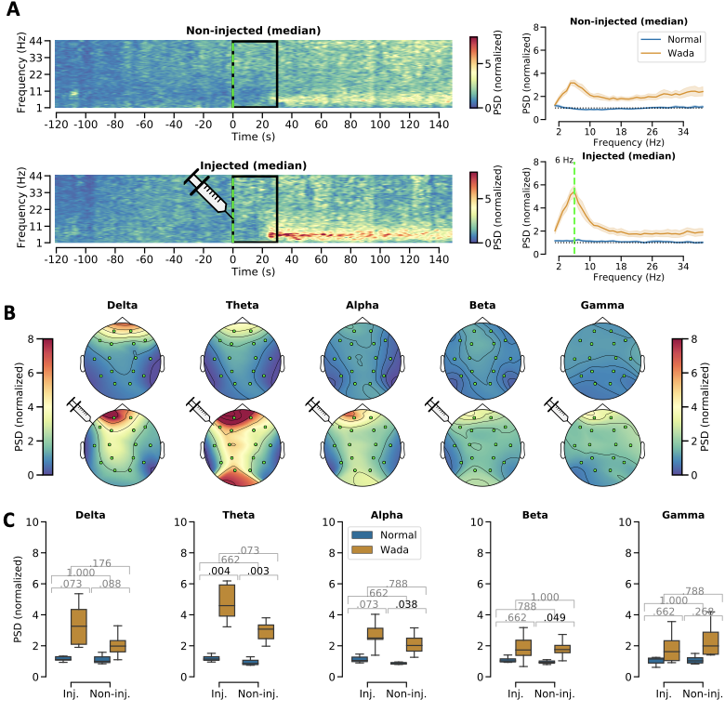
Figure S1 – Group level changes in EEG power spectrum following injection of anaesthetic in the left hemisphere (Wada test) normalized to the pre-injection baseline. (A, left) Median power spectral density (PSD) over time for electrodes on the injected, left hemisphere (ipsilateral) and on the non-injected, right hemisphere (contralateral).The time of injection is marked with a vertical green line in A, left panel. The black box indicates the time period for which the data that was discarded to let the effect of the drug stabilise. (A, right) Median PSDs averaged over time are shown. Blue line: pre-injection normal condition. Red line: Wada condition after the injection. The vertical green line indicates the frequency (6 Hz) of the peak amplitude on the injected side during Wada. A dotted black line shows the normalized median amplitude of the PSD. (B) Topographic visualisations of the PSD for each canonical frequency band of the EEG (top row: rest, bottom row: Wada). (C) Comparison of the PSD values for each canonical EEG band. Blue bars reflect normal condition, orange bars reflect Wada condition. In each plot, the p-values for every t-test (corrected for multiple comparisons) is noted. Statistically significant differences (p<0.05) are printed in black font. The black bars indicate the median, the extent of the boxes the interquartile range, whereas the whiskers extend to the rest of the distribution (excluding anything outside 1.5 times the interquartile range). Syringes indicate the time point of injection (A) and/or hemisphere of injection (A,B).

S2 Signal diversity analyses with three different measures: LZc, ACE, and SCE.
In addition to LZc we applied the following two measures of signal diversity to the spontaneous EEG, based on (Schartner et al., 2015).
- Amplitude coalition entropy (ACE) measures the variability of the amplitudes of the data using the idea of coalition entropy (Shanahan, 2010). The data was binarised as when calculating LZc, with a “1” or “0” indicating that a given channel was active or inactive at a given time point, respectively. The state or “coalition” for each time point, representing an instantaneous spatial pattern of activity, was defined by the particular set of active and inactive channels in that time point. For a given epoch, the frequency of occurrence of each coalition was recorded to give the empirical distribution of coalitions in that epoch. Then, the entropy of this distribution was calculated and normalized by the entropy of coalitions obtained from a scrambled version of the binarized original signal. This normalized entropy is our estimate of the ACE for that epoch.
- Synchrony coalition entropy (SCE) measures the variability in the synchrony of the channels in the data (Schartner et al., 2015). This measure uses the instantaneous Hilbert phase. If the absolute difference between the Hilbert phases of two channels was less than 0.8 radians apart (approx. 45 degrees) they were considered to be synchronised for that channel pair and time point and the value was set to 1. This produced binary sequences for all channel pairs, and coalition entropy was computed in a similar manner to the ACE, but by calculating the entropy of the distributions of coalitions a single channel is involved in (i.e. considering coalitions of all channel pairs a given channel is involved in). This yielded a coalition entropy value for each channel every epoch, and the final SCE value for the epoch was defined as the average coalition entropy across channels, normalized by the entropy of coalitions obtained from a scrambled version of the binarized original signal.
Although the measures are not identical, their values correlate quite strongly when calculated for neural signals, and appear to capture similar properties of the data. LZc and ACE are the most similar measures among the three, and even show similar behavior in simulated systems. In essence, both LZc and ACE capture signal differentiation, while SCE is more sensitive to both integration and differentiation as it is based on phase synchrony. This is due to the fact that SCE depends on the signal having at least some phase synchrony (either through coupling or correlated noise) in order to produce a differentiated binary matrix upon which it is calculated. LZc and ACE on the other hand do not. For a discussion of these issues, see e.g.Schartner, Michael Manfred (2017) On the relation between complex brain activity and consciousness. Doctoral thesis (PhD), University of Sussex., p. 34-36.
All three measures were computed using the Python code provided by (Schartner et al., 2015) for several segment lengths (0.5, 1, 1.5, 2.5, 4, 6, 9, 12, 15, and 20 s), frequency bands (0.1-1.6, 0.6-3.1, 1.6-5.1, 3.1-7.6, 5.1-10.6, 7.6-14.1, 10.6-18.1, 14.1-22.6, 18.1-27.6, 22.6-33.1, 27.6-39.1 and 33.1-45.6 Hz) and using either the eight channels on the left or on the right hemisphere. For each signal diversity measure, we performed statistical comparisons between conditions and hemispheres, using the broadband (0.1 - 45.6 Hz) and smallest segment length in which values had stabilized (in general, longer segments give more accurate estimates of diversity). Comparisons were done using repeated samples t-test. These results can be found in the supplementary materials (Figures S2, S3 and S4).
At the group level, the signal diversity measures (LZc, ACE, SCE) did not change significantly (t-test for repeated measurements) in the Wada test as compared with the normal condition although we observed a small trend towards lower signal diversity bilaterally during the Wada condition for all three signal diversity measures, across several frequency bands (see panels B in Figures S2, S3, and S4).
Again, only the non-significant trends could be observed for Lempel-Ziv complexity (LZc): (1) LZc increased on the right and dropped on the left in the delta/theta range (Figure S2A). (2) LZc showed a relative drop in the two lowest frequency ranges (0.1 - 3.1 Hz) where the slight decrease on the left side (in contrast to the slight increase on the right) lead to a noticeable difference in change between the hemispheres (Figure S2A, bottom). (3) As was the case for ACE, median LZc dropped in all bands on the left and in all but the lowest three (up to 5.1 Hz) on the right (Figure S2B). (4) The median LZc was lower in the injected hemisphere for the majority of the timepoints following the injection (Figure S2C). Overall, the median LZc did not differ significantly between hemispheres and conditions (Figure S2D).
Thus, only the non-significant trends listed in the following could be observed for amplitude coalition entropy (ACE). (1) ACE increased non-significantly for frequencies up to the beta band, for both hemispheres, after injection if segment lengths of 2.5 s or longer were used (Figure S3A). (2) The ACE increase on the right hemisphere was stronger than on the left hemisphere (the injected hemisphere) which coincided with a relative decrease of complexity on the left (Figure S3A, bottom). (3) The median ACE dropped in all bands on the left and in all but the lowest three (up to 5.1 Hz) on the right (Figure S3B). (4) The median ACE was lower on the injected hemisphere for the majority of the timepoints following the injection (Figure S3C). Overall, the median ACE did not differ significantly between hemispheres and conditions (Figure S3D).
Finally, only the non-significant trends could be observed for synchrony coalition entropy (SCE): (1) SCE increased non-significantly on both hemispheres for frequencies up to high beta and then dropped slightly for higher frequencies (Figure S4A). (2) The SCE drop in the higher frequency bands was slightly more pronounced on the right hemisphere (Figure S4A, bottom). (3) In contrast to the results with ACE and LZc, the median SCE increased in the lowest seven frequency bands (up to 18.1 Hz) on the left and the right hemisphere (with the exception of band four on the right, Figure S4B. (4) This was the only measure for which the median measures on the left (injected) exceeded the values on the right (non-injected). As with the other two measures, the median SCE did not differ significantly between hemispheres and conditions (Figure S4D).
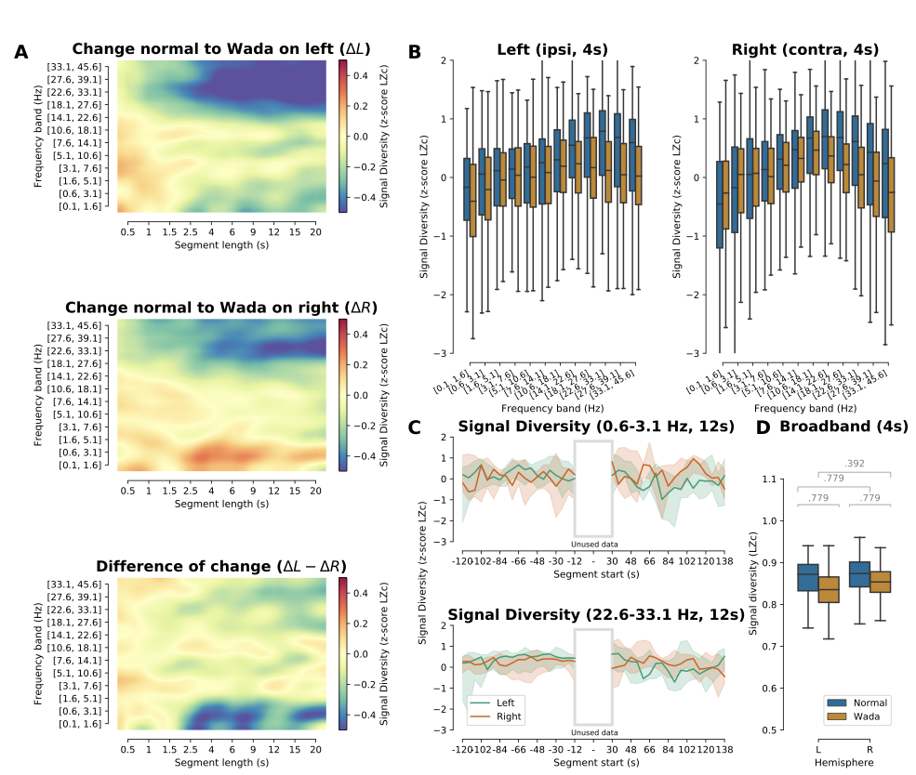
Figure S2 – Effects of the anaesthetic on LZc signal diversity values. (A) Signal diversity (Lempel-Ziv complexity; LZc) with different segment lengths and bands. Red indicates an increase either during Wada (top two images) or the difference of the change between hemispheres (bottom). (B) Distribution of signal diversity values per frequency band during rest (blue) and Wada (orange) on left (L) and right (R) hemisphere. (C) Temporal development of signal diversity for left (green) and right (hemisphere) in two exemplary bands (0.6 - 3.1 and 22.6 - 33.1 Hz). The white box indicates the 30 s immediately following the injection that we discarded to let the effects of the drug stabilize. Times given on the x-axis were the start times of the segments (12 s length, 50% overlap). (D) Comparison of signal diversity values between normal and Wada conditions using the broadband (all frequencies from 0.1 to 45.6 Hz as in panel A). (A-C) use the median of the z-scored signal diversity values. In panels (B) and (D) the black bars indicate the median, the extent of the boxes the inner quartiles whereas the whiskers extend to the rest of the distribution (excluding anything outside 1.5 times the interquartile range). In (C) the shaded area indicates the extent of the 95% confidence interval.

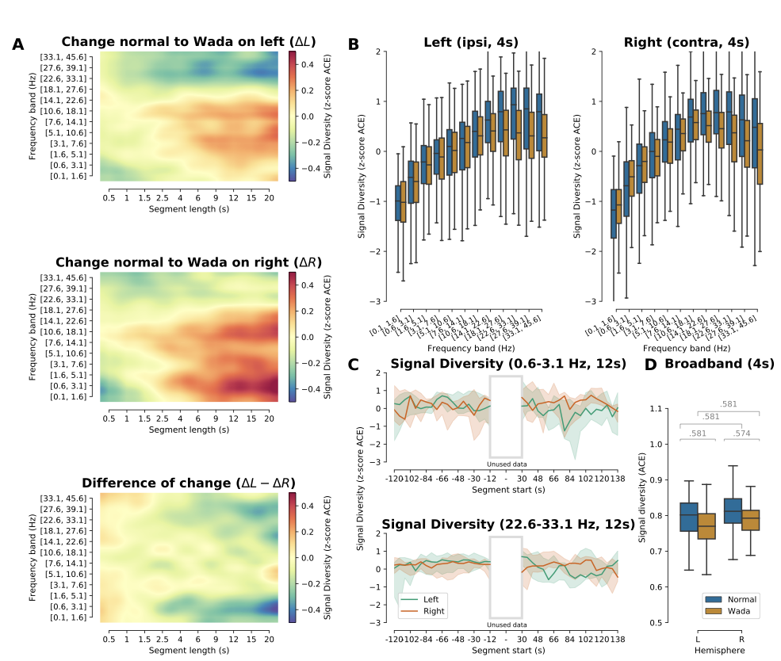

Figure S3 – Effects of the anaesthetic on ACE signal diversity values. (A) Signal diversity (Amplitude coalition entropy; ACE) with different segment lengths and bands. Red indicates an increase either during Wada (top two images) or the difference of the change between hemispheres (bottom). (B) Distribution of signal diversity values per frequency band during rest (blue) and Wada (orange) on left (L) and right (R) hemisphere. (C) Temporal development of signal diversity for left (green) and right (hemisphere) in two exemplary bands (0.6 - 3.1 and 22.6 - 33.1 Hz). The white box indicates the 30 s immediately following the injection that we discarded to let the effects of the drug stabilize. Times given on the x-axis were the start times of the segments (12 s length, 50% overlap). (D) Comparison of signal diversity values between normal and Wada conditions using the broadband (all frequencies from 0.1 to 45.6 Hz as in panel A). (A-C) use the median of the z-scored complexity values. In panels (B) and (D) the black bars indicate the median, the extent of the boxes indicate the inner quartiles whereas the whiskers extend to the rest of the distribution (excluding anything outside 1.5 times the interquartile range). In (C) the shaded area indicates the extent of the 95% confidence interval.
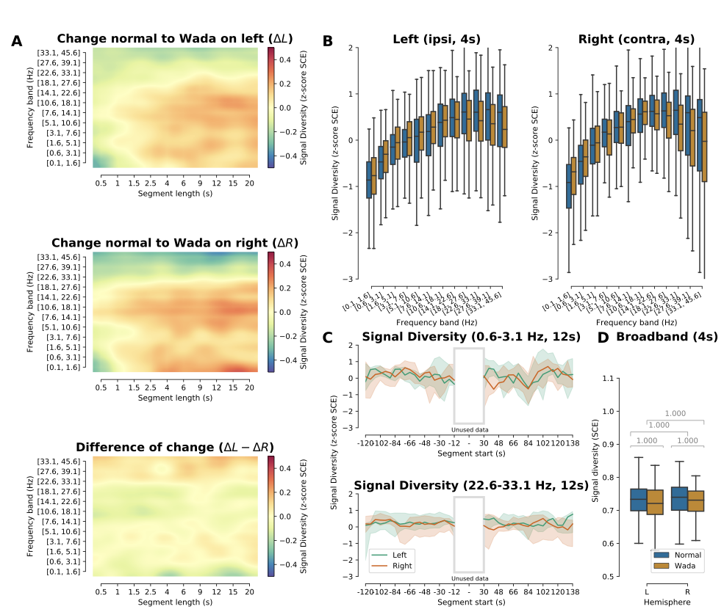
Figure S4 – Effects of the anaesthetic on SCE signal diversity values. (A) Signal diversity (Synchrony coalition entropy; SCE) with different segment lengths and bands. Red indicates an increase either during Wada (top two images) or the difference of the change between hemispheres (bottom). (B) Distribution of signal diversity values per band during rest (blue) and Wada (orange) on left (L) and right (R) hemisphere. (C) Temporal development of signal diversity for left (green) and right (hemisphere) in two exemplary bands (0.6 - 3.1 and 22.6 - 33.1 Hz). The white box indicates the 30 s immediately following the injection that we discarded to let the effects of the drug stabilize. Times given on the x-axis were the start times of the segments (12s length, 50% overlap). (D) Comparison of signal diversity values between normal and Wada conditions using the broadband (all frequencies from 0.1 to 45.6 Hz as in panel A). (A-C) use the median of the z-scored complexity values. In panels (B) and (D) the black bars indicate the median, the extent of the boxes the inner quartiles whereas the whiskers extend to the rest of the distribution (excluding anything outside 1.5 times the interquartile range). In (C) the shaded area indicates the extent of the 95% confidence interval.

S3 Influence of the choice of reference
We investigated the impact of the reference on our analysis of the PSD by comparing REST and median reference (Ríos-Herrera et al. 2019). Initially, we performed the same analysis as in the main part of the paper except that we referenced to median and then to A1 and A2 on the respective hemispheres. This had no influence on the PSD (see Figure S5).
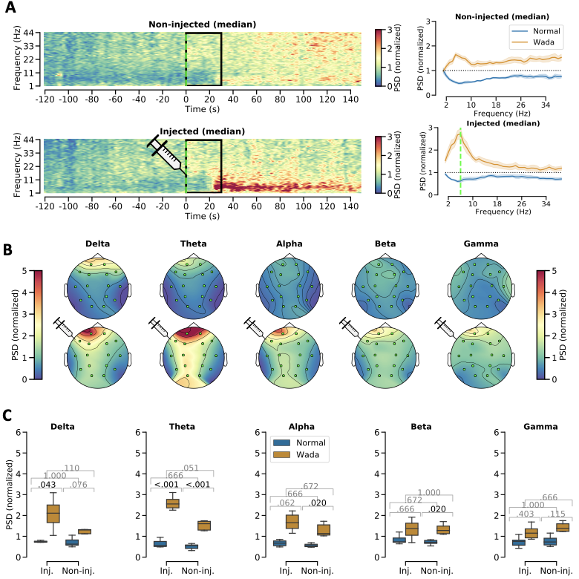
Figure S5 - Group level changes in EEG power spectrum following injection of anaesthetic in the left hemisphere (Wada test) using data initially referenced to the median. The data in this Figure was first referenced to the median and then referenced to A1/A2. The remaining analysis is identical to Figure 1.

In addition we performed the PSD analysis without re-referencing to A1 and A2 using the REST and median referenced data. This has a stronger influence on the data (see Figures S6 and S7). Similar trends can be observed using all referencing methods. Nonetheless we believe first referencing to REST (or median reference) and then to individual electrodes on the two hemispheres to be the correct approach which is why we performed the remaining analyses in this manner.

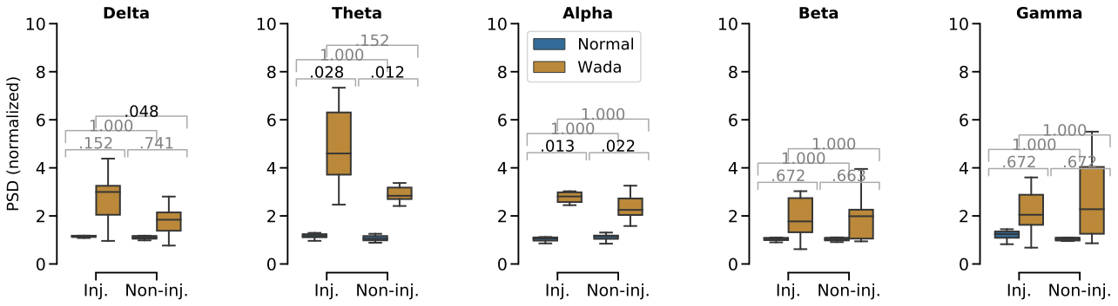
Figure S6 - Group level changes in EEG power spectrum following injection of anaesthetic in the left hemisphere (Wada test) using data initially referenced to the REST but not re-referencing to A1/A2. The data in this Figure was only referenced to the REST. The remaining analysis is identical to Figure 1. We restricted the figure to the comparison of the PSD in canonical frequency bands (see Figure 1C).

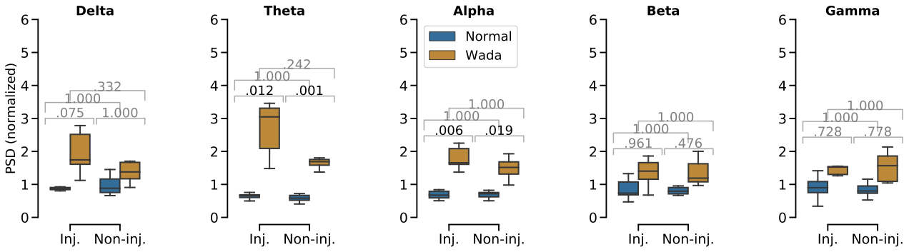
Figure S7 - Group level changes in EEG power spectrum following injection of anaesthetic in the left hemisphere (Wada test) using data initially referenced to the median but not re-referencing to A1/A2.. The data in this Figure was only referenced to the median. The remaining analysis is identical to Figure 1. We restricted the figure to the comparison of the PSD in canonical frequency bands (see Figure 1C).

S4 Epileptiform Activity

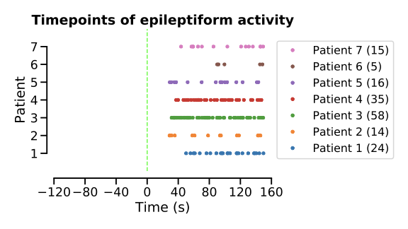
Figure S8 - Timepoints of epileptiform activity during the Wada procedure. A trained clinical electrophysiologist (epileptologist)clinician inspected the 270 seconds (120 s normal, 30 s rest, 120 s Wada) of EEG that were the basis of our analysis. Epileptiform activity in the form of inter-ictal spikes or sharp waves were marked atas events with the time points shown above. Each line represents one patient. The dashed vertical green line indicates the time point of the start of the injection. The numbers in parentheses in the legend are the number of discharges that were found.

Supplementary bibliography
Ríos-Herrera, W. A., Olguín-Rodríguez, P. V., Arzate-Mena, J. D., Corsi-Cabrera, M., Escalona, J., Marín-García, A., Ramos-Loyo, J., Rivera, A. L., Rivera-López, D., Zapata-Berruecos, J. F., & Müller, M. F. (2019). The Influence of EEG References on the Analysis of Spatio-Temporal Interrelation Patterns. Frontiers in Neuroscience, 13, 941.
Shanahan, M., 2010. Metastable chimera states in community-structured oscillator net- works. Chaos 20 (1), 013108. doi: 10.1063/1.3305451 .

