G protein-coupled receptors contain two conserved packing clusters

O. B. Sanchez-Reyes, A. L. G. Cooke, D. Tranter, M. Eilers, P. J. Reeves* and S. O. Smith*

Short Title: Conserved packing clusters in GPCRs

*To whom correspondence may be addressed: steven.o.smith@stonybrook.edu or preeves@essex.ac.uk.

Keywords: rhodopsin, GPCR, residue packing, group-conservation

ABSTRACT
G protein-coupled receptors (GPCRs) have evolved a seven-transmembrane helix framework that is responsive to a wide range of extracellular signals. An analysis of the interior packing of family A GPCR crystal structures reveals two clusters of highly packed residues that facilitate tight transmembrane helix association. These clusters are centered on amino acid positions 2.47 and 4.53, which are highly conserved as alanine and serine, and mediate the interactions of helices H1-H2 and H3-H4, respectively. The helical interfaces outside of these clusters in the TM core are lined with residues that are more loosely packed, a structural feature that facilitates motion of helices H5, H6 and H7, which is required for receptor activation. Mutation of the conserved small side chains residues within packing cluster 2 (amino acid positions 4.53 and 4.57) are shown to disrupt the structure of the visual receptor rhodopsin, whereas sites in packing cluster 1 (position 1.46 and position 2.47) are more tolerant to mutation but affect the overall stability of the protein. These findings reveal a common structural scaffold of GPCRs that is important for receptor folding and activation.

INTRODUCTION
The transmembrane (TM) helices of membrane proteins associate in a specific manner within the cell membrane to generate the final folded protein (1). This association can result in structures that range from tightly packed to highly dynamic depending on the function of the protein (2). G protein-coupled receptors (GPCRs) comprise a bundle of seven TM helices that appear to have both rigid and dynamic regions (3). Over the past ten years, a number of crystal structures have been determined of family A GPCRs in both inactive and active conformations (4-9). Comparison of these structures shows that TM helices H5 and H6 change orientation upon activation to expose the G protein-binding site on the intracellular surface of the receptor. Consequently, much of the focus on GPCRs has been on the molecular switches that regulate the dynamics of these helices (10, 11). The rigid components within GPCRs that can serve as a scaffold for the dynamic elements, and are the focus of this study, have not been studied in the same detail.
The receptors in the family A GPCRs are activated by a diverse range of signals and are correspondingly divided into several subfamilies (12).For example, light absorbed by a covalently bound 11-cis retinal chromophore activates the visual receptors. These receptors have evolved to be locked off in the dark and rapidly convert to a fully active conformation in the light (13, 14). Strong stabilizing interactions between TM helices hold the receptor in the inactive state reducing dark noise in vertebrate rod and cone cells, while transient stabilizing helix interactions formed in the active state hold the receptor in an open signaling conformation providing time for multiple G protein binding events. In contrast, the ligand-activated GPCRs appear to be more dynamic than the visual receptors (3, 15-17). For instance, in the amine receptor subfamily, the binding energy of small molecule amine agonists is much less than the light energy that is channeled into the visual receptors to drive receptor activation. Ligand binding stabilizes these receptors in a range of conformations from inactive to fully active. The high basal activity often observed in these receptors suggests that thermal energy is sufficient to toggle the receptor between inactive and active conformations (3).
In both the light- and ligand-activated family A GPCRs, the largest structural change upon GPCR activation is an outward rotation of TM helix H6. EPR studies first revealed that the intracellular end of TM helix H6 pivots outward upon activation (18). Blocking this outward rotation by cross-linking TM helices H3 and H6 prevents receptor activation (18, 19). Crystal structures of opsin showed that H6 motion is coupled with the reorientations of TM helices H5 and H7 (6, 7). Very similar changes in the orientations of H5, H6 and H7 are observed in the β₂-adrenergic receptor that is stabilized in the fully active conformation with bound agonist on the extracellular side of the receptor and bound nanobodies and G protein on the intracellular side of the receptor (20).
While the diversity between GPCR sequences occurs largely on the extracellular (ligand-binding) side of the receptor, residues in the TM core are highly conserved (Fig. 1). The TM core contains amino acids that have high sequence identities across GPCR subfamilies (Table S1) and residues that are highly conserved when considered as a group of similar amino acid types (Table S2) (14, 21). The signature residues with high sequence identity for family A GPCRs have largely been associated with receptor function (9). In contrast, the group-conserved residues with small and weakly polar side chains (Gly, Ala, Ser and Cys) are known to facilitate packing of the TM helices and interhelical hydrogen bonding (2, 22, 23), and a priori may have either structural or functional roles. In the TM core of family A GPCRs, group-conserved residues in TM helices H1-H4 appear to mediate close helical interactions similar to those formed by common structural motifs described for stable TM helix dimers (21). However, there are group-conserved residues both within (e.g. Ser3.39) and outside of the TM core (e.g. Ser3.47 and Ala7.42) that have been associated mainly with receptor function (24, 25).
To address the contribution of the group-conserved residues to GPCR structure and function, we first mutated these residues with small side chains within the TM domain of the visual receptor rhodopsin to leucine. In model TM dimers where group-conserved sites mediate stable structures, mutation to leucine disrupts helix packing and results in TM monomers (26). Rhodopsin is an ideal system for probing the structural and functional roles of this class of residues. The 11-cis retinal is covalently attached within the interior of rhodopsin as a protonated Schiff’s base that gives rise to a pigment with a maximum absorbance at 500 nm when the apoprotein rod opsin is correctly folded. The intensity and frequency of the visible absorption band relative to the 280 nm protein absorption band provides a sensitive assay for protein folding. We find that there are several group-conserved sites within rhodopsin where mutation leads to the partial or complete loss of the rhodopsin visible absorption band.
To directly compare the packing interactions of the group-conserved positions with other residues in the TM region of family A GPCRs, we calculated the packing density of TM residues in the GPCR crystal structures solved to date using the occluded surface (OS) packing method (27, 28). This method yields packing values for the individual atoms and amino acids in GPCR structures and allows one to identify the regions that contribute to tight helix-helix interactions. In addition to the visual and amine receptors, crystal structures have now been determined of receptors in several other subfamilies of family A GPCRs (9). Moreover, structures have been determined with bound agonists providing a range of different conformations ranging from inactive to fully active (29). On the basis of the packing analysis, we identified two conserved clusters of residues that are tightly associated and sensitive to mutation, and propose that these regions serve as a structural framework against which helices H5, H6 and H7 reorient upon activation.

MATERIALS AND METHODS
Occluded surface packing analysis
The OS method (27, 28) was used to analyze residue interactions in the GPCR crystal structures. In the OS calculation, van der Waals surfaces are drawn around each atom in the protein and normals are constructed which extend outward until they reach another surface or a length of 2.8 Å, the diameter of a water molecule. Those normals that strike another surface are considered occluded. The cutoff of 2.8 Å between amino acid surfaces accounts for the possibility that water can occupy that space and therefore the corresponding surface is defined as being non-occluded. The OS packing value is proportional to the ratio of the occluded surface area to the total surface area; the ratio is weighted by the distance to the occluding neighbors (i.e. the length of the normal). The OS method for characterizing protein packing has the advantage that packing values can be calculated at the level of individual atoms, amino acids or entire proteins. We have previously applied the OS method to membrane proteins whose crystal structures have been determined to high resolution, and reported the average packing values for amino acids found in the TM helices (22, 23).
We performed the OS calculation on the full GPCR structures including all ligands. Individual residues can be occluded by another residue or by a bound ligand. Structural waters were deleted from the coordinate files. Although water is increasingly recognized as a key player in GPCR structure and function, electron density for water is often not observed in the lower resolution GPCR crystal structures (30). As a result, in the studies below lower packing values occur for residues that have been found in contact with structural waters or that are adjacent to voids large enough to accommodate structural water. A single chain was used to calculate the packing values when multiple chains were present in the PDB coordinate file. Since some receptors have more available structures than others, the analysis described in the main text was limited to 28 unique sequences with the highest resolution. The receptors analyzed were as follows: 5-HT1B serotonin receptor (4IAQ), 5-HT2B serotonin receptor (4IB4), M1 acetylcholine receptor (5CXV), M2 acetylcholine receptor (3UON), M3 acetylcholine receptor (4U15), M4 acetylcholine receptor (5DSG), β₁-adrenergic receptor (4BVN), β₂-adrenergic receptor (2RH1), dopamine D3 receptor (3PBL), histamine receptor (3RZE), angiotensin II type 1 receptor (4ZUD), neurotensin NTS1 receptor (4BV0), δ-opioid receptor (4N6H), κ-opioid receptor (4DJH), μ-opioid receptor (4DKL), nociceptin/orphanin receptor (4EA3), orexin receptor 1 (4ZJC), orexin receptor 2 (4S0V), protease-activated receptor 1 (3VW7), chemokine receptor CCR5 (4MBS), chemokine receptor CXCR4 (3ODU), free fatty acid receptor FFA1 (4PHU), lysophosphatidic acid receptor LPA1 (4Z35), sphingosine-1-phosphate receptor S1P1 (3V2Y), adenosine A2A receptor (4EIY), P2Y1 purinoreceptor (4XNW), P2Y12 purinoreceptor (4NTJ), and rhodopsin (1U19). (See Table S3 for references).
We have, however, analyzed the packing of the large number of additional crystal structures of inactive and active rhodopsin and the β₂-adrenergic receptor. This analysis (see Supporting Information) was used to establish the variability of packing values between crystal structures of the same GPCR sequence, as well as to investigate the differences between active and inactive structures. The structures analyzed were as follows: inactive rhodopsin - 1F88, 1HZX, 1L9H, 1U19, 2HPY, 2G87, 2I35, 2I36, 2I37, 2J4Y, 2PED, 2X72, 3OAX, 2Z73, 2ZIY, 3AYM, 3AYN, 4WW3; active rhodopsin - 3CAP, 3DQB, 3PQR, 4A4M, 4BEY, 4BEZ, 4J4Q; inactive β₂-adrenergic receptor – 3D4S, 3NY8, 3NYA, 4GBR; active β₂-adrenergic receptor - 4LDE, 4LDL, 4LDO, 4QKX, 3P0G, 3PDS, 3SN6.
GPCR family alignments
The conservation data were obtained from structure-based sequence alignments of all families of GPCRs extracted from the GPCR database (31). These include family A excluding the olfactory receptors (283), family B secretin/adhesion (45), family C metabotropic glutamate (22) and family F (9), where the number of receptors aligned are in parentheses.

Measuring Rhodopsin Pigment Formation
All rod opsin mutants were constructed by Quikchange site-directed mutagenesis (Stratagene, San Diego, CA) and verified by DNA sequencing. Rod opsin mutants were expressed in COS-1 cells after DEAE dextran mediated transient transfection (32). Transfected COS-1 cells from two 15 cm dishes were harvested after growth for 60 h, resuspended in 4 ml of PBS and treated with 11-cis retinal (30 μM) for 14 h. Pigments were purified using Rho-1D4 immunoaffinity chromatography as described previously (33). Elution was performed in BTP buffer (10 mM, pH 6.0) containing a nonamer elution peptide (10 μM) corresponding to the C-terminus or rhodopsin (TETSQVAPA). UV-vis spectra of purified pigments were recorded at 20 °C using a Perkin Elmer λ35 UV-vis spectrophotometer equipped with water-jacketed cell holders. Spectra were acquired between 250 nm and 650 nm, 2 nm bandwidth, a response time of 1 s, and a scan speed of 480 nm/min.

RESULTS
Mutational analysis of tightly packed, group-conserved residues
The concept that small, weakly polar amino acids mediate helix packing emerged from structural studies of TM helix dimers (21), but these residues have largely not been mutated in a systematic way in polytopic helical membrane proteins (23). To address their role in stabilizing the 7-TM helix structure of GPCRs, we mutated the group-conserved sites in the visual receptor rhodopsin to residues with either similar or larger molecular volumes (Fig. 2). Mutation to similar size residues (e.g. serine) was expected to be tolerated, while mutation to larger size residues (e.g. leucine) was expected to disrupt helix packing. The structural read-out is the ability of the apoprotein rod opsin to fold correctly, form a functional ligand pocket, and as a consequence regenerate with 11-cis retinal to form the native retinal-protein complex visual pigment. The appearance of the visible absorption band at 500 nm along with its intensity relative to the 280 nm protein absorption band indicates that apoprotein binds the 11-cis retinal chromophore as a protonated Schiff’s base in its native environment. A correctly-folded retinal-protein complex has a 280/500 nm ratio of ~2 after elution from the Rho-1D4-Sepharose column under low-salt conditions (34). Generally, when opsin is not able to bind retinal and regenerate the 500 nm absorption spectrum, it exhibits a lower overall expression as reflected in a drop in intensity of the 280 nm absorption band. However, mutants at two sites studied (Ala7.42 and Ala7.46) express rod opsin at comparable levels to wild-type even though leucine substitutions block (A7.42L) or reduce (A7.46L) retinal regeneration. (Note: we use the corrected structure-based Ballesteros-Weinstein numbering system (35-37) for describing the relative position of amino acids within a TM sequence in the family A GPCRs along with indicating the residue identity with the highest conservation in the family A receptors.)
The sites that were most sensitive to mutation appear to be in the interface between H3 and H4 (Ala4.53 and Ala4.57), in the interface between H2 and H3 (Ala2.49) and in the interface between H6 and H7 (Ala7.42). Two of the four of these sites (Ala2.49 and Ala4.53) are within the TM core (Fig. 1). In these cases mutation to both S and L disrupts helix-helix packing. Ala4.53 along with Ala4.57 are part of an “AxxxA” motif, which mediates interaction with H3. The A4.53V mutation in rhodopsin leads to autosomal dominant retinitis pigmentosa (ADRP), an inherited degenerative disorder of the retina leading to progressive and irreversible vision loss. The disease is often caused by rhodopsin misfolding mutants (38).
Ala2.49 is part of the conserved LAxAD motif on H2. Interestingly, mutation to serine has a larger influence on receptor structure at this position than leucine.
Ala7.42 creates a notch on helix H7 for packing of the signature-conserved tryptophan (Trp6.48) on H6. The high expression of the A7.42S and A7.42L mutants relative to wild-type (as shown by the overall absorption of the expressed protein) suggests that the protein is not misfolded. A more likely explanation is that the large leucine side chain shifts the positions of the indole ring of Trp6.48 and prevents retinal binding. Mutation of Ala7.42 to larger residues often leads to constitutive activation (39, 40) consistent with the mechanism that the Trp6.48 side chain rotates upon activation.
Two clusters of tightly packed, conserved residues occur in family A GPCRs
In stable TM helix dimers the group-conserved residues mediate close helix packing, which in turn facilitates the formation of interhelical hydrogen bonds. Another possible role of these residues in polytopic membrane proteins is to create cavities for water molecules that may be important for protein function. To address the relative packing density of the group-conserved sites in GPCRs, we have calculated packing values for all TM residues in GPCR crystal structures that have been solved to date (22, 27). This analysis was carried out on the full receptor-ligand complexes. Packing values can theoretically range from 0.0 to 1, corresponding to totally exposed and totally occluded environments, respectively. However, the typical packing values for residues facing away from the helix bundle (i.e. facing the lipid acyl chains) are generally between ~0.2 – 0.3, while residues within the helix interfaces are typically between 0.35 and 0.6. The most tightly packed residues have packing values in the range of 0.56-0.65.
For the family A GPCRs, the average packing values of residues in the TM helices range from 0.227 (Leu1.59) to 0.600 (Ser4.53) (Fig. 3). Overall, H2 and H3 are the most tightly packed helices in the family A receptors. H3 occupies a central position in the receptor and has contacts with each of the other helices except H1 (9). On the extracellular side of H3 there are typically residues that are involved in ligand binding, while at the intracellular end of H3 is the conserved E/DRY sequence.
The signature (red) and group-conserved (blue) residues are found to have some of the highest packing values within the TM helices, particularly in the TM core (Fig. 3). Table 1 lists the ten most tightly packed residues. Of these ten, seven are in the TM core. See Table S4 for a complete list of TM residue packing values in the family A GPCRs. An analysis of the location of the most tightly packed residues in the family A GPCRs indicates that they are mostly clustered in two groups within the TM core, designated packing cluster 1 and cluster 2. One of the striking features shown in Table 1 is the absence of any highly packed residues at conserved locations on H6 and H7; thus these helices appear to have evolved to be loosely packed.
Cluster 1 is centered on residues 1.50 (0.569) and 2.47 (0.587) at the crossing point of helices H1 and H2 (Fig. 4A and C). Cluster 1 involves the interaction of four of the six most tightly packed amino acids: residues Gly1.46 (0.569), Asn1.50 (0.569), Ala2.47 (0.587) and Leu2.54 (0.572). The residue with the highest packing value in this cluster (2.47) lies at the crossing point of helices H1 and H2. The side chain of Asn1.50 is oriented by hydrogen bonding of its NH₂ group to the backbone carbonyls of Gly1.46 (0.569) and Ser7.46 (0.503). The side chain C=O of Asn1.50 in turn hydrogen bonds to Asp2.50 (0.536). The packing and orientation of these residues are facilitated through interactions with Val1.53 (0.536) and Ala2.47 (0.587). Ala2.47 is group-conserved (93 b %). Although cluster 1 appears to be tolerant to mutation (Fig. 2), the thermal stability of the G1.46L at 55 °C drops from 54.6 min for wild-type rhodopsin to < 1 min (41). In a similar fashion A2.47L is able to regenerate the wild-type spectrum, but is less thermally stable than the wild-type receptor (unpublished results).
In the analysis of packing cluster 1, we find that while the cluster is mainly localized between H1 and H2, there are often key packing interactions with H7. These interactions are important in activation and folding. For example, the backbone carbonyl of Ser7.46 is free to form interhelical hydrogen bonds due to the presence of conserved Pro7.50. As mentioned above, this carbonyl, along with the carbonyl of Gly1.46 within cluster 1, orients the tightly packed Asn1.50 side chain.
There is a second cluster of residues that mediates packing of TM helices H3 and H4. Cluster 2 is centered on Ser4.53 (0.600) on TM H4, which is at the crossing point of helices H3 and H4 (Fig. 4A and B, Fig. S1), and group-conserved as serine (38%) or alanine (34%). Ser4.53 is the most tightly packed residue in the TM domain and mediates close association of H3 and H4. Other residues that contribute to this cluster are Ala3.38 (0.586), Ser3.42 (0.563) and Ser4.57 (0.539). The A4.53L and A4.57L mutations in rhodopsin both disrupt receptor structure (Fig. 2). The side chain of Ser4.53 packs in the notch between residues 3.37 and 3.38 on H3. Position 3.38 is generally a small residue (61% group-conserved, although is an isoleucine in rhodopsin) and facilitates the interaction of Trp4.50 with polar residues on H2 and H3. As a result, even though H4 has many residues with low packing values, it appears to have evolved to tightly associate with H3 in this region through the group-conserved sites. Ser3.42 is below Ala3.38 and is part of the cluster as it interacts with Trp4.50. In rhodopsin, Ser3.42 is hydrogen bonds with Asn2.45. Asn2.45, in turn, hydrogen bonds with Trp4.50 (Fig. 4B).
There are several other group-conserved residues in the TM helices that have high packing values, but do not contribute to either of the two main packing clusters (Fig. 3, Table S4, Fig. S2). Two group-conserved residues (Ala2.49 and Ser3.39) are in the TM core between the two packing clusters. In most GPCR structures, with the notable exception of dark-state rhodopsin, these residues are in van der Waals contact across the H2-H3 interface.
Four other group-conserved sites (Ser3.47, Ala4.42, Cys6.47 and Ala7.42) lie above and below the core and interact with conserved aromatic residues (see Fig. S2). Ser3.39 likely has a functional role in coordinating a Na+ ion within the TM core (42). Residue 3.47 is conserved as a serine (48%) or alanine (36%) across the family A GPCRs and mediates the interaction between H3 and H5 at the level of the highly conserved positions Cys5.57 and Tyr5.58. Upon activation, this small residue serves as a molecular notch to orient the aromatic side chain of Tyr5.58, which interacts with Arg3.50. Mutation of this residue to a larger residue in rhodopsin destabilizes the Meta II active state (24). Ala4.42 mediates the interaction of H4 with the intracellular end of H2. This interaction is also mediated by a small residue-to-aromatic packing interaction. Position 4.42 is conserved as cysteine (73%) in the olfactory receptors and alanine (50%) in the other family A receptors, and interacts with Tyr2.41 and Pro2.38. Position 2.41 is conserved as a large hydrophobic residue and position 2.38 is often a proline. This proline in rhodopsin is the transition point between intracellular loop 1 and TM helix H2. Finally, Ala7.42 has a group conservation of 73% and forms the packing surface for the conserved Trp6.48 on H6. Ala7.42 also packs against Cys6.47, which is conserved 69% as a cysteine across the family A GPCRs (excluding the olfactory receptors that do not contain the conserved CWxP motif on H6).

DISCUSSION
The packing analysis presented here complements other approaches that focus mainly on the activation switches to understand the role and interplay of conserved residues in GPCRs (9, 43). Using an evolutionary tracing method, Lichtarge and colleagues (43) were able to subdivide mutations that caused functional defects into three regions: an extracellular ligand-binding region, an intracellular region where mutations affect G protein activation, and the TM core. They identified 39 generically important residues that included key sites in the packing clusters (e.g. Ser4.53, Trp4.50) and in the activation switches (e.g. Leu2.46, Trp6.48, Asn7.49). Babu and colleagues (9) identified a consensus network of 24 inter-TM helix contacts comprising 36 amino acids that mediate conserved non-covalent contacts within the seven helix bundle with TM helix H3 serving as a functional hub, and have identified three residues on the intracellular side of family A GPCRs that are involved in activation (44) Our analysis deconstructs the TM core to reveal the residues that stabilize structure (i.e. the packing clusters) and residues that mediate receptor conformational changes (i.e. the activation switches). The packing clusters defined here are similar to the protein sectors described by Ranganathan and colleagues whose conservation is correlated across families of sequences and involve amino acids that are in contact in the tertiary structure of the protein and have a distinct structural or functional role within a protein (45).
Location of the packing clusters relative to the activation switches
The TM core comprises the two packing clusters described above and two activation switches (Fig. 5). In contrast to the packing clusters, the activation switches have been extensively studied. The first activation switch has been described by (46) and involves Ile3.40 (0.519), Leu5.51 (0.436), Pro5.50 (0.557) and Phe6.44 (0.505). Other than Pro5.50, each of these residues is more loosely packed on average than the residues in the packing clusters, consistent with their functional roles. Phe6.44 is highly conserved (75%) and is observed to have the most motion in β₂-adrenergic receptor upon conversion to the active receptor (47). Phe6.44 interacts with Ile3.40 and Pro5.50. These residues have a conserved pairwise interaction in GPCRs (48).
The second activation switch includes Leu2.46 (0.479), Asp2.50 (0.537), Ser3.39 (0.510), Asn7.49 (0.480) and Pro7.50 (0.482) (see Fig. 5). Leu2.46 has a high sequence identity (93%) across the family A GPCRs, while Ser3.39 has the highest group conservation (95%) as a small residue (Ser, Gly, Ala) when the olfactory receptors are excluded from the analysis. Water surrounding Asn7.49 fills the space between this residue and Ser3.39 leading to the relatively low packing values (see Fig. S3, Methods). The conserved water network in the interior of the family A GPCRs contributes to both activation switches and is known to change upon activation (30, 48).
The switch regions interact with the packing clusters in two key places. Each switch region is centered on a conserved proline: Pro5.50 (switch 1) and Pro7.50 (switch 2). One unique aspect of prolines in TM helices is that they result in a free backbone C=O group that is able to mediate interhelical hydrogen bonds (49). In switch 1, the free C=O at position 5.46 due to Pro5.50 interacts with a polar residue (e.g. Glu3.37 in rhodopsin). In switch 2, the free C=O at Ser7.46 interacts with Asn1.50.
Comparison of the average packing values between active and inactive receptors can in principle reveal those regions of the receptor that undergo the largest structural changes upon activation. In rhodopsin and the β₂-adrenergic receptors, the packing values exhibit the largest differences at sites in the extracellular and/or intracellular regions of the receptor. Smaller, but significant, changes are also observed in the switch regions. For example, both Ser7.46 and Asn7.49 become more tightly packed in switch 2 upon activation (Fig. S4, S5).

Packing clusters are more highly conserved than the activation switches in family A GPCRs
Overall, the packing analysis reveals a highly conserved core that is balanced between residues that provide a rigid framework (packing clusters 1 and 2) and residues that are responsible for the dynamic transitions between inactive and active receptor conformations (activation switches 1 and 2). While the packing clusters are conserved as a structural unit, the activation switches in the family A GPCRs are not conserved, and appear to co-evolve with the ligands associated with different receptor families (or subfamilies). For example, the olfactory receptor subfamily appears to have a similar structure, but a different activation mechanism to accommodate its small, volatile ligands (see Tables S1 and S2). That is, residues in the packing clusters are conserved (e.g. Gly1.46, Asn1.50, Ala2.47, Asp2.50, Ser4.53, Ser4.57), while the key residues in activation switch 1 (Pro5.50, Phe6.44 and Ile3.40) as well as Trp6.48 and Pro6.50 are not. Rather, there is a conserved glutamate at position 3.39 and histidine at position 6.43. These residues would be predicted to be in close proximity in homology models of the olfactory receptors based on rhodopsin (50) and activation appears to proceed through a modified switch 2, where glutamic acid replaces Ser3.39. As a result, it appears that the packing clusters are conserved in order to preserve the overall fold of the receptors, and as suggested in Fig. S6 to preserve a folding pathway. These rigid clusters can provide a stable framework that enables the evolution of both the ligand binding elements and the activation switches within the TM core.
Packing clusters appear to be conserved in family B, C and F GPCRs
The recent crystal structure determination of receptors from other families of GPCRs allows us to extend our packing analysis beyond family A (Figs. S7 and S8). Table S5 presents a structure-based alignment of the family A, B, C and F receptors that accounts for the observation that the most conserved residue in a particular TM helix in one family is not necessarily the most conserved in another family. Using this alignment, we find that the most tightly packed residues for the family B, C and F GPCRs correspond to those in the family A receptors (Table S5). While the number of non-family A crystal structures is still very limited (two family B GPCRs, two family C GPCRs and one family F GPCR), this observation suggests that there is a conserved structural core that is common to all GPCR families.

AUTHOR CONTRIBUTIONS
O.B.S.-R. and M.E. performed the packing analyses. A.L.G.C. and D.T. performed the mutational analysis of rhodopsin. O.B.S.-R., S.O.S. and P.J.R. designed the study and wrote the manuscript.

ACKNOWLEDGEMENTS

This work was supported by a grant from the NIH (GM 41412) to SOS.

Table 1. Residues with the highest packing values in family A GPCR.¹
Helix Family A residue (packing value)
H1 1.46 G/S (0.569)
1.50 N (0.569)
H2 2.47 A (0.587)
2.54 G/L (0.572)
2.57 L/V (0.561)
H3 3.38 A/S (0.586)
3.42 S/T (0.563)
3.47 S/A (0.558)
H4 4.53 S/A (0.600)
H5 5.50 P (0.557)
¹The table lists the residues with the highest packing values in family A GPCRs. See Table S4 for the average packing values of full-length helices of the four families. Listed are the most conserved amino acids at each position in the family A GPCRs, excluding the olfactory receptors. If the most prevalent position was less than 50% conserved, then the two most conserved sites are listed. Residues in the TM core are shown in bold.

REFERENCES
1. Popot, J. L., and D. M. Engelman. 2000. Helical membrane protein folding, stability, and evolution. Annu. Rev. Biochem. 69:881-922.
2. Feng, X., and P. Barth. 2016. A topological and conformational stability alphabet for multipass membrane proteins. Nat. Chem. Biol. 12:167-173.
3. Deupi, X., and B. K. Kobilka. 2010. Energy landscapes as a tool to integrate GPCR structure, dynamics, and function. Physiology 25:293-303.
4. Palczewski, K., T. Kumasaka, T. Hori, C. A. Behnke, H. Motoshima, B. A. Fox, I. Le Trong, D. C. Teller, T. Okada, R. E. Stenkamp, M. Yamamoto, and M. Miyano. 2000. Crystal structure of rhodopsin: A G protein-coupled receptor. Science 289:739-745.
5. Li, J., P. C. Edwards, M. Burghammer, C. Villa, and G. F. X. Schertler. 2004. Structure of bovine rhodopsin in a trigonal crystal form. J. Mol. Biol. 343:1409-1438.
6. Park, J. H., P. Scheerer, K. P. Hofmann, H. W. Choe, and O. P. Ernst. 2008. Crystal structure of the ligand-free G-protein-coupled receptor opsin. Nature 454:183-187.
7. Scheerer, P., J. H. Park, P. W. Hildebrand, Y. J. Kim, N. Krauss, H. W. Choe, K. P. Hofmann, and O. P. Ernst. 2008. Crystal structure of opsin in its G-protein-interacting conformation. Nature 455:497-502.
8. Granier, S., and B. Kobilka. 2012. A new era of GPCR structural and chemical biology. Nat. Chem. Biol. 8:670-673.
9. Venkatakrishnan, A. J., X. Deupi, G. Lebon, C. G. Tate, G. F. Schertler, and M. M. Babu. 2013. Molecular signatures of G-protein-coupled receptors. Nature 494:185-194.
10. Nygaard, R., L. Valentin-Hansen, J. Mokrosinski, T. M. Frimurer, and T. W. Schwartz. 2010. Conserved water-mediated hydrogen bond network between TM-I, -II, -VI, and -VII in 7TM receptor activation. J. Biol. Chem. 285:19625-19636.
11. Valentin-Hansen, L., B. Holst, T. M. Frimurer, and T. W. Schwartz. 2012. PheVI:09 (Phe6.44) as a sliding microswitch in seven-transmembrane (7TM) G protein-coupled receptor activation. J. Biol. Chem. 287:43516-43526.
12. Kobilka, B. K. 2007. G protein coupled receptor structure and activation. Biochimica et Biophysica Acta - Biomembranes 1768:794-807.
13. Palczewski, K. 2006. G protein-coupled receptor rhodopsin. Annu. Rev. Biochem. 75:743-767.
14. Smith, S. O. 2010. Structure and activation of the visual pigment rhodopsin. Annual Review of Biophysics 39:309-328.
15. Bockenhauer, S., A. Fürstenberg, X. J. Yao, B. K. Kobilka, and W. E. Moerner. 2011. Conformational dynamics of single G protein-coupled receptors in solution. Journal of Physical Chemistry B 115:13328-13338.
16. Nygaard, R., Y. Zou, R. O. Dror, T. J. Mildorf, D. H. Arlow, A. Manglik, A. C. Pan, C. W. Liu, J. J. Fung, M. P. Bokoch, F. S. Thian, T. S. Kobilka, D. E. Shaw, L. Mueller, R. S. Prosser, and B. K. Kobilka. 2013. The dynamic process of β₂-adrenergic receptor activation. Cell 152:532-542.
17. Manglik, A., T. H. Kim, M. Masureel, C. Altenbach, Z. Y. Yang, D. Hilger, M. T. Lerch, T. S. Kobilka, F. S. Thian, W. L. Hubbell, R. S. Prosser, and B. K. Kobilka. 2015. Structural insights into the dynamic process of ß2-adrenergic receptor signaling. Cell 161:1101-1111.
18. Farrens, D. L., C. Altenbach, K. Yang, W. L. Hubbell, and H. G. Khorana. 1996. Requirement of rigid-body motion of transmembrane helices for light activation of rhodopsin. Science 274:768-770.
19. Sheikh, S. P., T. A. Zvyaga, O. Lichtarge, T. P. Sakmar, and H. R. Bourne. 1996. Rhodopsin activation blocked by metal-ion-binding sites linking transmembrane helices C and F. Nature 383:347-350.
20. Rasmussen, S. G. F., B. T. DeVree, Y. Zou, A. C. Kruse, K. Y. Chung, T. S. Kobilka, F. S. Thian, P. S. Chae, E. Pardon, D. Calinski, J. M. Mathiesen, S. T. A. Shah, J. A. Lyons, M. Caffrey, S. H. Gellman, J. Steyaert, G. Skiniotis, W. I. Weis, R. K. Sunahara, and B. K. Kobilka. 2011. Crystal structure of the β₂ adrenergic receptor-Gs protein complex. Nature 477:549-555.
21. Liu, W., M. Eilers, A. B. Patel, and S. O. Smith. 2004. Helix packing moments reveal diversity and conservation in membrane protein structure. J. Mol. Biol. 337:713-729.
22. Eilers, M., S. C. Shekar, T. Shieh, S. O. Smith, and P. J. Fleming. 2000. Internal packing of helical membrane proteins. Proc. Natl. Acad. Sci. USA 97:5796-5801.
23. Eilers, M., A. B. Patel, W. Liu, and S. O. Smith. 2002. Comparison of helix interactions in membrane and soluble α-bundle proteins. Biophys. J. 82:2720-2736.
24. Goncalves, J. A., K. South, S. Ahuja, E. Zaitseva, C. A. Opefi, M. Eilers, R. Vogel, P. J. Reeves, and S. O. Smith. 2010. Highly conserved tyrosine stabilizes the active state of rhodopsin. Proc. Natl. Acad. Sci. USA 107:19861-19866.
25. White, J. F., N. Noinaj, Y. Shibata, J. Love, B. Kloss, F. Xu, J. Gvozdenovic-Jeremic, P. Shah, J. Shiloach, C. G. Tate, and R. Grisshammer. 2012. Structure of the agonist-bound neurotensin receptor. Nature 490:508-513.
26. Lemmon, M. A., J. M. Flanagan, J. F. Hunt, B. D. Adair, B. J. Bormann, C. E. Dempsey, and D. M. Engelman. 1992. Glycophorin A dimerization is driven by specific interactions between transmembrane α-helices. J. Biol. Chem. 267:7683-7689.
27. Pattabiraman, N., K. B. Ward, and P. J. Fleming. 1995. Occluded molecular surface: analysis of protein packing. Journal of Molecular Recognition 8:334-344.
28. DeDecker, B. S., R. O'Brien, P. J. Fleming, J. H. Geiger, S. P. Jackson, and P. B. Sigler. 1996. The crystal structure of a hyperthermophilic archaeal TATA-box binding protein. J. Mol. Biol. 264:1072-1084.
29. Deupi, X. 2014. Relevance of rhodopsin studies for GPCR activation. Biochimica et biophysica acta 1837:674-682.
30. Blankenship, E., A. Vahedi-Faridi, and D. T. Lodowski. 2015. The high-resolution structure of activated opsin reveals a conserved solvent network in the transmembrane region essential for activation. Structure 23:2358-2364.
31. Isberg, V., B. Vroling, R. van der Kant, K. Li, G. Vriend, and D. Gloriam. 2014. GPCRDB: an information system for G protein-coupled receptors. Nucleic Acids Res 42:D422-425.
32. Oprian, D. D., R. S. Molday, R. J. Kaufman, and H. G. Khorana. 1987. Expression of a synthetic bovine rhodopsin gene in monkey kidney cells. Proc. Natl. Acad. Sci. USA 84:8874-8878.
33. Reeves, P. J., J. Klein-Seetharaman, E. V. Getmanova, M. Eilers, M. C. Loewen, S. O. Smith, and H. G. Khorana. 1999. Expression and purification of rhodopsin and its mutants from stable mammalian cell lines: application to NMR studies. Biochem. Soc. Trans. 27:950-955.
34. Ridge, K. D., Z. Lu, X. Liu, and H. G. Khorana. 1995. Structure and function in rhodopsin. Separation and characterization of the correctly folded and misfolded opsins produced on expression of an opsin mutant gene containing only the native intradiscal cysteine codons. Biochemistry 34:3261-3267.
35. Ballesteros, J. A., and H. Weinstein. 1995. Integrated methods for the construction of three dimensional models and computational probing of structure-function relations in G-protein coupled receptors. Methods in Neuroscience 25:366-428.
36. Munk, C., V. Isberg, S. Mordalski, K. Harpsoe, K. Rataj, A. S. Hauser, P. Kolb, A. J. Bojarski, G. Vriend, and D. E. Gloriam. 2016. GPCRdb: the G protein-coupled receptor database - an introduction. Br. J. Pharmacol. 173:2195-2207.
37. Isberg, V., C. de Graaf, A. Bortolato, V. Cherezov, V. Katritch, F. H. Marshal, S. Mordalski, J. P. Pin, R. C. Stevens, G. Vriend, and D. E. Gloriam. 2015. Generic GPCR residue numbers - aligning topology maps while minding the gaps. Trends Pharmacol. Sci. 36:22-31.
38. Sung, C. H., C. M. Davenport, and J. Nathans. 1993. Rhodopsin mutations responsible for autosomal-dominant retinitis-pigmentosa - clustering of functional classes along the polypeptide-chain. J. Biol. Chem. 268:26645-26649.
39. Steen, A., S. Thiele, D. Guo, L. S. Hansen, T. M. Frimurer, and M. M. Rosenkilde. 2013. Biased and constitutive signaling in the CC-chemokine receptor CCR5 by manipulating the interface between transmembrane helices 6 and 7. J. Biol. Chem. 288:12511-12521.
40. Arakawa, M., R. Chakraborty, J. Upadhyaya, M. Eilers, P. J. Reeves, S. O. Smith, and P. Chelikani. 2011. Structural and functional roles of small group-conserved amino acids present on helix-H7 in the β₂-adrenergic receptor. Biochimica et Biophysica Acta - Biomembranes 1808:1170-1178.
41. Bosch, L., E. Ramon, L. J. del Valle, and P. Garriga. 2003. Structural and functional role of helices I and II in rhodopsin - A novel interplay evidenced by mutations at Gly-51 and Gly-89 in the transmembrane domain. J. Biol. Chem. 278:20203-20209.
42. Katritch, V., G. Fenalti, E. E. Abola, B. L. Roth, V. Cherezov, and R. C. Stevens. 2014. Allosteric sodium in class A GPCR signaling. Trends Biochem Sci 39:233-244.
43. Madabushi, S., A. K. Gross, A. Philippi, E. C. Meng, T. G. Wensel, and O. Lichtarge. 2004. Evolutionary trace of G protein-coupled receptors reveals clusters of residues that determine global and class-specific functions. J. Biol. Chem. 279:8126-8132.
44. Venkatakrishnan, A. J., X. Deupi, G. Lebon, F. M. Heydenreich, T. Flock, T. Miljus, S. Balaji, M. Bouvier, D. B. Veprintsev, C. G. Tate, G. F. X. Schertler, and M. M. Babu. 2016. Diverse activation pathways in class A GPCRs converge near the G-protein-coupling region. Nature 536:484-487.
45. Halabi, N., O. Rivoire, S. Leibler, and R. Ranganathan. 2009. Protein Sectors: Evolutionary Units of Three-Dimensional Structure. Cell 138:774-786.
46. Rasmussen, S. G. F., H. J. Choi, J. J. Fung, E. Pardon, P. Casarosa, P. S. Chae, B. T. DeVree, D. M. Rosenbaum, F. S. Thian, T. S. Kobilka, A. Schnapp, I. Konetzki, R. K. Sunahara, S. H. Gellman, A. Pautsch, J. Steyaert, W. I. Weis, and B. K. Kobilka. 2011. Structure of a nanobody-stabilized active state of the β₂ adrenoceptor. Nature 469:175-180.
47. Kobilka, B. K. 2011. Structural insights into adrenergic receptor function and pharmacology. Trends Pharmacol. Sci. 32:213-218.
48. Huang, W. J., A. Manglik, A. J. Venkatakrishnan, T. Laeremans, E. N. Feinberg, A. L. Sanborn, H. E. Kato, K. E. Livingston, T. S. Thorsen, R. C. Kling, S. Granier, P. Gmeiner, S. M. Husbands, J. R. Traynor, W. I. Weis, J. Steyaert, R. O. Dror, and B. K. Kobilka. 2015. Structural insights into mu-opioid receptor activation. Nature 524:315-+.
49. Kimata, N., A. Pope, O. B. Sanchez-Reyes, M. Eilers, C. A. Opefi, M. Ziliox, P. J. Reeves, and S. O. Smith. 2016. Free backbone carbonyls mediate rhodopsin activation. Nat Struct Mol Biol 23:738-743.
50. Kim, S. K., and W. A. Goddard. 2014. Predicted 3D structures of olfactory receptors with details of odorant binding to OR1G1. J. Comput.-Aided Mol. Des. 28:1175-1190.
51. Choe, H. W., Y. J. Kim, J. H. Park, T. Morizumi, E. F. Pai, N. Krauss, K. P. Hofmann, P. Scheerer, and O. P. Ernst. 2011. Crystal structure of metarhodopsin II. Nature 471:651-655.

FIGURE 1. Conservation within the TM core of family A GPCRs. (A) The TM core comprises two helical turns in the middle of the transmembrane domain of GPCRs. (B) View of the TM core from the extracellular surface of rhodopsin. An analysis of amino acid conservation in the TM core shows that many residues (red) within the core have either high sequence identity (>70%) or have high sequence similarity (blue) as either glycine, alanine, serine or cysteine (>70%) (14). We refer to these two classes of residues as signature-conserved (red) and group-conserved (blue), respectively. The rhodopsin amino acid types are shown in this figure (e.g. Ile1.49 and Ile3.38 are generally conserved as glycine and alanine in the family A GPCRs).

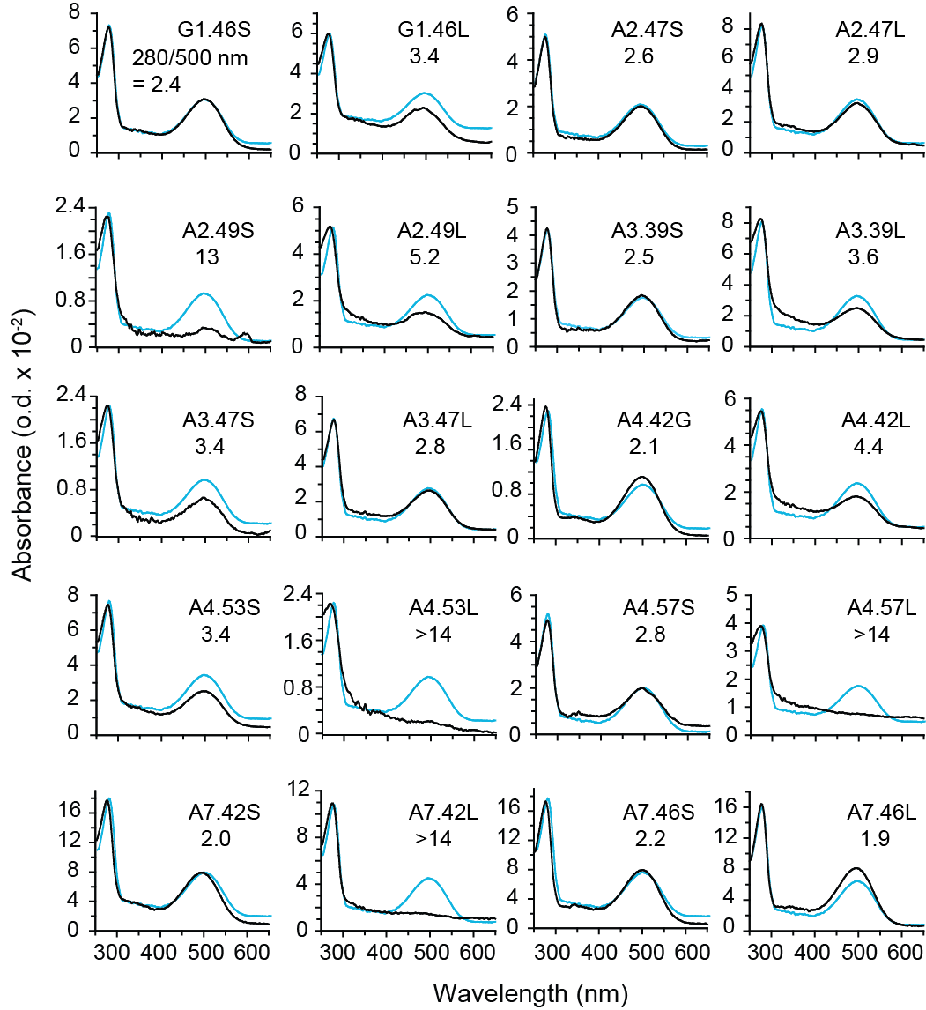

FIGURE 2. Mutational analysis of group-conserved sites in family A GPCRs. UV-Vis absorption spectra are presented of wild-type bovine rhodopsin (blue trace) and specific mutations at group-conserved sites within the TM helices (black trace). For each site, a mutation was made from the residue found in wild-type rhodopsin to another small, group-conserved residue (e.g. alanine to serine) or to leucine. The spectrum of wild-type rhodopsin (blue line) is overlaid in each case for comparison. The protein-bound retinal chromophore is responsible for the 500 nm absorption band. The 280 nm / 500 nm ratio is given in each panel and reflects the ability of the recombinantly expressed apo-protein rod opsin to bind 11-cis retinal. The y-axis scales correspond to the mutant absorption spectra. Using the same expression conditions, the scale for wild-type rhodopsin is the same as that shown for the G1.46S mutant. The wild-type absorption spectra in each of the other mutants are normalized to have the same 280 nm absorption intensity in order to more easily compare the relative absorbance at 500 nm. Spectra were recorded from a single set of transfection experiments. Similar results were obtained using an independent set of experiments with HEK293S cells used for expression.

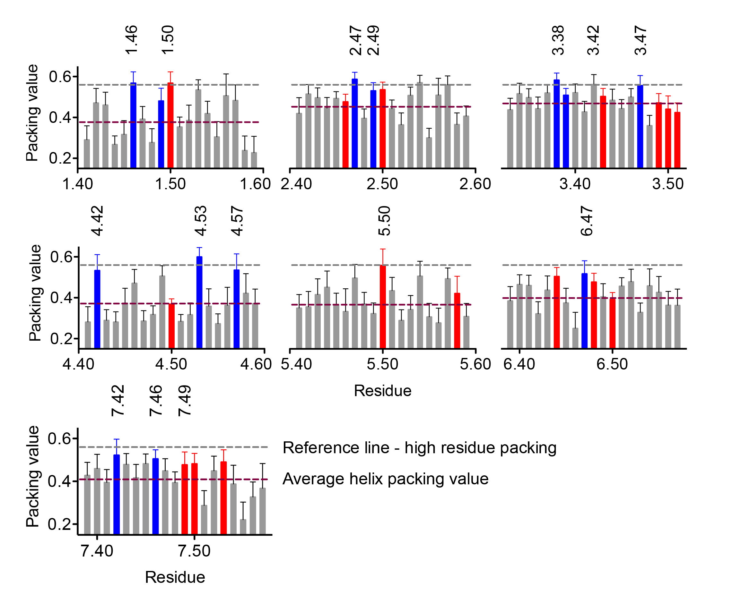

FIGURE 3. Packing analysis of family A GPCRs. The average packing values (+ s.d.) are shown for residues in the TM helices of 28 unique family A GPCRs (see Methods). The signature-conserved (red) and group-conserved (blue) sites within the TM helices are colored. Those signature- and group-conserved residues within the TM core shown in Fig. 1 are labeled with their Ballesteros-Weinstein designation above the histograms in black text. Other group-conserved residues with high packing values outside of the core are in labeled in grey. The average packing value for each helix is shown with a purple horizontal dashed line. A gray horizontal dashed line is also shown at the level of the 0.56 packing value as a point of reference.

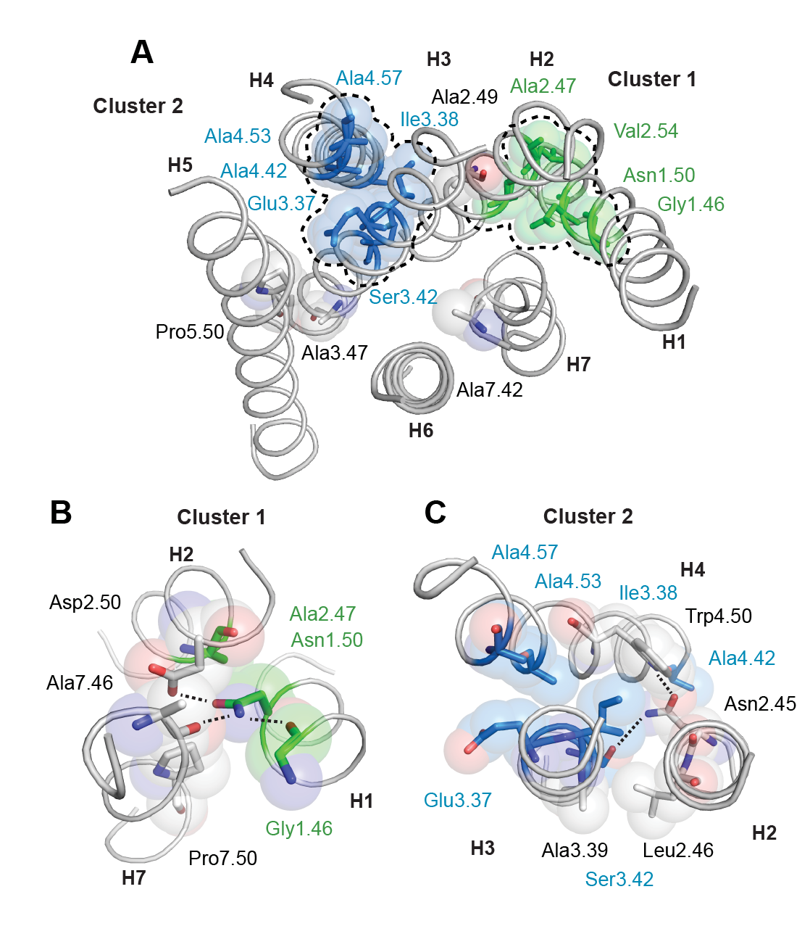

FIGURE 4. Tightly packed amino acids in family A GPCRs define two packing clusters. (A) View from the extracellular surface of bovine rhodopsin (1GZM) showing the residues with the highest packing values across the family A GPCRs. Two clusters of residues are highlighted (dashed lines). Packing cluster 2 (blue spheres) mediates interactions between H3 and H4. Packing cluster 1 (green spheres) mediates interactions between TM helices H1 and H2. (Note the amino acids shown in this figure at positions 2.54, 3.37, 3.38, 3.42, and 4.53 are those for bovine rhodopsin and differ from the residue type with the highest sequence identity at these positions in the family A GPCRs, i.e. Leu2.54, Tyr3.37, Ala3.38, and Ser4.53.) (B and C) Expanded views of clusters 1 and 2 showing packing and hydrogen bonding interactions (dashed lines). Although the structure shown is of bovine rhodopsin, both the packing and hydrogen bonding are conserved in the family A recpetors. Ala3.39, Leu2.46 and Pro7.50 (grey spheres) are not part of the packing clusters, but highly conserved in the family A receptors. Position 3.39 is conserved as a serine.

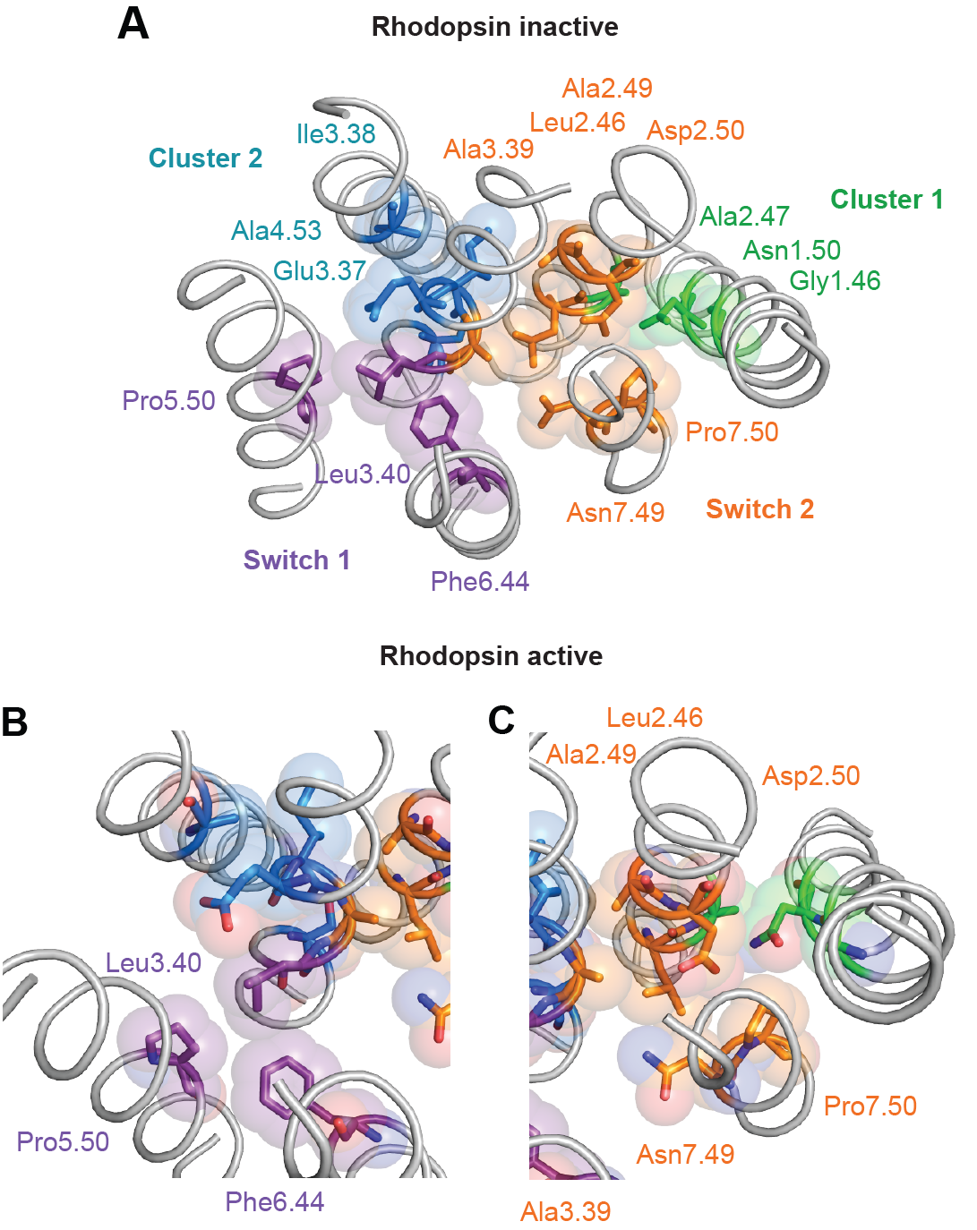

FIGURE 5. Decomposing the TM core into packing clusters and activation switches. (A) Structure of the TM core of rhodopsin (5) showing the residues involved in packing cluster 2 (blue), packing cluster 1 (green), activation switch 1 (purple) and activation switch 2 (orange). (B and C) Structure of the TM core of active Metarhodopsin II (51) showing the change in the relative positions of Leu3.40 and Phe6.44 in switch 1 and Leu2.46 and Ala3.39 in switch 2. The rhodopsin amino acid identities are shown in this figure.

