Brain indices of disagreement with one’s social values predict EU referendum voting behavior

Giulia Galli, Miroslav Sirota, Maurizio Materassi, Francesca Zaninotto, Phil Terry

SUPPLEMENTARY INFORMATION
Supplementary Text
Supplementary Tables 1 and 2
Supplementary Figures 1, 2 and 3

SUPPLEMENTARY TEXT
Voting behavior
All participants who reported an intention to vote Remain at the time of the experiment voted consistently with their intention except for one participant who did not vote. Among the participants who declared an intention to vote Leave, three changed their minds and then voted to remain in Europe, and one did not vote. 22 out of the 25 participants who were undecided at the time of testing reported having voted Remain and three reported having voted Leave.
ERP differences at anterior scalp locations in the N400 latency region in decided voters
At anterior scalp locations, the main effect of Statement Type was significant in participants who intended to vote Remain (F_{1,17} = 11.24, P = 0.004, η² = 0.398) and Leave (F_{1,17} = 6.87, P = 0.018, η² = 0.288), indicating positive-going waveforms for vote-inconsistent statements. In participants with the intention to vote Remain, the significant interaction between Statement Type and Electrode (F_{2,34} = 4.43, P = 0.032, ε = 0.745, η² = 0.207) further revealed that this effect was prominent at the two more anterior electrode positions (main effect of Statement Type at AF electrodes F_{1,17} = 10.86, P = 0.004, η² = 0.390; at F electrodes F_{1,17} = 17.76, P = 0.001, η² =0.511; at FC electrodes P = 0.343; Supplementary Fig. 3).
N400 effects as a function of response type
We further examined N400 effects as a function of response type. Participants disagreed with only a few statements consistent with their EU views (e.g., Remain voters disagreed with very few pro-EU statements), and agreed with only a few statements inconsistent with their EU views (e.g., Remain voters agreed with very few pro-Brexit statements), therefore the number of trials for those conditions did not allow the computation of mean amplitudes. We analysed the N400 in response to vote-consistent statements that participants agreed with, and vote-inconsistent statements that participants disagreed with. The analysis comprised the between-subjects factor Vote Intention (Remain vs Leave) and the within-subject factors Response Type (Vote-consistent/Agreed vs Vote-inconsistent/Disagreed), Anterior-Posterior (Anterior vs Posterior), ROI (five levels: Left, central left, central, central right, Right) and Electrode (three levels, each of the three electrodes comprising the ROI). This analysis was restricted to 17 participants with intention to vote Remain and 16 participants with intention to vote Leave due to insufficient trial numbers in one or more relevant condition. The results largely mirrored the results of the previously reported ANOVA. The interactions between Response Type and Anterior-Posterior (F_{1,31} = 27.63, P < 0.001, η² =0.471), and Response Type, Anterior-Posterior and Electrode (F_{2,62} = 11.34, P < 0.001, ε = 0.817, η² =0.268) were significant. At posterior scalp locations, we found a main effect of Response Type (F_{1,32} = 23.00, P < 0.001, η² =0.429), and an interaction between Response Type and Electrode (F_{2,64} = 7.44, P = 0.001, ε = 0.959, η² =0.189), indicating that vote-inconsistent statements that subjects disagreed with elicited more negative potentials than vote-consistent statements that subjects agreed with, in particular in the two most posterior electrode positions (main effect of Response Type at PO electrodes F_{1,32} = 25.18, P < 0.001, η² =0.440; at P electrodes F_{1,32} = 12.19, P = 0.001, η² =0.276; at CP electrodes p = 0.360). The fact that there was no interaction involving Vote Intention and Response Type (all Ps > 0.302) suggests that this N400 effect was very similar in the two groups. .
ERP differences in the 500-800 and 800-1200 ms time intervals in decided voters
ERP differences as a function of the type of statement emerged in post-N400 latency intervals. As evident in Supplementary Fig. 3, in both groups the sustained positivity for vote-inconsistent statements with onset in the N400 interval persisted until approximately 800 ms. Over a subset of posterior scalp sites, negativities for vote-inconsistent statements persisted until the end of the recording epoch. These differences were quantified by measuring mean amplitudes in the 500-800 and 800-1200 ms latency regions, and were tested using similar ANOVA of the N400. In the 500-800 ms time interval we found significant interactions between Vote Intention, Statement Type and Anterior-Posterior (F_{1,34} = 7.43, P = 0.010, η² = 0.179), between Vote Intention, Statement Type, Anterior-Posterior and Electrode (F_{2,68} = 4.13, P = 0.029, ε = 0.644, η² = 0.108), and between Vote Intention, Statement Type, ROI and Electrode (F_{8,272} = 2.75, P = 0.015, ε = 0.713, η² = 0.075). In the follow-up ANOVAs, a main effect of Statement Type emerged on anterior electrodes of participants with intention to vote Leave (F_{1,17} = 4.47, P = 0.050, η² = 0.208), indicating larger positivities for Remain compared to Leave sentences. No other main effect of Statement Type or interaction involving Electrode and ROI emerged in the follow-up ANOVAs (Ps > 0.096). In the 800-1200 latency window, no interaction involving Vote Intention, Statement type and any of the distributional factors emerged in the main ANOVA (Ps > 0.076).

Supplementary Table 1

 |  | STATEMENT TYPE
VOTE INTENTION |  | Remain | Leave
Remain (n = 18)
Response rate (%) |  | 66.8 (15.9) | 13.7 (15.7)
Reaction times (ms) |  | 1657 (560) | 1921 (924)
Leave (n = 18)
Response rate (%) |  | 28.9 (15.5) | 61.4 (15.9)
Reaction times (ms) |  | 1986 (487) | 1783 (469)

Supplementary Table 1: Agreement rates and reaction times on the behavioral task in participants with a definite vote intention at the time of testing. Standard deviations are displayed in parentheses.

Supplementary Table 2

 |  | STATEMENT TYPE
VOTE BEHAVIOR |  | Remain | Leave
Remain (n =22)
Response rate (%) |  | 52.5 (18.0) | 27.0 (15.2)
Reaction times (ms) |  | 1867 (523) | 1914 (540)
Leave (n = 3)
Response rate (%) |  | 41.1 (20.2) | 56.3 (24.0)
Reaction times (ms) |  | 1553 (85) | 1514 (84)

Supplementary Table 2: Agreement rates and reaction times on the behavioral task in undecided voters at the time of testing. Standard deviations are displayed in parentheses.

Supplementary Figure 1

Supplementary Figure 1: Electrode layout depicting the ten ROIs used for the statistical analyses

Supplementary Figure 2

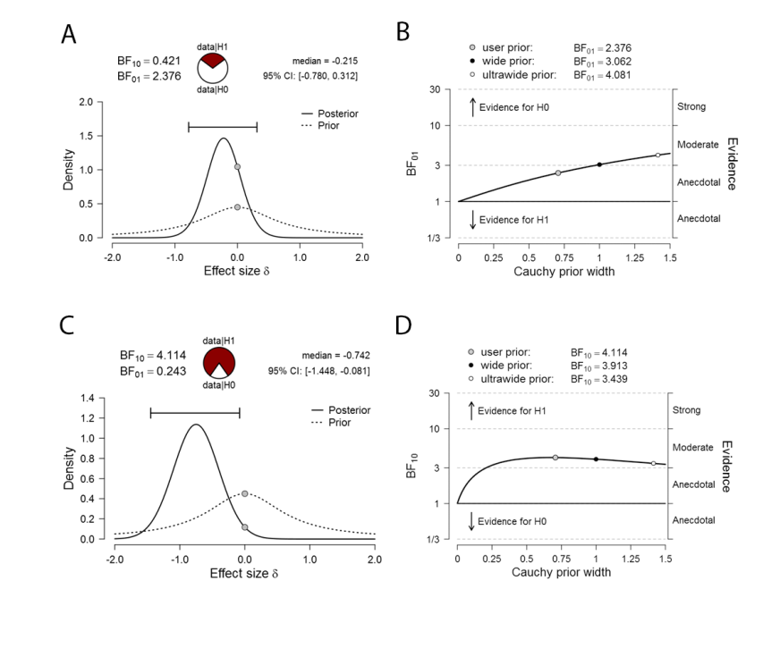
Supplementary Figure 2: Bayes factor analysis. (A) Bayes factor analysis (default t-test) comparing N400 effects between decided and undecided Remain voters. (B) Bayes Factor robustness check of the analysis reported in (A). (C) Bayes factor analysis (default t-test) comparing N400 effects between undecided Remain voters and decided Leave voters. (D) Bayes Factor robustness check of the analysis reported in (C). Note: BF₁₀/BF₀₁: Bayes factor of H₁ against H₀/ The Bayes Factor of H₀ against H₁; Prior – prior distribution, Posterior – posterior distribution; median - median point estimate of posterior distribution and the associated 95% credible interval; Cauchy prior width: prior distributions over the true effect size (δ) using different width: User prior (the default r-scale factor 0.707), wide prior (r-scale factor 1) and ultrawide prior (r-scale factor 1.414)

Supplementary Figure 3

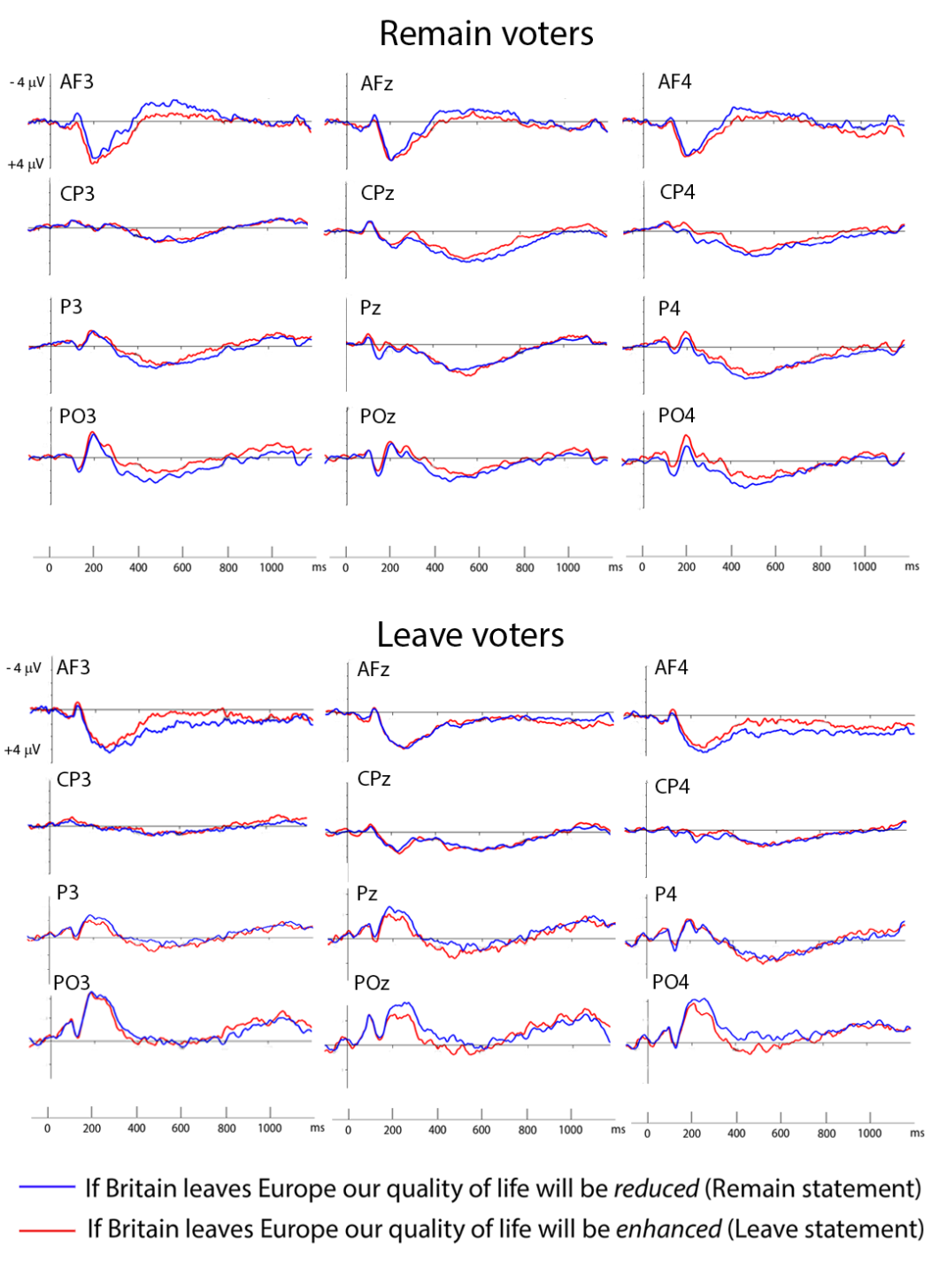

Supplementary Figure 3: ERP waveforms across a selection of 12 electrodes that entered the analysis. The figure highlights an effect of reversed polarity at anterior electrodes in the N400 latency region.

