**Appendix**

**Figure A1**

**Figure A2**

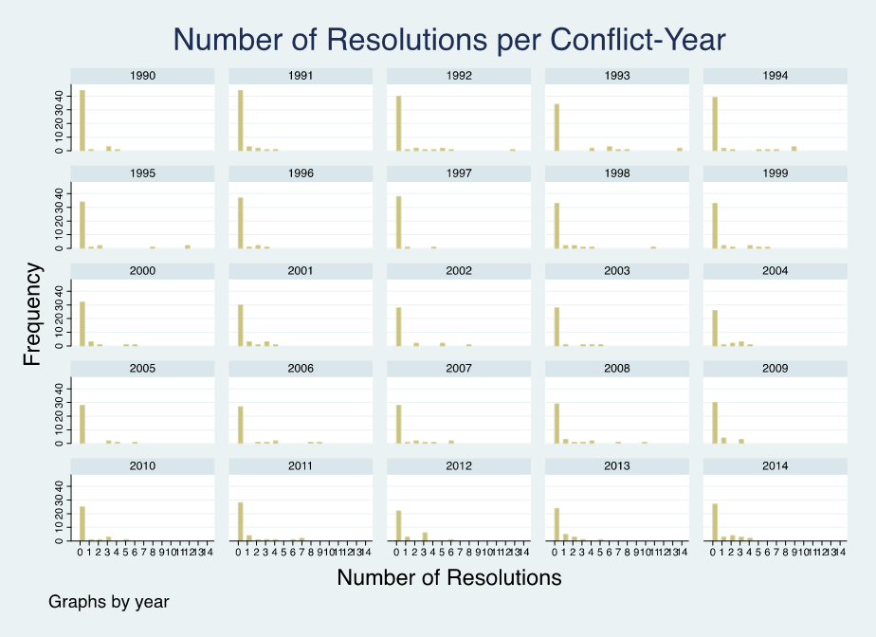

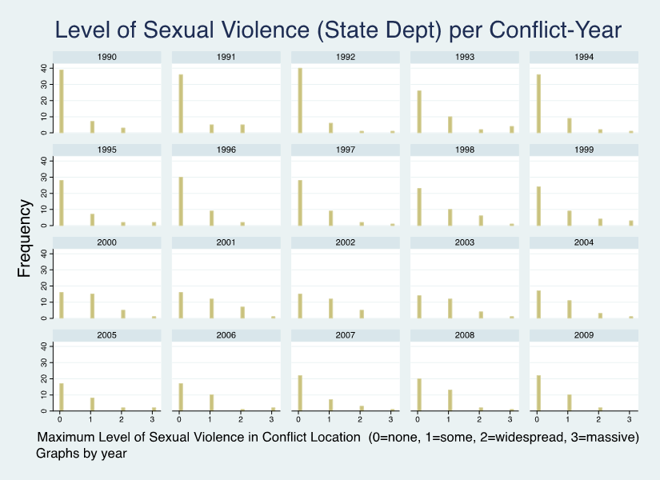**Figure A3**

**Figure A4**



**Figure A5**



**Table A1**

|  |  |  |  |  |
| --- | --- | --- | --- | --- |
| **Negative Binomial Logit: Count of High-Level UNSC Resolutions**  **in a Conflict-Year, 1990-2009** | | | | |
|  | **Model 1** | **Model 2** | **Model 3** | **Model 4** |
| **Sexual Violence**  **State Dept** |  | 0.399** |  |  |
|  | (0.133) |  |  |
|  |  |  |  |  |
| **Sexual Violence**  **HRW** |  |  | 0.568*** |  |
|  |  | (0.137) |  |
|  |  |  |  |  |
| **Sexual Violence**  **Amnesty Int** |  |  |  | 0.582*** |
|  |  |  | (0.116) |
|  |  |  |  |  |
| **UN Personnel t-1** | 1.151*** | 1.012*** | 0.689** | 1.002*** |
| (0.221) | (0.294) | (0.265) | (0.296) |
|  |  |  |  |  |
| **Cumulative Intensity** | 0.542** | 0.653* | 0.393 | 0.562* |
| (0.201) | (0.282) | (0.272) | (0.276) |
|  |  |  |  |  |
| **Conflict Duration t-1** | -0.0437*** | -0.0627*** | -0.0613*** | -0.0650*** |
| (0.00678) | (0.00994) | (0.00909) | (0.0101) |
|  |  |  |  |  |
| **Resolution 1325** | 0.619*** | 0.582* | 0.595* | 0.546* |
| (0.183) | (0.249) | (0.235) | (0.253) |
|  |  |  |  |  |
| **P5 Colony** | -0.648** | -0.680** | -0.619* | -0.672** |
| (0.204) | (0.254) | (0.247) | (0.244) |
|  |  |  |  |  |
| **rGDPpc** | -0.424 | -0.335 | -0.376 | -0.290 |
| (0.293) | (0.295) | (0.328) | (0.248) |
|  |  |  |  |  |
| **Population** | 0.0328 | 0.0220 | 0.0282 | 0.0162 |
| (0.0308) | (0.0331) | (0.0365) | (0.0264) |
|  |  |  |  |  |
| **Resolution t-1** | 1.888*** | 1.708*** | 1.631*** | 1.739*** |
| (0.246) | (0.297) | (0.267) | (0.296) |
|  |  |  |  |  |
| **Constant** | -2.412*** | -2.256*** | -1.841*** | -2.193*** |
| (0.268) | (0.317) | (0.309) | (0.298) |
| ***N*** | 1621 | 1040 | 893 | 1032 |
| **Pseudo. *R*2** | 0.306 | 0.310 | 0.326 | 0.322 |
| **Chi Square** | 322.64*** | 314.36*** | 224.91*** | 266.52*** |
| **ll** | -408.56 | -276.47 | -257.25 | -271.38 |
| **AIC** | 837.1 | 574.9 | 536.5 | 564.8 |
| **BIC** | 891.0 | 629.4 | 589.2 | 619.1 |

Alphas significant at p<0.001, Standard errors in parentheses, +*p* < 0.10, \**p* < 0.05, ** *p* < 0.01, *** *p* < 0.001

**Table A2**

|  |  |  |  |  |
| --- | --- | --- | --- | --- |
| **Ordered Logit: Highest Level of UNSC Resolutions**  **in a Conflict-Year, 1990-2009** | | | | |
|  | **Model 1** | **Model 2** | **Model 3** | **Model 4** |
| **Sexual Violence**  **State Dept** |  | 0.501*** |  |  |
|  | (0.130) |  |  |
|  |  |  |  |  |
| **Sexual Violence**  **HRW** |  |  | 0.619** |  |
|  |  | (0.189) |  |
|  |  |  |  |  |
| **Sexual Violence**  **Amnesty Int** |  |  |  | 0.657*** |
|  |  |  | (0.136) |
|  |  |  |  |  |
| **UN Personnel t-1** | 1.162*** | 1.298*** | 1.240*** | 1.358*** |
| (0.185) | (0.284) | (0.282) | (0.277) |
|  |  |  |  |  |
| **Cumulative Intensity** | 0.558** | 0.557* | 0.358 | 0.478 |
| (0.205) | (0.278) | (0.294) | (0.288) |
|  |  |  |  |  |
| **Conflict Duration t-1** | -0.0233*** | -0.0233* | -0.0225* | -0.0232* |
| (0.00684) | (0.0115) | (0.0114) | (0.0112) |
|  |  |  |  |  |
| **Resolution 1325** | 0.735*** | 0.348 | 0.351 | 0.380 |
| (0.201) | (0.258) | (0.271) | (0.256) |
|  |  |  |  |  |
| **P5 Colony** | -0.600** | -0.571* | -0.482 | -0.523* |
| (0.191) | (0.246) | (0.259) | (0.248) |
|  |  |  |  |  |
| **rGDPpc** | -0.445*** | -0.316 | -0.315 | -0.271 |
| (0.107) | (0.175) | (0.164) | (0.145) |
|  |  |  |  |  |
| **Population** | 0.0125 | -0.123 | -0.135 | -0.120 |
| (0.0250) | (0.107) | (0.108) | (0.104) |
|  |  |  |  |  |
| **Resolution t-1** | 3.695*** | 3.160*** | 2.935*** | 3.264*** |
| (0.280) | (0.375) | (0.389) | (0.374) |
|  |  |  |  |  |
| **Constant** | 4.848*** | 4.490*** | 4.043*** | 4.554*** |
| (0.327) | (0.383) | (0.395) | (0.391) |
| ***N*** | 1621 | 1040 | 893 | 1032 |
| **Pseudo. *R*2** | 0.403 | 0.390 | 0.391 | 0.392 |
| **Chi Square** | 460.24*** | 268.78*** | 226.90*** | 289.36*** |
| **ll** | -646.86 | -426.91 | -387.44 | -424.61 |
| **AIC** | 1321.7 | 883.8 | 804.9 | 879.2 |
| **BIC** | 1397.2 | 958.0 | 876.8 | 953.3 |

Standard errors in parentheses, +*p* < 0.10, \**p* < 0.05, ** *p* < 0.01, *** *p* < 0.001