Supplementary Materials
Supplementary Table S1
Breakdown of Audience Groups
Audience Group | Criteria | Total n
Regular Theatre Goers (1) | Participants who attend the theatre 3+ or 7+ times per year | 91
Theatre Novices (2) | Participants who “never” go to the theatre, or do so <3 times per year if the corresponding reason was interest-, geographic- or childcare-related | 17
Underserved Audiences (3) | Participants who “never” go to the theatre, or do so <3 times per year if the corresponding reason was related to physical and/or mental health restrictions, including caring responsibilities or economic factors. | 58
Note. Audiences retrospectively assigned to 1 of 3 groups according to the response to the question "Which option best describes your experience with theatre?"

Supplementary Table S2
Breakdown of Mobile Phone Device Tiers
Device Tier | Total N | Devices
1 (Best) | 52 | iPhone X,XR,XS,10,11,11-Pro,12; Huawei P30; Google Pixel 4; Samsung Galaxy S10, Note 10 Lite
2 (Good) | 54 | iPhone SE (2020), 8, 8-Plus; Samsung Galaxy S20, S9, S8; Xiaomi Mi Mix 3; Redmi 7A; Huawei P20, P20-Pro; Google Pixel 3A
3 (Okay) | 32 | iPhone 7, 7-Plus, 6, 6-S; Samsung Galaxy S7, A8, A71, A50; OnePLUS 6
4 (Cannot Guarantee) | 11 | Samsung Galaxy J3, M31; iPhone SE (2016); Asus Enfone; LG V20; Cubot King Kong 3; Motorola G8 Power Lite, Moto G5; Nokia 7
5 (Unknown) | 17 | No device specified by participant
Note. Tier 1 corresponds to ideal compatibility, e.g., the mobile device most likely to deliver the “best” experience. Allocation of mobile devices to their corresponding tier was guided by the author LKP.

Supplementary Table S3
Survey Items
Question/Statement | Response mode | Response label(s)
Performance information/memory prompts
- What was the most recent performance you watched using the LIVR app and headset? | Drop-down menu | -
- How did this most recent performance make you feel at the time of watching it? | “ | Multiple selections
- Briefly describe how you felt at the time of watching the performance | Free text response | -
- Briefly describe how you feel now about this most recently watched performance | “ | -
Emotional arousal
- While watching the performance, what was the intensity of this feeling? | Linear scale | 0 (No emotion) to 100% (Intense emotion)
Enjoyment, immersion and presence
- I enjoyed watching a theatre performance in virtual reality | 5-point Likert | Strongly agree, Somewhat agree, Neither agree nor disagree, Somewhat disagree, Strongly disagree
- During the performance, I was aware of distractions happening in the real world around me | “ | “  [re-coded for analysis]
- During the performance, it felt like I really was at a real-life theatre watching the performance | “ | “
- How soon into the performance did you find yourself feeling as though you “really were” at the theatre? | 5 alternative forced choice | Never, Later: 20+ minutes into the performance, Soon: within 10 mins of the beginning, Early: within 5 minutes of the beginning, The feeling came and went
Technology experience
- I enjoyed using a headset to watch theatre | 5-point Likert | Strongly agree, Somewhat agree, Neither agree nor disagree, Somewhat disagree, Strongly disagree
- I found the headset easy to use | “ | “
- I found the LIVR app easy to use | “ | “
- The set up was straightforward | “ | “
Wellbeing and social
- I was able to maintain engagement and focus while watching the performance | 5-point Likert | Strongly agree, Somewhat agree, Neither agree nor disagree, Somewhat disagree, Strongly disagree
- The experience helped me to feel less isolated | “ | “
- The experience was a positive distraction from other things | “ | “
- I would have enjoyed the experience more if I could have watched it with another person | “ | “
- I found myself talking about the performance/themes in the performance in conversations | “ | “
Traditional vs immersive-360 theatre
- How did the experience of watching a performance in a virtual environment compare with watching one in a real-life theatre? | 6 alternative forced choice | Exactly the same, Rather similar, Somewhat similar, Rather different, Extremely different, Not sure
- Experiencing immersive theatre has made me more likely to attend a real-life theatre in the future (disregarding COVID-19) | 5-point Likert | Strongly agree, Somewhat agree, Neither agree nor disagree, Somewhat disagree, Strongly disagree
- I am concerned that watching theatre in virtual reality could become a replacement for real-life theatre and auditoriums | “ | “
- I think that watching theatre in virtual reality is a good substitute for real-life theatre e.g., for those who are unable to access physical auditorium spaces | “ | “
Use during COVID-19
- Using virtual reality is a practical way for theatres to reach audiences at home while theatres are closed | 5-point Likert | Strongly agree, Somewhat agree, Neither agree nor disagree, Somewhat disagree, Strongly disagree
- If my local theatre hosted virtual events and performances online, I would be very interested | “ | “
Imporvements
- Could anything about the experience have been improved? | Free text response | -
Note. Survey items (all)

Supplementary Table S4
Semi-Structured Interview Questions
Opening questions: refresh memory and reflect
1. | Casting your mind back to when you last used the headset to watch a performance, what did you choose to watch and can you tell me a little bit about the performance itself?
2. | How would you describe the thoughts and feelings you experienced as you watched the performance?
VR technology
3. | Considering the VR technology you used to watch the performance – the headset and the app- how did you feel about the logistics of using these methods to experience theatre?
4. | Do you feel that your experience of the content of the performance was changed by the use of the technology, and if so, in what way?
Arousal
5. | When you think back to watching the performance, what thoughts and feelings are more prominent?
6. | Assuming that the performance did not evoke feelings of sadness, do you think that the experience of immersive theatre helped your overall sense of wellbeing?
Psychosocial
7. | Was there anything that you learnt from the performance? Has it made you think differently about anything?
8. | Did you feel connected to themes and/or performers while watching the performance?
9. | Do you think that your experience of immersive theatre would have been different had you have experienced it with someone else at the same time, and if so, why?
VR and traditional theatre
10. | Would having access to VR theatre change anything for you?
11. | Do you think that immersive theatre will have an impact on traditional theatre in any way?
12. | How did the experience of watching a performance in a virtual environment compare with watching one in a real-life theatre?
13. | Has the experience changed the way that you think about going to a real-life traditional theatre to see a performance?
Accessibility
14. | Do you think that immersive theatre is an effective way to reach audiences at home, especially for audiences who cannot get to traditional theatre spaces? For example, if they are physically or economically unable
15. | Do you think that immersive theatre is an effective way to reach audiences at home during COVID-19?
Note. Semi-structured interview items. Note that this was used as a guide and did not necessarily follow this format/structure.

Supplementary Figure S1
Suggestions for Improvement from 73% of Participants
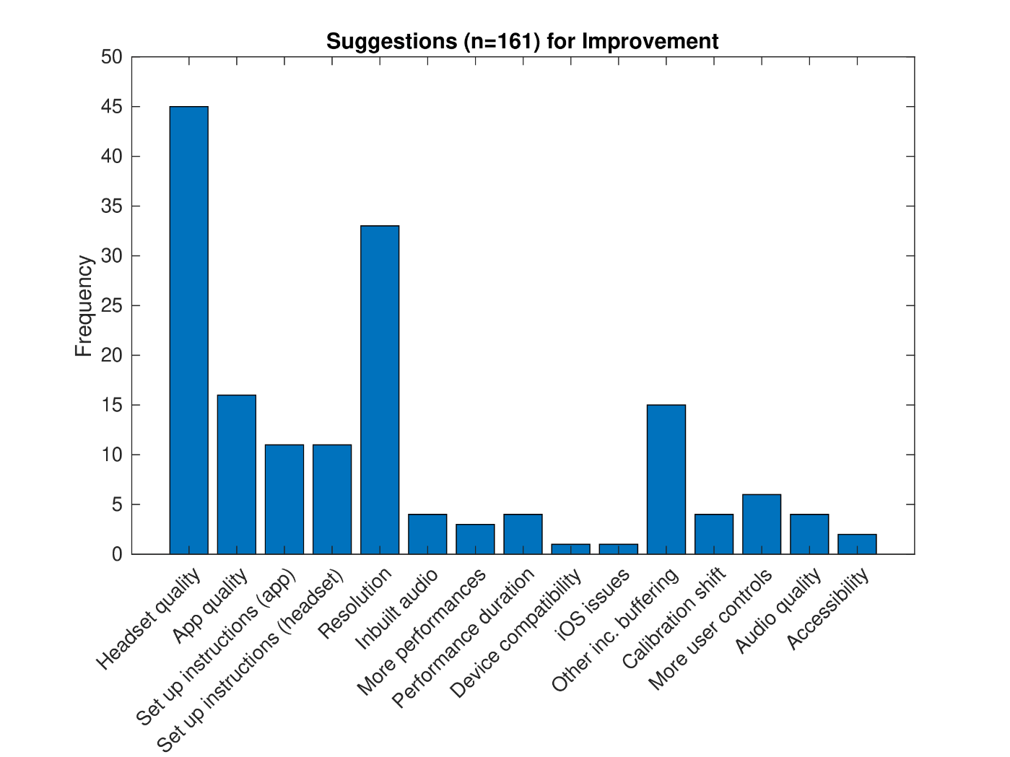
Note. All responses were coded retrospectively, resulting in 16 categories for suggestions for improving the experience, provided by 73% of all participants.

