**Supplementary material**

Appendix 1: Imputation of hourly wages

Hourly wages that are computed by dividing weekly or monthly wages by number of hours worked are known to suffer from division bias. This results in a distribution that is too smooth (i.e. the peak around the minimum wage is too small) and a too high proportion of implausibly low values. To mitigate against division bias, we use the imputation method suggested by Skinner et al. (2003). We have used both nearest neighbor and predictive mean matching. The results are very similar. In the following, we show results using nearest neighbor matching.

Figure A1 shows the distribution of hourly wages for the year 2016/17 using our imputed measure, the directly observed hourly wage measure in the data and the measured obtained by dividing monthly wages by hours of work (implicit measure). The imputed measure has some desirable properties compared to the implicit measure: sparseness to the left of the minimum and a significantly higher peak just to the right of the minimum. The directly observed measure has a very high peak around the minimum as most individuals paid by the hour are likely to have lower wages. Similar patterns are observed for the other years (Figure A2).

Figure A1: Hourly pay distribution according to three measures: direct (data only), implicit and direct + imputed values, 2016/2017

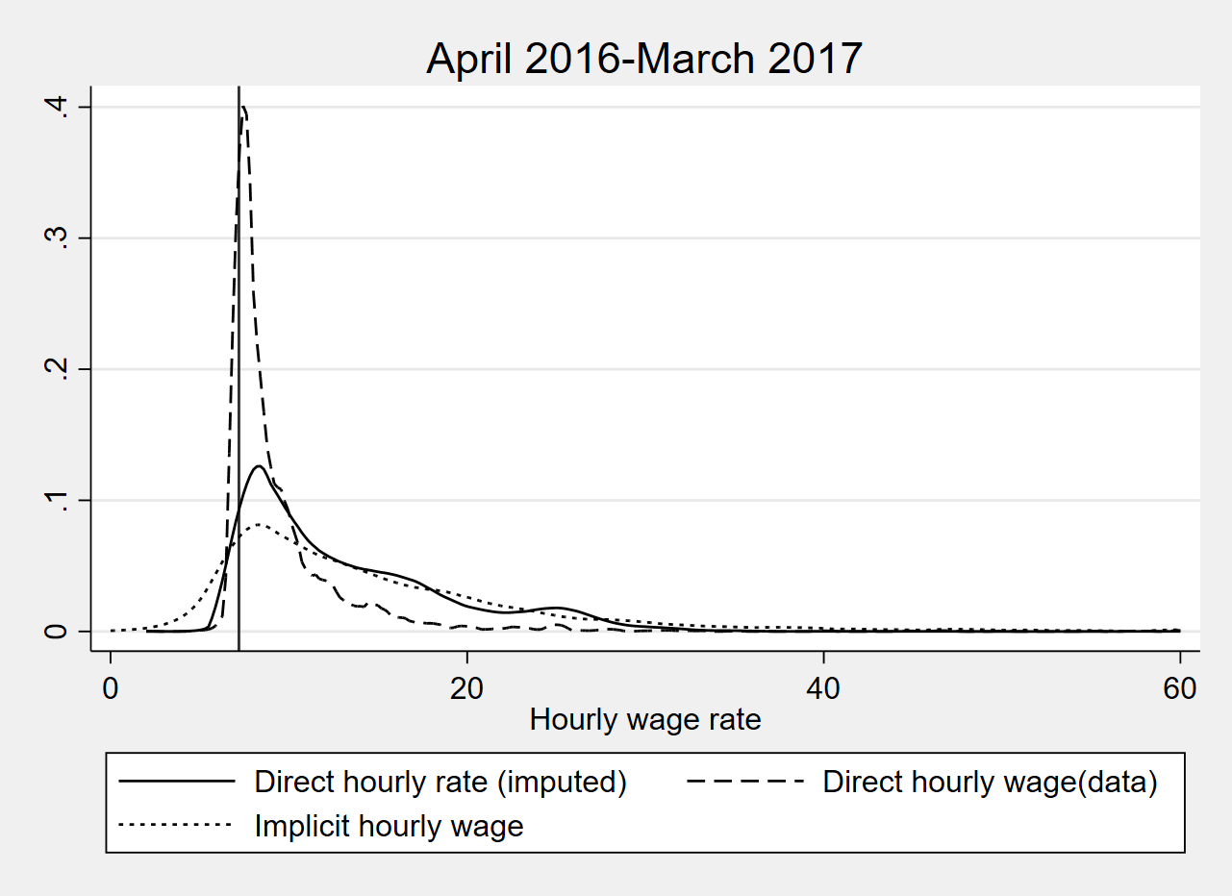

Notes: The direct measure is the hourly pay as reported by respondents in the data; the implicit measure is derived by dividing usual pau by usual working hours; the NLW is shown as a vertical black line.

Source: Authors’ calculations based on UKHLS, waves 1-10.

Figure A2: Hourly pay distributions according to three measures: ‘direct’, ‘implicit’, and ‘direct’ + imputed values between 2009 and 2018

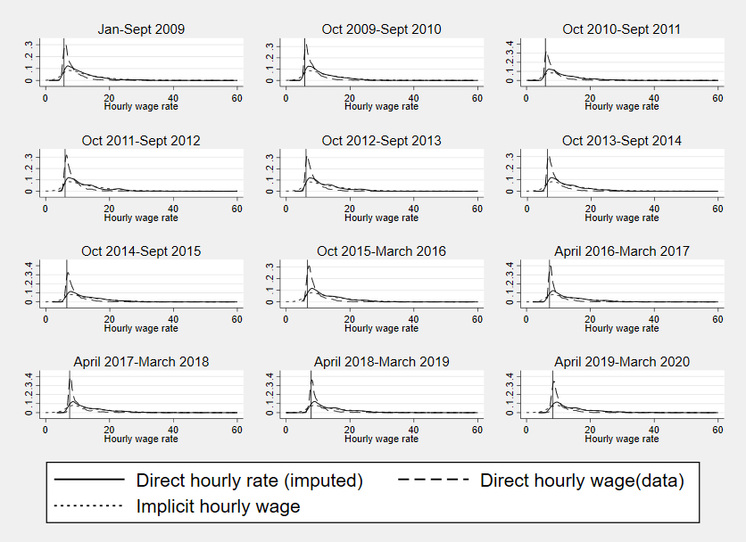

Note: Each graph corresponds to a period when the nominal minimum wage has been constant; the value of the minimum wage in force is shown as the vertical black line

Source: Authors calculations based on UKHLS, Waves 1-10

We next compare our imputed measure with estimates based on the Annual Survey of Hours and Earnings (ASHE). ASHE is a much larger survey containing information on approximately 1% of the labour force. It also has relatively accurate information on hourly wages reported by employers.

Figure A3 shows the proportion of workers on minimum hourly pay (calculated as pay below the minimum wage +5p), using the imputed hourly measure in UKHLS and hourly wages observed in ASHE. The proportion of minimum wage workers is almost identical between 2012 and 2016 but diverges slightly at the start and end of the period. The share of minimum wage workers is around 1 percentage lower in ASHE compared to UKHLS. Trends are however very similar with the share of minimum wage workers increasing until 2017/18 and falling subsequently.

Figure A3: Proportion of workers paid at or below the minimum hourly wage by year, UKHLS and ASHE

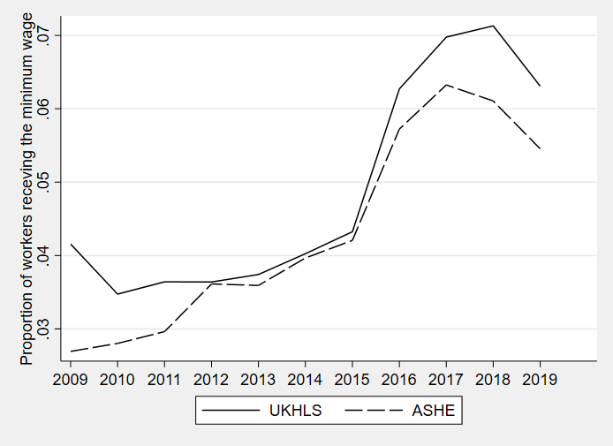

Note: The share of minimum wage workers is calculated as the proportion of workers aged 25-64 paid at or below the minimum (defined as the value of the minimum wage +5p). In ASHE, it includes only main jobs and periods unaffected by absence.

Source: UKHLS and ASHE

Figure A4: Distribution of hourly wages in UKHLS and ASHE, 2016

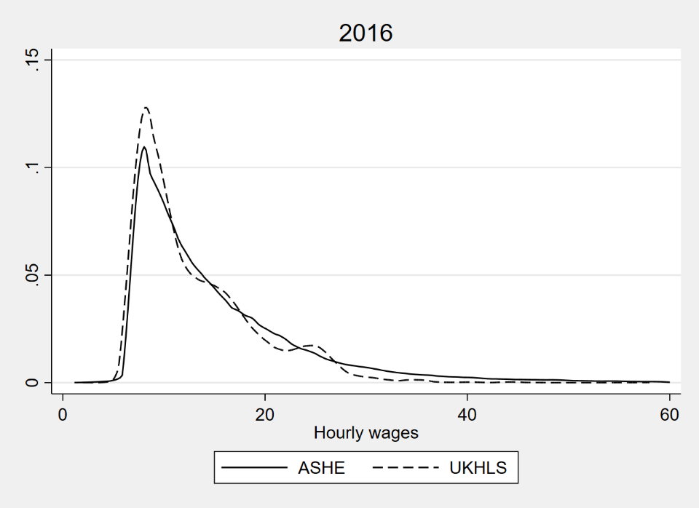

Source: UKHLS and ASHE

Figure A4 provides further information. It shows the distribution of hourly wages in UKHLS and ASHE in 2016. UKHLS data is collected throughout the year (i.e. it includes periods before and after the minimum wage increase in April 2016), whereas ASHE refers to April 2016. It is clear that the proportion of individuals paid at or just above the minimum is higher in UKHLS compared to ASHE. In contrast, there are fewer individuals with comparatively high wages. The pattern is repeated in other years, as shown in Figure A5.

Figure A5: Distribution of hourly wages in UKHLS and ASHE, 2009-2019

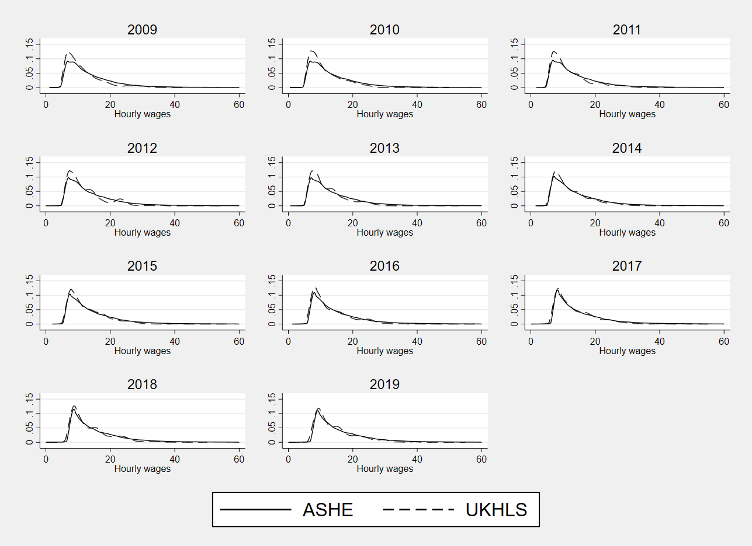

Source: UKHLS and ASHE

Finally, we examine outflows from minimum wage jobs in ASHE and UKHLS. Because in our ASHE dataset personal indicators were changed in 2011, we are unable to compute transition rates for 2011 and 2012. Transition rates for the remaining years are shown in Table A1.

Progression rates from minimum wage jobs to employment above the minimum but below the low pay threshold are around 10 points higher in UKHLS compared to ASHE. Trends however are very similar. Progression rates fell substantially in 2016 in both datasets, albeit the fall is twice as high in UKHLS compared to ASHE (approximately 16 vs 8 percentage points). Higher progression rates to low paid employment in UKHLS are mirrored in lower rates of remaining on minimum wage pay. Progression rates from minimum wage pay to ‘higher pay’, i.e. employment paid above the low pay threshold, are remarkably similar in the two datasets.

The existing patterns suggest that UKHLS might overestimate progression out of minimum wage and into employment paid above the minimum but below the low pay threshold and underestimate the share of minimum wage workers that do not progress. However, the main trends are very similar in the two data sources. Progression rates fell sharply in 2016 and remained lower subsequently.

Table A1: Transition rates out minimum wage pay by year, UKHLS and ASHE

| Year | Progression to low pay | | Progression to higher pay | | Remain on minimum wage | |
| --- | --- | --- | --- | --- | --- | --- |
|  | UKHLS | ASHE | UKHLS | ASHE | UKHLS | ASHE |
| 2010 | 44.19% | 33.43% | 11.71% | 12.89% | 44.10% | 53.69% |
| 2011 | 40.39% | - | 10.72% | - | 48.89% | - |
| 2012 | 43.57% | - | 9.54% | - | 46.89% | - |
| 2013 | 41.07% | 29.60% | 12.87% | 9.77% | 46.06% | 60.63% |
| 2014 | 43.32% | 29.88% | 14.65% | 12.04% | 42.03% | 58.08% |
| 2015 | 44.65% | 28.47% | 11.86% | 13.40% | 43.49% | 58.13% |
| 2016 | 28.99% | 20.40% | 14.54% | 14.66% | 56.47% | 64.94%% |
| 2017 | 33.40% | 22.84% | 18.32% | 17.77% | 48.28% | 59.40% |
| 2018 | 31.21% | 21.09% | 13.85% | 18.77% | 54.94% | 60.14% |
| 2019 | 32.21% | 19.80% | 19.67% | 22.52% | 48.06% | 57.68% |
| N | 2834 | 26576 |  |  |  |  |

Note: We do not observe transitions into non-employment in ASHE; to ensure comparability, cases observed to be in non-employment in UKHLS are set to missing.

Source: UKHLS and ASHE

Appendix 2: Additional Results

Table A2: Estimated coefficients of a discrete time model of transitions out of a minimum wage job using the lagged area share of minimum wage workers (Model1)

|  |  |  |  |  |  |
| --- | --- | --- | --- | --- | --- |
|  | Coefficient | SE | p-values | 95% CI | |
|  |  |  |  |  |  |
| **Progression to PAY ABOVE THE MINIMUM** |  |  |  |  |  |
| Time in min wage job | -0.203 | 0.078 | 0.009 | -0.355 | -0.050 |
| Time in min wage squared | 0.008 | 0.005 | 0.140 | -0.003 | 0.018 |
| Female | -0.115 | 0.099 | 0.245 | -0.310 | 0.079 |
| Age | -0.070 | 0.040 | 0.077 | -0.149 | 0.008 |
| Age square | 0.001 | 0.000 | 0.110 | 0.000 | 0.002 |
| Education |  |  |  |  |  |
| Other higher degree | -0.003 | 0.194 | 0.986 | -0.384 | 0.377 |
| A-level | -0.274 | 0.170 | 0.106 | -0.607 | 0.058 |
| GCSE | -0.376 | 0.171 | 0.028 | -0.711 | -0.041 |
| Other qualification | -0.348 | 0.206 | 0.092 | -0.752 | 0.057 |
| No qualification | -0.654 | 0.195 | 0.001 | -1.036 | -0.272 |
| Has child under 5 | -0.083 | 0.126 | 0.512 | -0.330 | 0.165 |
| Number of children |  |  |  |  |  |
| 1 | 0.161 | 0.122 | 0.188 | -0.078 | 0.400 |
| 2 | 0.100 | 0.119 | 0.400 | -0.133 | 0.333 |
| 3 | 0.364 | 0.152 | 0.016 | 0.067 | 0.661 |
| Self-reported health status | -0.139 | 0.091 | 0.128 | -0.318 | 0.040 |
| Ethnic Minority (0/1) | -0.115 | 0.170 | 0.499 | -0.448 | 0.218 |
| Immigrant (0/1) | 0.024 | 0.170 | 0.887 | -0.310 | 0.358 |
| Has previous unemployment spell (0/1) | -0.397 | 0.082 | 0.000 | -0.557 | -0.236 |
| Firm size (logged) | 0.048 | 0.018 | 0.007 | 0.013 | 0.083 |
| Public sector | 0.509 | 0.159 | 0.001 | 0.198 | 0.820 |
| Temporary contract | 0.285 | 0.175 | 0.103 | -0.058 | 0.628 |
| Part-time work | -0.422 | 0.094 | 0.000 | -0.606 | -0.238 |
| Industry |  |  |  |  |  |
| Manufacturing-food, beverages, textile | -0.334 | 2.022 | 0.869 | -4.296 | 3.629 |
| Manufacturing-basic industrial | 0.162 | 2.046 | 0.937 | -3.847 | 4.171 |
| Manufacturing-complex industrial | -0.323 | 2.007 | 0.872 | -4.256 | 3.610 |
| Construction and gas, electricity and water services | 0.394 | 2.115 | 0.852 | -3.752 | 4.540 |
| Wholesale and retail trade | -0.110 | 2.018 | 0.957 | -4.066 | 3.846 |
| Transportation and storage | -0.088 | 2.067 | 0.966 | -4.140 | 3.964 |
| Accommodation and food services | -0.281 | 2.013 | 0.889 | -4.226 | 3.664 |
| Information and communication | 0.827 | 5.594 | 0.882 | -10.136 | 11.791 |
| Finance and insurance and real-estate | 0.847 | 2.111 | 0.688 | -3.291 | 4.985 |
| Professional, scientific and technical services | 0.246 | 2.089 | 0.906 | -3.848 | 4.340 |
| Administrative and support services | -0.054 | 2.027 | 0.979 | -4.027 | 3.919 |
| Public administration, education, health and social work | -0.086 | 2.000 | 0.966 | -4.006 | 3.835 |
| Arts and other | -0.190 | 2.020 | 0.925 | -4.149 | 3.769 |
| Region |  |  |  |  |  |
| North West | 0.095 | 0.183 | 0.604 | -0.264 | 0.454 |
| Yorkshire and the Humber | 0.326 | 0.189 | 0.086 | -0.046 | 0.697 |
| East Midlands | 0.124 | 0.194 | 0.521 | -0.256 | 0.505 |
| West Midlands | -0.016 | 0.185 | 0.933 | -0.379 | 0.348 |
| East of England | 0.264 | 0.236 | 0.263 | -0.198 | 0.726 |
| London | 0.186 | 0.301 | 0.537 | -0.405 | 0.776 |
| South East | 0.334 | 0.231 | 0.147 | -0.118 | 0.786 |
| South West | 0.128 | 0.211 | 0.543 | -0.285 | 0.541 |
| Wales | 0.075 | 0.197 | 0.705 | -0.312 | 0.462 |
| Scotland | -0.101 | 0.221 | 0.647 | -0.533 | 0.331 |
| Year |  |  |  |  |  |
| 2011 | -0.335 | 0.570 | 0.557 | -1.452 | 0.782 |
| 2012 | -0.766 | 0.557 | 0.169 | -1.859 | 0.326 |
| 2013 | -0.310 | 0.599 | 0.605 | -1.485 | 0.865 |
| 2014 | -0.580 | 0.620 | 0.349 | -1.796 | 0.635 |
| 2015 | -0.105 | 0.629 | 0.868 | -1.338 | 1.129 |
| 2016 | -0.089 | 0.645 | 0.890 | -1.354 | 1.175 |
| 2017 | -0.692 | 0.476 | 0.147 | -1.626 | 0.242 |
| 2018 | -0.096 | 0.603 | 0.873 | -1.278 | 1.085 |
| 2019 | 0.099 | 0.670 | 0.882 | -1.214 | 1.412 |
| # months in-between interviews | 0.050 | 0.027 | 0.057 | -0.002 | 0.103 |
| Lagged share of min wage workers | -0.041 | 0.147 | 0.781 | -0.329 | 0.247 |
| Lagged share of min wage workers# Year |  |  |  |  |  |
| 2011 | 0.018 | 0.170 | 0.917 | -0.315 | 0.351 |
| 2012 | 0.133 | 0.153 | 0.385 | -0.168 | 0.434 |
| 2013 | -0.026 | 0.176 | 0.882 | -0.372 | 0.319 |
| 2014 | 0.092 | 0.174 | 0.599 | -0.250 | 0.434 |
| 2015 | -0.032 | 0.178 | 0.859 | -0.380 | 0.317 |
| 2016 | -0.109 | 0.173 | 0.527 | -0.447 | 0.229 |
| 2017 | 0.019 | 0.140 | 0.893 | -0.256 | 0.294 |
| 2018 | -0.048 | 0.160 | 0.766 | -0.361 | 0.265 |
| 2019 | -0.059 | 0.162 | 0.715 | -0.376 | 0.258 |
| Median TTWA wage level | 0.001 | 0.001 | 0.225 | 0.000 | 0.002 |
| Constant | 1.843 | 2.349 | 0.433 | -2.760 | 6.447 |
| **Transitions to NONEMPLOYMENT** |  |  |  |  |  |
| Time in min wage job | -0.254 | 0.117 | 0.030 | -0.483 | -0.024 |
| Time in min wage job squared | 0.009 | 0.008 | 0.262 | -0.007 | 0.025 |
| Female | -0.337 | 0.199 | 0.091 | -0.728 | 0.053 |
| Age | -0.061 | 0.071 | 0.391 | -0.199 | 0.078 |
| Age square | 0.001 | 0.001 | 0.507 | -0.001 | 0.002 |
| Education |  |  |  |  |  |
| Other higher degree | -0.042 | 0.365 | 0.909 | -0.757 | 0.673 |
| A-level etc | -0.302 | 0.337 | 0.370 | -0.963 | 0.358 |
| GCSE etc | -0.495 | 0.280 | 0.077 | -1.045 | 0.054 |
| Other qualification | -0.175 | 0.339 | 0.607 | -0.840 | 0.490 |
| No qualification | -0.478 | 0.354 | 0.176 | -1.171 | 0.215 |
| Has child under 5 | -0.024 | 0.214 | 0.912 | -0.444 | 0.396 |
| Number of children |  |  |  |  |  |
| 1 | 0.391 | 0.223 | 0.081 | -0.047 | 0.829 |
| 2 | 0.258 | 0.212 | 0.223 | -0.157 | 0.672 |
| 3 | 0.601 | 0.317 | 0.057 | -0.019 | 1.222 |
| Self-reported health status | 0.247 | 0.168 | 0.143 | -0.083 | 0.576 |
| Ethnic Minority (0/1) | 0.211 | 0.254 | 0.406 | -0.287 | 0.708 |
| Immigrant (0/1) | 0.283 | 0.260 | 0.276 | -0.226 | 0.793 |
| Has previous unemployment spell (0/1) | 1.708 | 0.187 | 0.000 | 1.341 | 2.074 |
| Firm size (logged) | -0.083 | 0.051 | 0.102 | -0.183 | 0.017 |
| Public sector | 0.295 | 0.294 | 0.315 | -0.281 | 0.872 |
| Temporary contract | 0.913 | 0.201 | 0.000 | 0.518 | 1.308 |
| Part-time work | -0.217 | 0.161 | 0.178 | -0.533 | 0.099 |
| Industry |  |  |  |  |  |
| Manufacturing-food, beverages, textile | 12.879 | 3.099 | 0.000 | 6.804 | 18.953 |
| Manufacturing-basic industrial | 12.999 | 3.108 | 0.000 | 6.907 | 19.091 |
| Manufacturing-complex industrial | 12.446 | 4.766 | 0.009 | 3.105 | 21.788 |
| Construction and gas, electricity and water services | 11.970 | 6.809 | 0.079 | -1.376 | 25.316 |
| Wholesale and retail trade | 13.105 | 3.054 | 0.000 | 7.119 | 19.091 |
| Transportation and storage | 13.748 | 3.060 | 0.000 | 7.750 | 19.746 |
| Accommodation and food services | 12.853 | 3.024 | 0.000 | 6.926 | 18.781 |
| Information and communication | 13.927 | 7.945 | 0.080 | -1.645 | 29.498 |
| Finance and insurance and real-estate | 12.258 | 6.857 | 0.074 | -1.181 | 25.697 |
| Professional, scientific and technical services | 12.059 | 6.937 | 0.082 | -1.537 | 25.654 |
| Administrative and support services | 13.123 | 3.044 | 0.000 | 7.156 | 19.089 |
| Public administration, education, health and social work | 12.787 | 3.078 | 0.000 | 6.755 | 18.819 |
| Arts and other | 13.117 | 3.138 | 0.000 | 6.966 | 19.267 |
| Region |  |  |  |  |  |
| North West | 0.274 | 0.370 | 0.458 | -0.450 | 0.999 |
| Yorkshire and the Humber | 0.298 | 0.405 | 0.461 | -0.495 | 1.092 |
| East Midlands | -0.248 | 0.398 | 0.534 | -1.029 | 0.533 |
| West Midlands | 0.274 | 0.400 | 0.494 | -0.510 | 1.058 |
| East of England | 0.072 | 0.514 | 0.889 | -0.935 | 1.079 |
| London | 0.198 | 0.554 | 0.721 | -0.888 | 1.284 |
| South East | 0.063 | 0.515 | 0.903 | -0.947 | 1.073 |
| South West | -0.194 | 0.444 | 0.662 | -1.064 | 0.676 |
| Wales | -0.182 | 0.437 | 0.678 | -1.039 | 0.675 |
| Scotland | 0.329 | 0.401 | 0.412 | -0.457 | 1.114 |
| Year |  |  |  |  |  |
| 2011 | 1.114 | 1.033 | 0.281 | -0.910 | 3.138 |
| 2012 | 0.130 | 1.103 | 0.906 | -2.032 | 2.291 |
| 2013 | -0.480 | 1.018 | 0.637 | -2.474 | 1.515 |
| 2014 | -0.955 | 1.125 | 0.396 | -3.160 | 1.250 |
| 2015 | -0.061 | 1.156 | 0.958 | -2.327 | 2.204 |
| 2016 | -0.323 | 1.174 | 0.783 | -2.624 | 1.978 |
| 2017 | -0.868 | 1.048 | 0.408 | -2.922 | 1.186 |
| 2018 | -0.067 | 0.980 | 0.945 | -1.989 | 1.854 |
| 2019 | -0.488 | 1.311 | 0.710 | -3.058 | 2.081 |
| # of months in-between interviews | -0.004 | 0.054 | 0.934 | -0.110 | 0.101 |
| Lagged share of min wage workers | 0.123 | 0.267 | 0.644 | -0.401 | 0.648 |
| Lagged share of min wage workers# Year |  |  |  |  |  |
| 2011 | -0.303 | 0.306 | 0.322 | -0.902 | 0.296 |
| 2012 | -0.129 | 0.331 | 0.697 | -0.778 | 0.520 |
| 2013 | 0.001 | 0.275 | 0.998 | -0.539 | 0.540 |
| 2014 | -0.014 | 0.312 | 0.965 | -0.625 | 0.597 |
| 2015 | -0.205 | 0.316 | 0.516 | -0.825 | 0.414 |
| 2016 | -0.238 | 0.314 | 0.447 | -0.853 | 0.376 |
| 2017 | -0.127 | 0.275 | 0.643 | -0.667 | 0.412 |
| 2018 | -0.158 | 0.267 | 0.555 | -0.681 | 0.366 |
| 2019 | -0.066 | 0.306 | 0.830 | -0.665 | 0.534 |
| Median TTWA wage level | 0.000 | 0.001 | 0.815 | -0.002 | 0.002 |
| Constant | -13.090 | 3.940 | 0.001 | -20.811 | -5.369 |
| N=4270 |  |  |  |  |  |

Note: Coefficients from an independent competing risks discrete time model, with the lagged share of minimum wage workers by area; Minimum wage jobs are defined as having an hourly pay less than the adult rate minimum wage level plus 5p; low paid employment is defined as job with an hourly pay above the minimum but less than 2/3 of the median hourly pay (as calculated by the Office for National Statistics); higher pay employment consists of jobs paying above the low pay threshold.

Source: Authors’ calculations based on UKHLS, Waves 1-10 and ASHE 2009-2019

Table A3: Estimated coefficients of a discrete time model of transitions out of minimum wage using the area share of minimum wage workers in 2009 interacted with the lag of the bite of the minimum wage at the national level and controlling for area wage levels (model 2)

|  |  |  |  |  |  |
| --- | --- | --- | --- | --- | --- |
| **Progression to PAY ABOVE THE MINIMUM** | Coefficient | SE | p-value | 95% CI | |
| Time in min wage job | -0.203 | 0.078 | 0.009 | -0.356 | -0.050 |
| Time in min job square | 0.008 | 0.005 | 0.139 | -0.003 | 0.018 |
| Female | -0.120 | 0.099 | 0.225 | -0.314 | 0.074 |
| Age | -0.067 | 0.040 | 0.089 | -0.145 | 0.010 |
| Age square | 0.001 | 0.000 | 0.127 | 0.000 | 0.002 |
| Education |  |  |  |  |  |
| Other higher degree | 0.002 | 0.192 | 0.992 | -0.373 | 0.377 |
| A-level | -0.277 | 0.168 | 0.098 | -0.606 | 0.052 |
| GCSE | -0.379 | 0.170 | 0.026 | -0.712 | -0.046 |
| Other qualification | -0.351 | 0.205 | 0.087 | -0.754 | 0.051 |
| No qualification | -0.654 | 0.194 | 0.001 | -1.034 | -0.274 |
| Has child under 5 | -0.075 | 0.125 | 0.546 | -0.319 | 0.169 |
| Number of children |  |  |  |  |  |
| 1 | 0.155 | 0.122 | 0.202 | -0.083 | 0.393 |
| 2 | 0.092 | 0.118 | 0.438 | -0.140 | 0.324 |
| 3 | 0.349 | 0.154 | 0.024 | 0.046 | 0.651 |
| Self-reported health status | -0.133 | 0.092 | 0.148 | -0.312 | 0.047 |
| Ethnic Minority (0/1) | -0.120 | 0.171 | 0.481 | -0.455 | 0.214 |
| Immigrant (0/1) | 0.027 | 0.172 | 0.873 | -0.310 | 0.364 |
| Has previous unemployment spell (0/1) | -0.395 | 0.083 | 0.000 | -0.557 | -0.232 |
| Firm size (logged) | 0.048 | 0.018 | 0.006 | 0.014 | 0.083 |
| Public sector | 0.511 | 0.157 | 0.001 | 0.203 | 0.820 |
| Temporary contract | 0.282 | 0.173 | 0.104 | -0.058 | 0.622 |
| Part-time work | -0.419 | 0.093 | 0.000 | -0.600 | -0.237 |
| Industry |  |  |  |  |  |
| Manufacturing-food, beverages, textile | -0.329 | 2.029 | 0.871 | -4.305 | 3.647 |
| Manufacturing-basic industrial | 0.161 | 2.052 | 0.938 | -3.861 | 4.183 |
| Manufacturing-complex industrial | -0.328 | 2.014 | 0.871 | -4.275 | 3.619 |
| Construction and gas, electricity and water services | 0.410 | 2.118 | 0.847 | -3.742 | 4.561 |
| Wholesale and retail trade | -0.116 | 2.022 | 0.954 | -4.080 | 3.848 |
| Transportation and storage | -0.093 | 2.069 | 0.964 | -4.148 | 3.962 |
| Accommodation and food services | -0.277 | 2.018 | 0.891 | -4.232 | 3.677 |
| Information and communication | 0.871 | 5.663 | 0.878 | -10.227 | 11.970 |
| Finance and insurance and real-estate | 0.830 | 2.113 | 0.694 | -3.311 | 4.971 |
| Professional, scientific and technical services | 0.247 | 2.090 | 0.906 | -3.850 | 4.344 |
| Administrative and support services | -0.049 | 2.033 | 0.981 | -4.033 | 3.935 |
| Public administration, education, health and social work | -0.088 | 2.004 | 0.965 | -4.015 | 3.839 |
| Arts and other | -0.190 | 2.025 | 0.925 | -4.159 | 3.778 |
| Region |  |  |  |  |  |
| North West | 0.064 | 0.178 | 0.718 | -0.284 | 0.412 |
| Yorkshire and the Humber | 0.300 | 0.188 | 0.111 | -0.069 | 0.669 |
| East Midlands | 0.080 | 0.186 | 0.668 | -0.285 | 0.445 |
| West Midlands | -0.020 | 0.182 | 0.911 | -0.376 | 0.335 |
| East of England | 0.247 | 0.232 | 0.286 | -0.207 | 0.702 |
| London | 0.171 | 0.299 | 0.566 | -0.414 | 0.757 |
| South East | 0.323 | 0.226 | 0.154 | -0.121 | 0.766 |
| South West | 0.150 | 0.204 | 0.463 | -0.250 | 0.550 |
| Wales | 0.098 | 0.194 | 0.612 | -0.281 | 0.477 |
| Scotland | -0.083 | 0.216 | 0.700 | -0.507 | 0.340 |
| Year |  |  |  |  |  |
| 2011 | -0.286 | 0.226 | 0.205 | -0.729 | 0.156 |
| 2012 | -0.344 | 0.277 | 0.215 | -0.887 | 0.199 |
| 2013 | -0.492 | 0.261 | 0.060 | -1.005 | 0.020 |
| 2014 | -0.282 | 0.266 | 0.288 | -0.803 | 0.238 |
| 2015 | -0.350 | 0.297 | 0.238 | -0.932 | 0.231 |
| 2016 | -0.750 | 0.311 | 0.016 | -1.359 | -0.141 |
| 2017 | -0.839 | 0.415 | 0.043 | -1.653 | -0.025 |
| 2018 | -0.755 | 0.453 | 0.095 | -1.642 | 0.132 |
| 2019 | -0.641 | 0.516 | 0.214 | -1.653 | 0.370 |
| Median TTWA wage level | 0.001 | 0.001 | 0.216 | 0.000 | 0.002 |
| # months in-between interviews | 0.051 | 0.027 | 0.060 | -0.002 | 0.104 |
| Share of minimum wage workers in 2009 | 0.508 | 0.592 | 0.391 | -0.653 | 1.668 |
| Lagged bite of the minimum wage at the national level | 0.054 | 0.062 | 0.390 | -0.069 | 0.176 |
| Share of min wage workers# Lagged national bite | -0.010 | 0.011 | 0.335 | -0.031 | 0.011 |
| Constant | -1.088 | 4.213 | 0.796 | -9.344 | 7.169 |
|  |  |  |  |  |  |
| **Transitions to NONEMPLOYMENT** |  |  |  |  |  |
| Time in min wage job | -0.245 | 0.117 | 0.037 | -0.475 | -0.015 |
| Time in min wage job squared | 0.009 | 0.008 | 0.287 | -0.007 | 0.025 |
| Female | -0.356 | 0.201 | 0.077 | -0.750 | 0.038 |
| Age | -0.056 | 0.067 | 0.407 | -0.188 | 0.076 |
| Age square | 0.000 | 0.001 | 0.529 | -0.001 | 0.002 |
| Education |  |  |  |  |  |
| Other higher degree | -0.015 | 0.361 | 0.966 | -0.723 | 0.692 |
| A-level | -0.313 | 0.340 | 0.357 | -0.979 | 0.353 |
| GCSE | -0.504 | 0.284 | 0.076 | -1.061 | 0.053 |
| Other qualification | -0.181 | 0.336 | 0.590 | -0.839 | 0.477 |
| No qualification | -0.468 | 0.354 | 0.186 | -1.163 | 0.226 |
| Has child under 5 | 0.001 | 0.217 | 0.997 | -0.425 | 0.426 |
| Number of children |  |  |  |  |  |
| 1 | 0.375 | 0.222 | 0.091 | -0.060 | 0.810 |
| 2 | 0.233 | 0.208 | 0.262 | -0.175 | 0.641 |
| 3 | 0.583 | 0.319 | 0.068 | -0.043 | 1.208 |
| Self-reported health status | 0.281 | 0.165 | 0.089 | -0.043 | 0.605 |
| Ethnic Minority (0/1) | 0.203 | 0.252 | 0.421 | -0.291 | 0.697 |
| Immigrant (0/1) | 0.294 | 0.265 | 0.267 | -0.225 | 0.813 |
| Has previous unemployment spell (0/1) | 1.703 | 0.187 | 0.000 | 1.337 | 2.069 |
| Firm size (logged) | -0.086 | 0.051 | 0.092 | -0.185 | 0.014 |
| Public sector | 0.329 | 0.286 | 0.250 | -0.232 | 0.890 |
| Temporary contract | 0.897 | 0.202 | 0.000 | 0.500 | 1.293 |
| Part-time work | -0.228 | 0.159 | 0.152 | -0.540 | 0.084 |
| Industry |  |  |  |  |  |
| Manufacturing-food, beverages, textile | 13.285 | 3.070 | 0.000 | 7.267 | 19.303 |
| Manufacturing-basic industrial | 13.419 | 3.073 | 0.000 | 7.396 | 19.442 |
| Manufacturing-complex industrial | 12.840 | 4.737 | 0.007 | 3.556 | 22.125 |
| Construction and gas, electricity and water services | 12.388 | 6.780 | 0.068 | -0.901 | 25.676 |
| Wholesale and retail trade | 13.502 | 3.040 | 0.000 | 7.544 | 19.460 |
| Transportation and storage | 14.142 | 3.067 | 0.000 | 8.130 | 20.153 |
| Accommodation and food services | 13.280 | 3.017 | 0.000 | 7.366 | 19.194 |
| Information and communication | 14.202 | 8.087 | 0.079 | -1.647 | 30.052 |
| Finance and insurance and real-estate | 12.506 | 6.867 | 0.069 | -0.953 | 25.966 |
| Professional, scientific and technical services | 12.473 | 6.985 | 0.074 | -1.218 | 26.164 |
| Administrative and support services | 13.519 | 3.040 | 0.000 | 7.561 | 19.478 |
| Public administration, education, health and social work | 13.174 | 3.067 | 0.000 | 7.164 | 19.185 |
| Arts and other | 13.529 | 3.109 | 0.000 | 7.437 | 19.622 |
| Region |  |  |  |  |  |
| North West | 0.212 | 0.374 | 0.570 | -0.520 | 0.944 |
| Yorkshire and the Humber | 0.267 | 0.408 | 0.513 | -0.532 | 1.067 |
| East Midlands | -0.287 | 0.399 | 0.472 | -1.069 | 0.496 |
| West Midlands | 0.297 | 0.402 | 0.459 | -0.490 | 1.084 |
| East of England | 0.035 | 0.514 | 0.946 | -0.972 | 1.043 |
| London | 0.231 | 0.566 | 0.683 | -0.877 | 1.340 |
| South East | -0.023 | 0.508 | 0.964 | -1.019 | 0.972 |
| South West | -0.234 | 0.449 | 0.602 | -1.114 | 0.646 |
| Wales | -0.143 | 0.430 | 0.740 | -0.985 | 0.699 |
| Scotland | 0.296 | 0.398 | 0.458 | -0.485 | 1.076 |
| Year |  |  |  |  |  |
| 2011 | 0.079 | 0.392 | 0.840 | -0.689 | 0.846 |
| 2012 | -0.632 | 0.442 | 0.153 | -1.498 | 0.235 |
| 2013 | -0.840 | 0.454 | 0.064 | -1.731 | 0.050 |
| 2014 | -1.324 | 0.473 | 0.005 | -2.251 | -0.396 |
| 2015 | -1.433 | 0.505 | 0.005 | -2.423 | -0.444 |
| 2016 | -2.029 | 0.537 | 0.000 | -3.082 | -0.976 |
| 2017 | -2.692 | 0.773 | 0.000 | -4.208 | -1.177 |
| 2018 | -2.340 | 0.903 | 0.010 | -4.111 | -0.570 |
| 2019 | -2.283 | 0.996 | 0.022 | -4.235 | -0.332 |
| Median TTWA wage level | 0.000 | 0.001 | 0.810 | -0.002 | 0.002 |
| # months in-between interviews | 0.006 | 0.053 | 0.907 | -0.099 | 0.111 |
| Share of minimum wage workers in 2009 | 0.161 | 0.967 | 0.867 | -1.734 | 2.056 |
| Lagged bite of the minimum wage at the national level | 0.228 | 0.115 | 0.047 | 0.003 | 0.453 |
| Share of min wage workers# Lagged national bite | -0.005 | 0.017 | 0.786 | -0.039 | 0.029 |
| Constant | -24.329 | 6.853 | 0.000 | -37.761 | -10.897 |
| N=4270 |  |  |  |  |  |

Note: Coefficients from an independent competing risks discrete time model, with the area share of minimum wage workers in 2009 interacted with the national bite; Minimum wage jobs are defined as having an hourly pay less than the adult rate minimum wage level plus 5p; low paid employment is defined as job with an hourly pay above the minimum but less than 2/3 of the median hourly pay (as calculated by the Office for National Statistics); higher pay employment consists of jobs paying above the low pay threshold.

Source: Authors’ calculations based on UKHLS, Waves 1-10 and ASHE 2009-2019

Table A4: Average marginal effects from four specifications: standard (M1), using longitudinal weights (M2) dropping observations with an observed changed in hours in the same employment relationship larger than 10% (M3), and adding employment rates at the TTWA-year level (M4)

|  |  |  |  |  |  |  |  |  |
| --- | --- | --- | --- | --- | --- | --- | --- | --- |
|  |  | M1 | | | | M2 | | |
|  | Minimum wage | | Pay above the minimum | Non-employment | Minimum wage | | Pay above the minimum | Non-employment |
| 2010 | 0.004 | | -0.014 | 0.011 | 0.007 | | -0.023 | 0.016 |
| 2011 | 0.011 | | 0.002 | -0.013 | 0.006 | | 0.019 | -0.025 |
| 2012 | -0.018 | | 0.021 | -0.004 | -0.003 | | 0.014 | -0.011 |
| 2013 | 0.009 | | -0.020 | 0.011 | 0.023 | | -0.033 | 0.010 |
| 2014 | -0.013 | | 0.009 | 0.004 | 0.016 | | -0.030 | 0.014 |
| 2015 | 0.017 | | -0.014 | -0.003 | 0.038 | | -0.032 | -0.005 |
| 2016 | 0.033 | | -0.031 | -0.002 | 0.047 | | -0.040 | -0.007 |
| 2017 | 0.005 | | -0.005 | 0.000 | 0.015 | | -0.005 | -0.011 |
| 2018 | 0.018 | | -0.019 | 0.001 | 0.017 | | -0.016 | -0.001 |
| 2019 | 0.017 | | -0.025 | 0.008 | 0.046 | | -0.036 | -0.010 |
| N | 4270 | | | | 2832 | | | |
|  | M3 | | | | M4 | | | |
|  | Minimum wage | | Pay above the minimum | Non-employment | Minimum wage | | Pay above the minimum | Non-employment |
| 2010 | -0.016 | | 0.004 | 0.012 |  | |  |  |
| 2011 | 0.019 | | -0.008 | -0.011 |  | |  |  |
| 2012 | -0.011 | | 0.018 | -0.008 |  | |  |  |
| 2013 | 0.005 | | -0.019 | 0.014 |  | |  |  |
| 2014 | -0.012 | | 0.010 | 0.002 | -0.014 | | 0.010 | 0.005 |
| 2015 | 0.021 | | -0.027 | 0.006 | 0.016 | | -0.017 | 0.000 |
| 2016 | 0.053 | | -0.049 | -0.005 | 0.029 | | -0.027 | -0.002 |
| 2017 | 0.005 | | -0.005 | 0.000 | 0.005 | | -0.005 | -0.000 |
| 2018 | 0.027 | | -0.028 | 0.001 | 0.017 | | -0.017 | 0.000 |
| 2019 | 0.017 | | -0.028 | 0.011 | 0.017 | | -0.024 | 0.007 |
| N | 3412 | |  |  | 2758 | |  |  |

Note: Employment rates refer to the population aged 16-64 and have been taken from the ONS NOMIS platform(https://www.nomisweb.co.uk/datasets/apsnew); unfortunately, we are only able to match observations starting in 2014.

Source: Authors’ calculations based on UKHLS, Waves 1-10 and ASHE 2009-2019

Table A5: Coefficients from a model of log hourly wage growth using the lagged area share of minimum wage workers and controlling for area wage level (model corresponding to Model 1 Table 1)

|  |  |  |  |  |  |
| --- | --- | --- | --- | --- | --- |
|  | Coefficient | SE | p-values | 95% CI | |
|  |  |  |  |  |  |
| Female | -0.028 | 0.021 | 0.186 | -0.069 | 0.014 |
| Age | -0.001 | 0.005 | 0.861 | -0.010 | 0.008 |
| Age square | 0.000 | 0.000 | 0.843 | 0.000 | 0.000 |
| Education |  |  |  |  |  |
| Other higher degree | -0.053 | 0.042 | 0.208 | -0.136 | 0.030 |
| A-level etc | -0.075 | 0.038 | 0.051 | -0.149 | 0.000 |
| GCSE etc | -0.095 | 0.035 | 0.007 | -0.164 | -0.027 |
| Other qualification | -0.097 | 0.049 | 0.048 | -0.193 | -0.001 |
| No qualification | -0.116 | 0.038 | 0.002 | -0.192 | -0.041 |
| Has child under 5 | -0.012 | 0.015 | 0.442 | -0.041 | 0.018 |
| Number of children |  |  |  |  |  |
| 1 | 0.001 | 0.009 | 0.919 | -0.017 | 0.019 |
| 2 | 0.002 | 0.010 | 0.818 | -0.018 | 0.022 |
| 3 | 0.016 | 0.012 | 0.163 | -0.007 | 0.040 |
| Self-reported health status | -0.010 | 0.014 | 0.468 | -0.038 | 0.018 |
| Ethnic Minority (0/1) | -0.017 | 0.028 | 0.548 | -0.070 | 0.037 |
| Immigrant (0/1) | -0.011 | 0.027 | 0.691 | -0.063 | 0.042 |
| Has previous unemployment spell (0/1) | -0.022 | 0.077 | 0.772 | -0.173 | 0.129 |
| Firm size (logged) | 0.004 | 0.006 | 0.457 | -0.007 | 0.016 |
| Public sector | 0.049 | 0.023 | 0.036 | 0.003 | 0.095 |
| Temporary contract | 0.043 | 0.032 | 0.187 | -0.021 | 0.106 |
| Part-time work | -0.035 | 0.025 | 0.157 | -0.084 | 0.014 |
| Industry |  |  |  |  |  |
| Manufacturing-food, beverages, textile | -0.043 | 0.029 | 0.142 | -0.100 | 0.014 |
| Manufacturing-basic industrial | 0.018 | 0.035 | 0.610 | -0.050 | 0.086 |
| Manufacturing-complex industrial | 0.006 | 0.033 | 0.854 | -0.058 | 0.070 |
| Construction and gas, electricity and water services | 0.050 | 0.048 | 0.297 | -0.044 | 0.144 |
| Wholesale and retail trade | -0.013 | 0.025 | 0.619 | -0.062 | 0.037 |
| Transportation and storage | 0.011 | 0.032 | 0.721 | -0.051 | 0.074 |
| Accommodation and food services | -0.026 | 0.027 | 0.341 | -0.079 | 0.027 |
| Information and communication | 0.187 | 0.108 | 0.083 | -0.025 | 0.398 |
| Finance and insurance and real-estate | 0.098 | 0.054 | 0.068 | -0.007 | 0.204 |
| Professional, scientific and technical services | 0.127 | 0.054 | 0.018 | 0.022 | 0.233 |
| Administrative and support services | 0.000 | 0.025 | 0.996 | -0.049 | 0.049 |
| Public administration, education, health and social work | -0.009 | 0.027 | 0.741 | -0.062 | 0.044 |
| Arts and other | 0.004 | 0.029 | 0.884 | -0.053 | 0.061 |
| Region |  |  |  |  |  |
| North West | 0.030 | 0.046 | 0.520 | -0.061 | 0.120 |
| Yorkshire and the Humber | 0.020 | 0.022 | 0.374 | -0.024 | 0.063 |
| East Midlands | 0.029 | 0.031 | 0.362 | -0.033 | 0.090 |
| West Midlands | 0.004 | 0.026 | 0.865 | -0.046 | 0.055 |
| East of England | 0.017 | 0.026 | 0.512 | -0.034 | 0.068 |
| London | 0.071 | 0.061 | 0.246 | -0.049 | 0.191 |
| South East | 0.056 | 0.032 | 0.077 | -0.006 | 0.119 |
| South West | 0.017 | 0.029 | 0.558 | -0.039 | 0.073 |
| Wales | 0.004 | 0.024 | 0.853 | -0.043 | 0.052 |
| Scotland | 0.004 | 0.026 | 0.875 | -0.048 | 0.056 |
| Year |  |  |  |  |  |
| 2011 | -0.026 | 0.053 | 0.627 | -0.129 | 0.078 |
| 2012 | -0.051 | 0.043 | 0.235 | -0.134 | 0.033 |
| 2013 | -0.079 | 0.052 | 0.134 | -0.181 | 0.024 |
| 2014 | -0.057 | 0.044 | 0.193 | -0.143 | 0.029 |
| 2015 | 0.004 | 0.040 | 0.921 | -0.074 | 0.081 |
| 2016 | 0.007 | 0.048 | 0.876 | -0.086 | 0.101 |
| 2017 | -0.064 | 0.046 | 0.157 | -0.154 | 0.025 |
| 2018 | -0.073 | 0.042 | 0.085 | -0.156 | 0.010 |
| 2019 | 0.022 | 0.057 | 0.701 | -0.090 | 0.134 |
| Inverse Mills Ratio | -0.054 | 0.389 | 0.889 | -0.816 | 0.708 |
| Lagged share of min wage workers | -0.006 | 0.009 | 0.540 | -0.023 | 0.012 |
| Lagged share of min wage workers# Year |  |  |  |  |  |
| 2011 | 0.004 | 0.011 | 0.742 | -0.018 | 0.025 |
| 2012 | 0.007 | 0.010 | 0.523 | -0.014 | 0.027 |
| 2013 | 0.016 | 0.015 | 0.275 | -0.013 | 0.046 |
| 2014 | 0.009 | 0.010 | 0.365 | -0.010 | 0.028 |
| 2015 | -0.004 | 0.010 | 0.728 | -0.023 | 0.016 |
| 2016 | 0.001 | 0.011 | 0.916 | -0.020 | 0.022 |
| 2017 | 0.008 | 0.009 | 0.422 | -0.011 | 0.026 |
| 2018 | 0.006 | 0.009 | 0.515 | -0.012 | 0.024 |
| 2019 | 0.001 | 0.010 | 0.921 | -0.019 | 0.021 |
| Median TTWA wage level | 0.000 | 0.000 | 0.045 | 0.000 | 0.000 |
| Month of the interview |  |  |  |  |  |
| 2 | 0.020 | 0.019 | 0.276 | -0.016 | 0.057 |
| 3 | -0.003 | 0.010 | 0.754 | -0.023 | 0.017 |
| 4 | 0.007 | 0.010 | 0.478 | -0.012 | 0.027 |
| 5 | 0.008 | 0.012 | 0.469 | -0.014 | 0.031 |
| 6 | 0.008 | 0.010 | 0.435 | -0.012 | 0.028 |
| 7 | 0.007 | 0.011 | 0.495 | -0.014 | 0.028 |
| 8 | -0.006 | 0.009 | 0.465 | -0.023 | 0.011 |
| 9 | -0.003 | 0.009 | 0.780 | -0.021 | 0.016 |
| 10 | -0.012 | 0.010 | 0.245 | -0.032 | 0.008 |
| 11 | 0.012 | 0.010 | 0.255 | -0.008 | 0.032 |
| 12 | -0.005 | 0.011 | 0.681 | -0.027 | 0.017 |
| # months in-between interviews | 0.003 | 0.002 | 0.096 | -0.001 | 0.006 |
| Constant | 0.165 | 0.168 | 0.325 | -0.164 | 0.495 |
| N= 3987 |  |  |  |  |  |

Note: Coefficients from the second step of a two-step Heckman regression, where the hazard of leaving the labour market is estimated using the same variables, plus household non-labour income, gross labour income from other household members, and age of youngest child interacted with gender.

Source: Authors’ calculations based on UKHLS, Waves 1-10 and ASHE 2009-2019

Table A6: Coefficients from a model of log hourly wage growth using the area share of minimum wage workers in 2009 interacted with the lag of the minimum wage at the national level , and controlling for the area median wage level (model corresponding to Model 2 Table 1)

|  |  |  |  |  |  |
| --- | --- | --- | --- | --- | --- |
|  | Coefficient | SE | p-values | 95% CI | |
| Female | -0.028 | 0.022 | 0.201 | -0.070 | 0.015 |
| Age | -0.001 | 0.005 | 0.865 | -0.010 | 0.008 |
| Age square | 0.000 | 0.000 | 0.846 | 0.000 | 0.000 |
| Education |  |  |  |  |  |
| Other higher degree | -0.055 | 0.042 | 0.199 | -0.138 | 0.029 |
| A-level etc | -0.075 | 0.038 | 0.048 | -0.150 | -0.001 |
| GCSE etc | -0.096 | 0.035 | 0.006 | -0.165 | -0.027 |
| Other qualification | -0.098 | 0.049 | 0.047 | -0.195 | -0.001 |
| No qualification | -0.117 | 0.038 | 0.002 | -0.192 | -0.041 |
| Has child under 5 | -0.012 | 0.015 | 0.436 | -0.041 | 0.018 |
| Number of children |  |  |  |  |  |
| 1.00 | 0.001 | 0.010 | 0.946 | -0.018 | 0.019 |
| 2.00 | 0.002 | 0.010 | 0.838 | -0.018 | 0.022 |
| 3.00 | 0.017 | 0.012 | 0.153 | -0.006 | 0.040 |
| Self-reported health status | -0.011 | 0.014 | 0.460 | -0.038 | 0.017 |
| Ethnic Minority (0/1) | -0.016 | 0.028 | 0.565 | -0.071 | 0.039 |
| Immigrant (0/1) | -0.011 | 0.027 | 0.688 | -0.063 | 0.041 |
| Has previous unemployment spell (0/1) | -0.022 | 0.077 | 0.778 | -0.173 | 0.130 |
| Firm size (logged) | 0.004 | 0.006 | 0.462 | -0.007 | 0.016 |
| Public sector | 0.049 | 0.023 | 0.037 | 0.003 | 0.094 |
| Temporary contract | 0.044 | 0.032 | 0.175 | -0.019 | 0.107 |
| Part-time work | -0.035 | 0.025 | 0.160 | -0.085 | 0.014 |
| Industry |  |  |  |  |  |
| Manufacturing-food, beverages, textile | -0.039 | 0.029 | 0.173 | -0.095 | 0.017 |
| Manufacturing-basic industrial | 0.020 | 0.035 | 0.568 | -0.048 | 0.087 |
| Manufacturing-complex industrial | 0.009 | 0.032 | 0.782 | -0.054 | 0.072 |
| Construction and gas, electricity and water services | 0.054 | 0.048 | 0.256 | -0.039 | 0.147 |
| Wholesale and retail trade | -0.011 | 0.025 | 0.671 | -0.060 | 0.039 |
| Transportation and storage | 0.012 | 0.031 | 0.693 | -0.049 | 0.073 |
| Accommodation and food services | -0.024 | 0.027 | 0.380 | -0.076 | 0.029 |
| Information and communication | 0.183 | 0.106 | 0.083 | -0.024 | 0.390 |
| Finance and insurance and real-estate | 0.095 | 0.054 | 0.080 | -0.011 | 0.202 |
| Professional, scientific and technical services | 0.126 | 0.054 | 0.020 | 0.020 | 0.231 |
| Administrative and support services | 0.003 | 0.025 | 0.909 | -0.046 | 0.052 |
| Public administration, education, health and social work | -0.007 | 0.027 | 0.803 | -0.059 | 0.046 |
| Arts and other | 0.006 | 0.029 | 0.824 | -0.050 | 0.063 |
| Region |  |  |  |  |  |
| North West | 0.028 | 0.045 | 0.539 | -0.061 | 0.116 |
| Yorkshire and the Humber | 0.017 | 0.022 | 0.441 | -0.026 | 0.061 |
| East Midlands | 0.025 | 0.031 | 0.416 | -0.035 | 0.085 |
| West Midlands | 0.004 | 0.026 | 0.867 | -0.046 | 0.055 |
| East of England | 0.012 | 0.025 | 0.614 | -0.036 | 0.061 |
| London | 0.073 | 0.062 | 0.236 | -0.048 | 0.194 |
| South East | 0.052 | 0.031 | 0.093 | -0.009 | 0.114 |
| South West | 0.014 | 0.028 | 0.618 | -0.041 | 0.069 |
| Wales | 0.005 | 0.024 | 0.837 | -0.042 | 0.052 |
| Scotland | 0.000 | 0.027 | 0.991 | -0.053 | 0.053 |
| Year |  |  |  |  |  |
| 2011 | -0.015 | 0.037 | 0.683 | -0.087 | 0.057 |
| 2012 | -0.025 | 0.026 | 0.334 | -0.077 | 0.026 |
| 2013 | -0.011 | 0.049 | 0.826 | -0.107 | 0.086 |
| 2014 | -0.022 | 0.032 | 0.483 | -0.085 | 0.040 |
| 2015 | -0.009 | 0.025 | 0.713 | -0.058 | 0.040 |
| 2016 | 0.017 | 0.031 | 0.583 | -0.043 | 0.077 |
| 2017 | -0.008 | 0.036 | 0.827 | -0.078 | 0.062 |
| 2018 | -0.021 | 0.039 | 0.588 | -0.096 | 0.055 |
| 2019 | 0.045 | 0.049 | 0.361 | -0.051 | 0.141 |
| Median TTWA wage level | 0.000 | 0.000 | 0.194 | 0.000 | 0.000 |
| Inverse Mills Ratio | -0.059 | 0.391 | 0.881 | -0.824 | 0.707 |
| Share of minimum wage workers in 2009 | -0.021 | 0.036 | 0.558 | -0.093 | 0.050 |
| Lagged bite of the minimum wage at the national level | -0.005 | 0.004 | 0.190 | -0.013 | 0.003 |
| Share of min wage workers# Lagged national bite | 0.000 | 0.001 | 0.644 | -0.001 | 0.002 |
| Interview month |  |  |  |  |  |
| 2 | 0.020 | 0.019 | 0.302 | -0.018 | 0.057 |
| 3 | -0.003 | 0.010 | 0.776 | -0.023 | 0.017 |
| 4 | 0.008 | 0.010 | 0.416 | -0.012 | 0.028 |
| 5 | 0.012 | 0.012 | 0.338 | -0.012 | 0.035 |
| 6 | 0.010 | 0.011 | 0.366 | -0.012 | 0.031 |
| 7 | 0.009 | 0.011 | 0.418 | -0.013 | 0.031 |
| 8 | -0.003 | 0.010 | 0.759 | -0.022 | 0.016 |
| 9 | 0.001 | 0.010 | 0.907 | -0.018 | 0.021 |
| 10 | -0.007 | 0.011 | 0.521 | -0.030 | 0.015 |
| 11 | 0.017 | 0.011 | 0.123 | -0.005 | 0.038 |
| 12 | 0.000 | 0.012 | 0.976 | -0.024 | 0.025 |
| # months in-between interviews | 0.003 | 0.002 | 0.144 | -0.001 | 0.006 |
| Constant | 0.478 | 0.260 | 0.066 | -0.031 | 0.987 |
| N=3964 |  |  |  |  |  |

Note: Coefficients from the second step of a two-step Heckman regression, where the hazard of leaving the labour market is estimated using the same variables, plus household non-labour income, gross labour income from other household members, and age of youngest child interacted with gender.

Source: Authors’ calculations based on UKHLS, Waves 1-10 and ASHE 2009-2019

Figure A6: Average marginal effects (and 95% confidence intervals) of the lagged share of minimum wage workers by year; 4 state model

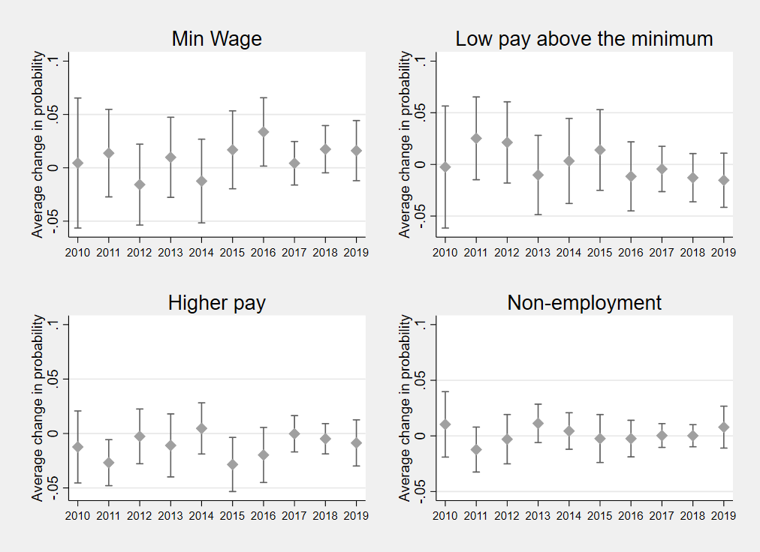

Note: Minimum wage jobs are defined as having an hourly pay less than the adult rate minimum wage level plus 5p; Standard errors are computed using bootstrapping with 100 replications.

Source: Authors’ calculations based on UKHLS, Waves 1-10 and ASHE 2009-2019