Supplementary materials
S1. Descriptive for individual richness variables, per country

Figure 1. Descriptives for individual richness variables for in the HL and SL, per country.
Panel A. Frequency of literacy activities (i.e., reading and writing) in each language, per country.
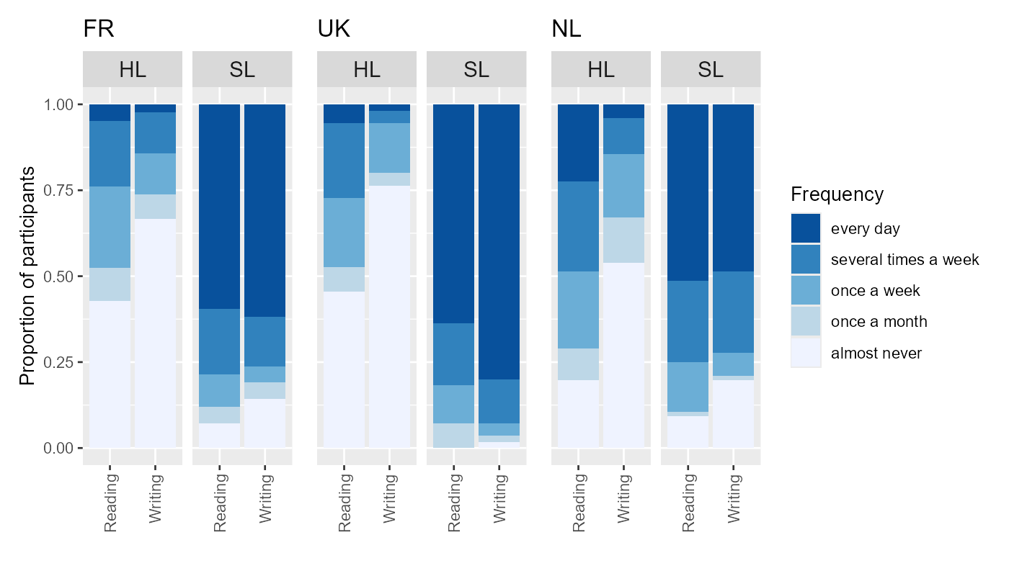

Panel B. Frequency of education-related activities (i.e., language lessons at mainstream school, language lesson outside mainstream school, time spent doing homework) in each language, per country.
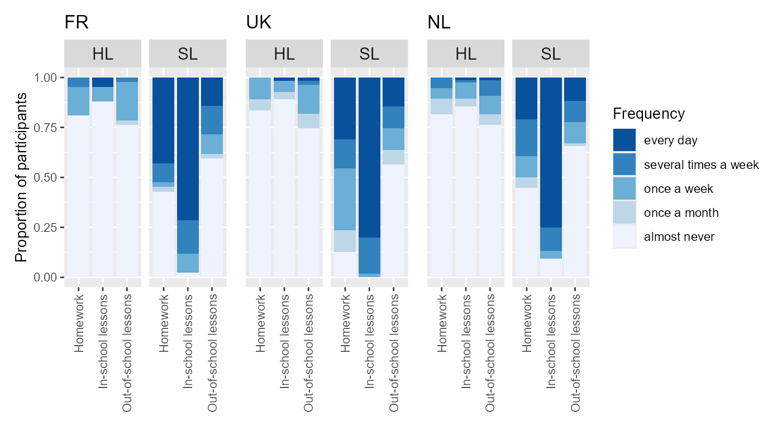

Panel C. Frequency of time spent with friends and on organised and tech-related activities in each language, per country.

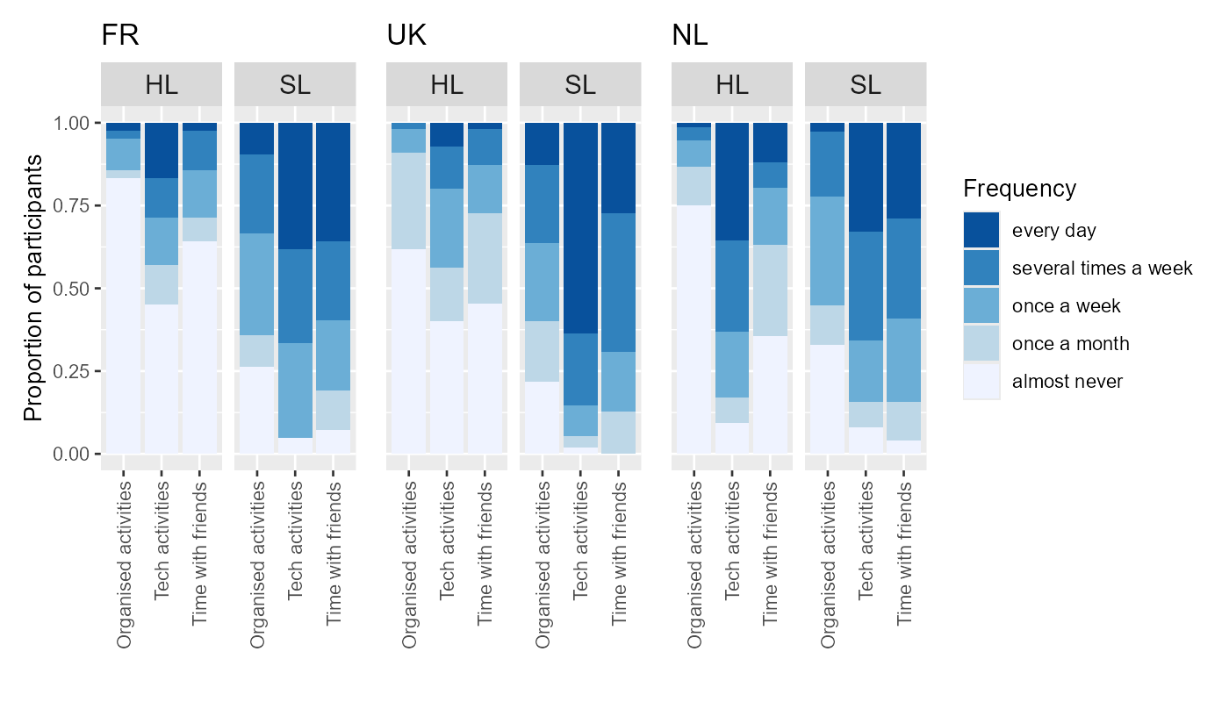

Figure 2. Number of different people who speak the language to the child at least once a week and how many of these speak the language very well, per country (top row: HL, bottom row: SL).

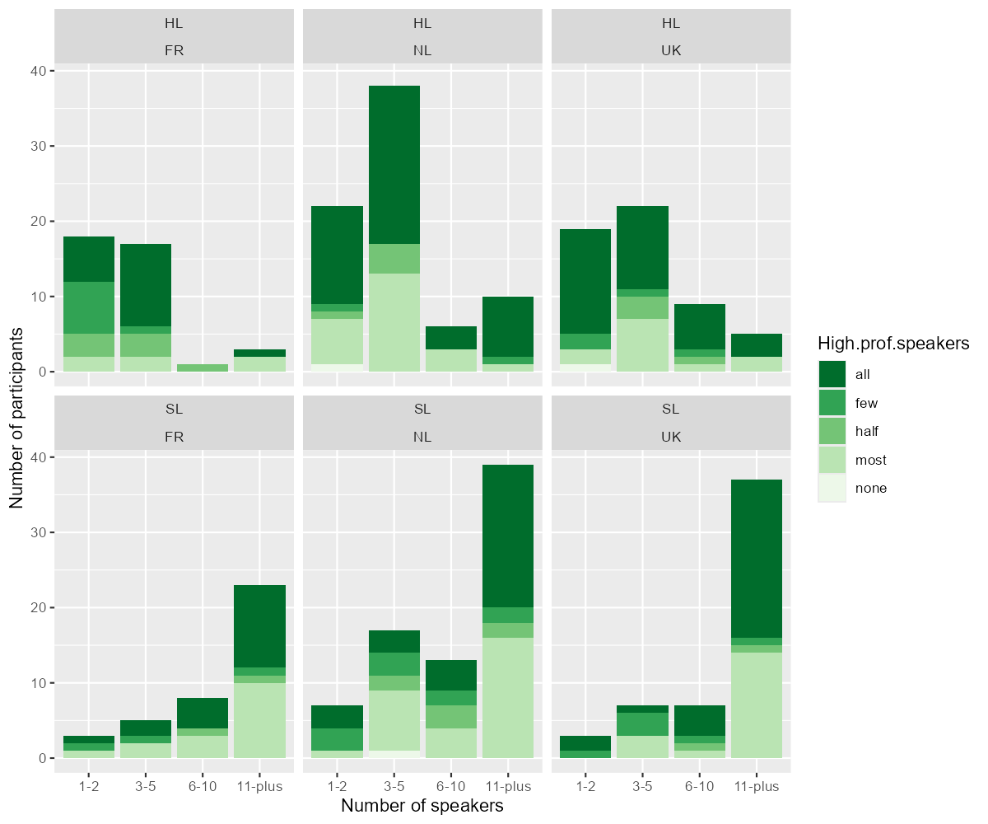

S2. Correlational analyses

Figure 3. Correlation matrix for individual variables contributing to HL richness.
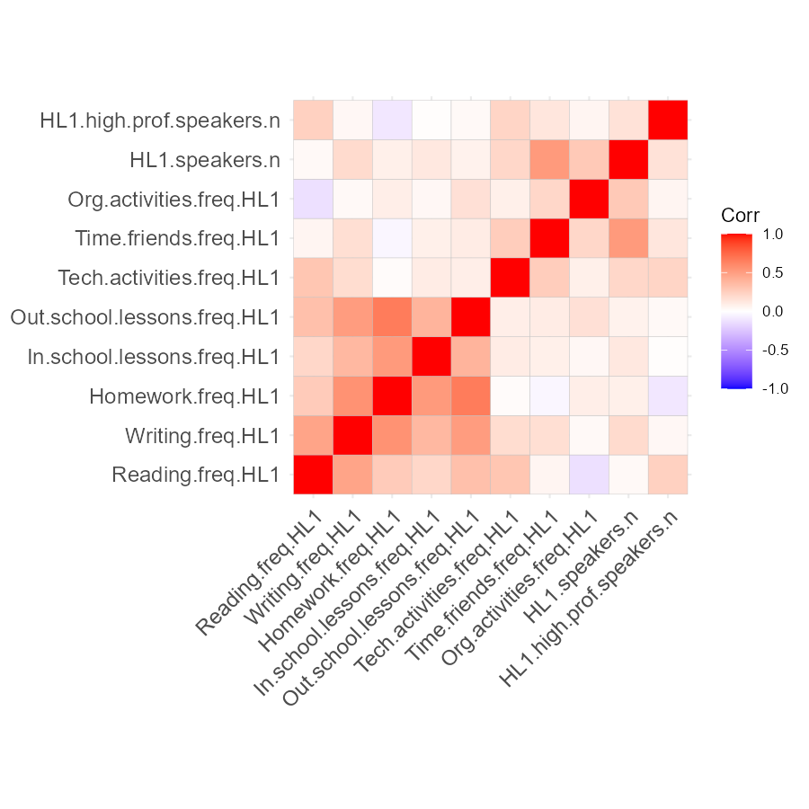

Figure 4. Correlation matrix for individual variables contributing to SL richness.
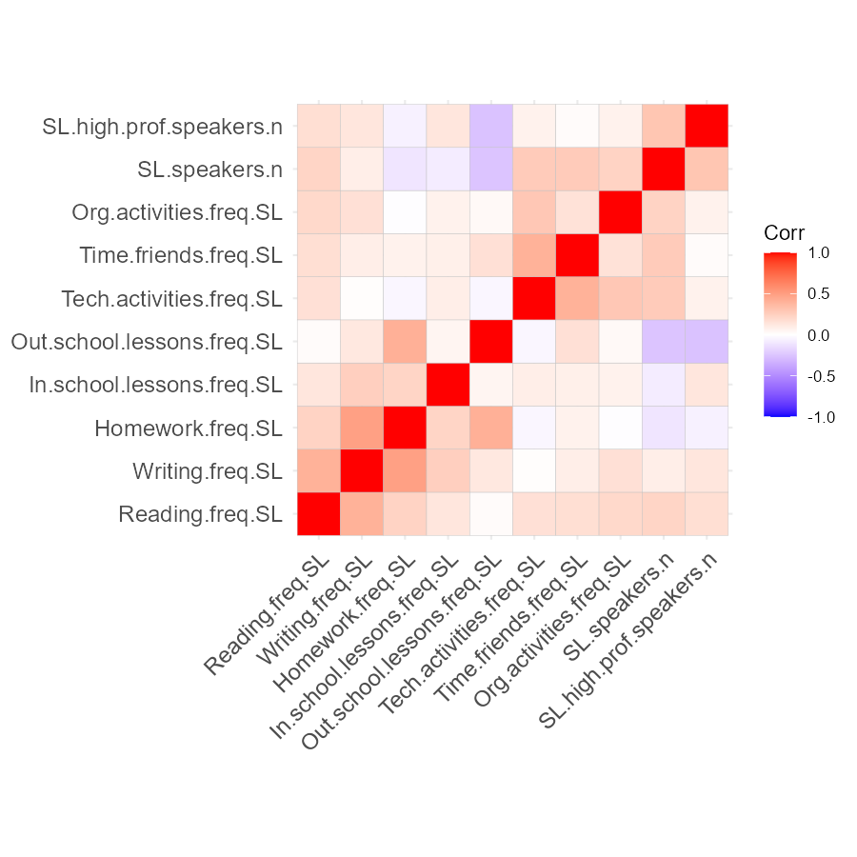
S3. Principal Components Analyses

Figure 5. Screeplot for PCA of richness variables for HL.
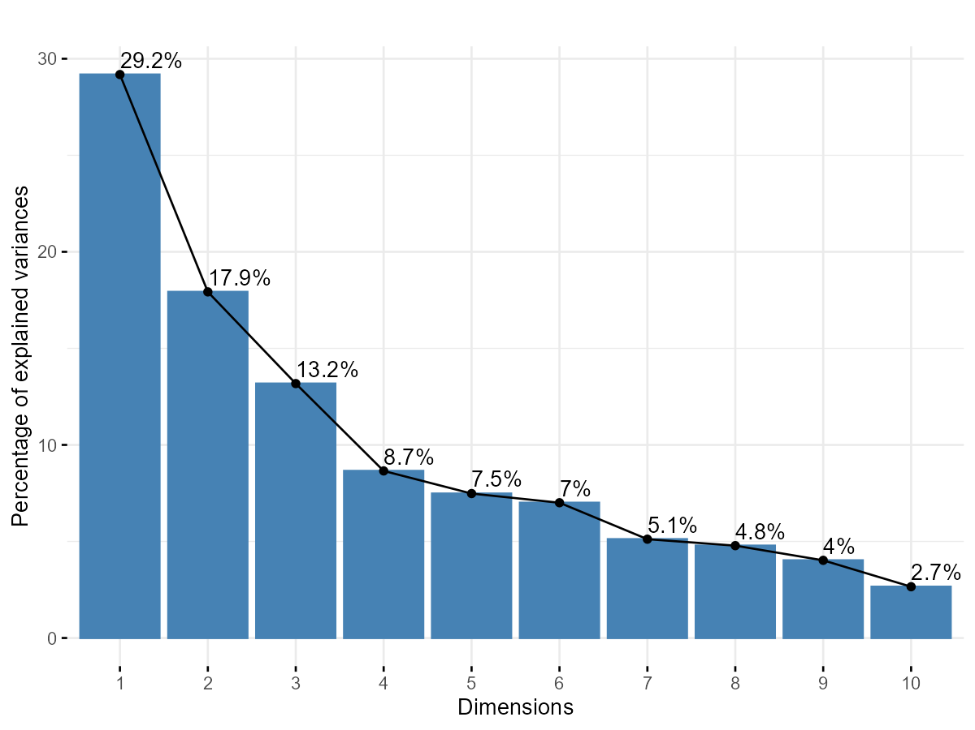

Figure 6. Screeplot for PCA of richness variables for SL.
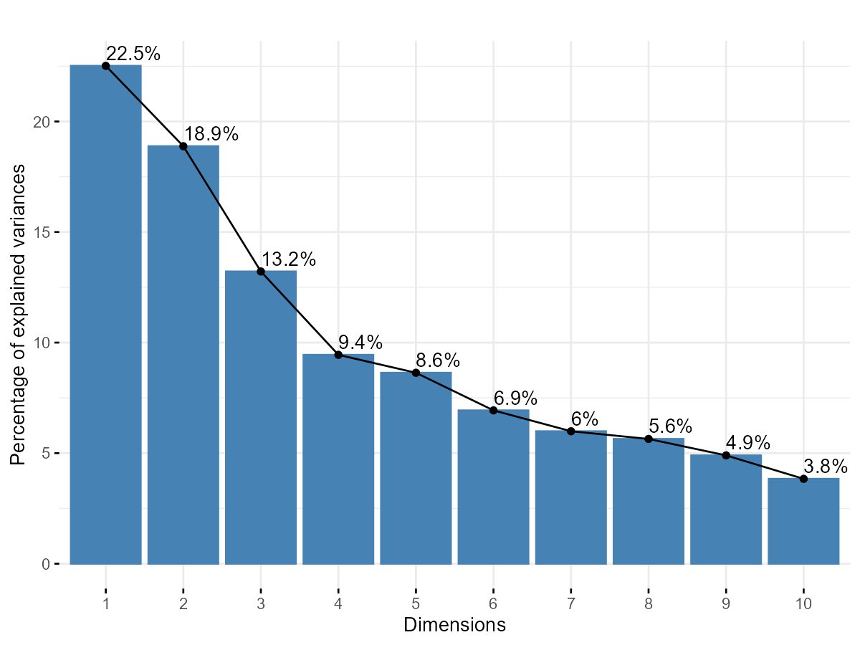

S4. Best-fitting models used to compare different richness scores

Table 1. Estimates and confidence intervals for best-fitting model for HL proficiency (indexed by parental estimation of understanding and speaking skills) based on comparison of different richness measures.
 | Estimate | 2.5 % | 97.5 %
hardly-at-all|not-very-well | -0.584 | -3.208 | 2.041
not-very-well|pretty-well | 3.744 | 1.028 | 6.460
pretty-well|very-well | 8.228 | 5.058 | 11.397
Modality: Speaking | -2.226 | -2.967 | -1.485
Current (weighted) exposure to SL | 11.402 | 7.386 | 15.418
Multilingualism: Trilingual | 1.816 | 0.412 | 3.221
Language concerns before age 4 | -1.747 | -3.312 | -0.182
Richness: original score excluding parental education | 1.773 | 0.465 | 3.081
Parental education | 0.510 | -0.100 | 1.119
SD (Intercept Respondent.ID) | 2.827

Table 2. Estimates and confidence intervals for best-fitting model for SL proficiency (indexed by vocabulary breadth) based on comparison of different richness measures.
 | Estimate | 2.5 % | 97.5 %
(Intercept) | -18.603 | -48.235 | 11.028
Age of onset to SL | -0.238 | -0.438 | -0.039
Born abroad | 9.127 | 1.498 | 16.757
Current (weighted) exposure to SL | -10.267 | -31.684 | 11.149
Cumulative exposure to SL | 16.601 | -1.143 | 34.346
Richness: original score | 30.100 | 6.112 | 54.089
Non-verbal IQ | 17.787 | 2.342 | 33.232
Forward digit span | 38.227 | 15.023 | 61.431
Non-word repetition | 26.593 | 5.346 | 47.840
SL: Dutch | 27.751 | 17.051 | 38.451
SL: English | 33.183 | 18.776 | 47.590
Older siblings | -2.930 | -4.839 | -1.022

Table 3. Estimates and confidence intervals for best-fitting model for SL proficiency (indexed by vocabulary depth) based on comparison of different richness measures.
 | Estimate | 2.5 % | 97.5 %
(Intercept) | -1.972 | -2.605 | -1.338
Forward digit span | 1.585 | 0.761 | 2.410
Language concerns before age 4 | -0.509 | -0.861 | -0.157
Backward digit span | 1.028 | 0.327 | 1.730
Richness: original score excluding parental education | 0.029 | -0.173 | 0.232

Table 4. Estimates and confidence intervals for best-fitting model for SL proficiency (indexed by sentence repetition) based on comparison of different richness measures.
 | Estimate | 2.5 % | 97.5 %
(Intercept) | -3.506 | -4.793 | -2.219
Age of onset to SL | -0.021 | -0.031 | -0.011
Forward digit span | 4.484 | 3.130 | 5.839
SL: Dutch | -1.254 | -1.867 | -0.641
SL: English | -2.078 | -2.735 | -1.421
Older siblings | -0.110 | -0.227 | 0.008
Richness: Literacy | 0.117 | -0.139 | 0.373
Richness: Social | 0.631 | 0.299 | 0.963
Parental education | 0.151 | -0.048 | 0.351

S5. Results of the O2-PLS analysis in relation to country

Figure 9. Distribution of factor loadings associated with three latent variables capturing shared variance in richness between the HL and SL

Panel A. HL
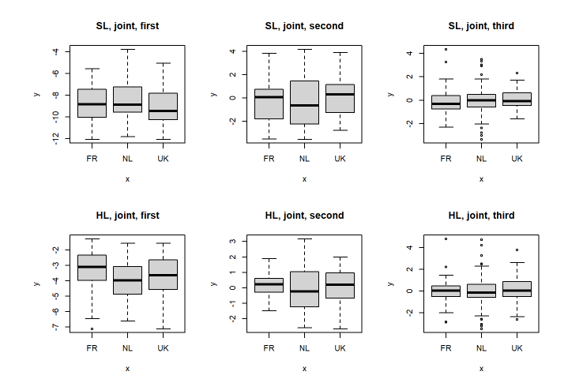

Panel B. SL

Table 5. Estimates and confidence intervals of linear regression model for first latent variable of the joint information contributed by the HL.
 | Estimate | 2.5 % | 97.5 %
(Intercept) | -3.274 | -3.673 | -2.876
SL: Dutch | -0.690 | -1.181 | -0.200
SL: English | -0.525 | -1.048 | -0.002

Figure 10. Distribution of factor loadings associated with three latent variables capturing orthogonal variance in richness between the HL and SL
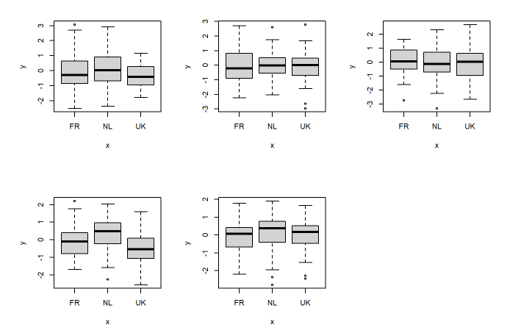

S6. Results of the O2-PLS analysis in relation to SES

Figure 11. Correlations between the three latent variables capturing shared variance in richness between the HL and SL and parental education (as a proxy for SES). The upper digit above each figure gives the correlation coefficient (NB: its sign cannot be interpreted) and the lower digit the rounded p-value (<.001 in each case).

Panel A. HL
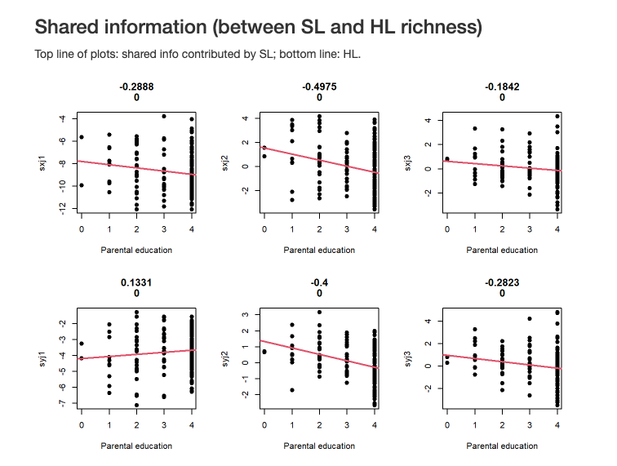

Panel B. SL

Figure 12. Correlations between the three latent variables capturing orthogonal variance in richness between the HL and SL and parental education (as a proxy for SES). NB: the sign of the correlation coefficient cannot be interpreted.

Panel A. HL
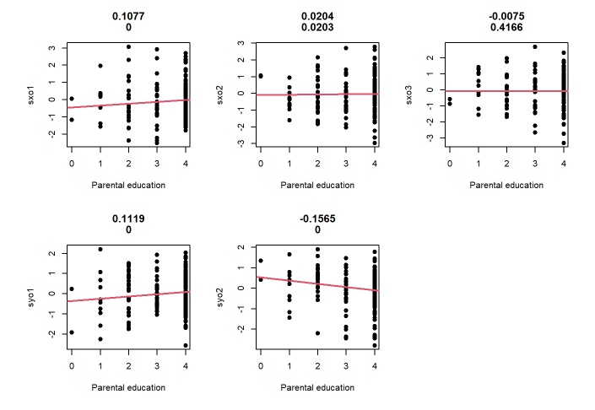

Panel B. SL

