Supplementary Data
Supplementary 1. Search terms per database
Database | Search terms | Filter | Date | Results
PubMed | (transcranial brain stimulation[Title/Abstract] OR transcranial magnetic stimulation[Title/Abstract] OR theta burst stimulation[Title/Abstract] OR transcranial direct current stimulation[Title/Abstract] OR transcranial electrical stimulation[Title/Abstract] OR transcranial alternating current stimulation[Title/Abstract]) AND (callous[Title/Abstract] OR psychopathy[Title/Abstract] OR empathy[Title/Abstract] OR emotional reactivity[Title/Abstract] OR guilt[Title/Abstract] OR prosocial [Title/Abstract] OR altruis*[Title/Abstract] OR cooperation[Title/Abstract] OR helping behavior [Title/Abstract]) | English, Humans, Child: birth-18 years, Adult: 19+ years, Young Adult: 19-24 years, Adult: 19-44 years, Middle Aged + Aged: 45+ years, Middle Aged: 45-64 years. | 25/11/2024 | 93
Web of Science Core Collection | (TS=(transcranial brain stimulation or transcranial magnetic stimulation or theta burst stimulation or transcranial direct current stimulation or transcranial electrical stimulation or transcranial alternating current stimulation)) AND (TS=(callous OR psychopathy OR empathy OR emotional reactivity OR guilt OR prosocial OR altruis* OR cooperation OR helping behavior) AND (ALL=((19-44 years OR Adult) OR (45-64 years OR Middle Aged) OR (45+ years OR Middle Aged + Aged))) NOT (TS=(animal)) | Refine terms: Languages (English) + Document Type (Article) | 28/11/2024 | 39
Scopus | ((TITLE-ABS-KEY ("transcranial brain stimulation" OR "transcranial magnetic stimulation" OR "theta burst stimulation" OR "transcranial direct current stimulation" OR "transcranial electrical stimulation" OR "transcranial alternating current stimulation" ) AND TITLE-ABS-KEY ("callous" OR "psychopathy" OR "empathy" OR "emotional reactivity" OR "guilt" OR "prosocial" OR "altruis*" OR "cooperation" OR "helping behavior"))) AND ( adult ) AND ( LIMIT-TO ( DOCTYPE , "ar" ) ) AND ( LIMIT-TO ( LANGUAGE , "English" ) ) | N/A | 28/11/2024 | 210

Supplementary 2. Excluded studies with reasons based on PICO criteria
Criteria | Reason | Number of exclusions
Article | Review article/meta-analysis | 41
Article | Commentary/discussion | 5
Article | Study protocol but not result of a study | 4
Population | Does not include human participants | 1
Population | Includes participants with major neurological conditions | 3
Intervention | Does not include a NIBS intervention | 7
Comparison | Does not include a control stimulation group | 2
Comparison | Case study | 2
Outcome | Does not investigate target outcome | 40
Outcome | Does not include behavioral measure of target outcome | 46
Outcome | Missing data for quantitative analysis | 2
Other | Unrelated topic | 82

Supplementary 3. Description of study measures
Empathy
Affective Resonance
Measures | Description
Emotional images ^{67,107,206–222} | Participants commonly view images that are categorized as neutral, positive, negative, and emotionally disturbing. They rate these images based on arousal, valence, and specific emotions they evoke (e.g., sadness, fear, discomfort).
Emotional videos ^{223–226} | Participants watch video clips designed to induce specific moods and then report their emotional reactions using standardized measures.
Music ²²⁷ | Participants rate their emotional reactions to a piece of sad music.
Word-fragment completion task ^{228,229} | Participants complete disgust-related words with missing letters. Faster word completion indicates more attention (reactivity) to emotional content.
Handgrip-force task ²³⁰ | Participants hold a handgrip while watching videos of crying infants. Increased pressure on the handgrip indicates more reactivity.
Empathy Quotient ²³¹ | A self-report questionnaire designed to measure empathy in adults, including a subscale to assess emotional reactivity.
Empathic Concern
Measures | Description
Pain empathy task ^{232–236} | Participants assess their emotional responses to images or videos that depict individuals in distressing situations (e.g., injured children). Ratings often include levels of empathic concern, vicarious pain, and distress.
Interpersonal Reactivity Index ^{227,235,237} | A self-report questionnaire designed to measure dispositional empathy, including a subscale to assess empathic concern.
Affect rating ²²⁸ | Participants rate their levels of pity before and after stimulation.
Prosociality
Charitable giving/altruism
Measures | Description
Dictator Game ^{238–246} | In various studies using the Dictator Game, participants are asked to divide a sum of money (e.g., $10) between themselves and another player or recipient, with different variations to explore factors influencing altruistic behavior and decision-making processes.
Costly helping ^{153,247–250} | Participants choose how much of their own tokens to donate to either reduce someone else’s distress or increase others’ tokens at a personal cost.
Donation task ^{220,236,246,251,252} | Participants decide how to allocate resources – such as money or credits – to various causes or organizations. Their decisions were influenced by the conditions of the task, such as whether they were making donations publicly or privately.
Helping/Cooperation
Measures | Description
Helping tasks ^{153,253} | Participants in these tasks are required to make decisions about helping others at no personal cost in various scenarios.
Cooperation and social dilemma tasks ^{250,254–256} | Participants engage in decision-making scenarios where cooperation or defection influenced both personal and group outcomes. These tasks explore how individuals balance personal benefits against collective good in various settings.
Prosocial intervention ²⁵⁹ | Participants watch video clips showing different types of interactions (i.e., cooperative, noncooperative, conflictual, and neutral) and then rate how much they empathized with the actors and their intention to intervene in each scenario. Prosocial behavior is determined when participants intervene more in conflictual/noncooperative scenarios.
Reciprocity
Measures | Description
Trust Game ^{241,258–260} | Trust games involve a trustor who sends resources to a trustee, who then decides how much to return. Some variations explore how the visibility of the trustee’s decisions (whether anonymous or revealed) affects their willingness to reciprocate.
Holdup Game ^{261,262} | Participants receive money from an investor and decide how much they will give back in return. The level of reciprocity is indicated by the benefit returned relative to the initial investment.
Redistribution Game ²¹⁰ | Participants are given the opportunity to rectify an unfair distribution made by another party.
Guilt
Measures | Description
Guilt Knowledge Test ²⁶³ | Participants rate their feelings of guilt on a scale from 0 (no guilt) to 5 (maximum guilt) after deception while being asked about a crime.
Calgary Depression Scale for Schizophrenia – Factor II ²⁶⁴ | Clinician rated outcome measure that assesses the level of depression in people with schizophrenia. Factor II in this questionnaire evaluates pathological guilt.
Affect rating ²²⁸ | Participants rated their levels of altruistic and deontological guilt before and after stimulation.
Psychopathy Traits
Measures | Description
Psychopathic Personality Inventory ²⁶⁵ | Self-report measure of both global psychopathy and the component traits of psychopathy, comprising eight subscales, including one measuring cold-heartedness (i.e., callousness).
Self-Report Psychopathy Scale-Short Form ²³⁵ | Self-reported inventory designed to measure psychopathy subdivided into four different facets, two of which include callous traits and interpersonal manipulative style.

Supplementary 4. Exploratory analyses
A subset of studies combined anodal and cathodal stimulation over ROIs either using a bilateral bipolar montage 153,208,213,225,236,254,258,264–266 or via HD-tDCS ^{218,235,237,239,248,267}. Bilateral bipolar tDCS employs polar opposite electrodes over functionally relevant brain regions simultaneously, while HD-tDCS uses a central anode or cathode over the ROI surrounded by return electrodes with opposite polarity. As these protocols cannot be categorized as strictly anodal or cathodal ²⁶⁸, we categorized them separately for exploratory analyses.
Effects of bipolar tDCS
A total of 9 studies (19 effects) used a bilateral bipolar tDCS montage, typically targeting the DLPFC or OFC at stimulation intensities between 1.5–2 mA for around 15 to 33 min – with the exception of one study applying stimulation for only 5 min ²¹³. Overall, the evidence for modulation of socio-affective outcomes is mixed. For empathy, studies have shown both positive ²¹³ and negative ²²⁵ effects on affective resonance following left-anodal/right-cathodal DLPFC stimulation, whereas right-anodal/left-cathodal ^{213,225} and bilateral DLPFC stimulation ^{208,236} showed no significant differences from sham. Findings on prosocial behavior are similarly mixed. On one hand, left-anodal/right-cathodal stimulation to the DLPFC ²⁵⁴ and right-anodal/left-cathodal stimulation to the OFC ²⁵⁸ enhanced cooperative behavior relative to sham. By contrast, other montages produced no significant changes in cooperation or charitable giving ^{236,258}. Only one study targeted guilt directly, reporting reduced self-reported feelings of guilt following right-cathodal/left-anodal OFC stimulation ²⁶⁴. We also identified one study specifically testing the effects of both right-cathodal/left-anodal and right-anodal/left-cathodal stimulation over the DLPFC on relevant psychopathy traits (particularly cold-heartedness) ²⁶⁵, although no significant changes were observed relative to sham.
Meta-analyses on these data overall revealed a non-significant mean effect size of g = 0.18, 95% CI -0.58 to 0.94, p = 0.640) and high between-study variability (τ² = 2.63, I² = 96.49%, 95% PI -2.99 to 3.35). Moderator analyses were not performed due to limited number of independent studies.
Effects of HD-tDCS
A total of 6 studies (13 effects) applied HD-tDCS at intensities typically around 2 mA for about 20 minutes, although one study applied 1.5 mA stimulation for 11.8 minutes ²⁶⁷. Protocols ranged from single-session stimulation to 10-session interventions. Overall, the evidence for socio-affective modulation is mixed. For prosocial outcomes, anodal HD-tDCS of the right TPJ increased charitable giving ²³⁹ and cathodal stimulation of the right DLPFC and IPL reduced helping behavior ²⁴⁸, which is consistent with the expected effects typically seen in these polarities. Empathy-related outcomes were more heterogeneous, with cathodal stimulation of the right IFC showing no change in affective resonance ²⁶⁷, anodal stimulation of the right ATL ²³⁷ or the right DLPFC ²¹⁸ decreasing emotional responses, and multi-session anodal stimulation of the VMPFC producing no significant effects on affective resonance, empathic concern, or general empathy ²³⁵. Similarly, anodal HD-tDCS over the VMPFC produced no measurable effects on psychopathic expression ²³⁵.
Heterogeneity assessments indicated substantial between-study variability (τ² = 0.53, I² = 90.17%, 95% PI -1.53 to 1.33), with no significant overall effect of HD-tDCS on target outcomes (g = -0.10, 95% CI -0.52 to 0.32, p = 0.636). Given the small number of studies, we did not assess moderation.
Supplementary 5. Leave-one-out analyses and influence diagnostics
HF-rTMS
Study | Estimate | Pval | CI.lb | CI.ub | Tau2 | I2 | Rstudent | Cook.d
1 | 0.49 | 0.052 | 0.00 | 0.98 | 1.15 | 92.86 | 1.60 | 0.12
2* | 0.40 | 0.042 | 0.02 | 0.79 | 0.67 | 88.51 | 4.06 | 0.48
3 | 0.61 | 0.023 | 0.08 | 1.14 | 1.33 | 93.67 | -0.49 | 0.01
4 | 0.62 | 0.022 | 0.09 | 1.14 | 1.32 | 93.63 | -0.60 | 0.02
5 | 0.61 | 0.022 | 0.09 | 1.14 | 1.33 | 93.65 | -0.54 | 0.02
6 | 0.61 | 0.024 | 0.08 | 1.14 | 1.33 | 93.69 | -0.46 | 0.01
7 | 0.66 | 0.011 | 0.15 | 1.16 | 1.22 | 93.15 | -1.34 | 0.08
8 | 0.61 | 0.022 | 0.09 | 1.14 | 1.32 | 93.66 | -0.55 | 0.02
9 | 0.64 | 0.016 | 0.12 | 1.15 | 1.27 | 93.50 | -0.98 | 0.05
10 | 0.60 | 0.025 | 0.07 | 1.13 | 1.34 | 93.78 | -0.35 | 0.01
11 | 0.62 | 0.022 | 0.09 | 1.14 | 1.33 | 93.14 | -0.55 | 0.02
12 | 0.62 | 0.021 | 0.10 | 1.15 | 1.32 | 93.09 | -0.66 | 0.02
13 | 0.61 | 0.025 | 0.08 | 1.14 | 1.34 | 93.20 | -0.41 | 0.01
14 | 0.58 | 0.030 | 0.06 | 1.11 | 1.34 | 93.88 | -0.04 | 0.00
15 | 0.63 | 0.019 | 0.10 | 1.15 | 1.30 | 93.52 | -0.76 | 0.03
16 | 0.48 | 0.053 | -0.01 | 0.97 | 1.12 | 92.54 | 1.76 | 0.15
17 | 0.55 | 0.040 | 0.03 | 1.08 | 1.33 | 93.52 | 0.46 | 0.01
18 | 0.55 | 0.039 | 0.03 | 1.08 | 1.33 | 93.76 | 0.48 | 0.01
19 | 0.54 | 0.042 | 0.02 | 1.07 | 1.31 | 93.69 | 0.67 | 0.02
20 | 0.58 | 0.033 | 0.05 | 1.11 | 1.35 | 93.83 | 0.07 | 0.00
21 | 0.58 | 0.031 | 0.05 | 1.11 | 1.35 | 93.83 | -0.04 | 0.00
A-tDCS
Study | Estimate | Pval | CI.lb | CI.ub | Tau2 | I2 | Rstudent | Cook.d
1 | 0.60 | 0.042 | 0.04 | 1.16 | 3.38 | 98.34 | -0.48 | 0.02
2 | 0.61 | 0.044 | 0.09 | 1.12 | 2.86 | 98.07 | -1.3 | 0.03
3 | 0.59 | 0.044 | 0.02 | 1.15 | 3.44 | 98.37 | -0.16 | 0.01
4 | 0.58 | 0.046 | 0.02 | 1.15 | 3.45 | 98.38 | -0.06 | 0
5 | 0.58 | 0.038 | 0.02 | 1.14 | 3.45 | 98.38 | -0.02 | 0
6 | 0.57 | 0.045 | 0.01 | 1.14 | 3.43 | 98.39 | 0.09 | 0
7 | 0.59 | 0.048 | 0.03 | 1.15 | 3.4 | 98.37 | -0.39 | 0.01
8 | 0.58 | 0.043 | 0.01 | 1.14 | 3.44 | 98.38 | 0.06 | 0
9 | 0.57 | 0.040 | 0.01 | 1.13 | 3.41 | 98.35 | 0.22 | 0
10 | 0.58 | 0.037 | 0.02 | 1.15 | 3.45 | 98.35 | -0.08 | 0.01
11 | 0.59 | 0.039 | 0.03 | 1.15 | 3.43 | 98.33 | -0.27 | 0.01
12 | 0.6 | 0.038 | 0.04 | 1.16 | 3.39 | 98.32 | -0.45 | 0.02
13 | 0.59 | 0.040 | 0.03 | 1.15 | 3.42 | 98.33 | -0.34 | 0.01
14 | 0.59 | 0.044 | 0.03 | 1.16 | 3.41 | 98.33 | -0.38 | 0.01
15 | 0.59 | 0.047 | 0.03 | 1.15 | 3.43 | 98.34 | -0.27 | 0.01
16 | 0.58 | 0.038 | 0.02 | 1.15 | 3.45 | 98.35 | -0.05 | 0
17 | 0.57 | 0.035 | 0.01 | 1.13 | 3.4 | 98.39 | 0.2 | 0
18 | 0.59 | 0.037 | 0.03 | 1.15 | 3.41 | 98.38 | -0.36 | 0.01
19 | 0.6 | 0.032 | 0.04 | 1.16 | 3.36 | 98.32 | -0.54 | 0.02
20 | 0.6 | 0.046 | 0.04 | 1.16 | 3.39 | 98.34 | -0.46 | 0.02
21 | 0.6 | 0.044 | 0.05 | 1.15 | 3.29 | 98.32 | -0.69 | 0.02
22 | 0.57 | 0.039 | 0.01 | 1.14 | 3.44 | 98.38 | 0.08 | 0
23 | 0.58 | 0.051 | 0.02 | 1.14 | 3.45 | 98.39 | -0.06 | 0
24 | 0.59 | 0.035 | 0.03 | 1.15 | 3.42 | 98.37 | -0.32 | 0.01
25 | 0.49 | 0.052 | 0 | 0.99 | 2.65 | 97.93 | 1.36 | 0.07
26 | 0.6 | 0.045 | 0.04 | 1.16 | 3.36 | 98.34 | -0.53 | 0.02
27 | 0.54 | 0.051 | 0 | 1.08 | 3.19 | 98.28 | 0.71 | 0.01
28 | 0.58 | 0.050 | 0.01 | 1.14 | 3.44 | 98.39 | 0.04 | 0
29 | 0.55 | 0.048 | 0 | 1.1 | 3.28 | 98.32 | 0.56 | 0
30 | 0.56 | 0.027 | 0 | 1.11 | 3.33 | 98.35 | 0.44 | 0
31 | 0.57 | 0.010 | 0.01 | 1.13 | 3.4 | 98.38 | 0.25 | 0
32 | 0.61 | 0.037 | 0.07 | 1.14 | 3.11 | 98.24 | -0.98 | 0.03
33 | 0.59 | 0.046 | 0.14 | 1.04 | 2.14 | 97.45 | -2.01 | 0.01
34 | 0.6 | 0.044 | 0.04 | 1.16 | 3.39 | 98.34 | -0.43 | 0.02
35 | 0.57 | 0.037 | 0.01 | 1.13 | 3.43 | 98.36 | 0.15 | 0
36 | 0.58 | 0.043 | 0.02 | 1.14 | 3.44 | 98.39 | -0.03 | 0
37 | 0.6 | 0.036 | 0.04 | 1.16 | 3.39 | 98.36 | -0.44 | 0.02
38 | 0.58 | 0.017 | 0.02 | 1.15 | 3.45 | 98.38 | -0.1 | 0.01
39 | 0.6 | 0.046 | 0.04 | 1.16 | 3.38 | 98.34 | -0.47 | 0.02
40* | 0.33 | 0.049 | 0.06 | 0.6 | 0.76 | 93.21 | 10.16 | 0.75
41 | 0.57 | 0.052 | 0.01 | 1.14 | 3.43 | 98.38 | 0.1 | 0
42 | 0.56 | 0.051 | 0 | 1.12 | 3.37 | 98.36 | 0.36 | 0
43 | 0.54 | 0.042 | 0 | 1.08 | 3.2 | 98.27 | 0.71 | 0.01
44 | 0.55 | 0.044 | 0 | 1.1 | 3.28 | 98.32 | 0.55 | 0
C-tDCS
Study | Estimate | Pval | CI.lb | CI.ub | Tau2 | I2 | Rstudent | Cook.d
1 | 0.17 | 0.31 | -0.15 | 0.49 | 0.28 | 76.34 | 0.06 | 0.00
2 | 0.12 | 0.43 | -0.18 | 0.43 | 0.24 | 73.48 | 1.22 | 0.10
3 | 0.14 | 0.38 | -0.17 | 0.46 | 0.27 | 75.43 | 0.68 | 0.03
4 | 0.15 | 0.36 | -0.17 | 0.47 | 0.28 | 75.85 | 0.50 | 0.02
5 | 0.14 | 0.38 | -0.18 | 0.47 | 0.28 | 74.32 | 0.59 | 0.03
6 | 0.15 | 0.37 | -0.17 | 0.47 | 0.28 | 74.61 | 0.47 | 0.02
7 | 0.24 | 0.10 | -0.04 | 0.53 | 0.20 | 69.06 | -1.84 | 0.20
8 | 0.23 | 0.12 | -0.06 | 0.53 | 0.22 | 71.10 | -1.55 | 0.16
9 | 0.19 | 0.24 | -0.13 | 0.51 | 0.28 | 76.01 | -0.49 | 0.02
10 | 0.24 | 0.11 | -0.05 | 0.52 | 0.21 | 70.38 | -1.84 | 0.18
11 | 0.14 | 0.39 | -0.18 | 0.45 | 0.26 | 75.07 | 0.87 | 0.05
12 | 0.10 | 0.48 | -0.18 | 0.38 | 0.19 | 69.26 | 2.04 | 0.21
13 | 0.19 | 0.26 | -0.14 | 0.51 | 0.28 | 75.86 | -0.37 | 0.01
14 | 0.17 | 0.29 | -0.15 | 0.50 | 0.29 | 76.21 | -0.07 | 0.00
15 | 0.19 | 0.25 | -0.13 | 0.51 | 0.28 | 75.86 | -0.42 | 0.01
Note. HF-rTMS: high frequency repetitive transcranial magnetic stimulation; Pval: p value; CI.lb: 95% confidence interval (lower bound); CI.ub: 95% confidence interval (upper bound); Tau2: tau squared value; I2: I squared value; Cook.d: cook distance; A-tDCS: anodal transcranial direct current stimulation; C-tDCS: cathodal transcranial direct current stimulation.
* indicating significant single-study influence on overall effects.

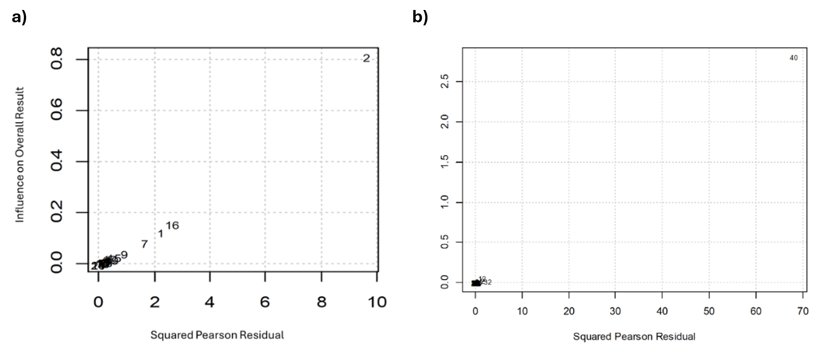
Supplementary 6. Baujat plots
Note. Baujat plots display the influence of individual trials on the overall effect sizes in studies using high-frequency rTMS (Panel A) and anodal tDCS (Panel B). In the rTMS analysis, Study 2 (Balconi & Canavesio, 2014) notably drives the overall effects. Likewise, for tDCS trials, the plot highlights that Study 40 (Yuan et al., 2017) significantly impacts the aggregated findings.

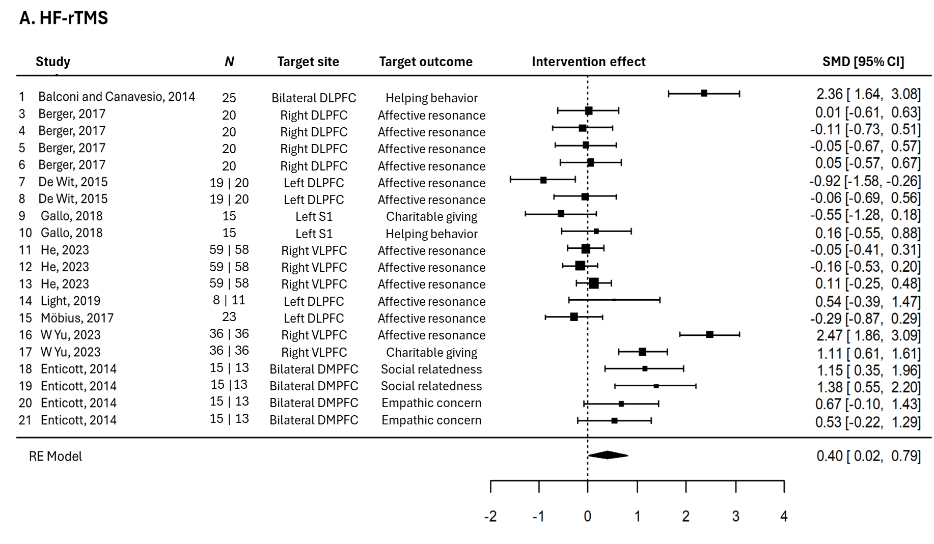
Supplementary 7. Forest plots
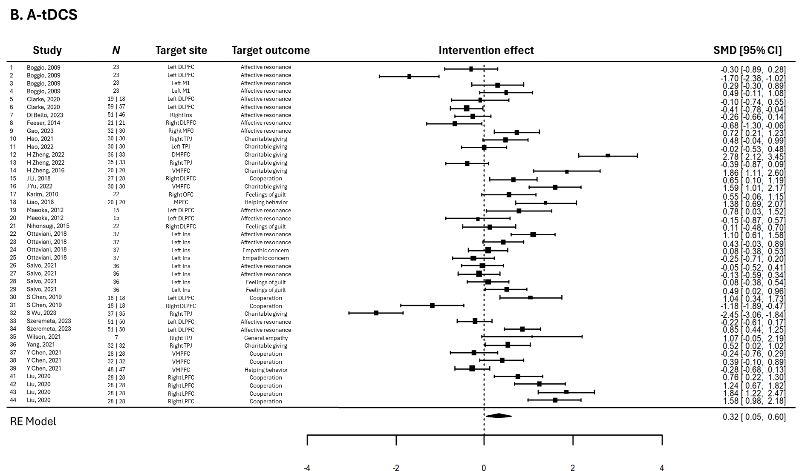
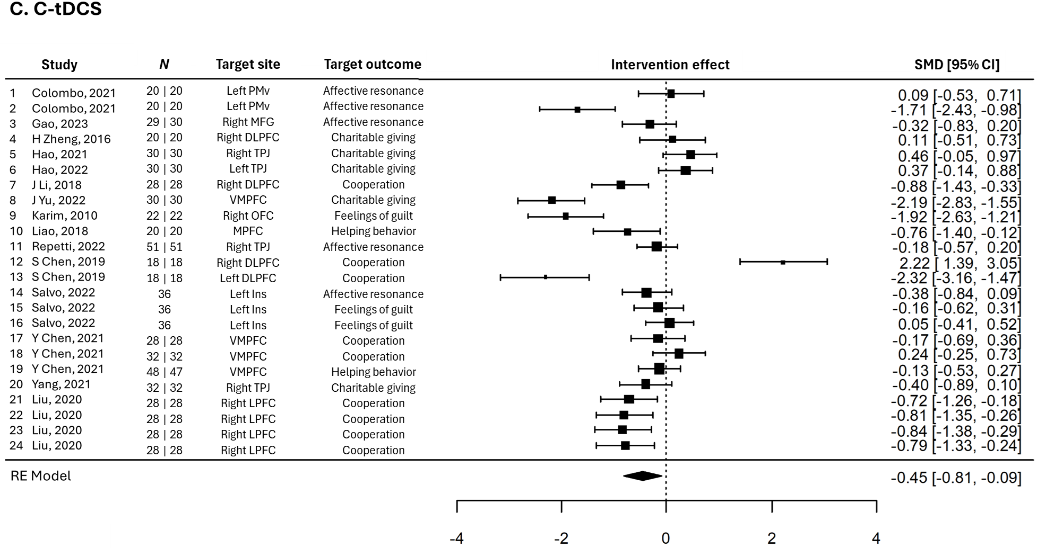
Note. Forest plots depict intervention effects in trials involving high-frequency rTMS (A), anodal tDCS (B) and cathodal tDCS (C) after excluding outliers. Targeted brain area for intervention and behavioral outcomes for each intervention are presented in the two contiguous columns, with numerical values of the effects (SMD) presented at the right side of each forest plot. References of studies for each extracted effect are presented at the left side of each forest plot. N: number of participants; SMD: standardized mean difference; 95% CI: 95% confidence interval; RE model: random effects model.

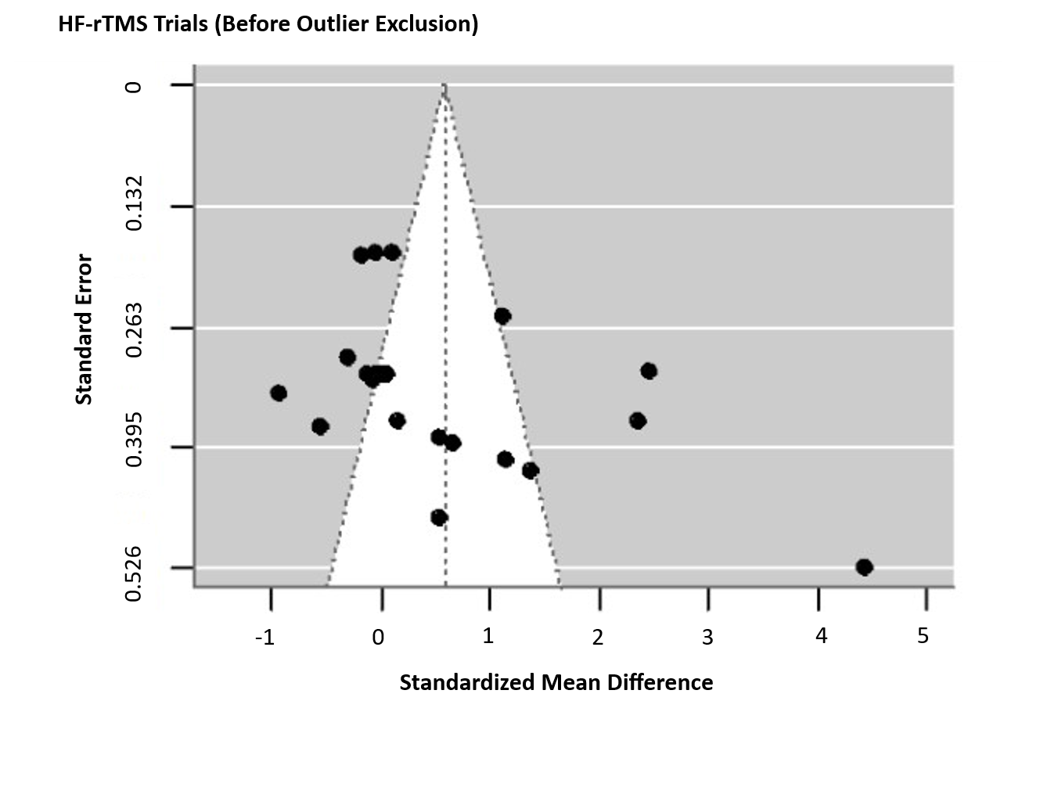
Supplementary 8. Funnel plots
