Supplementary Material
Section 1: Sensitivity Analyses
For both experiments, simulation-based sensitivity analyses were conducted on the smallest effect size of interest, the three-way interaction between Item Type, Retention interval, and Lag² from models of first-response recall. First, observed power estimates were generated using the powerSim function from the simr package in R (Green & MacLeod, 2016). For each experiment, 500 simulations of the relevant generalized linear mixed-effects model were conducted; proportions of model simulations for which Wald’s Z-tests of the critical interaction produced p-values below the threshold of 0.05 were computed. Next, power curves were generated, characterizing the ability to detect the critical interaction in each experiment across a range of six feasible effect sizes surrounding the observed effect sizes of interest. Since the powerSim function from simr expects effect sizes on the log odds scale, we used the log odds values of the critical interaction effect from Experiments 1 and 2 (0.145 and 0.094, respectively) to motivate our selection of effect sizes, which ranged from log odds of 0.05 to 0.30 by increments of 0.05. Using the models of interest from both experiments, each log odds value was substituted as the effect size for the critical three-way interaction, and the powerSim function was used to estimate power, with specifications identical to the observed power analyses described above. For ease of interpretability, log odds effect sizes were then exponentiated to produce odds ratios. The results of these analyses are plotted below in Figure S1.

Figure S1
Power Curves Generated from Simulation-Based Sensitivity Analyses
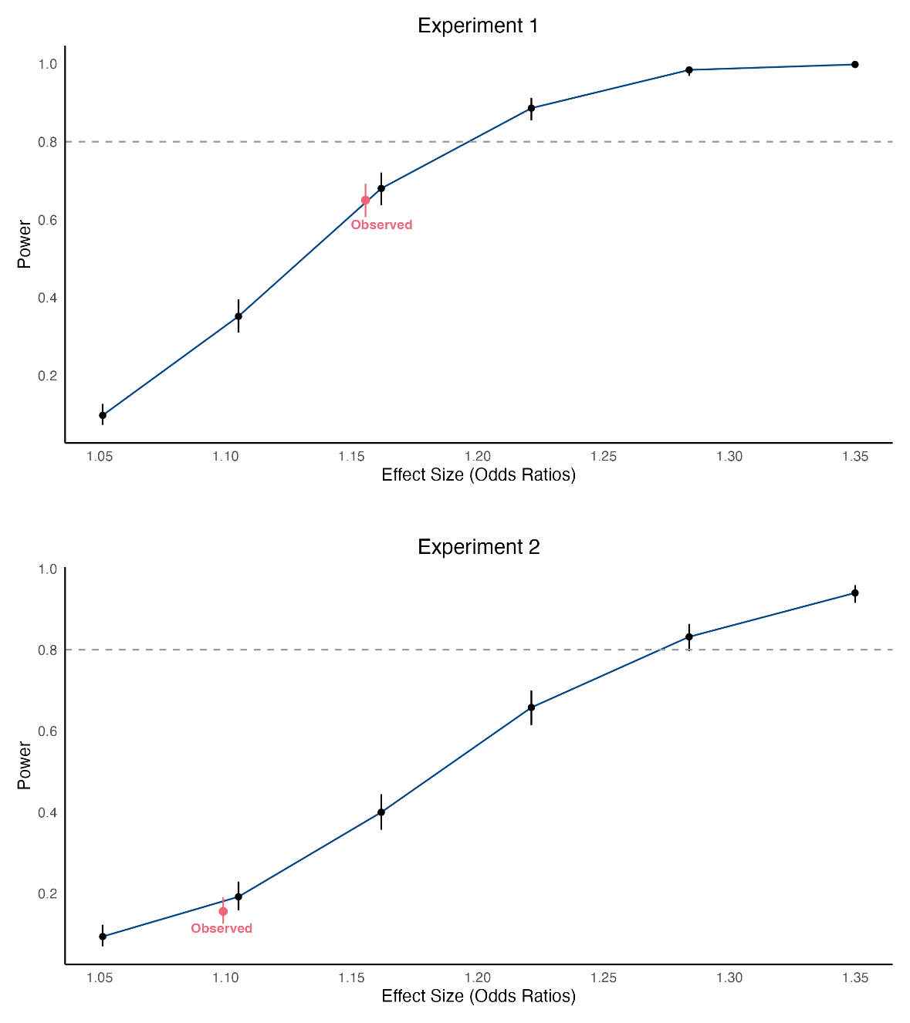
Note. Black points indicate power estimates for hypothetical effect sizes. Red points indicate power estimates derived from sensitivity analyses based on the observed effect size of the critical three-way interaction in Experiments 1 (OR = 1.16) and 2 (OR = 1.10). Gray dashed lines indicate the conventional threshold for power, .80. For all analyses, n = 120. Error bars represent 95% confidence intervals.

Section 2: Site-Specific Effects
In both experiments, we collected data from two sites: the University of North Carolina at Greensboro (UNCG) and the University of Essex (UofE). While we reported all results in the main manuscript collapsed over site, we noted that some models indicated site-specific effects. None of these effects change the inferences that can be drawn from the aggregate samples, but we describe the site-specific effects here for completeness. The complete modeling approach is described in the main manuscript. As a reminder, we fit logistic mixed-effects models to each memory response outcome variable, treated lag (both linear and quadratic) and retention interval were treated as z-scored continuous fixed effects, and used crossed random intercepts for subjects and items. All model specifications are provided in the analysis scripts on OSF (https://osf.io/cvmqx/) and in Wilkinson-Rodgers notion in what follows.
Experiment 1
2.1: Change Recollection on Test Trials
Change recollection responses on test trials were also accurate for A-B, A-C items and inaccurate for A-B items. The differences between accurate and inaccurate responses were compared across all combinations of lag and retention interval using the following model: logit[P(change recollection)] ~ Site × Item type × Retention interval × Lag + Site × Item type × Retention interval × Lag² + (1 | Subject) + (1 | Item). The model included 21600 observations and explained the following variance: R²_{M} = .39, R²_{C} = .52. Table S1 reports site-specific fixed‐effect ORs. The significant Site × Item type interaction shows that the difference between accurate and inaccurate change recollection responses was smaller at UNCG than Essex. Accurate response probabilities were not significantly different between sites (UNCG: .74 [.69, .78] vs. Essex: .72 [.67, .77]), OR = 1.10, p = .58, but inaccurate response probabilities were significantly higher at UNCG than Essex (UNCG: .12 [.10, .15] vs. Essex: .08 [.07, .10]), OR = 1.52, p = .02.
Table S1
Odds Ratios from a Mixed-Effects Logistic Regression Model of Change Recollection: Experiment 1
Predictor | OR (95% CI) | p
Site | 0.98 (0.67, 1.45) | = .929
Site × Item Type | 0.61 (0.44, 0.86) | = .004
Site × Retention Interval | 1.03 (0.84, 1.26) | = .757
Site × Lag | 1.07 (0.94, 1.22) | = .294
Site × Lag² | 0.92 (0.77, 1.11) | = .401
Site × Item Type × Retention Interval | 0.80 (0.58, 1.12) | = .197
Site × Item Type × Lag | 0.92 (0.74, 1.13) | = .421
Site × Retention Interval × Lag | 0.91 (0.81, 1.04) | = .167
Site × Item Type × Lag² | 1.18 (0.88, 1.59) | = .263
Site × Retention Interval × Lag² | 0.94 (0.79, 1.13) | = .520
Site × Item Type × Retention Interval × Lag | 1.01 (0.82, 1.24) | = .927
Site × Item Type × Retention Interval × Lag² | 1.31 (0.97, 1.76) | = .074
Note. Predictors for Retention interval and Lag were standardized (mean-centered and scaled to unit variance) prior to model estimation to address model convergence issues. Odds ratios (ORs) reflect the multiplicative change in the odds of first-response recall associated with a one standard deviation increase in the predictor, holding other variables constant. Interaction terms represent combined effects of standardized predictors. For categorical contrasts, UNCG served as the reference level for Site. The statistically significant OR is displayed in bold.
Experiment 2
2.2: First-Response Recall
First-response recall for both item types was compared across all combinations of lag and retention intervals using the following model: logit[P(recall)] ~ Site × Item type × Retention interval × Lag + Site × Item type × Retention interval × Lag² + (1 | Subject) + (1 | Item). The model included 21600 observations and explained the following variance: R²_{M} = .05, R²_{C} = .33. Table S2 reports site-specific fixed‐effect ORs. The model showed a significant site-specific Site × Retention Interval × Lag interaction, which is visualized in Figure S1. Examination of the linear slopes (all negative) across lags for each retention interval, reported here as changes in log-odds [and 95% Cis], indicated that: At retention interval 4, the slope was steeper at UNCG (b = -0.58 [-0.67, -0.50]) than UofE (b = -0.38 [-0.46, -0.39]); at retention interval 16, the slope magnitudes did not differ between UNCG (b = -0.35 [-0.41, -0.29]) and UofE (-0.33 [-0.39, -0.27]); and at retention interval 48, the slope magnitudes did not differ between UNCG (-0.11 [-.20, -.03]) and UofE (-0.28 [-0.37, -0.20]).
Table S2
Odds Ratios from a Mixed-Effects Logistic Regression Model of First-Response Recall: Experiment 2
Predictor | OR (95% CI) | p
Site | 0.79 (0.55, 1.14) | = .206
Site × Item Type | 1.31 (1.00, 1.71) | = .052
Site × Retention Interval | 0.94 (0.78, 1.14) | = .558
Site × Lag | 0.98 (0.86, 1.10) | = .697
Site × Lag² | 1.10 (0.93, 1.31) | = .264
Site × Item Type × Retention Interval | 1.06 (0.81, 1.39) | = .670
Site × Item Type × Lag | 1.09 (0.92, 1.29) | = .344
Site × Retention Interval × Lag | 0.84 (0.74, 0.95) | = .004
Site × Item Type × Lag² | 0.86 (0.68, 1.10) | = .232
Site × Retention Interval × Lag² | 1.12 (0.95, 1.33) | = .187
Site × Item Type × Retention Interval × Lag | 0.98 (0.82, 1.16) | = .776
Site × Item Type × Retention Interval × Lag² | 0.92 (0.72, 1.17) | = .506
Note. Predictors for Retention interval and Lag were standardized (mean-centered and scaled to unit variance) prior to model estimation to address model convergence issues. Odds ratios (ORs) reflect the multiplicative change in the odds of first-response recall associated with a one standard deviation increase in the predictor, holding other variables constant. Interaction terms represent combined effects of standardized predictors. For categorical contrasts, UNCG served as the reference level for Site. The statistically significant OR is displayed in bold.
Figure S2
Probabilities of First-Response Recall
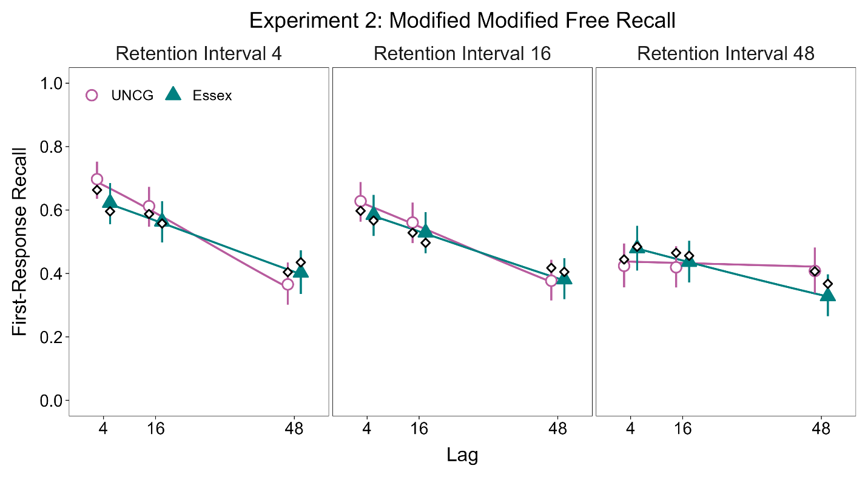
Note. Estimates are model-derived from a mixed-effects analysis; error bars represent 95% confidence intervals. Observed means appear as white-filled diamonds. Corresponding odds ratios for fixed effects and linear slope estimates of the lag functions appear in Table S2.
2.3: Change Recollection on Test Trials
Change recollection responses on test trials were also accurate for A-B, A-C items and inaccurate for A-B items. The differences between accurate and inaccurate responses were compared across all combinations of lag and retention interval using the model: logit[P(change recollection)] ~ Site × Item type × Retention interval × Lag + Site × Item type × Retention interval × Lag² + (1 | Subject) + (1 | Item). The model included 21600 observations and explained the following variance: R²_{M} = .31, R²_{C} = .48. Table S3 reports site-specific fixed‐effect ORs. The model showed a significant effect of Site, showing that the total probability of change recollection responses was higher at UofE (.49 [.43, .56]) than UNCG (.27 [.22, .33]). This effect was qualified by a significant Site × Item Type interaction, which shows that the difference between accurate and inaccurate change recollection responses was larger at UNCG than Essex, and that the difference within each response was smaller for accurate than inaccurate responses (accurate responses: UNCG = .60 [.54, .66] vs. Essex = .75 [.70, .80]), OR = 0.52, p < .001, (inaccurate responses: UNCG = .08 [.06, .11] vs. Essex = .24 [.19, .29]), OR = 0.29, p < .001.
Table S3
Odds Ratios from a Mixed-Effects Logistic Regression Model of Change Recollection: Experiment 2
Predictor | OR (95% CI) | p
Site | 1.97 (1.31, 2.96) | = .001
Site × Item Type | 1.83 (1.33, 2.51) | < .001
Site × Retention Interval | 1.16 (0.96, 1.41) | = .128
Site × Lag | 1.02 (0.90, 1.15) | = .804
Site × Lag² | 1.01 (0.85, 1.20) | = .913
Site × Item Type × Retention Interval | 0.83 (0.61, 1.14) | = .252
Site × Item Type × Lag | 1.02 (0.84, 1.24) | = .859
Site × Retention Interval × Lag | 0.98 (0.87, 1.11) | = .727
Site × Item Type × Lag² | 0.95 (0.72, 1.26) | = .739
Site × Retention Interval × Lag² | 0.95 (0.80, 1.13) | = .585
Site × Item Type × Retention Interval × Lag | 1.00 (0.82, 1.21) | = .988
Site × Item Type × Retention Interval × Lag² | 1.10 (0.83, 1.44) | = .516
Note. Predictors for Retention interval and Lag were standardized (mean-centered and scaled to unit variance) prior to model estimation to address model convergence issues. Odds ratios (ORs) reflect the multiplicative change in the odds of first-response recall associated with a one standard deviation increase in the predictor, holding other variables constant. Interaction terms represent combined effects of standardized predictors. For categorical contrasts, UNCG served as the reference level for Site. The statistically significant ORs are displayed in bold.
2.4: First-Response Recall Conditionalized on Change Classifications
The differences in first-response recall associated with the three states of change awareness (change detected and recollected; change detected and not recollected; change not detected) were compared across all combinations of lag and retention interval using the following model: logit[P(recall)] ~ Site × Classification × Retention interval × Lag + Site × Classification × Retention interval × Lag² + (1 | Subject) + (1 | Item). The model included 10800 observations and explained the following variance: R²_{M} = .34, R²_{C} = .48. Table S4 reports site-specific fixed‐effect ORs. The significant effect of Site showed that recall was higher at UNCG than UofE, and the significant Site × Classification interaction showed that this difference occured when participants detected and recollected changes (UNCG = .84 [.81, .87] > UofE = .73 [.69, .77]), OR = 1.93, p < .001, when participants detected and did not recollect changes (UNCG = .33 [.27, .38] > UofE = .25 [.20, .31]), OR = 1.44, p = .04, but not when participants did not detect changes (UNCG = .16 [.13, .19] ≈ UofE = .15 [.12, .19]), OR = 1.05, p = .77.
Table S4
Wald’s χ² Tests from Mixed-Effects Logistic Regression of First-Response Recall by Change Classification: Experiment 2
Predictor | χ²(df) | p
Site | 12.87 (1) | < .001
Site × Classification | 16.85 (2) | < .001
Site × Retention interval | 0.09 (1) | = .768
Site × Lag | 0.01 (1) | = .938
Site × Lag² | 0.53 (1) | = .467
Site × Classification × Retention interval | 0.57 (2) | = .753
Site × Classification × Lag | 0.30 (2) | = .862
Site × Retention interval × Lag | 3.74 (1) | = .053
Site × Classification × Lag² | 0.24 (2) | = .888
Site × Retention interval × Lag² | 1.33 (1) | = .249
Site × Classification × Retention interval × Lag | 1.71 (2) | = .426
Site × Classification × Retention interval × Lag² | 0.08 (2) | = .963
Note. Predictors for Retention interval and Lag were standardized (mean-centered and scaled to unit variance) prior to model estimation to address model convergence issues. Because the categorical predictor change classification (Classification) had more than two levels, Wald’s χ² tests are reported instead of odds ratios. The omnibus test provides a more interpretable summary of the overall effect than individual contrasts from the model output. The χ² statistic reflects how much the inclusion of the predictor improves model fit, providing an index of the overall contribution of that predictor rather than focusing only on pairwise contrasts. Interaction terms represent combined effects of standardized predictors. For categorical contrasts, change detected and recollected served as the reference level for change classification. The statistically significant χ² statistic are displayed in bold.

